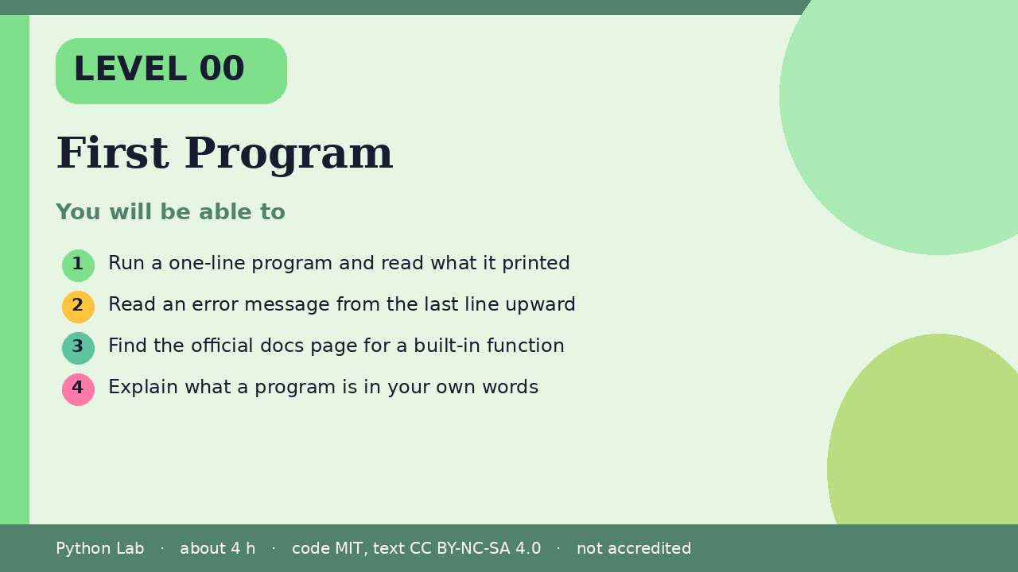

First Program
Level 00 · about 4 hours · Python 3.8+ · examples run on CPython 3.12.3
Project: A Hello, me card

You will be able to
Outcome | My notes
Run a one-line program and read what it printed
Read an error message from the last line upward
Find the official docs page for a built-in function
Explain what a program is in your own words

First Program

What a program is
A program is a list of instructions a computer follows in order. Python reads your file from the top and does each instruction in turn.

Your first print
print shows a value on the screen. Text goes inside quotes.
Code
print("Hello, me")
print("My first program")

Output (CPython 3.12.3)
Hello, me
My first program

Printing more than text
You can print numbers and do arithmetic. Python works the answer out before it prints.
Code
print(2 + 3)
print("2 + 3 =", 2 + 3)

Output (CPython 3.12.3)
5
2 + 3 = 5

Reading an error
An error is not a failure. A traceback is a map: start at the last line, which names the problem. This example catches the error so you can see its message.
Code
try:
print(undefined_name)
except NameError as err:
print("NameError:", err)

Output (CPython 3.12.3)
NameError: name 'undefined_name' is not defined

Find the docs
Every built-in function has a page in the official documentation. Search for print() and read its parameters, such as sep and end.
Code
print("a", "b", "c", sep="-")
print("no newline", end="!")
print()

Output (CPython 3.12.3)
a-b-c
no newline!

Check yourself
- What does print("2 + 3") show, compared with print(2 + 3)?
- Which line of a traceback names the problem?
- What does sep change?

Project: Hello, me card
Print four lines: your name, one thing you are learning, one thing you like, and today's goal. Then change the sep between two items.

Sources
Title | URL
Python tutorial: An informal introduction | https://docs.python.org/3/tutorial/introduction.html
Python docs: print() | https://docs.python.org/3/library/functions.html#print
Python tutorial: Errors and exceptions | https://docs.python.org/3/tutorial/errors.html
Code © CypherMonkeyLabs, MIT. Text CC BY-NC-SA 4.0. Educational material, not accredited coursework. No outcome is promised.

