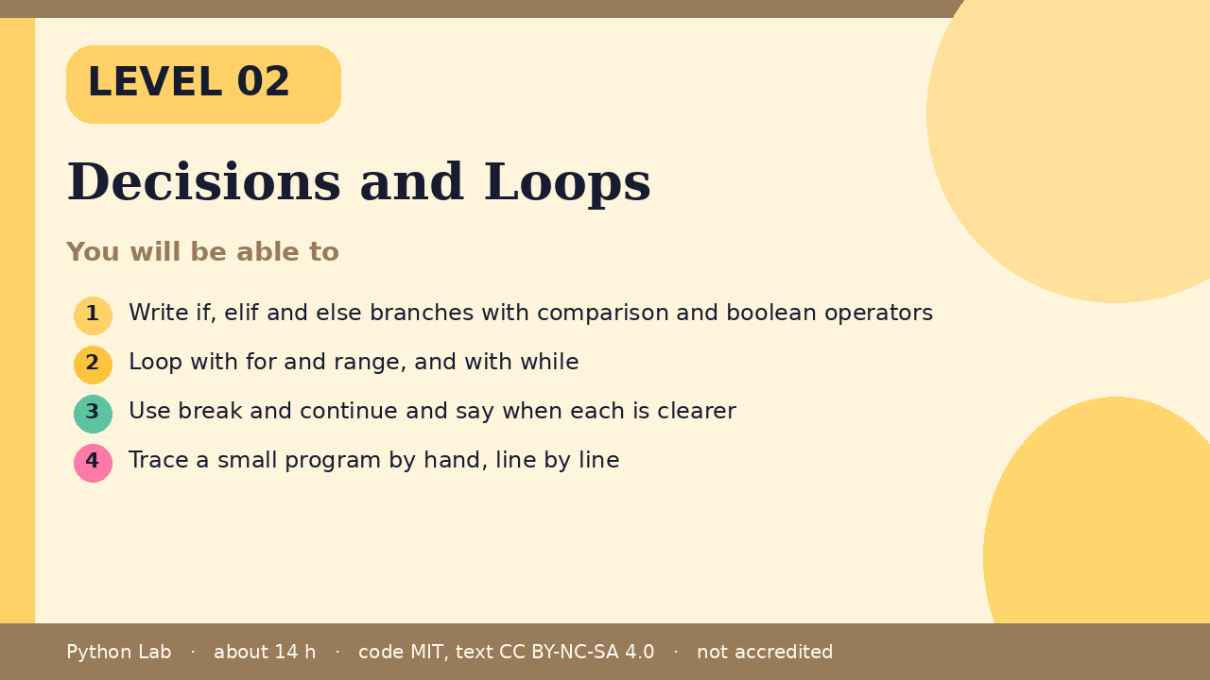

Decisions and Loops
Level 02 · about 14 hours · Python 3.8+ · examples run on CPython 3.12.3
Project: A number-guess game

You will be able to
Outcome | My notes
Write if, elif and else branches with comparison and boolean operators
Loop with for and range, and with while
Use break and continue and say when each is clearer
Trace a small program by hand, line by line

Decisions and Loops

Decisions with if
Python runs the first branch whose test is true. Indentation shows which lines belong to the branch.
Code
score = 72
if score >= 90:
grade = "A"
elif score >= 70:
grade = "C or better"
else:
grade = "keep practising"
print(grade)

Output (CPython 3.12.3)
C or better

Comparing and combining
Comparisons give booleans. Combine them with and, or, not.
Code
age = 15
has_ticket = True
print(age >= 13 and has_ticket)
print(not has_ticket)

Output (CPython 3.12.3)
True
False

Loops with for and range
range(n) counts from 0 up to n - 1.
Code
for i in range(3):
print("lap", i)
print(sum(range(1, 6)))

Output (CPython 3.12.3)
lap 0
lap 1
lap 2
15

Loops with while
A while loop repeats as long as its test is true. Change something inside, or it never ends.
Code
n = 3
while n > 0:
print(n)
n -= 1
print("go")

Output (CPython 3.12.3)
3
2
1
go

break and continue
break leaves the loop. continue skips to the next pass.
Code
for i in range(10):
if i % 2 == 0:
continue
if i > 7:
break
print(i)

Output (CPython 3.12.3)
1
3
5
7

Tracing by hand
Write each name and its value after every line. Compare your table with the output.
Code
total = 0
for i in range(1, 4):
total += i
print(i, total)

Output (CPython 3.12.3)
1 1
2 3
3 6

Check yourself
- Which branch runs when score is 70?
- How many times does for i in range(3) run its body?
- What does continue do?

Project: Number-guess game
The computer picks a number from 1 to 20 (use a fixed number first). Loop until the guess is right, print "higher" or "lower", and stop after 6 tries.

Sources
Title | URL
Python tutorial: More control flow tools | https://docs.python.org/3/tutorial/controlflow.html
PEP 8 Style Guide for Python Code | https://peps.python.org/pep-0008/
Python docs: Truth value testing | https://docs.python.org/3/library/stdtypes.html#truth-value-testing
Code © CypherMonkeyLabs, MIT. Text CC BY-NC-SA 4.0. Educational material, not accredited coursework. No outcome is promised.

