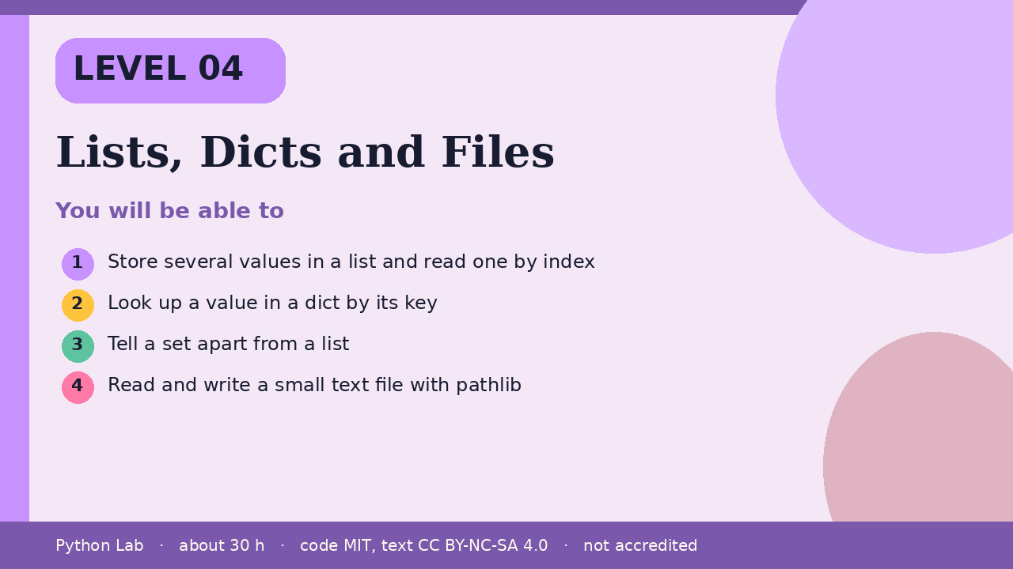

Lists, Dicts and Files
Level 04 · about 30 hours · Python 3.8+ · examples run on CPython 3.12.3
Project: An address card kept in a dict and saved as a text file

You will be able to
Outcome | My notes
Store several values in a list and read one by index
Look up a value in a dict by its key
Tell a set apart from a list
Read and write a small text file with pathlib

Lists, Dicts and Files

A list keeps an order
A list is a mutable sequence. Indexes start at 0. append adds at the end. The Python wiki's TimeComplexity page describes CPython list costs; it is community notes, not a language guarantee.
Code
names = ["Ada", "Grace"]
names.append("Guido")
print(names[0], len(names))
print(names[1:3])

Output (CPython 3.12.3)
Ada 3
['Grace', 'Guido']

A dict looks up by key
A dict maps each key to one value. in tests keys, not values.
Code
card = {"name": "Ada", "year": 1815}
print(card["name"])
print("year" in card)
print(card.get("city", "unknown"))

Output (CPython 3.12.3)
Ada
True
unknown

A set keeps unique items
A set does not keep order you can rely on, and it drops duplicates.
Code
tools = {"pen", "ink", "pen"}
print(len(tools))
print("ink" in tools)

Output (CPython 3.12.3)
2
True

A file should say its encoding
pathlib.Path is the object-oriented way to name a file. write_text and read_text take an encoding. This sample uses a temporary directory so the build does not leave a file behind.
Code
import tempfile
from pathlib import Path
folder = Path(tempfile.mkdtemp())
path = folder / "card.txt"
path.write_text("Ada\n", encoding="utf-8")
print(path.read_text(encoding="utf-8").strip())

Output (CPython 3.12.3)
Ada

Check yourself
- What is the index of the first item in a list?
- Does in on a dict test keys or values?
- Why pass encoding="utf-8" when you read text?

Sources
Title | URL
Python docs: Built-in types | https://docs.python.org/3/library/stdtypes.html
Python docs: pathlib | https://docs.python.org/3/library/pathlib.html
Python tutorial: Input and output | https://docs.python.org/3/tutorial/inputoutput.html
Python wiki: TimeComplexity | https://wiki.python.org/moin/TimeComplexity
Code © CypherMonkeyLabs, MIT. Text CC BY-NC-SA 4.0. Educational material, not accredited coursework. No outcome is promised.

