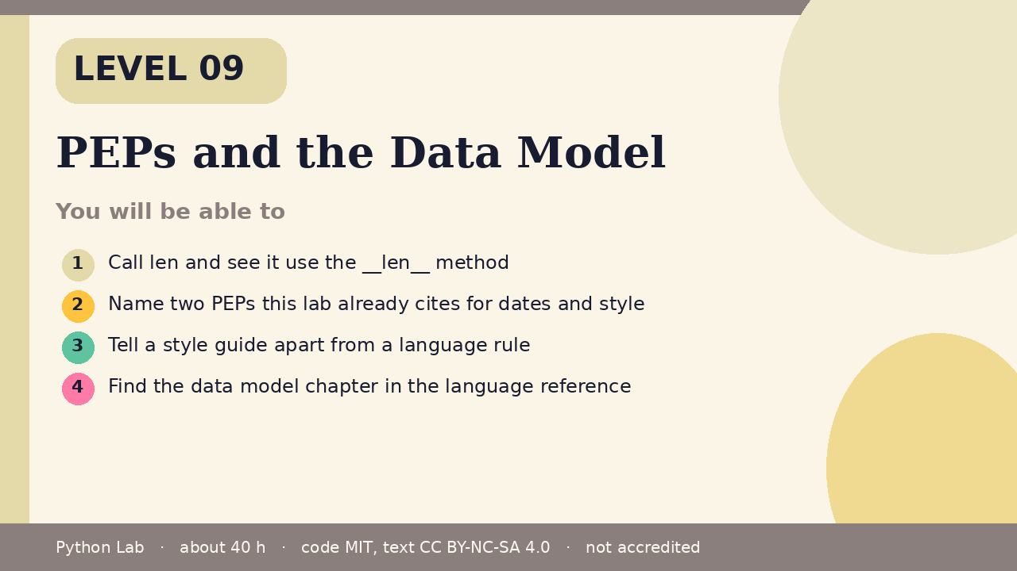

PEPs and the Data Model
Level 09 · about 40 hours · Python 3.8+ · examples run on CPython 3.12.3
Project: A small Bag whose len is the number of items you stored

You will be able to
Outcome | My notes
Call len and see it use the __len__ method
Name two PEPs this lab already cites for dates and style
Tell a style guide apart from a language rule
Find the data model chapter in the language reference

PEPs and the Data Model

len asks the object
The data model says operations such as len look up special methods. A class can supply __len__. len then returns that integer.
Code
class Bag:
def __init__(self, items):
self.items = list(items)
def __len__(self):
return len(self.items)
print(len(Bag(["pen", "ink"])))
print("py".__len__())

Output (CPython 3.12.3)
2
2

A PEP is a design document
PEP 8 is the style guide. Formatting tools may warn about it. CPython does not reject a program for ignoring it. PEP 790 is the 3.15 release schedule. This lab's sources record 3.15.0 final as 9 October 2026 from that PEP. The PEP index lists the documents.
Code
cited = ["PEP 8", "PEP 790"]
print(", ".join(cited))
print("style guide" != "syntax rule")

Output (CPython 3.12.3)
PEP 8, PEP 790
True

Where to read next
Open the data model chapter when you want the rule for a special method. Open the PEP index when you want the history of a change. The pages linked under Sources are the ones this Level uses.

Check yourself
- Which method does len call?
- Is PEP 8 a compiler rule?
- Which PEP in the sources is the 3.15 schedule?

Sources
Title | URL
Python reference: Data model | https://docs.python.org/3/reference/datamodel.html
PEP 8 – Style Guide for Python Code | https://peps.python.org/pep-0008/
PEP 790 – Python 3.15 Release Schedule | https://peps.python.org/pep-0790/
PEP index | https://peps.python.org/
Code © CypherMonkeyLabs, MIT. Text CC BY-NC-SA 4.0. Educational material, not accredited coursework. No outcome is promised.

