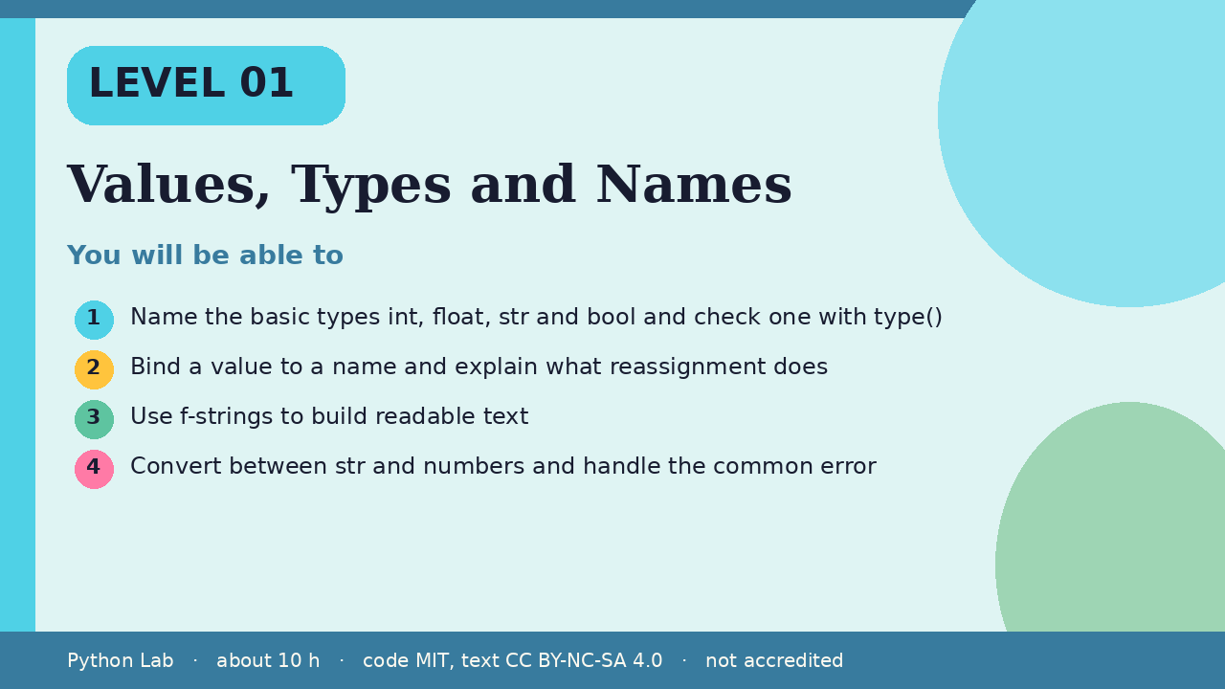

Values, Types and Names
Level 01 · about 10 hours · Python 3.8+ · examples run on CPython 3.12.3
Project: A tip and tax calculator

You will be able to
Outcome | My notes
Name the basic types int, float, str and bool and check one with type()
Bind a value to a name and explain what reassignment does
Use f-strings to build readable text
Convert between str and numbers and handle the common error

Values, Types and Names

Values have types
Every value has a type. type() tells you which.
Code
print(type(42))
print(type(3.5))
print(type("hi"))
print(type(True))

Output (CPython 3.12.3)
<class 'int'>
<class 'float'>
<class 'str'>
<class 'bool'>

Names point at values
A name is a label stuck to a value. Reassigning moves the label; it does not change the old value.
Code
total = 10
total = total + 5
print(total)

Output (CPython 3.12.3)
15

Numbers and arithmetic
/ always gives a float. // divides and rounds down. % gives the remainder.
Code
print(7 / 2)
print(7 // 2)
print(7 % 2)
print(2 ** 10)

Output (CPython 3.12.3)
3.5
3
1
1024

Strings and f-strings
An f-string puts values into text. Format specs control decimals.
Code
name = "Ada"
price = 19.5
print(f"{name} pays {price:.2f}")
print(name.upper(), len(name))

Output (CPython 3.12.3)
Ada pays 19.50
ADA 3

Converting types
input() always returns text. Convert it before doing arithmetic.
Code
text = "12"
print(int(text) + 1)
try:
int("twelve")
except ValueError as err:
print("ValueError:", err)

Output (CPython 3.12.3)
13
ValueError: invalid literal for int() with base 10: 'twelve'

Check yourself
- What is type(7 / 2)?
- After total = 10 and total = total + 5, what does total name?
- Why must you convert the result of input() before adding numbers?

Project: Tip and tax calculator
Ask for a bill, a tip percent and a tax percent, convert them, and print the total with two decimals using an f-string.

Sources
Title | URL
Python tutorial: An informal introduction | https://docs.python.org/3/tutorial/introduction.html
Python reference: The data model | https://docs.python.org/3/reference/datamodel.html
Python docs: Formatted string literals | https://docs.python.org/3/reference/lexical_analysis.html#f-strings
PEP 8 Style Guide for Python Code | https://peps.python.org/pep-0008/
Code © CypherMonkeyLabs, MIT. Text CC BY-NC-SA 4.0. Educational material, not accredited coursework. No outcome is promised.

