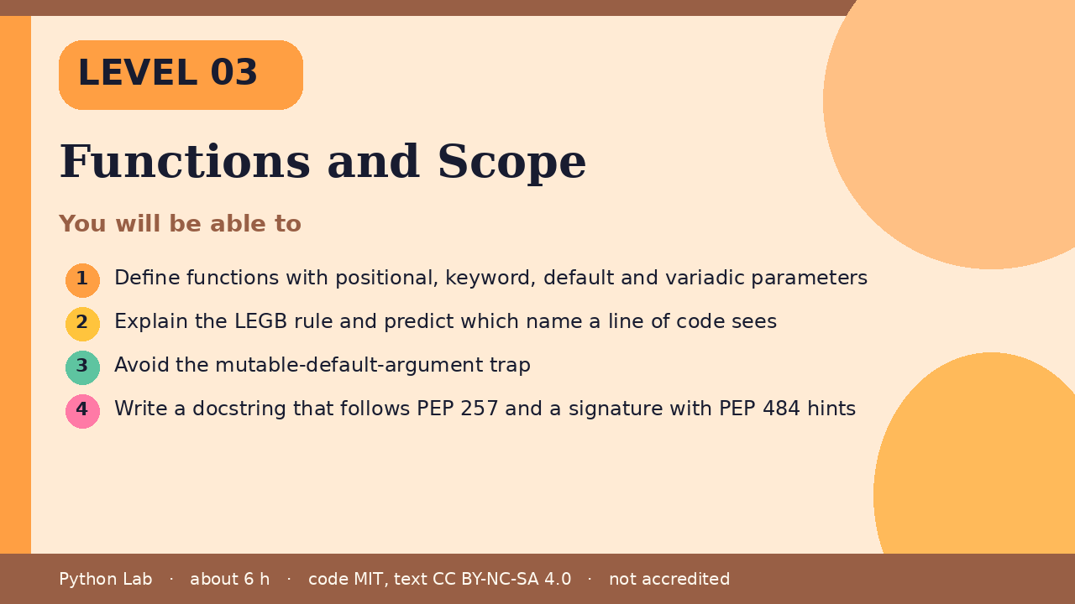

Functions and Scope
Level 03 · about 6 hours · Python 3.8+ · examples run on CPython 3.12.3
Project: Unit converter CLI with tested pure functions

You will be able to
Outcome | My notes
Define functions with positional, keyword, default and variadic parameters
Explain the LEGB rule and predict which name a line of code sees
Avoid the mutable-default-argument trap
Write a docstring that follows PEP 257 and a signature with PEP 484 hints

Functions and Scope

Why functions
A function gives a block of code a name so you can reuse it and test it alone. Keep each function doing one thing and returning a value instead of printing it.

Defining and calling
Code
def area(width, height=1):
"""Return the area of a rectangle."""
return width * height
print(area(3, 4))
print(area(5))
print(area(height=2, width=6))

Output (CPython 3.12.3)
12
5
12

- width is a required parameter; height has a default value.
- Keyword arguments let you pass values by name, in any order.

Variadic parameters
args collects extra positional arguments into a tuple; kwargs collects extra keyword arguments into a dict.
Code
def describe(*args, **kwargs):
return len(args), sorted(kwargs)
print(describe(1, 2, 3, unit="cm", colour="red"))

Output (CPython 3.12.3)
(3, ['colour', 'unit'])

The LEGB rule
Python looks a name up in this order: Local, Enclosing function, Global, Built-in. Assigning to a name inside a function makes it local to that function unless you declare global or nonlocal.
Code
x = "global"
def outer():
x = "enclosing"
def inner():
nonlocal x
x = "changed by inner"
inner()
return x
print(outer())
print(x)

Output (CPython 3.12.3)
changed by inner
global

The mutable default trap
Default values are evaluated once, when the def runs, not on each call.
Code
def add_item(item, bucket=[]):
bucket.append(item)
return bucket
print(add_item("a"))
print(add_item("b"))
def add_item_safe(item, bucket=None):
if bucket is None:
bucket = []
bucket.append(item)
return bucket
print(add_item_safe("a"))
print(add_item_safe("b"))

Output (CPython 3.12.3)
['a']
['a', 'b']
['a']
['b']

Docstrings and hints
PEP 257 describes docstring conventions: a short summary line, then detail if needed. PEP 484 defines the type-hint syntax. Hints are not enforced at run time; a checker such as mypy or pyright reads them.
Code
def celsius_to_fahrenheit(c: float) -> float:
"""Convert degrees Celsius to degrees Fahrenheit."""
return c * 9 / 5 + 32
print(celsius_to_fahrenheit(100))

Output (CPython 3.12.3)
212.0

Check yourself
- What does area(height=2, width=6) return?
- Why does add_item("b") print ['a', 'b']?
- Which scope does a name assigned inside inner belong to without nonlocal?

Project: Unit converter CLI
Build three pure functions (km to miles, kg to pounds, Celsius to Fahrenheit), add docstrings and hints, then write four pytest tests. Stretch: accept values with argparse.

Sources
Title | URL
Python tutorial: More on defining functions | https://docs.python.org/3/tutorial/controlflow.html#defining-functions
PEP 257 Docstring Conventions | https://peps.python.org/pep-0257/
PEP 484 Type Hints | https://peps.python.org/pep-0484/
PEP 8 Style Guide for Python Code | https://peps.python.org/pep-0008/
Python reference: Naming and binding | https://docs.python.org/3/reference/executionmodel.html#naming-and-binding
Code © CypherMonkeyLabs, MIT. Text CC BY-NC-SA 4.0. Educational material, not accredited coursework. No outcome is promised.

