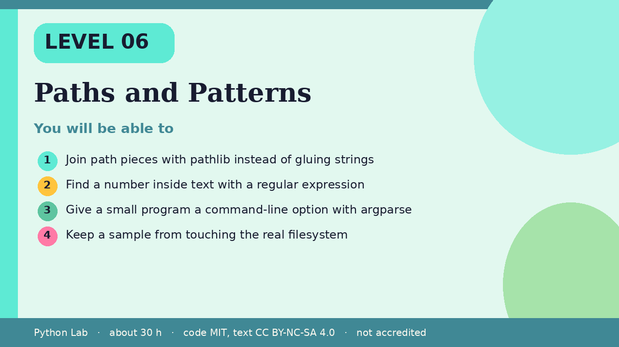

Paths and Patterns
Level 06 · about 30 hours · Python 3.8+ · examples run on CPython 3.12.3
Project: A tiny note-sorter that accepts --title

You will be able to
Outcome | My notes
Join path pieces with pathlib instead of gluing strings
Find a number inside text with a regular expression
Give a small program a command-line option with argparse
Keep a sample from touching the real filesystem

Paths and Patterns

Paths are objects
pathlib.Path joins pieces with /. as_posix shows the forward-slash form, which is what the docs use in examples.
Code
from pathlib import Path
path = Path("notes") / "week" / "a.txt"
print(path.as_posix())
print(path.suffix)

Output (CPython 3.12.3)
notes/week/a.txt
.txt

Patterns find a piece of text
re.search returns a match object, or None when nothing matched. This example looks for digits.
Code
import re
match = re.search(r"\d+", "room 12b")
print(match.group(0) if match else "none")
print(re.sub(r"\s+", "-", "a b c"))

Output (CPython 3.12.3)
12
a-b-c

argparse reads options
parse_args([]) reads an empty argument list, so the build does not depend on how the script was started. The default is what a user would get if they passed no flags.
Code
import argparse
parser = argparse.ArgumentParser(prog="notes")
parser.add_argument("--title", default="inbox")
args = parser.parse_args([])
print(args.title)

Output (CPython 3.12.3)
inbox

Check yourself
- What does Path("notes") / "a.txt" produce?
- What does re.search return when the pattern is missing?
- Why does this page call parse_args([])?

Sources
Title | URL
Python docs: pathlib | https://docs.python.org/3/library/pathlib.html
Python docs: re | https://docs.python.org/3/library/re.html
Python docs: argparse | https://docs.python.org/3/library/argparse.html
Code © CypherMonkeyLabs, MIT. Text CC BY-NC-SA 4.0. Educational material, not accredited coursework. No outcome is promised.

