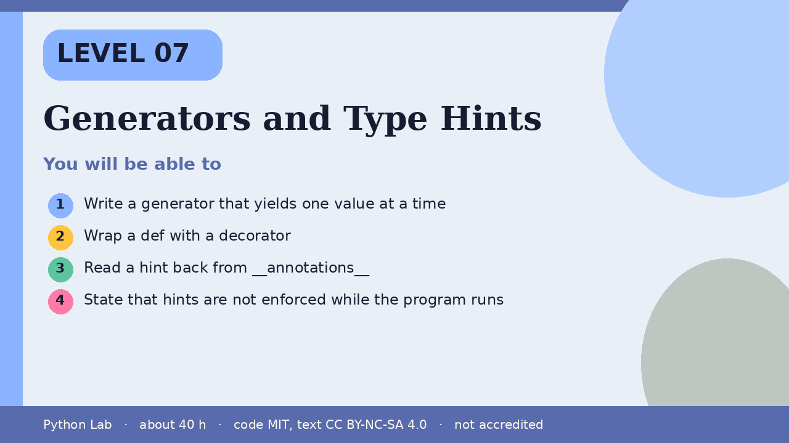

Generators and Type Hints
Level 07 · about 40 hours · Python 3.9+ · examples run on CPython 3.12.3
Project: A countdown generator with a hinted total

You will be able to
Outcome | My notes
Write a generator that yields one value at a time
Wrap a def with a decorator
Read a hint back from __annotations__
State that hints are not enforced while the program runs

Generators and Type Hints

yield pauses and resumes
A generator produces values one at a time. list pulls every yielded value. The reference describes yield as the way a generator sends a value to its caller.
Code
def countdown(n):
while n:
yield n
n -= 1
print(list(countdown(3)))

Output (CPython 3.12.3)
[3, 2, 1]

A decorator wraps a def
The glossary defines a decorator as a way to return a new object, usually a wrapper, that replaces the original. This wrapper uppercases the returned text. Hints are not involved yet.
Code
def shout(fn):
def wrapped(text):
return fn(text).upper()
return wrapped
@shout
def greet(text):
return "hi " + text
print(greet("ada"))

Output (CPython 3.12.3)
HI ADA

Hints are readable, not a gate
PEP 484 says type hints are optional and are not required at runtime. CPython stores them on __annotations__. It does not reject a call that ignores them. typing is the standard-library module for the hint names.
Code
def add(a: int, b: int) -> int:
return a + b
print(add(2, 5))
print(add.__annotations__["return"].__name__)

Output (CPython 3.12.3)
7
int

Check yourself
- What does yield do that return does not?
- What does a decorator return?
- Does Python stop you when a call ignores a hint?

Sources
Title | URL
Python reference: Yield expressions | https://docs.python.org/3/reference/expressions.html#yield-expressions
Python glossary: decorator | https://docs.python.org/3/glossary.html#term-decorator
Python docs: typing | https://docs.python.org/3/library/typing.html
PEP 484 – Type Hints | https://peps.python.org/pep-0484/
Code © CypherMonkeyLabs, MIT. Text CC BY-NC-SA 4.0. Educational material, not accredited coursework. No outcome is promised.

