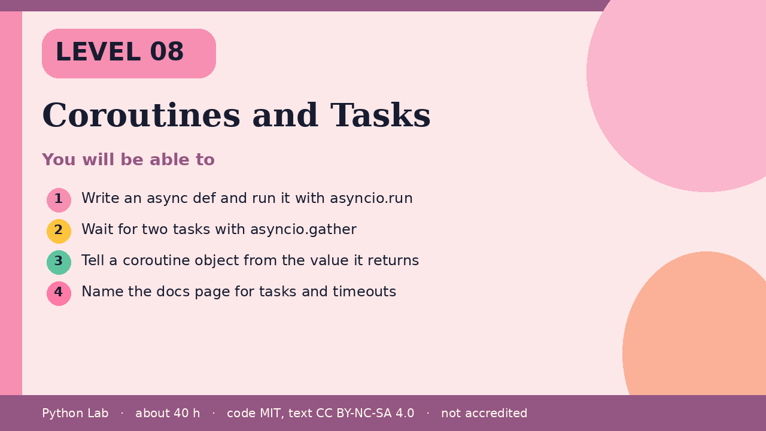

Coroutines and Tasks
Level 08 · about 40 hours · Python 3.8+ · examples run on CPython 3.12.3
Project: Two tiny coroutines gathered into one result

You will be able to
Outcome | My notes
Write an async def and run it with asyncio.run
Wait for two tasks with asyncio.gather
Tell a coroutine object from the value it returns
Name the docs page for tasks and timeouts

Coroutines and Tasks

asyncio.run drives one coroutine
async def defines a coroutine. Calling it does not run the body; it returns a coroutine object. asyncio.run creates an event loop, runs that coroutine, and closes the loop.
Code
import asyncio
async def ping():
return "pong"
print(asyncio.run(ping()))

Output (CPython 3.12.3)
pong

gather waits for more than one
asyncio.gather schedules the awaitables together and returns their results in order. The tasks page in the docs covers gather, cancellation, and timeouts.
Code
import asyncio
async def add(a, b):
return a + b
async def main():
return await asyncio.gather(add(1, 2), add(3, 4))
print(asyncio.run(main()))

Output (CPython 3.12.3)
[3, 7]

A coroutine is not the result
Printing the coroutine object without awaiting it does not print the return value. This sample closes it so the build does not warn about a coroutine that was never awaited.
Code
async def ping():
return "pong"
coro = ping()
print(type(coro).__name__)
coro.close()

Output (CPython 3.12.3)
coroutine

Check yourself
- What does calling an async def return before you await it?
- What does asyncio.gather preserve about order?
- Which docs page describes create_task and timeouts?

Sources
Title | URL
Python docs: asyncio | https://docs.python.org/3/library/asyncio.html
Python docs: Coroutines and Tasks | https://docs.python.org/3/library/asyncio-task.html
Code © CypherMonkeyLabs, MIT. Text CC BY-NC-SA 4.0. Educational material, not accredited coursework. No outcome is promised.

