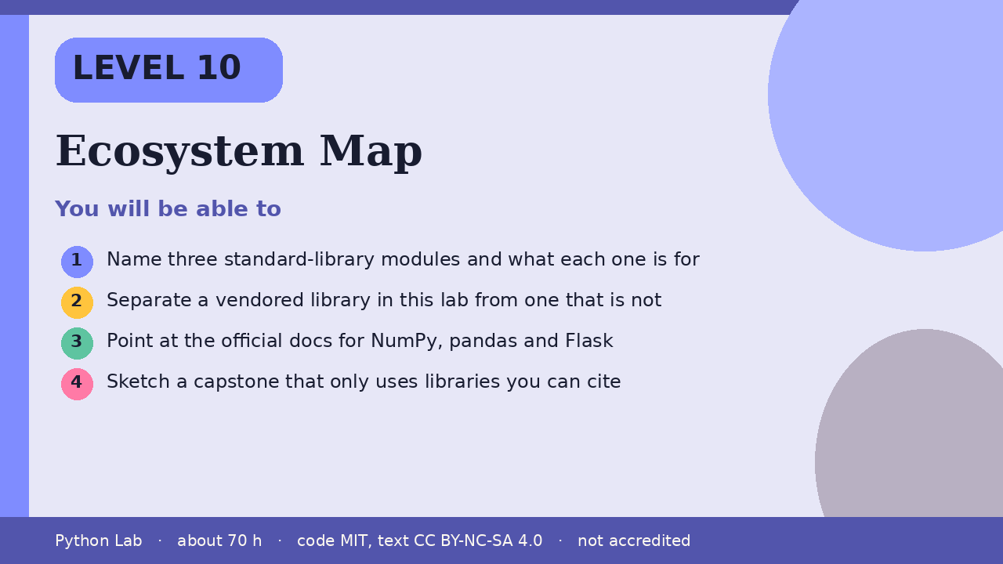

Ecosystem Map
Level 10 · about 70 hours · Python 3.8+ · examples run on CPython 3.12.3
Project: A one-page map of three libraries, each with its docs link

You will be able to
Outcome | My notes
Name three standard-library modules and what each one is for
Separate a vendored library in this lab from one that is not
Point at the official docs for NumPy, pandas and Flask
Sketch a capstone that only uses libraries you can cite

Ecosystem Map

Start from the standard library
json, pathlib and math ship with Python. You do not install them. This sample only checks that math.sqrt returns the value the docs describe for a perfect square.
Code
import math
mods = ["json", "pathlib", "math"]
print(", ".join(mods))
print(math.sqrt(9))

Output (CPython 3.12.3)
json, pathlib, math
3.0

This lab vendors some libraries and not others
The browser runtime in this site vendors Pyodide, NumPy 2.4.6 and pandas 3.0.2. Flask is not part of that runtime. The build machine for these files does not import Flask or NumPy, so this page does not print their versions. Read their docs from the links under Sources.
Code
vendored_here = ["Pyodide", "NumPy", "pandas"]
not_vendored_here = ["Flask"]
print("vendored: " + ", ".join(vendored_here))
print("not vendored: " + ", ".join(not_vendored_here))

Output (CPython 3.12.3)
vendored: Pyodide, NumPy, pandas
not vendored: Flask

A capstone is a project you choose
Pick one small program that uses the standard library, and optionally NumPy or pandas inside the lab's browser runner. Write down the docs page you followed. This Level does not grade it and does not promise a job, a certificate, or a result.

Check yourself
- Name one standard-library module from the first sample.
- Which of NumPy and Flask is vendored in this lab's browser runtime?
- What belongs on your capstone map besides the library name?

Sources
Title | URL
The Python Tutorial | https://docs.python.org/3/tutorial/index.html
NumPy documentation | https://numpy.org/doc/stable/
pandas documentation | https://pandas.pydata.org/docs/
Flask documentation | https://flask.palletsprojects.com/
Pyodide | https://pyodide.org/en/stable/
Code © CypherMonkeyLabs, MIT. Text CC BY-NC-SA 4.0. Educational material, not accredited coursework. No outcome is promised.

