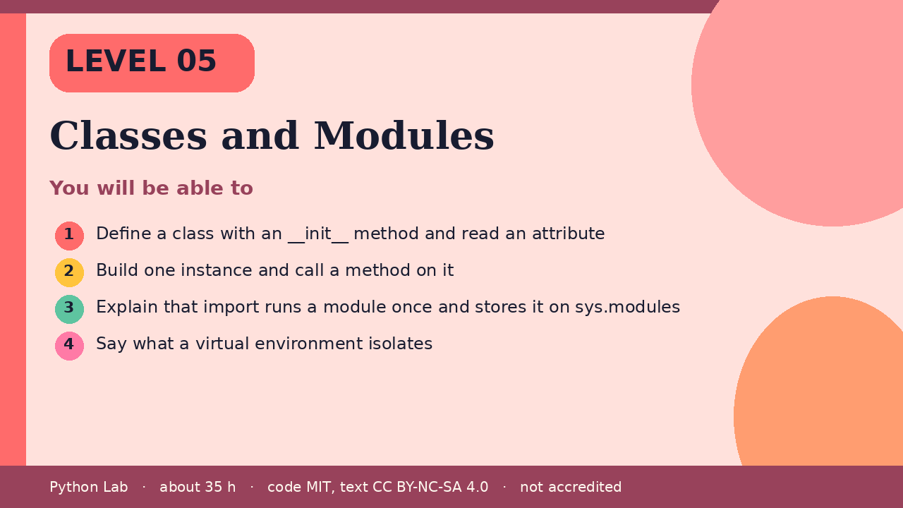

Classes and Modules
Level 05 · about 35 hours · Python 3.8+ · examples run on CPython 3.12.3
Project: A Note class plus a one-line import check

You will be able to
Outcome | My notes
Define a class with an __init__ method and read an attribute
Build one instance and call a method on it
Explain that import runs a module once and stores it on sys.modules
Say what a virtual environment isolates

Classes and Modules

A class bundles data and methods
The tutorial describes a class as a way to bundle data and the operations on that data. __init__ runs when you call the class. self is the instance.
Code
class Note:
def __init__(self, text):
self.text = text
def shout(self):
return self.text.upper()
note = Note("hello")
print(note.text)
print(note.shout())

Output (CPython 3.12.3)
hello
HELLO

import runs the module once
import executes a module and keeps the module object in sys.modules. Importing again returns that same object. json is in the standard library, so this sample does not install anything.
Code
import json
import sys
print("json" in sys.modules)
print(json.dumps({"ok": True}))

Output (CPython 3.12.3)
True
{"ok": true}

A virtual environment isolates installs
venv creates an environment with its own site-packages. PEP 405 is the design. This page does not create an environment during the build, because that would write a folder. The check below only reports that the venv module can be found.
Code
import importlib.util
print(importlib.util.find_spec("venv") is not None)

Output (CPython 3.12.3)
True

Check yourself
- When does __init__ run?
- Where does Python keep a module after the first import?
- What does a virtual environment keep separate?

Sources
Title | URL
Python tutorial: Classes | https://docs.python.org/3/tutorial/classes.html
Python tutorial: Modules | https://docs.python.org/3/tutorial/modules.html
Python docs: venv | https://docs.python.org/3/library/venv.html
PEP 405 – Python Virtual Environments | https://peps.python.org/pep-0405/
Code © CypherMonkeyLabs, MIT. Text CC BY-NC-SA 4.0. Educational material, not accredited coursework. No outcome is promised.

