Java Assignment - 1

Name: Saloman Raju Sarikokkula
Date: 15-03-2026
Topics: Java Introduction, Compiler, Text Editors vs IDEs, Classes and Packages

Date: Mar 11, 2026

The First Program

HelloWorld.java

public class HelloWorld {
public static void main (String [] args) { System.out.println("Hello, world!");
}
}

Expected Output:

Hello, world!
Can be (compiled and) executed in any text editor or IDE. The HelloWorld.java file's execution in VSCode.
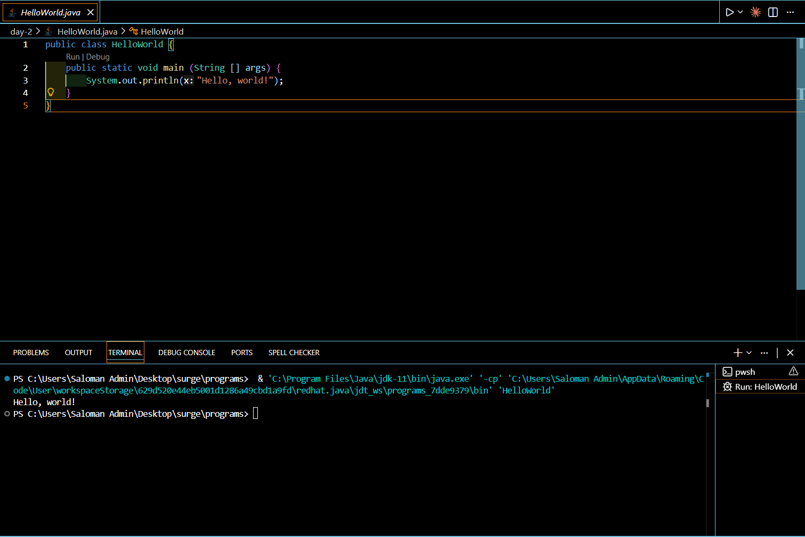

Compiler

Translates source code(.java file) into binary bit code (.class file)

Syntax:
- Javac <program_name>.java //compile
- Java <program_name> //run

Example:

HelloWorld.java —> HelloWorld.class

- Javac HelloWorld.java //compile
- Java HelloWorld //run

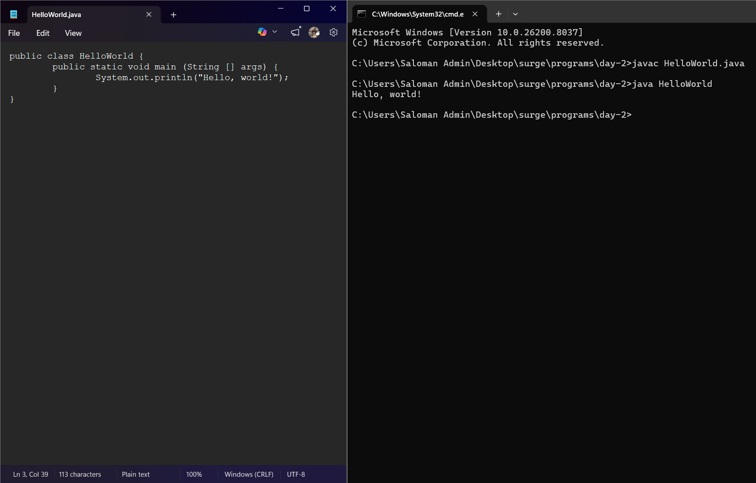

Text Editors VS IDEs

Text Editors: Notepad, Notepad++, Sublime Text, etc.
IDEs: Visual Studio Code, Eclipse IDE, IntelliJ IDE, etc.

Text Editors

    - Write Code.
    - Save file.
    - Compile manually in command prompt in the respective directory.
4. If errors exist, correct them manually in file until there's no errors. And save again.
5. Run/execute for Output.

Ex: Notepad++
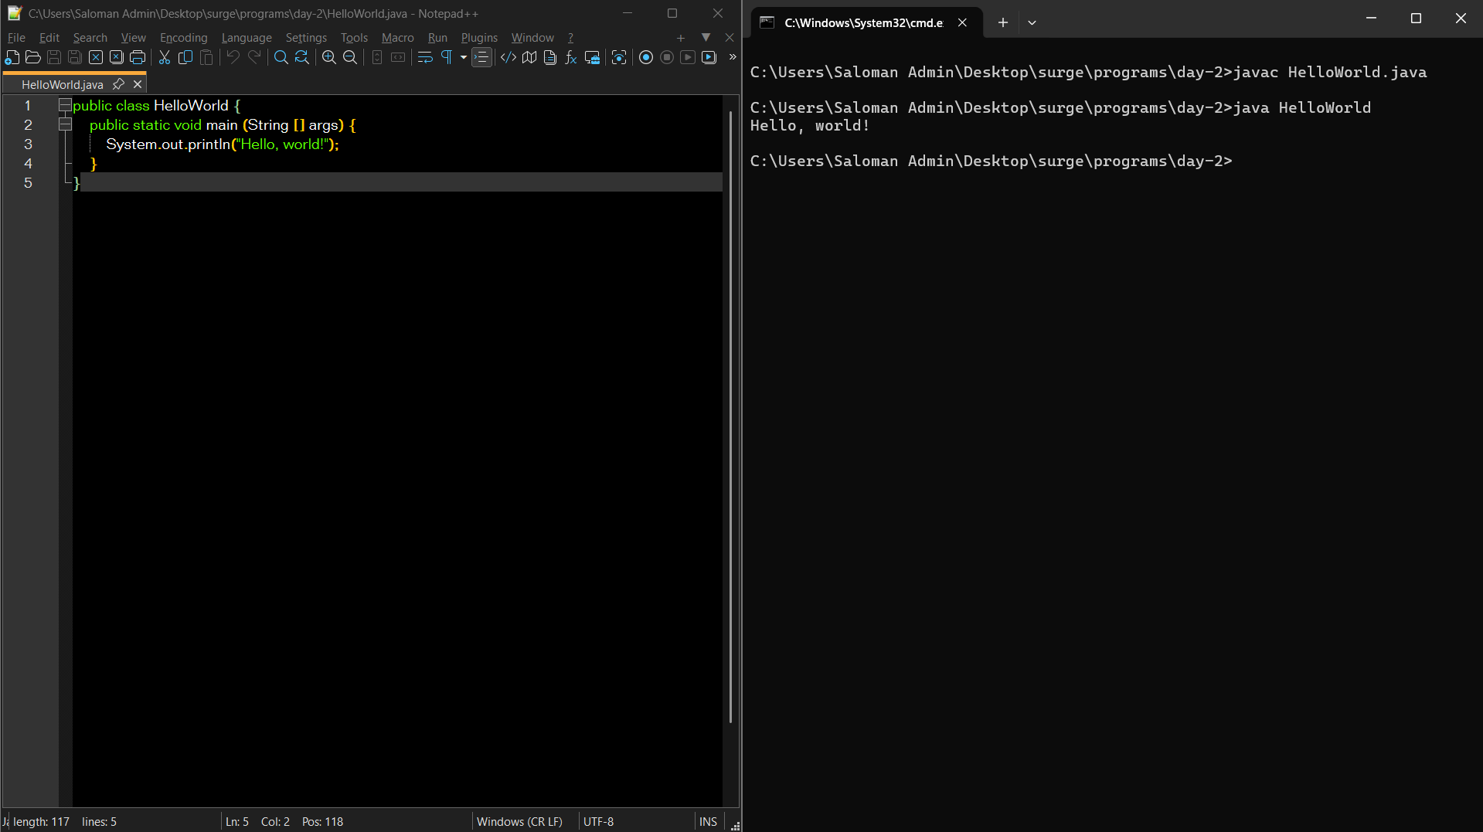

IDEs

    - Write code.
    - Save file.
    - Run/execute directly.

Ex: Visual Studio Code
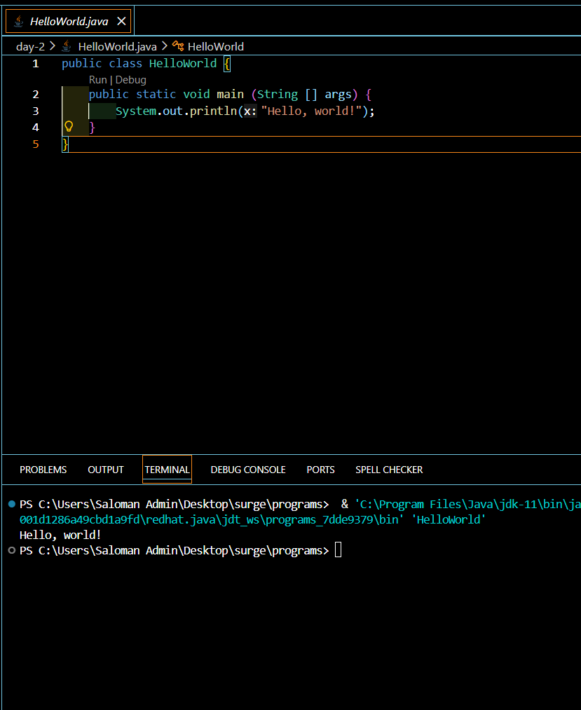

Date: Mar 12, 2026

Class
The template for creating an object.

Syntax:

public class <class_name> {}

Example:

public class Employee {}

Example in VSCode:
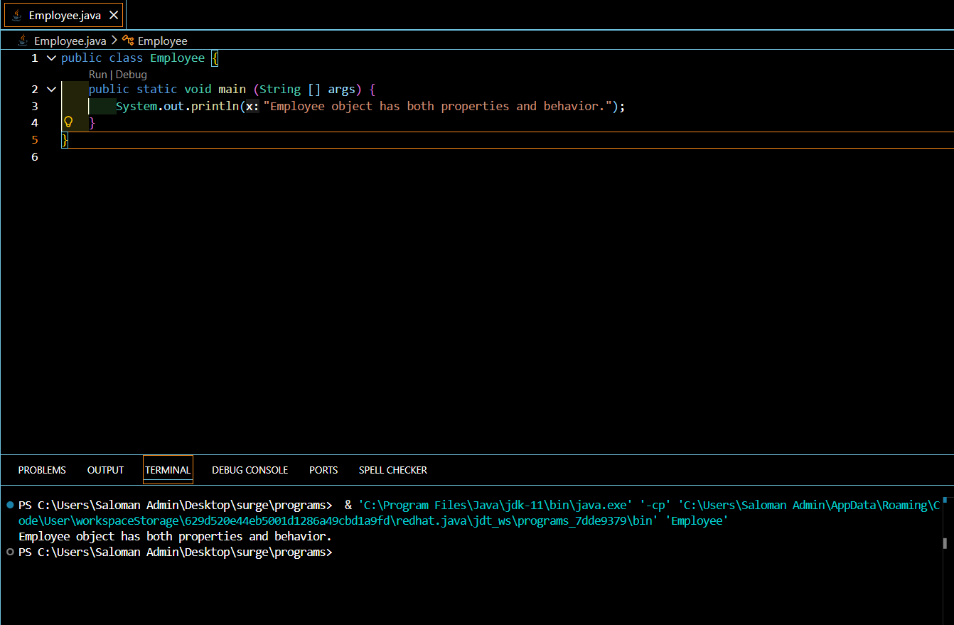

Packages

The container/folder which holds the multiple java classes together.

Syntax:

package <package1Name>.<package2Name>.<package3Name>...;

Dot ( . ) is used to connect the packages.

Example:

package day3.topics.subTopic;

Example in VSCode:

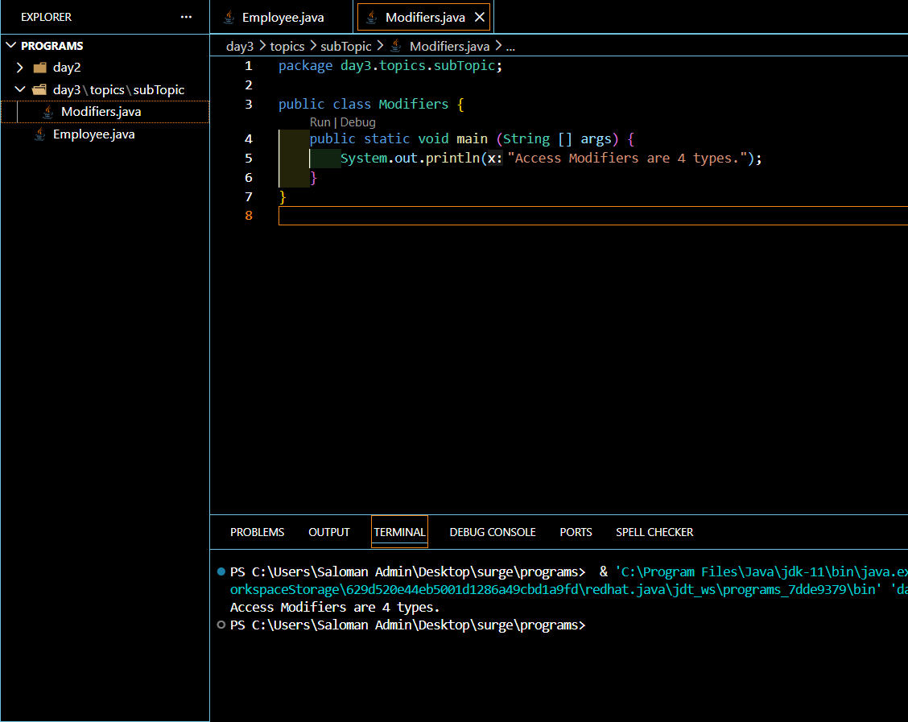

The structure of the packages and files is like the following for above code in day3 package:

day3 (super package of all)
|
|- topics (super package of current package)
|
|- subTopic (current package)
|
|--Modifiers.java (current file)

