Java Assignment - 2

Name: Saloman Raju Sarikokkula
Date of Submission: 21-03-2026

Date: 16-03-2026

Topics: Data types & Variables

Data Types

Data types are used to define the type and size of the value where a variable is going to store in it. Categorize into Two types:
- Primitive: byte, short, int, long, float, double, char, boolean.
- Non-Primitive: String, Array, Class, Interface, Collection.

Primitive Data Types

These are in-built or predefined data types.

Syntax:

<data_type> <variable> = <value>

Example:

int number = 20;

Program:

package day4.assignment; public class DataTypes {
public static void main(String[] args) { int rollNo = 4;

boolean presentToday = true; long mobileNum = 9320392369L; char bloodGroup = 'A';
double amountPaid = 1000.00;

System.out.println(rollNo); System.out.println(presentToday); System.out.println(mobileNum); System.out.println(bloodGroup); System.out.println(amountPaid);
}
}

Execution in VSCode:

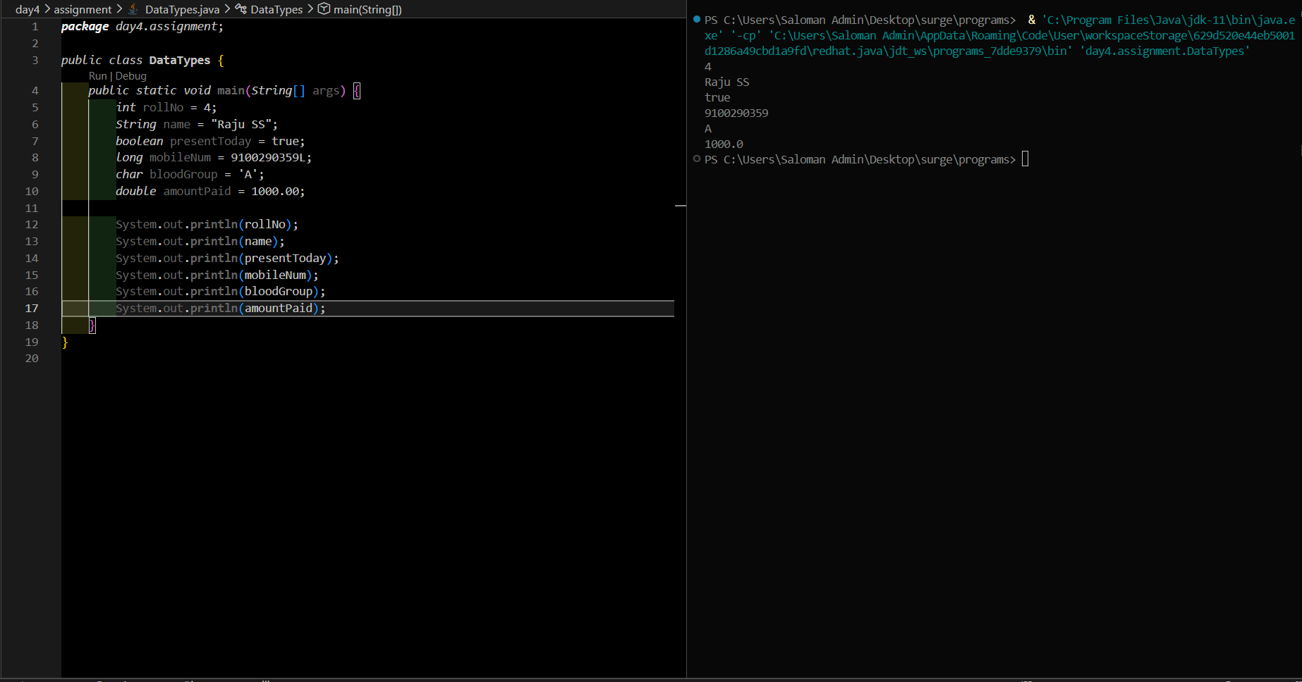

Non-Primitive Data Types

These are the data types which store references rather values. That's why they are also called as Reference Data Types
Types: String, Array, Class, Interface, Collection, .etc.

Syntax:

<data_type> <ref_variable> = new <data_type>([vals]);

Example:

String name = new String("phantom");

Variables

Variables are the containers which are used to store the values during the program execution. These are Three types:
- Local Variables
- Instance Variables
- Static Variables

Local Variables

The variables which are defined inside the methods are called Local variables.

They don't have default values.

Example:

public class Sample {

public void sample () { // method definition String name = "Dall-E"; // local variable
}

}

Instance Variables

The non-static variables which are defined inside a class but outside the methods are called Instance Variables or Non-static Field.
Each object gets their separate instance of these instance variables.

Example:

public class Employee
{
int employeeId; //Instance Variable OR Non-Static field
}

Static Variables

The static variables belongs to class and only one copy shared across all the objects. The word static is used to define them.

Example:

public class Employee
{
static String companyName; // Static variable
}

Execution in VSCode:

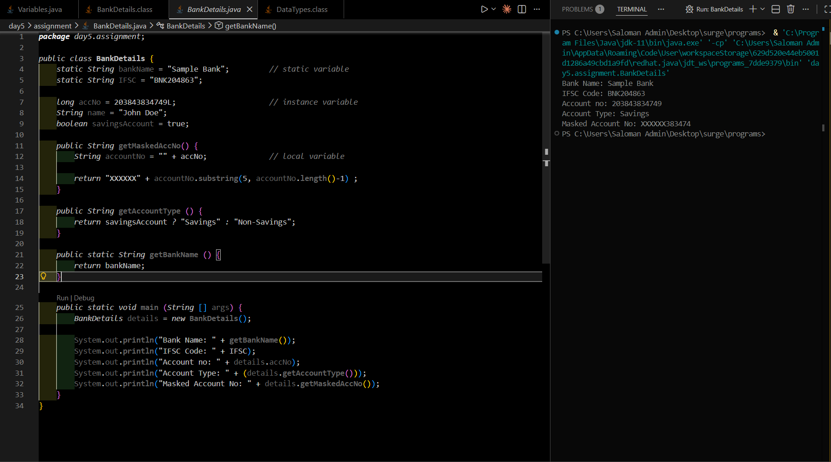

Date: 17-03-2026

Topics: Methods & Constructor

Methods

A block of code which is used to perform various operations or printing data.
It promotes the code reusability, as it only defines once, but can be called multiple times. These are two types:
- Pre-defined or In-built methods
- User-defined or Custom methods

Predefined Method

A method which is developed by the language developer itself.
No need to define these methods explicitly, but can be called multiple times.

Example: String.length(), String.substring(), etc.

User- defined Method

A method defined by user based on their own requirements or specifications. It has two parts:
  - Method Definition
  - Method Calling

Syntax:

class Sample
{
<access_modifier> [static] <return_type> <someMethodName>([params]) {
// method definition
..operations
..
.
}

public void anyOtherMethod () {
<someMethodName>(params); // method calling
}
}

Example:

public class Methods { int x = 20;

public static void printHello() { // method definition System.out.println("Hello, world!");
}

public static void main(String args []) {

Methods.printHello(); // method calling
}
}

Execution in VSCode:

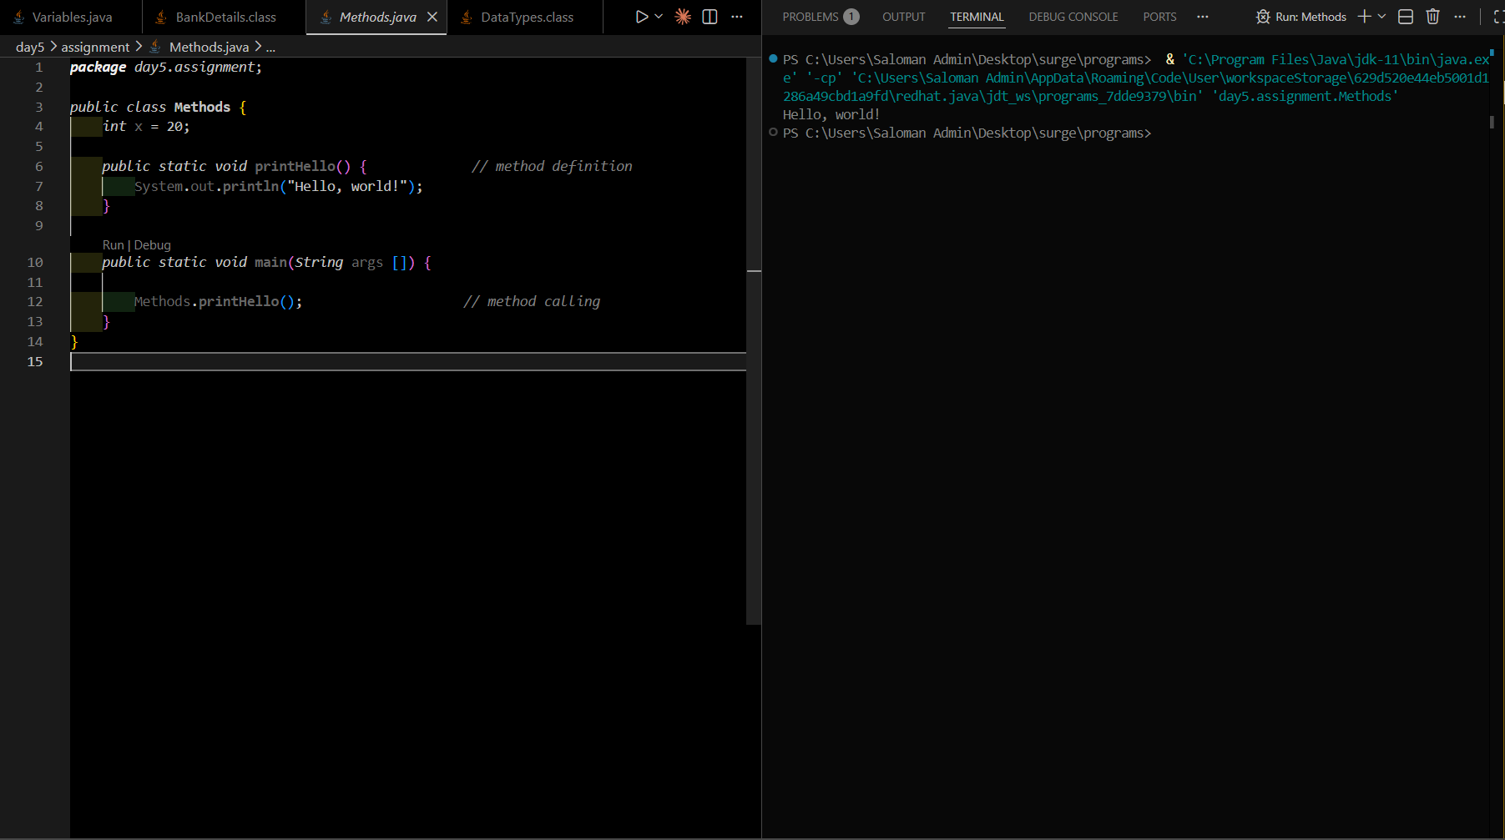

Constructor

It is used to construct object, that's why it's called as Constructor.
The main purpose is to initialize the object properties with user-defined values. It is a method with name same as the class name, but without any return type. There are three types of constructors:
    - Default No Argument Constructor: Added by compiler.
    - Non-Parameterized Constructor: Added by user, but have no arguments.
    - Parameterized Constructor: Added by user, but have parameters.

Syntax:

class ClassName
{
[accessModiefier] className() { // constructor
..
..
}
}

Example:

class Student
{
String name;

public Student(String name) // constructor
{
this.name = name; return;
}

public static void main(String [] args)
{
Student s1 = new Student();
}
}

Execution in VSCode:

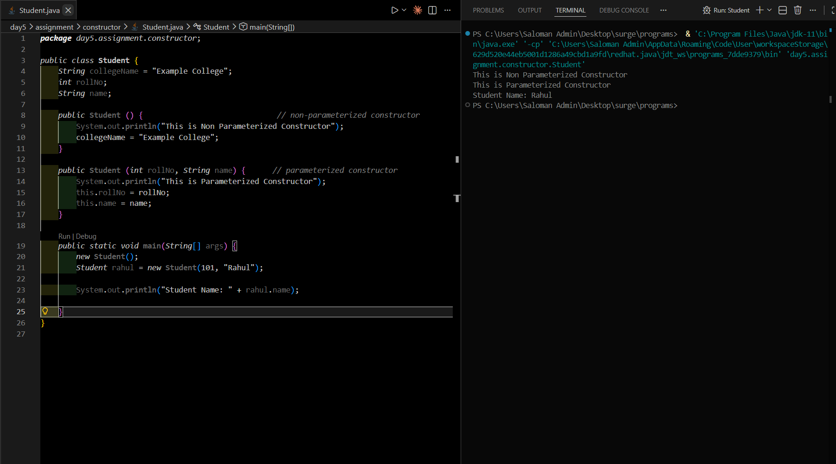

Date: 18-03-2026

Topics: Scanner Class & Operators

Scanner Class

It is pre-defined class available in java.util package introduced from jdk 1.5v. It is used to read the data or input from the user.
Methods of Scanner class:
public String next(): To read a single word.
public String nextLine(): To read multiple words or complete line. public byte nextByte(): To read byte value.
public short nextShort(): To read short value.
public int nextInt(): To read int value.
public long nextLong(): To read long value. public float nextFloat(): To read float value.
public double nextDouble(): To read double value.
public boolean nextBoolean(): To read boolean value.
public char next().charAt(0): To read a single char value.

Syntax:

import java.util.Scanner;

class Sample {
public static void main (String args [])
{
//object creation for Scanner class
Scanner sc = new ScannerSystem.in);

int x = sc.nextInt(); // reads int value
}
}

Example:

import java.util.Scanner; public class ReadInput {
public static void main(String[] args) {
Scanner inputReader = new Scanner(System.in);

System.out.print("Enter int val: "); int intVal = inputReader.nextInt(); System.out.println();

System.out.println(intVal);

inputReader.close();
}
}

Execution in VSCode:

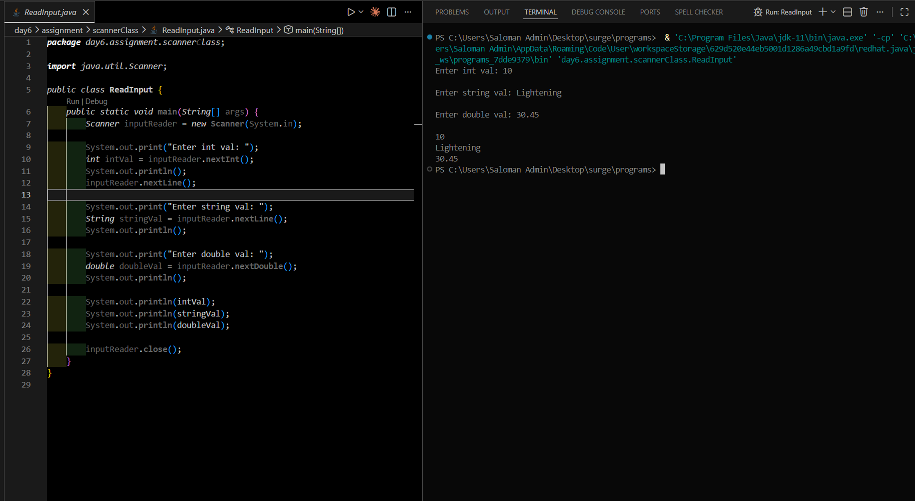

Operators

An operator is a symbol used to perform some operations on operands. Types of Operators:
- Arithmetic
- Assignment
- Logical
4. Relational
5. Unary
6.Boolean
7.Ternary

S.No | Operator | Symbols | Examples
1. | Arithmetic | +, -, *, /, % | a + b, a-b, a*b
2. | Assignment | =, +=, *=,/=, %= | a = 10, a+= 20
3. | Logical | &&, ||, ! | (a>b) && (a<b)
4. | Relational | >, <, >=, <=, != | a > b, c <= d
5. | Unary | ++, — | a++, —b
6. | Boolean | &, | | a & b, a | c
7. | Unary | expr ? true : false | n>2 ? true: false

Execution in VSCode:
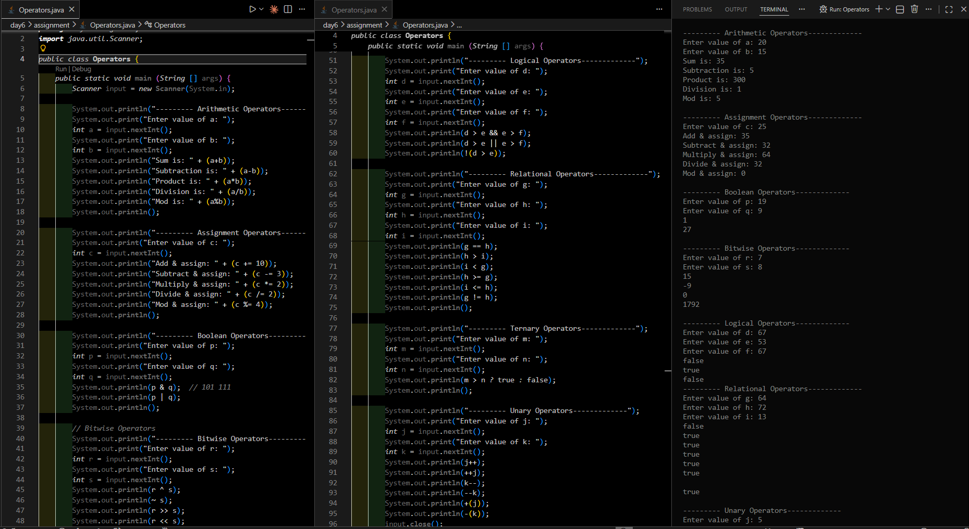

Date: 20-03-2026

Topics: Conditional Statements & Comments

Conditional Statements

Conditional Statements allow the user to control the flow of the program by executing certain block of code only if specific condition is true.
Types:
- Simple -if
- if-else
- if-else if-else
4. switch statement

simple - if

Executes a block of code only if certain condition is true.

Syntax:

if (condition or expression) { statement1
statement2
...
}

Example:

int age = 18;

if (age >= 18) {
System.out.println("You are eligible to vote.");
}

if - else

Executes one block of code only if certain condition is true, otherwise executes another block of code.

Syntax:

if (condition or expression) { statement1
statement2
...
}
else {
statement1 statement2
...
}

Example:

int age = 18;

if (age >= 18) {
System.out.println("You are eligible to vote.");
}
else {
System.out.println("You are NOT eligible to vote.");
}

if-else if-else

Checks multiple conditions in sequence and executes the respective block whose condition is true.

Syntax:

if (condition or expression) { statements
...
}
else if (condition or expression) { statements
...
}
else {
statements
...
}

Example:

int marks = 85;

if (marks >= 90) { System.out.println("Grade: A");
} else if (marks >= 80) { System.out.println("Grade: B");
} else if (marks >= 70) { System.out.println("Grade: C");
} else {
System.out.println("Grade: D");
}

Execution in VSCode:

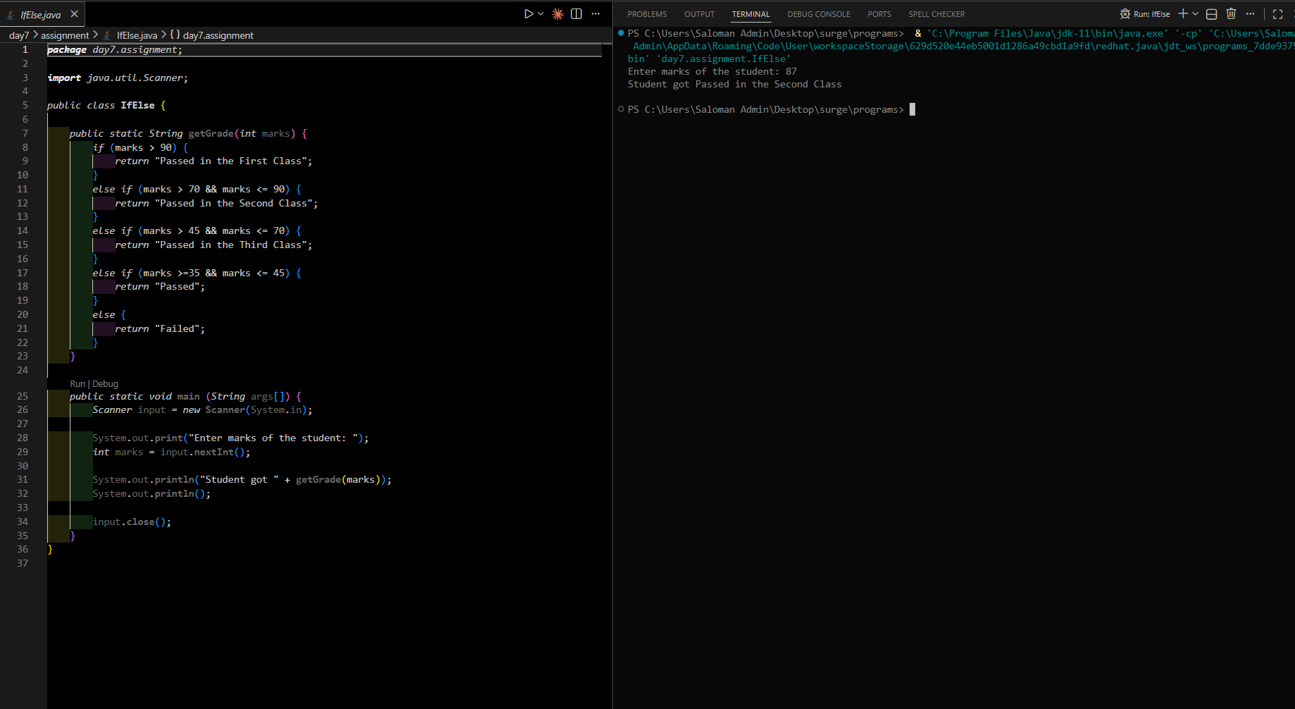

switch statement

Selects one of the blocks of code based on the value and executes it.

Syntax:

switch (valuex) {
case val1: { stmts
break;
}
case val2: { stmts
break;
}
Example:
int day = 3;
switch (day) {
case 1:
System.out.println("Monday"); break;
case 2:
System.out.println("Tuesday"); break;
case 3:
System.out.println("Wednesday"); break;
default:
System.out.println("Invalid day");
}

Execution in VSCode:

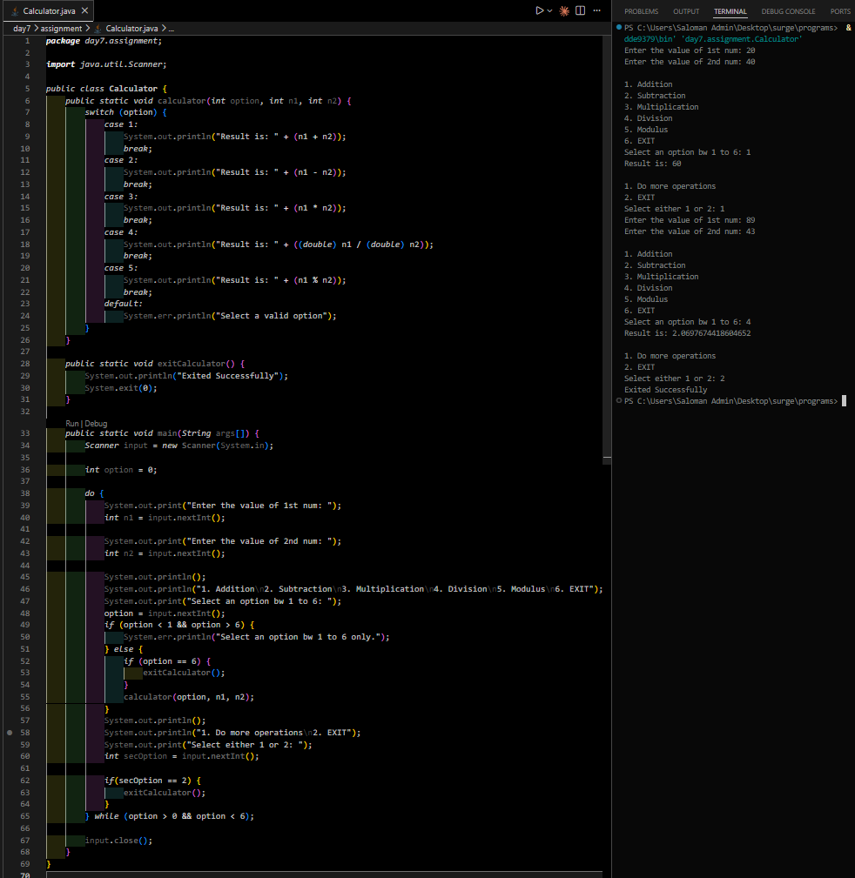

Comments

Comments are statements whose execution is usually ignored by the compiler.
These are helpful for code explanation and documentation.
These are three types:
- Single line
- Muti-line
- Documentation

Single Line Comment

Used for short or single line explanations

Syntax and Example:

Multi-line Comments

Used for longer explanations that span multiple lines.

Syntax and Example:

/*
This is a multi-line comment. It can span several lines.
*/

int calculateSum(int a, int b)
{
return a + b;
}

Documents Comments

Used to generate API documentation. These comments are placed before classes, methods, or fields.

Syntax and Example:

/**
- This method calculates the sum of two integers.
- @param a the first integer
- @param b the second integer
- @return the sum of a and b
*/
public int add(int a, int b) { return a + b;
}

THE END

