Java Assignment - 3

Name: Saloman Raju Sarikokkula

Overview of the week

S.No | Date | Topic
1. | 23/03/2026 | Looping Statements
2. | 25/03/2026 | Arrays
3. | 26/03/2026 | Strings

Looping Statements
Used to execute a block of code multiple times.
Three types:
- for loop
- while loop
- do-while loop

- for() loop
Best when you the know exact count of iterations
Syntax:

for(initialization; condition; updatation){ stmts..
}
Example:

for (int i = 0; i < 5; i++) {
System.out.println("Count: " + i);
}

Enhancedfor() loop

Designed for iterating arrays and collections, no index needed.
Syntax:

for(<DataType> var: <array/collection>){ stmts..
}
Example:

int[] numbers = {1, 2, 3, 4, 5}; for (int num : numbers) {
System.out.println(num);
}
- while() loop
Runs as long as the condition is true, best when the exact count of iterations is unknown.
Syntax:

while(condition){ stmts..
}
Example:

int i = 0;
while (i < 5) {
System.out.println("Count: " + i); i++
}
- do-while() loop
Runs as long as the condition is true, but executes at least once unlike while loop.
Syntax:

do {
stmts..
} while(condition);
Example:

int i = 0; do {
System.out.println("Count: " + i); i++;
} while (i < 5);
Execution on VS Code
Program to print table using while and do-while loops with scanner class.
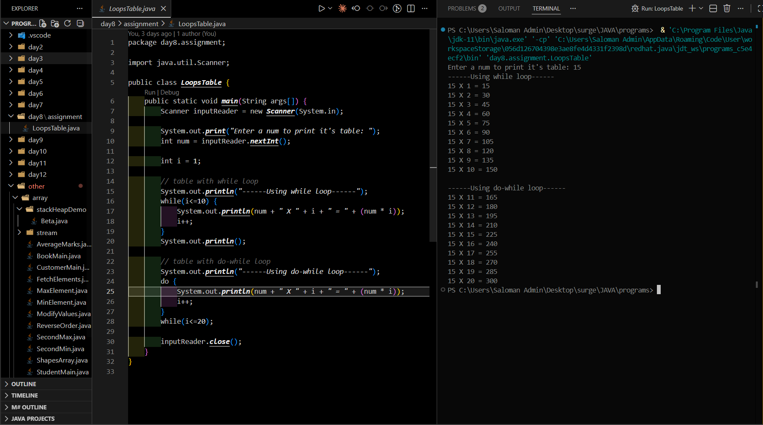

Arrays
A container with fixed size which stores the ordered collection of homogeneous data.
A non-primitive data which is developed to tackle the single value storing prob of primitive data types.
Two types:
  - Single Dimensional - Data is stored in a single dimensional contiguous memory.
  - Multi-Dimensional - It's like an Array of Arrays - like table or grid.
    - Square [rows = cols]
    - Jagged [each row has its own length]

Syntax with example:
// Declaration
int[] nums; // 1D int [] [] nums // 2D

// Declaration + allocation
int[] nums = new int[5]; // 5 elements, all default to 0 //1D int[][] nums = new int[3][3]; // 9 elements, all default to 0 //2D
// Declaration + initialization
int[] nums = {10, 20, 30, 40, 50};
int[][] nums = {{10, 20, 30}, {40, 50, 60}, {70, 80, 90}};
//1D
//21D
// Explicit form
int[] nums = new int[]{10, 20, 30, 40, 50};
//1D
int[][] nums = new int[][]{{10, 20, 30}, {40, 50, 60}, {70, 80, 90}}; //2D
Execution on VS Code
Program to print the:
- 1D array with while loop
- Multi D array with for loop
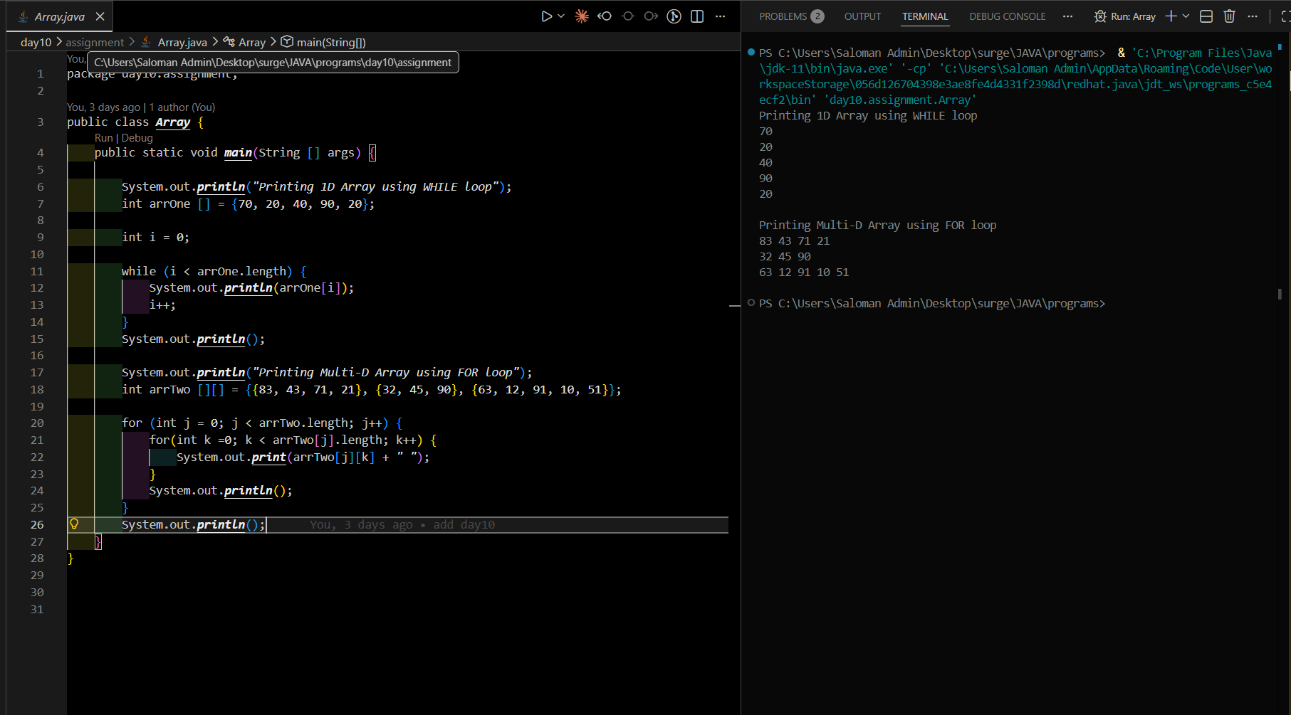

Strings
It's a pre-defined class from java.util package which stores the sequence of characters. It's a non-primitive data type whose data is stored in the String pool in Heap.
They are immutable in terms of address.

Syntax with example:
// String literal (stored in String Pool) String name = "Hello";

// Using new keyword (stored in Heap) String name = new String("Hello");
String methods:

String s = "Hello, World!";

s.length() // 13
s.charAt(0) // 'H'
s.indexOf("World") // 7
s.substring(7) // "World!"
s.substring(7, 12) // "World"
s.toUpperCase() // "HELLO, WORLD!"
s.toLowerCase() // "hello, world!"
s.trim() // removes leading/trailing spaces s.replace("World", "Java") // "Hello, Java!"
s.contains("World") // true
s.startsWith("Hello") // true
s.endsWith("!") // true
s.isEmpty() // false
s.split(", ") // ["Hello", "World!"]
Execution on VS Code
Program to show different methods of the String class.
