|  |  |  |
| --- | --- | --- |
| **ACTOR** | **ACTOR’S GOALS** | **USE CASE NAME** |
| Client | To create an Account | UC-1 SignUp |
| Client | To SignIn to the system | UC-2 SignIn |
| Client | To change password | UC-3 ChangePassword |
| Client | To be able to de-activate the Account | UC-4 DeActivate |
| Client | To search for salons by Name | UC-5 SearchBySalonName |
| Client | To search for salons by location | UC-6 SearchByLocation |
| Client | To search a salon by price range and get results of all salons in that price range. | UC-7 SearchSalonByPrice |
| Client | To search for a salon by distance to the salon and get results of all salons within the specified distance. | UC-8  SearchSalonByProximity |
| Client | To be able to see where salon is situated on Google maps. | UC-9 ViewSalonOnMap |
| Client | To be able to get route from where the client is to the salon on Google maps. | UC-10 GetSalonRoute |
| Client | To be able to get salon address on Google maps salon position. | UC-11 GetSalonAddress |

Use Case Diagram: Account Management Subsystem

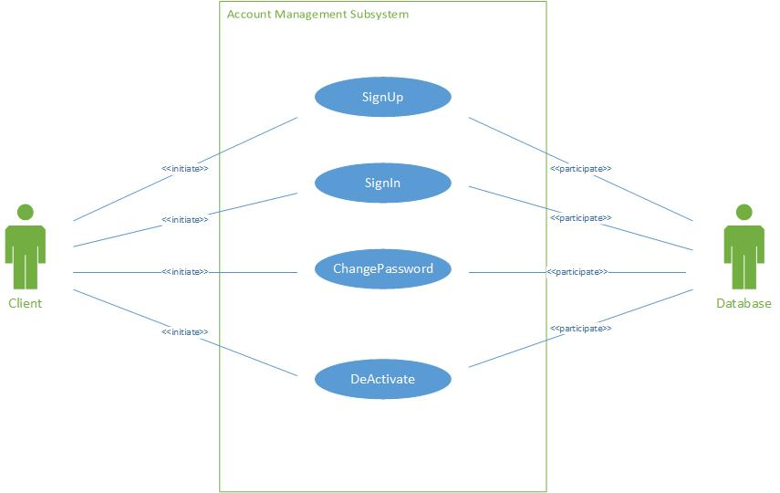

Use Case Diagram: Searching

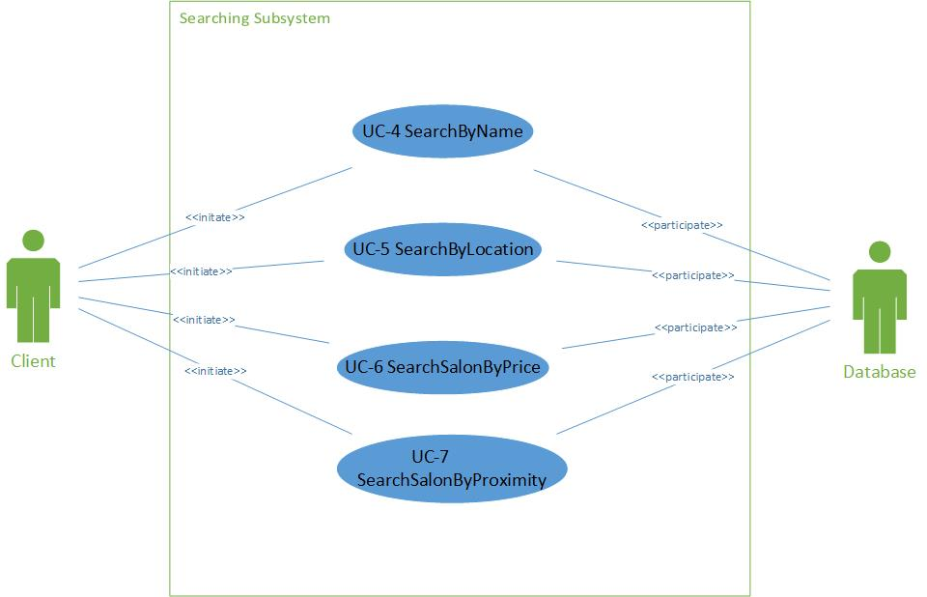

Use Case Diagram: Salon Management

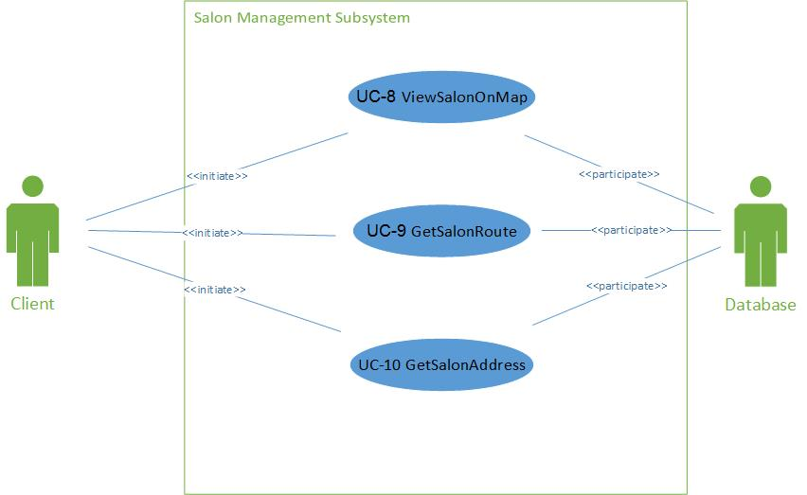

|  |  |
| --- | --- |
| Use Case UC-1 |  |
| Related Requirements: | Req1 |
| Initiating Actor: | Client |
| Actor’s Goal: | To create an account |
| Participating Actors: | Database |
| Preconditions: | None worth mentioning |
| Post conditions: | A new client is added into the database. |
| Flow of Events for Main Success Scenario:  1. Client goes to home page, clicks on the hyperlink “Sign Up”.  2. System prompts the client to enter their details.  3. The client enters required details and then submits.  4. The System records the new data into the database and signals completion. | |

|  |  |
| --- | --- |
| Use Case UC-2 |  |
| Related Requirements: | Req2 |
| Initiating Actor: | Client |
| Actor’s Goal: | To sign in to the system |
| Participating Actors: | Database |
| Preconditions: | None worth mentioning |
| Post conditions: | A Client is logged in to the system. |
| Flow of Events for Main Success Scenario:  1. Client goes to home page, clicks on the hyperlink “Sign in”.  2. System prompts the client to enter their details.  3. The client enters required details and then submits.  4. System prepares a database query to verify whether the details provided are valid. | |

|  |  |
| --- | --- |
| Use Case UC-2 | ChangePassword |
| Related Requirements: | Req 3 |
| Initiating Actor: | Client |
| Actor’s Goal: | To change password |
| Participating Actors: | Database |
| Preconditions: | None worth mentioning |
| Postconditions: | System successfully updates the client’s password. |
| Flow of Events for Main Success Scenario:  1. The client clicks on sign in hyperlink.  2. The system displays the sign in form.  3. The client clicks on “Forgot Password” hyperlink.  4. System prepares a database query to verify whether the email address provided is in the database. If the email address is found in the database, then an email will be sent to the client with a link that when clicked will direct the client to a page where they can register a new password.  5. System prepares another database query to update the password.  6. Client will then login using the email address and the updated password. | |

|  |  |
| --- | --- |
| Use Case UC-5 | SearchByLocation |
| Related Requirements: | Req12 |
| Initiating Actor: | Any Client |
| Actor’s Goal: | To search for salons by Location |
| Participating Actors: | Google Maps |
| Preconditions: | • The sets of salons and their locations are stored in the system database.  • The system displays the menu of available functions at the home page of the system, “search by hairstyle”, “search by location”, “search by price range” and “search by name”. |
| Postconditions: | A page with all salons in the location searched will be generated |
| Flow of Events for Main Success Scenario:  1. Client goes to home page search drop down menu, chooses option “search by Location”.  2. System allows client to enter the location.  3. System prepares a database query to search the database and returns all the salons in the location searched.  4. Clients can then select the salons of their choice. | |

|  |  |
| --- | --- |
| Use Case UC-6 | SearchSalonByPrice |
| Related Requirements: | Req15 |
| Initiating Actor: | Any client |
| Actor’s Goal: | To search for a salon by price range. |
| Participating Actors: | Database |
| Preconditions: | • The set of salons and price ranges stored in the system database.  • The system displays the menu of available functions at the home page of the system, “search by hairstyle”, “search by location”, “search by price range”. |
| Postconditions: | Drop down menu of all salons in that price range. |
| Flow of Events for Main Success Scenario:  1. Client goes to home page search drop down menu, chooses option “search by price range”.  2. System allows client to enter price range.  3. System shows results of salons by price range. | |

|  |  |
| --- | --- |
| Use Case UC-7 | SearchSalonByProximity |
| Related Requirements: | Req17 |
| Initiating Actor: | Any client |
| Actor’s Goal: | To search a salon by distance to the salon and get results of all salons within the specified distance. |
| Participating Actors: | Database |
| Preconditions: | • The set of salons stored in the system database.  • The system displays the menu of available functions at the home page of the system, “search by hairstyle”, “search by location”, “search by price range”. |
| Postconditions: | Drop down menu of all salons within the specified distance. |
| Flow of Events for Main Success Scenario:  1. Client goes to home page search drop down menu, chooses option “search by proximity”.  2. System allows client to enter distance.  3. System shows results of salons in distance specified. | |

|  |  |
| --- | --- |
| Use Case U-8 | ViewSalonOnMap |
| Related Requirements: | Req26 |
| Initiating Actor: | Any client |
| Actor’s Goal: | To be able to see where salon is situated on Google maps. |
| Participating Actors: | Google Maps |
| Preconditions: | • The set of salons and IP addresses stored in the system database.  • The system displays available options at the salon page, one of which is view salon on map. |
| Postconditions: | Google map shows position of salon. |
| Flow of Events for Main Success Scenario:  1. Client goes to home page search drop down menu, chooses one of the options “search by hairstyle”, “search by location”, “search by price range”.  2. System allows client to enter distance, or price, or hairstyle.  3. System shows results of salons with specified information. | |

|  |  |
| --- | --- |
| Use Case UC-9 | GetSalonRoute |
| Related Requirements: | Req27 |
| Initiating Actor: | Any client |
| Actor’s Goal: | To be able to get route from where the client is to the salon on Google maps. |
| Participating Actors: | Google Maps |
| Preconditions: | • The set of salons and IP addresses stored in the system database.  • The system displays available options at the salon page, one of which is get route. |
| Postconditions: | Google maps calculates route from current position to salon position and shows route on map. |
| Flow of Events for Main Success Scenario:  1. Client goes to home page search drop down menu, chooses one of the options “search by hairstyle”, “search by location”, “search by price range”.  2. System allows client to enter distance, or price, or hairstyle.  3. System shows results of salons with specified information. | |

|  |  |
| --- | --- |
| Use Case UC-10 | GetSalonAddress |
| Related Requirements: | Req29 |
| Initiating Actor: | Any client |
| Actor’s Goal: | To be able to get salon address on Google maps salon position. |
| Participating Actors: | Google Maps |
| Preconditions: | • The set of salons and IP addresses stored in the system database.  • The system displays available options at the salon page, one of which is view salon on map. |
| Postconditions: | Google map shows position of salon. |
| Flow of Events for Main Success Scenario:  1. Client goes to home page search drop down menu, chooses one of the options “search by hairstyle”, “search by location”, “search by price range”.  2. System allows client to enter distance, or price, or hairstyle.  3. System shows results of salons with specified information. | |