I installed kodi on a base, otherwise untouched Ubuntu installation. Following the instructions found in the wiki: http://kodi.wiki/view/HOW-TO_compile_XBMC_for_Linux_on_Debian/Ubuntu

I received a number of errors while running the ./configure section, which verifies dependencies.

The full dependencies can be found by pulling them from the nightly builds, running these commands (https://github.com/xbmc/xbmc/blob/master/docs/README.ubuntu):

$ sudo apt-get install software-properties-common
$ sudo add-apt-repository -s ppa:team-xbmc/xbmc-nightly
$ sudo add-apt-repository ppa:team-xbmc/xbmc-ppa-build-depends
$ sudo apt-get update
$ sudo apt-get build-dep kodi

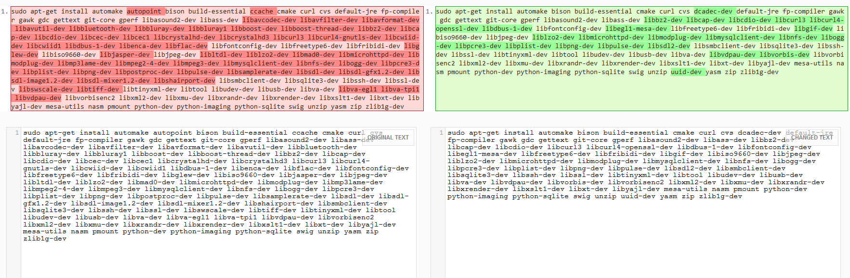
However I believe this should be added to the base instructions or made more clear, as it was time consuming to hunt down the conflict. Furthermore, upon inspecting the dependencies listed in both places I found the following differences:

This indicates that there are 7 additional commands, and 8 removals. This would be trivial if not for the errors when running the indicated commands, and I shall endeavor to determine whether these documents are not both updated simultaneously.

