Analog Signal Conditioning Project Report
Name: Melvin DIleep
Student ID:125EI0015
Op-Amp Selected: AD8051

Abstract
This project investigated analog signal conditioning using LTspice. A non-inverting amplifier with a gain of 10 and an RC low-pass filter with a cutoff frequency of approximately 1 kHz were designed, simulated, and analysed. An ideal behavioural op-amp model was first used to verify gain calculations before replacing it with the commercial AD8051 SPICE model. Operating point, transient and AC sweep simulations were performed. The real model demonstrated practical behaviour such as finite bandwidth and dependence on supply voltages, while the ideal model maintained constant gain. The amplifier and filter were then integrated into a complete signal chain. Simulation results closely matched theoretical calculations, confirming the design process and illustrating the differences between ideal and real operational amplifiers.

1. Introduction
Signal conditioning is used to amplify, filter and prepare analogue signals before further processing. In this project, LTspice was used to study sinusoidal sources, RC filters and operational amplifiers. The objectives were to design a non-inverting amplifier with a voltage gain of 10, design a first-order RC low-pass filter with a cutoff frequency of approximately 1 kHz, compare ideal and real op-amp models, and analyse the complete signal chain using transient and AC simulations.

2. Theory
For a non-inverting amplifier, the voltage gain is:
Av = 1 + (R2/R1)
For Av = 10, R1 = 10 kΩ and R2 = 90 kΩ were selected.
The cutoff frequency of a first-order RC low-pass filter is:
fc = 1/(2πRC)
Using R = 10 kΩ and C = 15.9 nF gives a cutoff frequency of approximately 1 kHz. The gain-bandwidth product (GBP) limits the usable bandwidth of a real op-amp. For the AD8051 (GBP ≈ 110 MHz), the expected closed-loop bandwidth at a gain of 10 is approximately 11 MHz.

3. Op-Amp Selection
Parameter | LM741 | TL071 | AD8051
GBP | 1 MHz | 4 MHz | 110 MHz
Slew Rate | 0.5 V/µs | 16 V/µs | 145 V/µs
Supply | ±15 V | ±3 to ±18 V | 3–12 V / ±5 V
Selected | No | No | Yes
The AD8051 was selected because of its high gain-bandwidth product, high slew rate and suitability for high-speed analogue applications. Although its advantages are not obvious at 1 kHz, they become significant at much higher frequencies where lower-performance op-amps begin to lose gain.

4. Design Calculations
Target amplifier gain: 10
R1 = 10 kΩ
R2 = 90 kΩ
Target filter cutoff frequency: 1 kHz
Selected values: R = 10 kΩ, C = 15.9 nF
Calculated cutoff frequency ≈ 1 kHz
Expected closed-loop bandwidth of AD8051 ≈ 11 MHz.

5. Simulation Results
- SIM-1: Operating point analysis confirmed the output voltage was approximately 0 V.
- 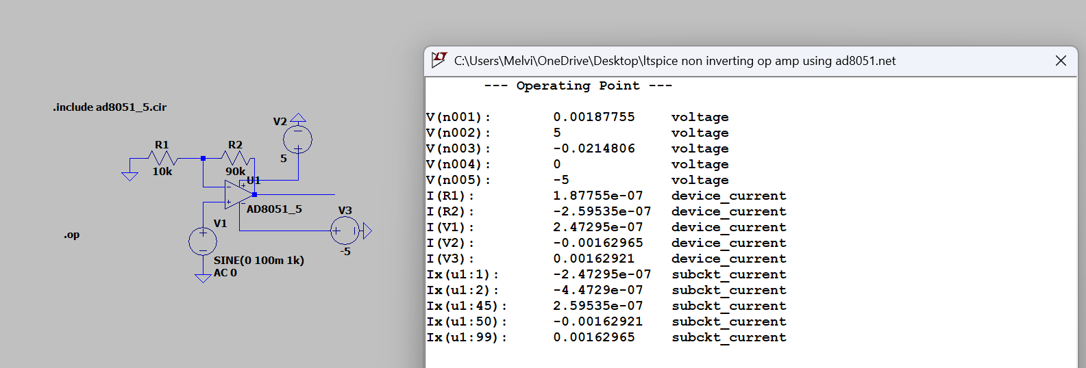
- SIM-2: At 100 Hz (0.1fc), the amplifier produced approximately 1 V peak and the filter caused negligible attenuation.
- SIM-3: At 10 kHz (10fc), the RC filter attenuated the output as expected.
- SIM-4: AC sweep of the AD8051 showed a passband gain of approximately 20 dB with gain roll-off at high frequencies due to finite bandwidth.
- SIM-5: The complete signal chain produced a passband gain of approximately 20 dB and a cutoff frequency close to 1 kHz.

6. Discussion
The simulations closely matched theoretical calculations. Minor differences are attributed to practical limitations included in the AD8051 SPICE model, such as finite bandwidth, output limitations and internal compensation. The ideal model was useful for verifying calculations, whereas the real model demonstrated the behaviour of a practical operational amplifier.

7. Conclusion
The project successfully demonstrated the design and simulation of an amplifier and RC low-pass filter using LTspice. Calculated component values produced the desired gain and cutoff frequency. Comparison of the ideal and AD8051 models showed the importance of bandwidth and real device characteristics. The complete signal chain performed as expected and the simulation results agreed well with theoretical analysis.

References
[1] Texas Instruments, 'Op Amps for Everyone'.
[2] Analog Devices, 'AD8051 Datasheet'.
[3] LTspice User Guide.
