**Clickers Specifications**

[[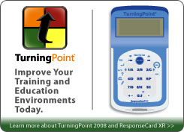](http://www.turningtechnologies.com/xr2008.cfm)](http://www.turningtechnologies.com/xr2008.cfm)ResponseCard® XR is Turning Technologies' latest, most innovative response hardware currently available. ResponseCard XR's multi-line LCD display and alphanumeric entry make it an ideal tool for self-paced assessment. Boasting the largest storage capacity of any keypad on the market, ResponseCard XR utilizes the most advanced technology available ensuring maximum user participation.

ResponseCard XR keypads and receiver fit into a light weight, custom carrying case. Compact size and light weight design ensures ease of system transportation whether it be from room to room or around the globe.

**Specifications**

[[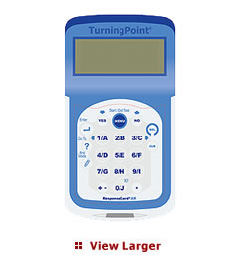](javascript:void();)](javascript:void();)

**Enclosure**

* Lightweight, compact, card format.
* Dimensions: 4.0" L x 2.5" W x 0.75" H.
* Weight: 2.0 oz (with batteries).
* Angled LCD screen for optimum viewing.
* Durable, rugged case ensures maximum longevity under extreme conditions.

**User Input**

* 20 Key (1(A) – 10(J)), Answer Mode, Go to, Enter, Yes, No, Menu, Select, Clear, +/-, .(decimal).

**Display**

* Easy to read LCD Display.
* Dimensions: 50 mm x 20mm viewable area.
* Display Features: Channel Number, Battery Life Indicator, Answer Choice, Response Confirmation.

**Power & Power Management**

* Powered by two AAA batteries.
* Average battery life is 6 to 12 months.

**User Identification**

* Fixed ID.
* Setup is plug and play with TurningPoint 2008.

**RF Technology**

* Available Channels: Up to 74 sessions can be running at one time in close proximity without interference.

**Range**

* In presentation mode - Range for one RF Receiver is 200 feet (400 ft coverage)
* In self-paced testing mode - Data is stored in nonvolatile memory until individual finishes test and uploads responses.

**Receiver Compatibility**

* ResponseCard XR requires a 2.4 version RF Receiver with 2008 licensing..

**Functionality Highlights**

**Input Capabilities**

* Alphanumeric Entry
* Multi-Digit Entry
* Decimal Point Entry
* Positive/Negative Entry

**Roster Creation**

* Automatically create participant rosters with ResponseCard XR's user stored data or have participants login to existing rosters. Easily move from one classroom or session to another.

**Self-Paced Testing**

* Participants use ResponseCard XR to navigate to any question on the test or assignment and select a response. The ResponseCard XR has the largest storage capacity in the industry, storing all responses into nonvolatile memory to ensure data security and stability.

**Successful Transmission**

* Participants and administrators receive visual successful transmission notification.

**USB Capabilities**

* Firmware upgrades via ResponseCard XR's USB port allow for product updates.