CORE ORGANIZING PRINCIPLE — MUSIC AS INTONATION
In this reference, music is not treated as a separate theme beside linguistics. Musical pitch, rhythm, timing, stress, phrasing, contour, and related expressive features are treated as parts or extensions of intonation and prosody. Musical examples are therefore used to describe how structured sound carries linguistic, expressive, and narrative information.
HIERARCHY / LEVELS
A level is a hierarchical grouping: a larger unit that contains smaller units and can itself belong to a larger unit. Levels are therefore not simply a list of topics. They describe scale and nesting—for example, sound → syllable → word → phrase → clause → utterance → discourse, with prosodic/intonational structure operating across these levels.
Editorial principle for this edition: organize the material primarily by hierarchy and function. Avoid presenting Music, Linguistics, Grammar, and Narrative as unrelated parallel subjects when the document's central idea connects them through structured sound, intonation, prosody, and larger hierarchical units.

LINGUISTICS — Language, Prosody, Music & Narrative
Reorganized and edited working reference. The original material has been retained as far as possible, while repeated items, obvious spelling errors, terminology, and section order have been cleaned up.

Foundations of Linguistics

Intro.
Level | Length | Description / Function | Tonal Center Behavior | Harmonic Function | Melodic Function | Rhythmic Function
Tone / Pitch / Interval | Instant / single sound | The smallest musical element — one note or interval. | No tonal center; raw material.
Cell | A few notes | A tiny rhythmic or melodic fragment (even smaller than a motive). | Too short for a tonal center but helps imply one.  Implied — a few notes hint at a key (e.g., C–E–G suggests C major). | Rarely full chords; may outline a harmony. | Defines a basic contour or rhythmic identity.
Motive | 1–2 beats | A short recurring idea that can be developed.  The smallest musical idea — a short rhythm or melodic shape. | Suggests tonal direction through its notes.  Usually too short to establish a clear tonal center — more about melodic shape.  Usually too short to establish a tonal center; suggests one through pitch choice. | Defines characteristic shape or interval. | Defines a rhythmic identity — short pattern or groove that repeats.
Figure | 1–2 beats | A decorative or accompaniment pattern (e.g., arpeggio, Alberti bass). | Reinforces harmony of the current tonal center.
Idea | 1 or more motives
Subphrase | 1–2 measures | A small part of a phrase; often leads toward a cadence. | Supports tonal motion within a phrase.  Momentary sense of key through short cadences or leading tones. | Simple chord motion (I–V, ii–V). | Develops a motive; begins tension/release.  Extends motive toward a cadence. | Small grouping rhythm; often regular but may build syncopation.
Phrase | 2–4 measures | A complete musical thought that ends with a cadence (like a musical sentence). A complete musical thought, often ending with a cadence.  Musical sentence | Implies or confirms a tonal center briefly.  Clearly felt — cadences confirm the tonal center. Establishes or implies a tonal center.  Usually implies the tonal center through melody and cadence.  Within a phrase or period, stay mostly centered — but you can use brief chords from other keys for tension or color. | Typical progressions (I–IV–V–I, ii–V–I). | Complete musical idea with rise/fall.  Complete melodic idea with contour. | Metric pattern established (4/4, 3/4, etc.); rhythm supports phrase flow.
Sentence | ~8 measures (2+2+4 pattern) | Short idea → repetition → continuation. A developmental structure: short idea repeated or varied, then a longer continuation. | Reinforces the tonal center while adding motion.  Center reinforced through repetition and continuation. Reinforces the tonal center but may add motion through dominant or chromatic chords. | Moves from tonic → dominant → tonic with more harmonic rhythm. | Development and drive toward cadence.
Period | 2 phrases (antecedent + consequent)  2 phrases (question + answer)  4–8 measures | The first phrase ends with a weak cadence, the second with a strong one — creating balance. Balanced structure, question and answer. | Confirms the tonal center more clearly.  Strongly confirmed — ends firmly in tonic. Confirms the tonal center.  Often clearly confirms the tonal center with a cadence (e.g., authentic cadence to the tonic). | Larger harmonic arc: tonic → dominant → tonic. | Question–answer pattern in melody.  Question–answer balance in melody. | Periodic rhythm — regular phrase lengths, symmetrical timing.
Section / Theme | 8–32+ measures | Larger unit such as verse, chorus, exposition, etc. A larger division like verse, chorus, exposition, etc. | Usually stays in one tonal center.  One stable tonal center (may briefly visit others).  Usually stays in one tonal center, though may briefly visit others.  Often stays in one tonal center, though it may temporarily visit others.  Use one tonal center for each section to give the listener a sense of place.  Change tonal centers between sections to create contrast or progression. | Full harmonic progressions, modulations, and cadences. | Broader melodic shapes and phrases.  Broader melodic arcs and sequences. | Rhythmic character defines section (groove, meter, texture); possible contrast between sections.
Form | Multiple sections | The complete architecture of the piece (e.g., binary, ternary, sonata, rondo, pop form). | Defines the overall tonal plan — when and how tonal centers appear or change.
Part / Movement | Entire large section of a multi-movement work. | One complete, self-contained section (e.g., a sonata movement). | May explore several tonal centers but returns “home.”  Primary key plus secondary keys (for contrast and drama). | Large-scale harmonic plan (e.g., sonata form). | Thematic development, transformation.
Entire Piece | — | Whole composition. The full composition viewed as a whole. | Has an overall tonal center that gives the piece its identity (e.g., “Sonata in C Major”).  Global tonal center (home key).  Has an overall tonal center or journey through several centers. | Overall key relationships between sections or movements. | Thematic unity — melodies may return in different tonal contexts.  Long-term melodic unity and return. | Temporal proportion — how rhythm shapes the pacing of the whole work.
Cycle / Entire Piece | Whole work (e.g., symphony, suite, album). | The full musical narrative. | Has an overall tonal plan or journey through multiple centers.  Tonal plan across movements (e.g., C–G–A–C). | Relationships between movement keys for balance or narrative. | Motives or themes recur across movements. | Macro-rhythm: tempo and character contrasts (fast–slow–dance–fin ale).
Multi-Movement Cycle / Collection | Several complete pieces linked together. | e.g., symphony, sonata, concerto, song cycle. | Each movement has its own tonal center; often related by key or contrast. |  | Shared motives across works.

Linguistics.
metadata:
category: Linguistics
level: Beginner
language: en

description: "A dialect is a variation of a language used by a particular group of people, characterized by differences in pronunciation, vocabulary, and grammar."

applications:
- "Understanding regional and cultural differences"
- "Language learning and translation"
- "Sociolinguistics and cultural studies"
- "Literature and media representation"
- "Communication within communities"

topics:
- name: Phonetics
- name: Vocabulary
- name: Grammar
- name: Accent
- name: Sociolinguistics

concepts:
- dialect: "A regional or social variety of a language"
- accent: "The way words are pronounced"
- idiolect: "An individual’s unique way of speaking"
- register: "Level of formality in language use"
- slang: "Informal words used by specific groups"

examples:
- expression: "y'all"
explanation: "Plural form of 'you' in some English dialects"
- expression: "lorry"
explanation: "British English word for 'truck'"
- expression: "ain’t"
explanation: "Nonstandard contraction used in some dialects"

attributes:
- name: Pronunciation Variation
description: Differences in how sounds are produced.
- name: Vocabulary Differences
description: Use of different words for the same meaning.
- name: Grammatical Variation
description: Differences in sentence structure and rules.
- name: Regional Influence
description: Shaped by geography and local culture.
- name: Social Influence
description: Influenced by class, age, and social groups.

methods:
- name: Comparative Analysis
description: Compare dialects to identify differences and similarities.

- name: Phonetic Transcription
description: Use symbols (IPA) to represent pronunciation.

- name: Field Observation
description: Study how people use language in real-life contexts.

- name: Corpus Analysis
description: Analyze large collections of spoken or written language.

- name: Elicitation
description: Ask speakers to produce specific language forms.

1. Attributes (The State/Data) Attributes represent the core components, modules, and interfaces that make up the structure of a language.

modules: A collection of the individual, rule-based systems of grammar.
Elements: Phonology, Morphology, Syntax, Semantics, Pragmatics.

interfaces: The crossover zones that connect the modules together.
Elements: Morph syntax, Syntax, Prosody, Phono semantics.

mediums: The physical channels used to express the language.
Elements: Speech, Writing, Sign Language.

lexicon: The mental dictionary containing all vocabulary and morphemes.

historical data: The lineage, evolution, and etymological roots of words over time.

2. Functions (The Methods/Operations) Functions are the analytical tools and processes linguists execute to break down and understand an utterance.

parse syntax(utterance): Analyzes the structural arrangement of words into phrases, clauses, and sentences.

analyze morphology(word): Breaks a word down into its component morphemes (roots, prefixes, suffixes).

map prosody(audio input): Tracks the rhythm, pitch, and intonation lines of spoken text.

decode semantics(context level): Determines literal meaning at the word, phrase, clause, or sentence level.

evaluate pragmatics(social context): Interprets the implied meaning based on who is speaking, where, and why.

trace etymology(word): Looks back through historical data to find the origin and evolution of a term.

3. Parameters (The Variables/Constraints) Parameters are the specific settings or variables passed into the functions that alter how language behaves or is interpreted.

language type: The structural profile of the language being processed (e.g., Isolating, Agglutinative, Fusional).

word order: The syntactic rule of the language (e.g., SVO for English, SOV for Japanese).

modality: Dictates the primary input type (e.g., Acoustic, Visual Text, Spatial Gestural).

time period: The historical setting for the analysis (e.g., Synchronic for modern-day, Diachronic for tracking across centuries).

social variables: Contextual data that alters speech patterns (e.g., Dialect, Socioeconomic Status, Formality Level).

The key concepts: Modules and Interfaces
In linguistics, these different layers are called modules (or domains of grammar), and the areas where they meet, overlap, and influence each other are formally called interfaces. When you look at speech as a series of simultaneous "lines" or tracks running at the same time, you are looking at inter-modular interactions. Because human speech is produced as a single stream of sound, a speaker must map syntax, morphology, and prosody simultaneously. The Key Concepts: Modules and Interfaces Linguists use two primary terms to describe this phenomenon: 1. Language Modules (The Component Tracks) The word "line" in this context refers to a specific linguistic module. Each module has its own set of rules: The Morphological Line: Deals with word structure and meaningful pieces (morphemes).The Syntactic Line: Deals with structural word order, phrases, and clauses. The Prosodic Line: Deals with the rhythm, melody, intonation, and phrasing of the spoken voice.2. Grammar Interfaces (Where the Lines Cross)Because human language requires these tracks to run at the exact same time, they constantly collide. The specific crossover zones are named after the modules they connect: The Morph syntax Interface: Where morphology meets syntax. This explains how a word’s structural position in a clause (syntax) forces it to take a specific grammatical ending (morphology).The Syntax-Prosody Interface: Where sentence structure meets vocal rhythm. For example, when you reach the boundary between two clauses, your brain tells your voice to pause or change its pitch. The Prosodic Morphology Interface: Where word building meets sound constraints. For instance, a language might alter the shape of a prefix purely to match the stress pattern or syllable structure of a root word.

Meanings.
Meanings are built from semantic relations.

Semantic line.
Semantic line - literal and conventional meaning.

Lexical Semantics for words.
Focus: Synonyms (words with similar meanings), antonyms (opposites), and how words can have multiple meanings (polysemy).

Phrasal semantics for phrases.
Focus: Idioms, metaphors, and modifiers.

Structural semantics for sentences.
This level looks at how the grammatical structure of a whole sentence creates a complete thought. It relies on the Principle of Compositionality: the meaning of a sentence comes from the meaning of its parts plus the way those parts are put together.
Example 1: “The dog bit the man” vs. “The man bit the dog.” The words are identical, but the semantics change completely because the word order changes who did the biting.
Example 2: “Colorless green ideas sleep furiously.” This famous sentence by linguist Noam Chomsky is perfectly correct in its grammar (syntax), but it makes no sense in meaning (semantics).

Conceptual line.
Conceptual line – underlying ideas and categories.

Referential line.
Referential line – connections between languages and real-world entities.

Context and Use.

Pragmatic line.
Pragmatic line – meaning in context, speaker intentions.

Discourse line.
Discourse line – organization across sentences and larger texts.

Narrative line.
Narrative line – story structure and progression.

Rhetorical line.
Rhetorical line – persuasive and stylistic strategies.

Dialogic line.
Dialogic line – interaction between speakers.

Social and Cultural

Sociolinguistic line.
Sociolinguistic line – language variation across groups and situations.

Register line.
Register line – level of formality and style.

Ideological line.
Ideological line – values and worldviews expressed through language.

Cultural line.
Cultural line – culturally embedded meanings and references.

Cognitive and Communicative
Communication is built from pragmatic and discourse choices.

Cognitive line.
Cognitive line – mental representations and processing.

Information-structural line.
Information-structural line – topic, focus, given/new information.

Communicative line.
Communicative line – functional goals of communication.

Literary and Artistic.

Poetic line.
Poetic line – aesthetic organization of language.

Stylistic line.
Stylistic line – characteristic expressive choices.

Symbolic line.
Symbolic line – use of symbols and metaphorical systems.

Metaphorical line.
Metaphorical line – figurative conceptual mappings.

Aesthetic line.
Aesthetic line – artistic qualities beyond literal meaning.

Hierarchy Lines.

Speech, Sound, Phonetics & Rhyme

Spelling rules.

Sounds.
Sounds are built from articulatory features.
12 Sounds in Western Music.
32 Sounds in Exotic Music.

Form. Symbol.

Noises.

Symbols.

Letters.

Vowels.

Notes.

Pitch – how high or low a note sound.
Octave 2:1
Perfect fifth 3:2
Perfect fourth 4:3

Pitchs’ Intervals.
See document(s): interval-table.webp, Note intervals.jpg
Tone, Semitone, Double tone
Малая секунда, Секунда, Увеличенная секунда
Малая-увеличенная-малая интервалы создают арабское звучание.

Intervals.

Unison First.

Minor Second.

Major Second.

Minor Third.

Major Third.

Perfect Fourth.

Augmented Fourth.

Perfect Fifth.

Minor Six.

Major Six.

Minor Seventh.

Major Seventh.

Consonances and Dissonances intervals.
Perfect consonances 1 / 5 / 8
Imperfect Consonances 3 / 6
Common-practice dissonances include seconds and sevenths; the fourth is context-dependent and is often treated as dissonant above the bass.
Chromatic alterations (# and ♭) do not themselves define an interval as dissonant; their effect depends on the resulting interval and harmonic context.
Compound harmonic intervals
See document(s): Compound Intervals.jpg
Compound intervals are intervals larger than an octave. (Above 6 tones). The first line below shows the number of semitones. From a to x are the figure references shown in the tables below. Compound intervals are functionally the same as the corresponding simple intervals (those an octave or less in size). Thus, a 9th is a compound 2nd (M9), an 11th is a compound 4th (P11) and a 13th is compound 6th (M13).

Duration – the length of a musical note

Timbre – the tone of a musical note
See document(s): Usefull Timbre Vocabulary.jpg
This describes the unique quality or color of a sound, which differentiates one instrument or voice from another.

Overtones make sound design.

Harmonic overtone.
Harmonics A 220 Tonic
220*1=220 A
220*2=440 A
220*3=660 E
220*4=880 A
220*5=1100 C# Middient
220*6=1320 E
220*7=1540 G Fifth
220*8=1760 A

Enharmonic overtone.

Amplitude.

Dynamic.
The volume and intensity of noise, showing contrasts between loud and soft.
Dynamics – how loud/quiet the noise is (either the overall sound or of individual notes/instruments within it)

Sound intensity
alarms intense by association.

Adaptive audio.
Define when each instrument is playing.
1.Event=> React with sound.
2.Event=>Game variable=>Replace or modify sound=> React with sound.
3.Event=>Game variable X=>Replace or modify sound=>Variable Y=> Change X, change tempo=> React with sound.
Reactive
input-sensitive

Energy

Loudness.

Assonantal line.
Assonantal line – repetition of vowel sounds.

Consonantal line.
Consonantal line – repetition of consonantal sounds.

Звучность.
Иногда под "звучностью" имеют в виду, как громко или четко звучит конкретная буква в произнесённом слове. Это может быть связано с:
ударением;
оглушением/озвончением;
ассимиляцией;
редукцией гласных и т.д.
Например,
В слове "сказка" звук [з] оглушается под влиянием [к], и звучит как [с], т.е. реально произносится [скаска].
В слове "молоко" гласная "о" в первом слоге редуцируется и звучит как [ə] или [а], т.е. [мəлако́].

The Accents. (Tea'mim - Cantillations)
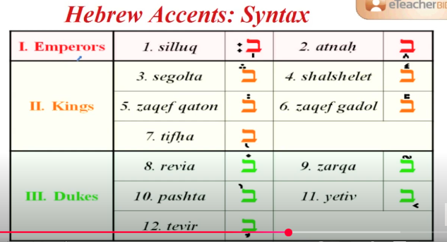
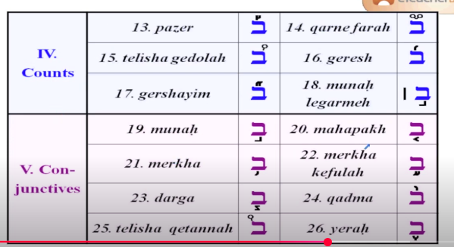

Consonants.

Rhymes.

Perfect rhyme

Letter Family Rhymes.

Plosives B, G, D, P, T, K

Fricatives V, Z, J, F, S, SH, CH, ZH, TH

Nasals N, M, NG

Additive Rhyme Gas-Mask.

Subtractive Rhyme Feet-Me

Consonance Kit-CAt, Book-Back

Assonance Gas-Mad

Prosody, Intonation, Rhythm & Temporal Structure

Level.

Orthography line or graphology.

Punctuation.

Pauses.

Rhythm.

Pulse.
Every click of metronome.
Pulse splits time up into steady chunks called beats so that every beat is the same length of time.

Tempo.
Tempo – the speed of the pulse
The tempo making a tempo at the start of the new line tells us to return to the original tempo at this point.

Tempo types.
Grave means - Slow and Solemn (20 - 40 bpm)
Lento/Largo - means Very Slow (40 - 60 bpm)
Adagio - means Slow (66-76 bpm)
Andante — walking pace (approximately 76–108 BPM in this document's scale).
Moderato — moderately paced (approximately 108–120 BPM in this document's scale).
Allegro - means Fast (120-168 bpm)
Presto - means Very Fast (168 - 200 bpm)
Prestissimo - means Very Very Fast (>200bpm)
Accelerando (accel.) - get quicker
Rallentando (rall.) - slow down.
Ritardando (rit.) - Slow down.
RUBATO - vary the tempo as you play it.

Beats.
A beat is one unit of the steady pulse.

Main beat.

Secondary beat.

Meter.

Rhythm.
See document(s): Basic Rhythms.jpg
Rhythm is the organization of durations and accents; tempo is the speed of the underlying pulse.
1. Tresillo
The tresillo is the most fundamental rhythmic pattern in Sub-Saharan African music as well as Latin American music. The term translates to “triplet”—that said, it’s important to note that even though there are three notes in the rhythm, it’s a duple-based pattern (meaning we divide the beat with even numbers). In common time, the tresillo could look like two dotted quarter notes followed by a quarter note.
2. Hemiola
An extremely common application of polyrhythms, the hemiola creates a two-against-three feel (i.e. one rhythm is playing three evenly-spaced notes in the same duration of time that another rhythm is playing two). Hemiolas are widely used in drum patterns as well as melodies.
3. 12/8 bell
Also simply known as “the bell pattern” in Central and Western African music, the 12/8 bell is a unique pattern that can easily be heard in both 4 and in 3. An audio illusion of sorts, this pattern can really open up a listener’s ears to the idea of rhythmic perception.
4. Clave
The clave is one of the staple rhythms of many Afro-Cuban genres as well as Sub-Saharan African music. It’s a four-beat pattern that builds on the structure of the tresillo, and slight variations create the son clave, rumba clave, 2-3 son clave, and 2-3 rumba clave. Influences of this rhythm can be found across an incredibly wide range of genres, even including the likes of EDM and hip hop.
5. Tha dhi gi na thom
Last but not least, tha dhi gi na thom is an element of the South Indian tradition known as Solkattu. Constituted by five-note groupings, this rhythm can really help musicians develop their understanding of subdivision and tuplets.
6. Charleston
7. 4/3
8. Double Tresillo
9. 3:2 Son Clave

Basic Rhythms.

Rhythm rudiment.mhtml
See document(s): Rhythm rudiment.jpg

Rhythm Syllables_ Systems for reading rhythms in the classroom – Listen – Play – Create.mhtml
See document(s): Rhythm Syllables_ Systems for reading rhythms in the classroom – Listen – Play – Create.mhtml

Godfried Toussaint Most Valueble Arbre rythmique
See document(s): Godfried T. Toussaint - The geometry of musical rhythm _ what makes a _good_ rhythm good_ (2020).pdf
Make rhythm by geometry.
Ритм четырехстишья. Образуется как дерево.
Block 8 8
размер 4 4
такт 2 2 2 2
пульс слогов 1 1 1 1 1 1 1 1
Так и Размер
See document(s): Такт_Размер.pdf

1. Add Primary notes. 2. Add Texture between the primary notes. 3. Tweak the swing tempo. 4. Change the voicings. Add higher or lower notes with different harmonics> 5. Add Accents. 6.Syncopation.

Syncopation.

OnBeat or OffBeat.

Time signatures.
Simple
Compound
Complex

PolyRhythm

Polymetr

Instruments.
beat speed

Drum
Element Function
Cymbals is beats separation.
Snare is Energy is reach of harmonics. More harmonics more energy.
Toms is Variety
Kick is Groove

Groove - is a rhythm that contais a magic balance of on-beat notes and off-beat notes. kick is total creative freedom for 4 bar loop / polymeter.
Groove is done by high note and the low note.
Too-cha-too-too-cha
Hi-hat give a count and repetitive pattern. Put snare on 2 and 4.
Give a crash cymbal when something important happends, like change of partB or start.
Use toms and snare to make fill-ins before the event.
Variation in the end of bar to gain attention.
Tension longer variation in the end.
Notification to introduce transion from verse to chorus. if next slow go slow, if fast go faster.

Basic set:
10" Tom Shell: C
12" Tom Shell: F
Floor Tom Shell: C#
Snare SHell: A
Bass drum Shell: G#

Kick

Snare

Tom-1 / Tom-2

Cymbals

Rim

Clap

C-hat / O-hat

Crash

Ride

Sound Production, Timbre, Instruments & Intonational Realization

Hardware.

Instruments

Guitar

Guitar body

Guitar types

Classical Guitar.

Acoustic Guitar.

Electric Guitar.

Electro-Acoustic Guitar.

Bass Guitar.

BYJU'S Music Curriculum

Headstock

the Straight headstock, the Tilted-back headstock, and the Scarf headstock

Tuners

Vintage or Sealed Tuner Machines

Sealed tuners, Lock-in tuners, side mounted tuners, vintage closed-back, vintage open-back, and staggered posts

Tuning pegs

Nut

Standard Nut · Compensated Nut · Locking Nut · Roller Nut · Zero Fret.

Neck

1. C-Shape Neck and C-chunky · 2. U-Shape Neck and BB Bat · 3. V-Shape (V-soft V-hard) · 4. D-Shape Neck · 5. A-Symmetrical Neck.

Rosewood, Mahogany, Maple, Wenge and Koa

Bolt-On vs Set Neck vs Neck-Through

Fretboard

Rose Wood

Maple

Ebony

Frets sizes

the tang

the crown

Bridge

Hard Tail Bridges, Tune-O-Matic Bridges and Wraparound Bridges

Saddle

Drop-in Saddle · Long (Set) Saddle · Straight (or Uncompensated Saddle) · Compensated Saddle · Adjustable Saddle

Pickup

Single coil

Humbucker

PAF, vintage or moderate output, high output, and active

Strings

roundwound, flatwound and halfround

Inlay

Cut away

Venetian and Florentine

Pick guard

Sound hole

Body

Parlor, OO, OOO, Orchestra Model, Grand Auditorium, Dreadnaught, Slope-Shouldered Dreadnaught, and Jumbo

Setup

adjust action

truss rod

string radius

pickup height

clean your fingerboard and frets

Постановка левой/правой руки

Чистый звук ноты (не размазанный звук)

Скрипы на смене позицый

Гриф от себя. Кисть ровная пальцы к струнам. Левая рука большой палец указывает на средний. Переходы по струнам за счет вращения кисти. Пул-офф пальцем вниз по струне. Вибрато вращением кисти. Подтяжки вращением кисти и помогать другими пальцами. Атака-резкий щелчек по струне в первй такт. Правая рука двигает всей кистьюб раслабленно.

Finger style

Bass line

Two notes

Chords

Ghosts notes

Arpeggios

One chord arp

Chord Change Arp

Open String arp

Mute Arp

Slide, Hammer on, pull off arp

Tapping arp

Harmonic arp

sweep arp

Melody arp

Harmonics

Hammer on / Pull off

Melody

Tapping

Techniques

Sustain & Pitch Harmonic

Strum

Natural Harmonic

Palm Mute

Slide In from below & Slide Out downwards

Legato Slide (Poly Legato)

Hammer-On & Pull-Off

Tap

Vibrato

Stroke Noise

Effects

Filters
See document(s): Filters.jpg

Compressor
See document(s): Simple compressor.jpg

Threshold

8-Band-EQ

Echo

IR Reverb

Bypass All FXs

Vcv Modules

1. Clock
MIDI-CV interfaces
Clock Generator modules
Square-Wave LFOs/VCOs

Signals

Gates

Triggers

Divide clock

2. Sequencer

CV sequencer
See document(s): Scaled CV output.jpg

Gate sequence
See document(s): Gate Seq.jpg

Trigger Sequencer

3. ADSR CV Envelope AD generator Decay generator AHDSR generator hold

Exponential modules for audio Linear modules for CV

4. VCA Amplifier/Attenuator

Acoustic ambient sound source
synth Yamaha pcm piano vco with nsx-39

FL studio
*MIDI notes are played from top to bottom. So? shift top notes little bit to right to change timing.

Types of audio synthesis

Addition Synthesis

Subtractive Synthesis

AM Synthesis

FM Synthesis

Wavetable Synthesis

Waveshaping

Hard Sync

Granular Synthesis

Filters and EQ's

Low Pass

High Pass

Band-pass

Notch

Feedforward

FEedback

High Shelf

Low Shelf

Tilt

Comb

Formant

All Pass

Parametric Eq

Graphic Eq

Envelope
Control Pitch, Volume and Timbre.
Sustain up or down.

Attack

Decay

Sustain

Release

Filter envelope

Types

Strings Bell

Piano Bass

Lead Gate

Pads

Sequence

Effects

Processive chain

Saturation

Subtractive EQ

Compression

Additive EQ

Effects

Reverb

Delay

Intonation, Pitch Organization, Harmony & Musical Expression

Level.

Syllables.

Stressed, Unstressed syllables.
Trochee. Pronounced DUH-duh, as in “ladder.”
Lamb. Pronounced duh-DUH, as in “indeed.”
Spondee. Pronounced DUH-DUH, as in “TV.”
Dactyl. Pronounced DUH-duh-duh, as in “certainly.”
Anapest. Pronounced duh-duh-DUH, as in “what the heck!” (Anapestic poetry typically divides its stressed syllables across multiple words.)

Melodic Scales.
See document(s): Available Tensions - The Jazz Piano Site.mhtml, Modes.png, Chord Relationships and Emotion.mp4, Key.webp
Scale makes mood from Dark to Light.
Tension made out of half tone | tone | double tone | interval in scale.
1. Pentatonic scale
2. Diatonic scale
3. Triad Targeting and 7th & 9ths
3.1 Always start on a chord tone.
3.2 If you move through the scale< keep going until you arrive on another chord tone.
3.3 If skipping notes, only move from one chord tone to another.
3.4 7th & 9ths are same as 3rd and 7th, they add flavour.
4. Chromatic scale
4.1 Quick passing notes.
4.2 Always start chromatic movement from a note in the scale.
4.3 And continue chromatic movement until you reach another note in the scale.
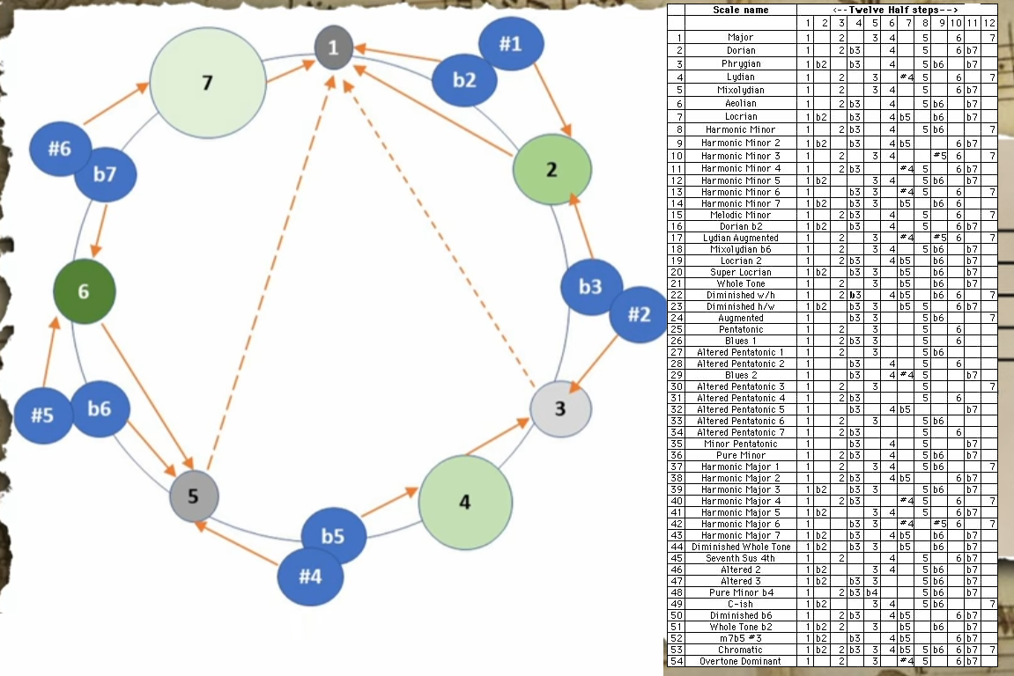

Tune temperament

The Pythagorean Comma

Equal temperament.

1/4 comma

1/3 comma

1537 Rule

Fibonacci Ratios in Harmonic Patterns
38.2% 50% 61.8% 161.8% 261.8% 361.8%

Scale is.

Composers guide to modes of scale.
See document(s): The Composer’s Guide to Modes.mhtml

Scale Intervals.

Tonic.
Tonic function (abbreviated “ton.”): The I
chord has tonic function, which is a state of stability and rest. Tonic chords do not demand progression to other chords.

Tonic Chords: I, iii-, vi-
A tonic chord contains the stable third of the key and at least one other note from the I chord. Clearly the I chord is a tonic chord, but so is the third chord: Emin contains the tones E and G, both from the tonic chord. Amin contains the third as well as the tonic note itself. Both of these chords sound similar to the tonic chord. We’ll call the three chord iii-, the lowercase numerals and minus sign indicating that it is a minor chord. We’ll call the six chord vi-.

Super tonic.

Mediant.

Subdominant.
Pre-dominant function (abbreviated “pre-dom.”): The IV and ii
(chords containing the subdominant 4 and submediant 6 ) tend to progress to chords of dominant function.

Subdominant Chords: IV, ii-
The subdominant chords both contain the note “F”, significant because that note creates a gravitational pull away from the tonic chord. They also both do not contain the tone “B”, which is a strong tone that tends to create the expectation of resolving up to C. These chords have a stronger pull than tonic chords, but a less-stronger pull than dominant chords. When one of these chords appears, it is possible that a dominant chord is approaching; however, sometimes a subdominant chord will appear and then return to the tonic. These chords are stable enough to go almost anywhere. This is especially true of the IV chord, which often resolves back to I without a dominant chord.

Dominant
Dominant function (abbreviated “dom.”): The V
and vii (chords containing the leading tone 7 and supertonic 2 ) tend to progress to tonic (I). Special note: The I/5th chord has dominant function when it resolves to the V chord, as in the third chord from the end of the “Star-Spangled Banner.”

Dominant Chords: V7, vii˚
Both of these chords contain the tones “F” and “B”, and therefore have the maximum amount of conflict and tension. These two tones want to resolve to the tones “E” and “C” respectively, tones in the tonic chord. This expectation is the reason why the chord will often be followed by a tonic, which will contain the expected notes and complete the resolution. The V chord is used much more often than the vii˚ chord is, for reasons we won’t explore here.

Submediant

Tonic Substitute (T)

Predominant(PD)

"Bridge" chord to connect T with PD

Leading tone

Scale types.
See document(s): List of musical scales and modes - Wikipedia.mhtml

Pentatonic scale

Diatonic scale
See document(s): scales_of_harmonies.pdf, Modes.png
These terms may mean different things in different contexts. Very often, diatonic refers to musical elements derived from the modes and transpositions of the "white note scale" C–D–E–F–G–A–B.[b] In some usages it includes all forms of heptatonic scale that are in common use in Western music (the major, and all forms of the minor).
Modes change the mood of the scale from dark to bright.
When you change one note of the scale you change all chords and they will sound different.
Tips:
Relative scales and tonal center.
Focus on the root of mode to give the feeling. Play chord and then the scale.
Then you use modes tonality stays the same. Modes is like accent in speak.

Authentic Modes: Образуются комбинацией мажорного/минорного/уменьшонного аккордов.
Достаточно двух аккордов чтобы выстроить 6 нот гаммы.
Ionian (note of intrest 7th)
Dorian - Tone, Tone, Tone, Tone, Tone, Semitone, Tone (note of intrest natural 6th)
Phrygian - (note of intrest flat 2nd) (dark/mysterious/exotic)
Lydian - (note of intrest triton - #4th and 1st/3rd/5th) (dreamy/floating/si-fi). 1/2/7 chords are for chord progression. avoid 5th chord as it reset.
Mixolydian - flaten the 7th note (note of intrest flat7th) (fun rock/major)
Aeolian (seventh up) #7 (note of intrest minor 6th) (rock&roll)
Locrian - dimineshed.
Plagal modes:
HypoIonian and etc.

Modes used to blend two chords from different scales.
For example: Am-D-Am-D
Am (A B C D E F G )
D (D E F# G A B C#)
Adding F# to A minor scale you will get Dorian mode. ADorian (A B C D E F# G ).
Or remove B and F from Am scale you will get A minor Pentatonic. Am (A C D E G ).

Major scale
See document(s): Modes Compearing.jpg

When you move up the keyboard you can brighten/darken the pentatonic scale and change the root note.

Ionian

Dorian

Phrygian

Lydian

Mixolydian

Aeolian
Natural 1-2-b3-4-5-b6-b7
Harmonic 1-2-b3-4-5-b6-7 To add more tantion from dominant-to-tonic by making Vmajor7.
Melodic 1-2-b3-4-5-6-7 Чтобы убрать арабское звучание

Locrian/Diminished scale

Циганский мажор
1-b2-#3-b4-5-b6-#7

Harmonic Major scale.

Double Harmonic Major scale.

Harmonic Minor scale
The seventh note of scale is #
A B C D E F G#

Locrian #6

Ionian #5

Dorian #4

Phrygian Dom.

Lydian #2

Ultra Locrian

Melodic Minor scale

Dorian b2

Lydian Aug.

Lydian Dom.

Mixolydian b6

Half Dim.

Altoered

Whole tone scale

Diminished scale

Octatonic scale

Messiaen's modes of limited transposition

Alpha Beta & Gamma Chords
See document(s): Octatonic chord progration variations.jpg

Hexatonic scale

Blues scale
Major and Minor blues
The major blues scale is 1, 2,♭3, 3, 5, 6, ♭7 and the minor is 1, 2, ♭3, 4, ♭5, 5, ♭7.

Blues scale
Major and Minor blues
The major blues scale is 1, 2,♭3, 3, 5, 6 and the minor is 1, ♭3, 4, ♭5, 5, ♭7.

Double blues scale
Add Aminor and Amajor pentatonic scales together.
Take a slide u/down from C to C# to add blusy feeling.

Heptatonic Pattern = 1st – 2nd – Flattened 3rd – 4th – Flattened 5th – 6th – Flattened 7th (The 7 note scale)

Minor pentatonic - Pattern = 1st – Flattened 3rd – 4th – 5th – Flattened 7th

Pattern = 1st – 2nd – Flattened 3rd – 3rd – 4th – 5th – 6th – Flattened 7th – 7th (The 9 note scale)

Hexatonic - Pattern = 1st – Flattened 3rd – 4th – Flattened 5th/5th – Flattened 7th (The 6 note scale)

Nonatonic scale

Chromatic scale
Chromatic most often refers to structures derived from the twelve-note chromatic scale, which consists of all semitones.

Augmented scale

Altoered scale

Bebob scale

Exotic scales
See document(s): 25 Exotic Scales For Guitar - Charts, Diagrams And Audio.mhtml

1 - Byzantine Scale
See document(s): jazz-guitar-licks.com/blog/exotic-scales-guitar.html#01

2 - Enigmatic Scale
See document(s): jazz-guitar-licks.com/blog/exotic-scales-guitar.html#02

3 - Persian Scale
See document(s): jazz-guitar-licks.com/blog/exotic-scales-guitar.html#03

4 - Javanese Pelog Scale
See document(s): jazz-guitar-licks.com/blog/exotic-scales-guitar.html#04

5 - Neapolitan Minor Scale
See document(s): jazz-guitar-licks.com/blog/exotic-scales-guitar.html#05

6 - Neapolitan Major Scale
See document(s): jazz-guitar-licks.com/blog/exotic-scales-guitar.html#06

7 - Hungarian Minor Scale
See document(s): jazz-guitar-licks.com/blog/exotic-scales-guitar.html#07

8 - Overtone Scale
See document(s): jazz-guitar-licks.com/blog/exotic-scales-guitar.html#08

9 - Hindu Scale
See document(s): jazz-guitar-licks.com/blog/exotic-scales-guitar.html#09

10 - Romanian Major Scale
See document(s): jazz-guitar-licks.com/blog/exotic-scales-guitar.html#10

11 - Hungarian Major Scale
See document(s): jazz-guitar-licks.com/blog/exotic-scales-guitar.html#11

12 - Spanish Gipsy Scale
See document(s): jazz-guitar-licks.com/blog/exotic-scales-guitar.html#12

13 - Arabian Scale
See document(s): jazz-guitar-licks.com/blog/exotic-scales-guitar.html#13

14 - Asian Scale
See document(s): jazz-guitar-licks.com/blog/exotic-scales-guitar.html#14

15 - Prometheus Scale
See document(s): jazz-guitar-licks.com/blog/exotic-scales-guitar.html#15

16 - Ritsu Scale
See document(s): jazz-guitar-licks.com/blog/exotic-scales-guitar.html#16

17 - In Sen Scale
See document(s): jazz-guitar-licks.com/blog/exotic-scales-guitar.html#17

18 - Iwato Scale
See document(s): jazz-guitar-licks.com/blog/exotic-scales-guitar.html#18

19 - Scottish Pentatonic Scale
See document(s): jazz-guitar-licks.com/blog/exotic-scales-guitar.html#19

20 - Han-Kumoï Scale
See document(s): jazz-guitar-licks.com/blog/exotic-scales-guitar.html#20

21 - Hon-Kumoï-joshi Scale
See document(s): jazz-guitar-licks.com/blog/exotic-scales-guitar.html#21

22 - Egyptian Scale
See document(s): jazz-guitar-licks.com/blog/exotic-scales-guitar.html#22

23 - Hirajoshi Scale
See document(s): jazz-guitar-licks.com/blog/exotic-scales-guitar.html#23

24 - Balinese Pelog Scale
See document(s): jazz-guitar-licks.com/blog/exotic-scales-guitar.html#24

25 - Mongolian Scale
See document(s): jazz-guitar-licks.com/blog/exotic-scales-guitar.html#25

Scale’s modes.

🎶 Every emotional category can be expressed by selecting:
- Cadence = emotional resolution pattern
- Scale = emotional color
- Progression = emotional movement
This means you can literally write:
Emotion Wheel → Cadence + Scale + Progression
And the entire wheel becomes a musical “dictionary.”
Great — here is a complete 48-emotion musical chart based on the Plutchik-style emotion wheel.
Each emotion has:
- Cadence (resolution pattern)
- Scale/Mode (emotional color)
- Chord progression (musical movement)
- Reason/feel (why it fits)
This system is consistent, expandable, and composition-ready.

🎡 48-Emotion Musical Chart
(Organized by 8 core emotions → 3 intensities each → 6 secondary/tertiary blends)

1. JOY (core family)

1.1 Serenity
- Cadence: Plagal (IV → I)
- Scale: Lydian
- Progression: I – II – IV – I
- Feel: calm, glowing, peaceful

1.2 Joy
- Cadence: Perfect Authentic (V → I)
- Scale: Major (Ionian)
- Progression: I – IV – V – I
- Feel: bright, confident

1.3 Ecstasy
- Cadence: Extended authentic (V⁷ → I)
- Scale: Lydian augmented
- Progression: I – V – ♯IV° – I
- Feel: soaring, euphoric

1.4 Love (Joy + Trust)
- Cadence: IV → I (Amen cadence)
- Scale: Ionian/Lydian
- Progression: I – IV – I – V – I
- Feel: warm, embracing

1.5 Optimism (Joy + Anticipation)
- Cadence: Half cadence → Perfect
- Scale: Mixolydian → Ionian
- Progression: I – ii – V | V – I
- Feel: hopeful → fulfilled

1.6 Guilt-relief (Joy + Sadness inverse blend)
- Cadence: Imperfect → Plagal
- Scale: Major with modal mixture
- Progression: I – vi – ii – IV – I
- Feel: bittersweet joy

2. TRUST

2.1 Acceptance
- Cadence: Plagal (IV → I)
- Scale: Mixolydian
- Progression: I – ♭VII – IV – I
- Feel: stable, grounded

2.2 Trust
- Cadence: Authentic
- Scale: Major
- Progression: I – V – I
- Feel: reliability, strength

2.3 Admiration
- Cadence: Lydian plagal (IV♯ → I)
- Scale: Lydian
- Progression: I – II – V – I
- Feel: uplifted, inspired

2.4 Love (Trust + Joy)
(Already above)

2.5 Submission (Trust + Fear)
- Cadence: Minor plagal (iv → i)
- Scale: Dorian
- Progression: i – iv – i
- Feel: yielding, soft

2.6 Loyalty (Trust + Sadness)
- Cadence: Imperfect
- Scale: Mixolydian minor mixture
- Progression: I – V – vi – IV
- Feel: devoted, emotional

3. ANTICIPATION

3.1 Interest
- Cadence: Half cadence (→ V)
- Scale: Major
- Progression: I – vi – ii – V
- Feel: leaning forward, curious

3.2 Anticipation
- Cadence: Half cadence
- Scale: Mixolydian
- Progression: I – iii – ii – V
- Feel: expectation

3.3 Vigilance
- Cadence: Phrygian half
- Scale: Phrygian
- Progression: i – ♭II – V
- Feel: alert, tense

3.4 Optimism (Anticipation + Joy)
(Defined above)

3.5 Anxiety (Anticipation + Fear)
- Cadence: Deceptive
- Scale: Harmonic minor
- Progression: i – iv – V – vi
- Feel: unresolved, spiraling

3.6 Cynicism (Anticipation + Disgust)
- Cadence: Imperfect → no resolution
- Scale: Locrian
- Progression: i° – ♭II – iv°
- Feel: skeptical, uneasy

4. ANGER

4.1 Annoyance
- Cadence: Imperfect
- Scale: Aeolian
- Progression: i – v – ♭VII – i
- Feel: friction without explosion

4.2 Anger
- Cadence: Phrygian (♭II → I)
- Scale: Phrygian dominant
- Progression: i – ♭II – I
- Feel: hard attack

4.3 Rage
- Cadence: Strong authentic (V⁷ → i)
- Scale: Harmonic minor
- Progression: i – iv – V⁷ – i
- Feel: explosive, sharp

4.4 Dominance (Anger + Trust)
- Cadence: Perfect
- Scale: Mixolydian ♭6
- Progression: I – V – ♭VI – I
- Feel: powerful, imposing

4.5 Contempt (Anger + Disgust)
- Cadence: Plagal minor
- Scale: Phrygian
- Progression: i – iv – ♭II – i
- Feel: sneering, dark

4.6 Pride (Anger + Joy)
- Cadence: V → I (grand)
- Scale: Lydian
- Progression: I – V – IV – I
- Feel: triumphant

5. FEAR

5.1 Apprehension
- Cadence: Imperfect
- Scale: Dorian
- Progression: i – ii° – v
- Feel: unsure, small tension

5.2 Fear
- Cadence: Deceptive (V → vi)
- Scale: Harmonic minor
- Progression: i – iv – V – vi
- Feel: suspense → swerve

5.3 Terror
- Cadence: Chromatic descent → i
- Scale: Locrian or octatonic
- Progression: ♭VI – V – iv° – i
- Feel: extreme threat

5.4 Anxiety (Fear + Anticipation)
(Defined above)

5.5 Submission (Fear + Trust)
(Above)

5.6 Despair (Fear + Sadness)
- Cadence: none (ends hanging)
- Scale: Aeolian
- Progression: i – ♭VI – ♭VII – iv
- Feel: hopeless, sinking

6. DISGUST

6.1 Boredom
- Cadence: Weak imperfect
- Scale: Mixolydian
- Progression: I – IV – V – IV
- Feel: no resolution

6.2 Disgust
- Cadence: Minor plagal (iv → i)
- Scale: Phrygian
- Progression: i – ♭II – iv – i
- Feel: disturbed

6.3 Loathing
- Cadence: Phrygian dominant
- Scale: Phrygian dominant
- Progression: i – ♭II – ♭III
- Feel: severe revulsion

6.4 Contempt (Disgust + Anger)
(Already listed)

6.5 Cynicism (Disgust + Anticipation)
(Already listed)

6.6 Remorse (Disgust + Sadness)
- Cadence: Imperfect minor
- Scale: Aeolian
- Progression: i – iv – v – i
- Feel: shame, heaviness

7. SADNESS

7.1 Pensiveness
- Cadence: Imperfect
- Scale: Dorian
- Progression: i – vii° – i
- Feel: introspective

7.2 Sadness
- Cadence: Weak V → i
- Scale: Aeolian
- Progression: i – iv – v – i
- Feel: melancholy

7.3 Grief
- Cadence: Descending lament
- Scale: Harmonic minor
- Progression: i – V – i – V
- Feel: deep sorrow

7.4 Remorse (Sadness + Disgust)
(Above)

7.5 Despair (Sadness + Fear)
(Above)

7.6 Regret (Sadness + Joy inverse)
- Cadence: Deceptive then imperfect
- Scale: Aeolian
- Progression: i – V – vi – iv
- Feel: sad reflection

8. SURPRISE

8.1 Distraction
- Cadence: No resolution
- Scale: Whole-tone
- Progression: I – II – III
- Feel: floating, unfocused

8.2 Surprise
- Cadence: Deceptive
- Scale: Lydian augmented
- Progression: I – V – ♭VI
- Feel: sudden shift

8.3 Amazement
- Cadence: Rising authentic
- Scale: Lydian
- Progression: I – II – V – I
- Feel: awe, breathless

8.4 Confusion (Surprise + Disgust)
- Cadence: Locrian unresolved
- Scale: Locrian
- Progression: i° – ♭II – vii°
- Feel: unstable

8.5 Shock (Surprise + Fear)
- Cadence: Chromatic deceptive
- Scale: Octatonic
- Progression: i – V+ – vi°
- Feel: jolt, disorientation

8.6 Curiosity (Surprise + Anticipation)
- Cadence: Half cadence
- Scale: Mixolydian
- Progression: I – ii – V
- Feel: interested, exploring

Chord.
Chords made out of scale notes.
See document(s): Какие аккорды можно - ч.1 [Теория музыки по-пацански] - YouTube

Chord note or Non-chord note (passing notes).

Stable tones and Tension tones.
Stable or Tension note can be on beat and off beat creating different fills.

Chord tones

Passing tones.

Leaps.

Arpeggios.

Chord mood.
See document(s): Right chord, right mood (thinking beyond major and minor) _ Bandzoogle Blog.mhtml
Chord described by tension note in it.
Chord relations and emotions
See document(s): Chord Relationships and Emotion.mhtml

Chord types.

Triads – built from thirds (usually major or minor).
Example: C–E–G (C major triad)

Major triad

Minor triad

Suspended 2/4 chord
See document(s): Suspended chords.jpg, How Sus Chords Work and When To Play Them.mhtml
Ноты аккорды задерживается и разрешается в следующем аккорде.

Shell chord.
or without 1/5
или Децима
Две ноты описывают аккорд полностью. настроение и гармонию.

Power chord
or without 3

Augmented

Diminished
Symmetric chord
Is connection between any chromatic chords.
Is dissonant chord and can be resolve to any note one step above. Cdim. to Db,Dbm, E, Em, G, Gm, Bb, Bbm.
Only 3 dim7 chords
One has ROOT in common
One Has the FIFTH in common
One has V to I in common
C Eb Gb A
C# E G Bb
D F Ab B

Half diminished

Altoered chord

Forth apart triads
Example E-A-D

Fifth apart triads
Take forth apart C-F-Bb and switch sides Bb-F-C.

Extended Chords

Seventh Chords.
See document(s): Chord Formula.jpg, Chord symbols.png, Chords combinations.jpg
Первое обращение трезвучия. Обозначается цифрой 6, прибавляемой снизу к знаку функции Т6, S6, D6.

Ninth Chords.

Eleventh Chords.

Quartal chords – built from fourths.
Example: C–F–B♭

Quintal chords – built from fifths.
Example: C–G–D

Secundal chords – built from seconds.
Example: C–D–E

Cluster chords – a type of secundal harmony where notes are very close together, often adjacent.
Example: C–C♯–D

Tetrachord

Polychord

Lexicon, Parts of Speech & Grammar

Level. Parts of speech.

Morphology (morphemes): internal structure of words; roots, prefixes, suffixes, postfixes, infixes, inflections.
Аффикс — это общий термин, который обозначает морфемы, добавляемые к корню слова для изменения его значения или грамматической формы.
- Корни – идея которую выражает слово.
- Префиксы — добавляются в начале слова. Пример: пере-ехать, без-звучный.
- Суффиксы — добавляются в конце слова. Пример: красн-енький, стол-ик.
- Инфиксы — вставляются внутрь корня. Инфиксами часто пользуются в некоторых языках, например, в арабском.
- Постфиксы — стоят после корня и окончания (редко встречается в русском языке). Пример: "сама-то".
- Интерфиксы — соединяют части сложных слов. Пример: вод-о-пад, земл-е-делие.
- Pre modifiers -
- Post modifiers –

Hebrew Root Types ("Gzarot")
1. Basic Root Structure
Most Hebrew words are built from 3-letter roots.
Root letters can change depending on voice, tense, aspect, modality, person, gender, number etc.

2. Main Gzarot (Root Types / Irregular Patterns)
Gzarah Shlemah ("Complete Root")
No weak letters.
Behaves normally in all conjugations.

Peh-Nun (פ"נ)
First root letter is נ (nun).
The נ often disappears in conjugation.
Example: נ.פ.ל → יפול (will fall)

Peh-Gutteral (פ"א גרונית)
First letter is a guttural (א, ה, ח, ע).
May affect vowel patterns.

Ayin-Ayin (ע״ע)
Second and third letters are the same.
Often merge or simplify.
Example: ס.ב.ב → סוב

Ayin-Vav/Yod (ע״ו/ע״י)
Second letter is ו or י.
Tends to drop or change in conjugation.
Example: ק.ו.ם → יקום

Lamed-Gutteral (ל"א גרונית)
Last letter is guttural.
May affect suffixes and vowels.

Lamed-Heh (ל״ה)
Last letter is ה.
The ה may disappear or change in conjugation.
Example: ב.נ.ה → יבנה

Vocabular by semantic.
Entities (Things, what exists)
Humans
Animals
Plants
Objects
Natural features
Actions (Events, what happens)
Movement
Creation
Destruction
Giving / Receiving
Communication
Work
Perception (how things are experienced)
Seeing
Hearing
Smelling
Tasting
Touching
Cognition (Mind, mental processes)
Knowing
Thinking
Understanding
Remembering
Learing
Deciding
Emotion (Internal feelings)
Love
Fear
Joy
Anger
Sadness
Trust
Relationships (how things connected)
Family
Friendship
Leadership
Following
Ownership
Covenant
State of Condition (how something is)
Living
Dying
Being full/empty
Strong/Weak
Pure/Impure
Whole/Broken
Space (location and movement)
Up/Down
In/Out
Near/Far
Front/Back
East/West
Time (temporae relations)
Beginning
Ending
Continuing
Returning
Waiting
Value and Evaluation (judgment and ethics)
Good/Bad
Holy/Profane
Justice
Trith
Beauty
Government & Society
Law
Government
War
Peace
Trade
Nature
Water
Fire
Earth
Sky
Weather
Agriculture
Food

Work & Craft

People | Human experience
 |  | Body |  | Head
 |  | Hand |  | Eyes
 |  | Foot |  | Ears
 |  |  |  | Mouth
 |  |  | Heart
 |  |  | Blood
 |  |  | Bone
 |  | Movement | Communication | Perception | Thought | Emotion | Life | Food & Agriculture | Nature | Home | Work & Craft | Combat | Government & Society | Religion | Time | Quantity & Quality | Relationships
 |  | Walking | Speaking |  |  | Love |  |  |  |  | Building
 |  | Running | Saying |  |  | Hate |  |  |  |  | Destroying
 |  | Entering | Calling |  |  | Fear |  |  |  |  | Cutting
 |  | Leaving | Naming |  |  | Trust |  |  |  |  | Joining
 |  | Climbing | Asking |  |  | Hope |  |  |  |  | Measuring
 |  | Descending | Answering |  |  | Joy |  |  |  |  | Counting
 |  | Returning | Writing |  |  | Sadness |  |  |  |  | Buying
 |  | Turning | Reading |  |  | Anger |  |  |  |  | Selling
 |  | Carrying | Teaching |  |  | Jealousy |  |  |  |  | Paying
 |  | Throwing | Learning |  |  | Mercy |  |  |  |  | Working
 |  | Pulling | Commanding |  |  | Compassion |  |  |  |  | Resting
 |  | Pushing | Blessing
 |  |  | praising

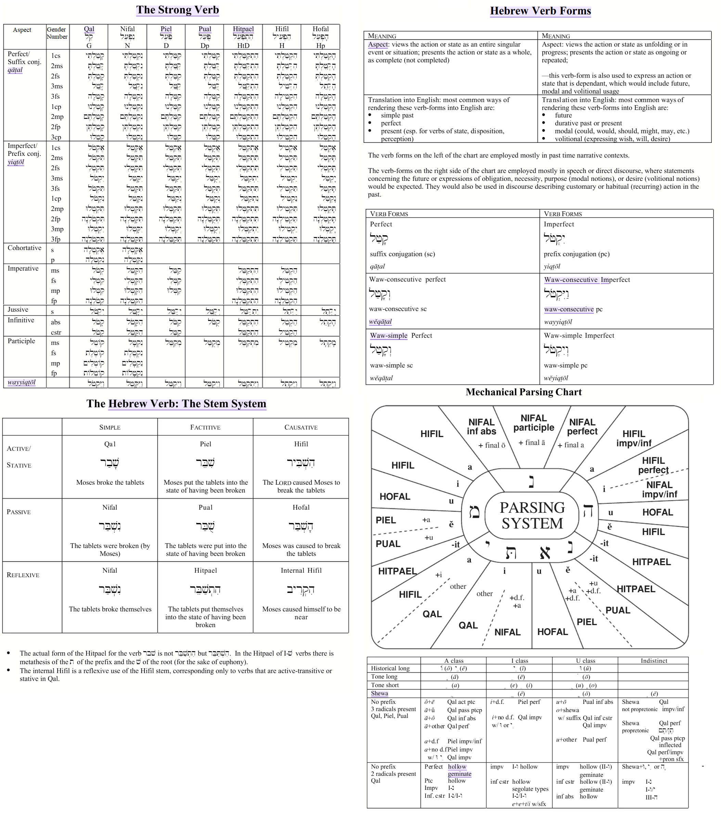

Affixes

Prefixxies

(when) כ
Moment in time (when)

(to) ל
To do (to run)

(from) מ
Negative meaning. Action not happening or no longer happening (from)

No prefix (-ing)

(while) ב
Duration of time(while)

Words.

The words are convey its meaning and mood.
Words Properties

Lemma/Lexica/Root/Base form: dictionary form

Word: actual form

Etymology – word origins and historical development.

Semantics: literal meaning, implied meaning

Collocation: common word partners.

Lexicon: vocabulary and word choice.
Noun | Verb | Adjective | Adverb
A Slow | Slowing | Slow | Slowly

DICTIONARY: PRONOUNS AND FUNCTIONAL GROUPS
===================================================================

[PRONOUNS]
-- Subject Pronouns --
I | First-person singular subject
you | Second-person singular/plural subject/object
he | Third-person singular masculine subject
she | Third-person singular feminine subject
it | Third-person singular neuter subject/object
we | First-person plural subject
they | Third-person plural subject

-- Object Pronouns --
me | First-person singular object
him | Third-person singular masculine object
her | Third-person singular feminine object/possessive adjective
us | First-person plural object
them | Third-person plural object

-- Possessive Pronouns --
mine | First-person singular possessive pronoun
yours | Second-person singular/plural possessive pronoun
his | Third-person singular masculine possessive adjective/pronoun
hers | Third-person singular feminine possessive pronoun
ours | First-person plural possessive pronoun
theirs | Third-person plural possessive pronoun

-- Reflexive Pronouns --
myself | First-person singular reflexive
yourself | Second-person singular reflexive
himself | Third-person singular masculine reflexive
herself | Third-person singular feminine reflexive
itself | Third-person singular neuter reflexive
ourselves | First-person plural reflexive
yourselves | Second-person plural reflexive
themselves | Third-person plural reflexive

-- Relative & Demonstrative Pronouns --
who | Relative/interrogative pronoun for persons (subject)
whom | Relative/interrogative pronoun for persons (object)
whose | Relative/interrogative possessive pronoun
which | Relative/interrogative pronoun for things
that | Relative/demonstrative pronoun
this | Demonstrative pronoun (singular, near)
these | Demonstrative pronoun (plural, near)
those | Demonstrative pronoun (plural, far)

-- Indefinite Pronouns --
anyone | Any person
everyone | Every person
someone | An unspecified person
no one | No person
anything | Any thing
everything | Every thing
something | An unspecified thing
nothing | No thing

Pronoun Determiner

Interrogative Pronouns (Question)
English | Hebrew | Russian | Turkey | German
What to do
What do
What have done
What is doing
What have been doing
What did
What had done
What was doing
What was had been doing
what will do
What will have done
What will been doing
What will had been doing
How | כמה (Kama) | Как
How much | כמה (Kama) | Сколько
How many | כמה (Kama) | Сколько
How often | כמה פעמים (Kama Pe'amim)
How necessary | עד כמה הכרחי (Ad Kama Hechrakhi)
How frequently | באיזו תדירות (Be'eizo Tadirut)
How long | כמה זמן (Kama Zman)
How feeling | איך מרגישים (Eich Margishim)
How good | עד כמה טוב (Ad Kama Tov)
Who, What, | מי (mi) מה (má) איך (Eich) כיצד(kizad) | Именительный падеж (-)  кто, что,
Like who, like what | כמו מי, מה (кмо ми, ма) | Как кто, что
Which | איזה (эйзе) | Какой (-ый, -ой, -ий)
 | איזו (эйзо) | Какая (-ая, -яя)
 | איזה (эйзе) | Какое (-ое, -ее)
 | אילו (эйлу) | Какие (-ые, -ие)
Which | אשר / איזה (ашер / эйзе) | Который (номер)
Which, for male | אשר / איזו (ашер / эйзо) | Которая
Which, for female | אשר / איזה (ашер / эйзе) | Которое
Which, for it | אשר / איזה (ашер / эйзе) | Которого
Which | אילו (эйлу) | Которых
Whose | של מי (шель ми) | Родительный падеж (-а)  принадлежности, отсутствия, недостатка  кого, чего, чей, какого
Whom
For whom, what | עבור מי, מה (авур ми, ма) | Для кого, чего
Behind whom, what | מאחורי מי, מה (меахорей) | Позади кого, чего
Opposite to whom, what | מול מי, מה (муль ми, ма) | Напротив кого, чего
From whom, what | מ-מי, מה (ми-ми, ма) | От кого, чего
Near whom, what | ליד מי, מה (леяд ми, ма) | Возле кого, чего
Near whom, what | ליד מי, מה (леяд ми, ма) | Около кого, чего
Near whom, what | בקרבת מי, מה (бекарват ми, ма) | Подле кого, чего
Instead of whom, what | במקום מי, מה (бимком ми, ма) | Вместо кого, чего
Because of whom, what | בגלל מי, מה (биглал ми, ма) | Из-за кого, чего
At whom, what | אצל מי, מה (эцель ми, ма) | У кого, чего
Without whom, what | בלי מי, מה (бли ми) | Без кого, чего
For the sake of whom, what | למען מי, מה (лемаан ми, ма) | Ради кого, чего
After whom, what | אחרי מי, מה (ахарей ми, ма) | Позднее кого, чего
After whom, what | אחרי מי, מה, (ахарей ми, ма) | После кого, чего
Because of whom, what | בגלל מי, מה, של מי (биглаль ми, ма) | Из-за кого, чего
Out of whom, what | מתוך מי, מה, של מי (митох ми, ма) | Из / C кого, чего
 | עבור מי, מה (авур ми, ма) | До кого, чего
Whose | של מי (шель ми) | Чей
Whose | של מי (шель ми) | Чья
Whose | של מי (шель ми) | Чьё
Whose | של מי (шель ми) | Чьи
Which | איזה (эйзе) | Какого (-ого, -его)
which | איזו (эйзо) | Какой (-ой, -ей)
which | איזה (эйзе) | Какого (-ого, -его)
which | אילו (эйлу) | Каких (-ых, -их)
To whom, what | למי, מה (ле ми, ма) | Дательный падеж (-у)  получателя действия  кому, чему, какому
Towards whom, what | אל מי, מה (эль ми, ма) | К кому, чему
About whom, what | על מי, מה (аль ми, ма) | По кому, чему
Thanks to whom, what | בזכות מי, מה (бизхут ми, ма) | Благодаря кому, чему
According to whom, what | על פי מי, מה (аль пи ми, ма) | Согласно кому, чему
Contrary to whom, what | בניגוד למי, מה (бенигуд ле ми, ма) | Вопреки кому, чему
which | איזה (эйзе) | Какому (-ому, -ему)
which | איזו (эйзо) | Какой (-ой, ей)
which | איזה (эйзе) | Какому (-ому, -ему)
which | אילו (эйлу) | Каким (-ым, -им)
Whom, what, | את מי, מה (эт ми, ма) | Винительный падеж (-а)  направление движения  Кого, что, куда
Into whom, what | בתוך מי, מה (бетох ми, ма) | В кого, что
On whom, what | על מי, מה (аль ми, ма) | На кого, что
About whom, what | על מי, מה (аль ми, ма) | Про кого, что
For whom, what | עבור מי, מה (авур ми, ма) | За кого, что
Across whom, what | מעבר ל (Me'ever Le) | Через кого, что
Through whom, what | בְּעַד מי, מה | Сквозь кого, что
which | איזה (эйзе) | Какой (-ый, -ой, -ий)
which | איזה (эйзе) | Какую (-ую, -юю)
which | אילו (эйлу) | Какое (-ое, -ее)
which | איזה (эйзе) | Какие ( -ые, -ие)
which | איזו (эйзо) | Какого (-ого, -его)
which | איזו (эйзо) | Каких (-ых, -их)
By whom, what | במי, במה (бе-ми, ба-ма) | Творительный падеж (-ом)  способа действия или средства  кем, чем, каким
With whom, what | עם מי, מה (им ми, ма) | С кем, чем
Under whom, what | תחת מי, מה (тахат ми, ма) | Под кем, чем
Above whom, what | מעל מי, מה (меаль ми, ма) | Над кем, чем
 | אחרי מי, מה (ахарей ми, ма) | За кем, чем
In front of whom, what | לפני מי, מה (лифней ми, ма) | Перед кем, чем
Between whom, what | בין מי, מה (бейн ми, ма) | Между кем, чем
Together with whom, what | ביחד עם מי, מה (беяхад им ми, ма) | Вместе с кем, чем
 | צמוד ל- מי, מה (цамуд ле- ми, ма) | Вплотную с кем, чем
 | בנפרד מ- מי, מה (бе-нифрад ми- ми, ма) | Порознь с кем, чем
Which | איזה (эйзе) | Каким (-ым, -им)
which | איזו (эйзо) | Какой (-ой, -ою, -уй, -ею)
which | איזה (эйзе) | Каким (-ым, -им)
which | אילו (эйлу) | Какими (-ыми, -ими)
 | על ידי מי, מה (аль йедей) | Предложный падеж (-е) (где)  (местонахождения или направления)  о ком, о чем, о каком
In whom, what | בתוך מי, מה (бетох ми, ма) | В ком, чем
About whom, what | על מי, מה (аль ми, ма) | О, об ком, чем
On whom, what | על מי, מה (аль ми, ма) | На ком, чем
in what or concerning what, | אצל מי (эцель ми) במה (бамэ) | При ком, чем
Which | איזה (эйзе) | О каком (-ом, -ем)
which | איזו (эйзо) | О какой (-ой, -ей)
which | איזה (эйзе) | О каком (-ом, -ем)
which | אילו (эйлу) | О каких (-ых, -их)
Where | איפה (Eifo) | Где
Everywhere |  | Везде
Here |  | Здесь, тут
There |  | Там
Where to | לאן (леан) | Куда
on |  | На
in |  | В
there |  | туда
here |  | сюда
Where from | מאין (меаин) | Откуда
from |  | из
from here |  | отсюда
from there |  | оттуда
When, | מתי (Matai) | Когда
how long |  | как долго
how often |  | как часто
till when |  | до каких пор
from when |  | с каких пор
Now: | עכשיו (Achshav) | Сейчас
Later: | מאוחר יותר (Me'uchar Yoter) | Позже
Yesterday: | אתמול (Etmol) | Вчера
Tomorrow: | מחר (Machar) | Завтра
At 6pm: | בשעה שש בערב (Besha'a Shesh Ba'erev) | В шесть вечера
At | ב (Be)
 | אצל (Etzel) | у
On | על (Al) | на
In | ב (Be) | в
During | במהלך (B'mehalach) | вовремя
Before | לפני (Lifnei) | перед, до
After | אחרי (Acharei) | после
Why, | למה (Lama) | Почему
To | ל (Le) | к чему
For | בשביל (Bishvil) | для чего
For | עבור (Avur) | для кого
That |  | что
So that | כדי ש (K'dei She) | так что
Because |  | потому что
If

Pronominal Suffixes

Relative Pronouns.
Used to connect clauses. Who, whom, that, which, where, whose, whomever, whichever, wherever

Intensive Pronouns.

Indefinite Pronouns.

Personal Pronoun (Who)

Subjective Pronouns
I: | אני (ani) | Я | Ben
You (singular male): | אתה (ata) | Ты | Sen
You (singular female): | את (at) | Ты | Sen
He: | הוא (hu) | Он | O
She: | היא (hi) | Она | O
It (singular male): | הוא (hu) | Оно | O
It (singular female): | היא (hi) | Оно | O
We: | אנחנו (anachnu) | Мы | Biz
You (plural female) | אתם (atem) | Вы | Siz
You (plural male) | אתן (aten) | Вы | Siz
They (plural male): | הם (hem) | Они | Onlar
Them (plural female): | הן (hen) | Они | Onlar

Objective Pronouns (by, with, like, as, in, on, after.)

Objective Pronouns (by, with, like, as, in, on, after.)

Me: | אותי (otí) | Меня
You (singular male): | אותך (otchá) | Тебя
You (singular female): | אותך (otákh) | Тебя
Him: | אותו (otó) | Его
Her: | אותה (otá) | Её
It (singular male): | אותו (otó) | Это
It (singular female): | אותה (otá) | Это
Us: | אותנו (otánu) | Нас
Them (plural male): | אותם (otám) | Их
Them (plural female): | אותן (otán) | Их

Reflexive Pronouns (whom)

Reflexive Pronouns (whom)
Myself: | עצמי (atzmí)
Yourself (singular male): | עצמך (atzmchá)
Yourself (singular female): | עצמך (atzmách)
Himself: | עצמו (atzmó)
Herself: | עצמה (atzmá)
Itself: | עצמו (atzmó),
Itself: | עצמה (atzmá)
Ourselves: | עצמנו (atzménu)
Yourselves (plural male): | עצמכם (atzmchékhém)
Yourselves (plural female): | עצמכן (atzmchékhén)
Themselves: | עצמם (atzmám) e
Themselves: | עצמן (atzmán)
Each other: | זה את זה (ze et ze),
Each other: | זו את זו (zo et zo)
One another: | זה את זה (ze et ze),
One another: | זו את זו (zo et zo),

Demonstrative Pronoun (Subject / Object)

Possessive Pronoun

Direct Object Pronouns (stand alone Whose) (Whose, of who, of what)
Mine: | שלי (shelí) | Мое
Yours (singular male): | שלך (shelchá), | Твоё
Yours (singular female): | שלך (shelákh) | Твоё
His: | שלו (sheló) | Его
Hers: | שלה (sheláh) | Её
Its (singular male): | שלו (sheló), | Его
Its (singular female): | שלה (sheláh) | Его
Ours: | שלנו (shelánu) | Наше
Theirs (plural male): | שלהם (shelahém) | Их
Theirs (plural female): | שלהן (shelahén) | Ихнее

Indirect Adjective (used before nouns Whose) (Whose, of who, of what)
My: | שלי (shelí) | Моя | Benin (|)m,(i)m, (u)m, (u)m
Your (singular male): | שלך (shelchá) | Твоя | Senin (|)n, (i)n, (u)n, (u)n
Your (singula female): | שלך (shelákh) | Твоя | Senin
His: | שלו (sheló) | Его | Onun (s)|, (s)I, (s)u, (s)u
Her: | שלה (sheláh) | Её | Onun
Its (singular male): | שלו (sheló), | Его | Onun
Its (singular female): | שלה (sheláh) | Его | Onun
Our: | שלנו (shelánu) | Наше | Bizin (|)m|z, (i)miz, (u)muz, (u)muz
 |  | Наша / Нашей
Ours |  | Наши | Sizin (|)n|z, (i)niz, (u)nuz, (u)nuz
Their (plural male) | שלהם (shelahém), | Их | Onlarin lar|, lari
Their (plural female): | שלהן (shelahén) | Ихнее | Onlarin

Determiners.

Negatives Pronouns (No)
No: | לא (Lo)
None: | שום דבר (Shum Davar)
Nothing | שום דבר (Shum Davar)
Nobody | אף אחד (Af Echad)
No one: | אף אחד (Af Echad)
Nowhere | בשום מקום (Beshum Makom)
Notime | בשום זמן (Beshum Zman)
Not

Quantity Pronoun (Group)
A
Any
Both | שניהם (Shneihem)
Each
Every
Few | מעט (Me'at)
Many | רבים (Rabim)
Several | כמה (Kama)
Some
All | כל (Kol)
Ordinal numbers: | (one, two, three).
Cardinal numbers: | (first, second, fourth).

Definite Pronouns (This)
The: | ה
This (singular male): | זה (Ze)
This (singular female): | זאת (Zot)
That (singular male): | ההוא (Ha'hu)
That (singular female): | ההיא (Ha'hi)
These (plural): | אלה (Eleh)
Those (plural): | ההם (Ha'hem)

Indefinite Pronouns (Any)
Another:
Any: | כל (Kol)
Anybody: | כל אחד (Kol Echad)
Anyone: | כל אחד (Kol Echad)
Anything: | כל דבר (Kol Davar)
Anywhere: | בכל מקום (Bechol Makom)
Anytime: | בכל זמן (Bechol Zman)

General Pronouns (Each)
Each: | כל אחד (Kol Echad)
Eachtime:
Eachbody:
Every: | כל (Kol)
Everybody: | כולם (Kulam)
Everyone: | כולם (Kulam)
Everything: | הכל (Hakol)
Everywhere: | בכל מקום (Bechol Makom)
Everytime: | כל פעם (Kol Pa'am)

Indefinite Pronouns (Some)
Some: | כמה (Kama)
Someother: | אחר (Acher)
Somebody: | מישהו (Mishehu)
Someone: | מישהו (Mishehu)
Something: | משהו (Mashehu)
Somewhere: | איפשהו (Eifoshehu)
Every
===================================================================

CLOSED-CLASS FUNCTIONAL WORDS DICTIONARY (Non-Content Words)
===================================================================
[DETERMINERS]
-- Articles --
the | Definite specific article
a | Indefinite singular article (consonant start)
an | Indefinite singular article (vowel start)

-- Demonstratives --
this | Singular near-distance determiner
that | Singular far-distance determiner
these | Plural near-distance determiner
those | Plural far-distance determiner

-- Quantifiers & Numerals --
some | Unspecified quantity
any | Indiscriminate quantity
all | Total quantity
each | Individual items in a group
every | All members of a group collectively
few | Small countable quantity
many | Large countable quantity
much | Large uncountable quantity
no | Zero quantity

[PREPOSITIONS / ADPOSITIONS]
-- Space and Time --
in | Enclosed space or specific time period
on | Surface contact or specific day
at | Specific point or location
by | Near, agent, or deadline
from | Point of origin
to | Direction or destination
with | Accompaniment or instrument
without | Absence of something
for | Duration or intended recipient
of | Possession or association
through | Moving from one side to the other
under | Lower than a surface
over | Higher than a surface
between | In the space separating two things

[CONJUNCTIONS]
-- Coordinating Conjunctions (FANBOYS) --
and | Addition of items/clauses
but | Contrast or exception
or | Altoernative option
nor | Negative alternative
for | Reason or cause (formal)
yet | Contrast despite something
so | Consequence or result

-- Subordinating Conjunctions --
because | Reason explanation
although | Concession or contrast
if | Condition requirement
unless | Except under the condition that
since | Time starting point or reason
while | During the time that
whereas | Direct contrast

[INTERJECTIONS]
-- Response and Exclamation Markers --
oh | Expressing surprise or realization
ah | Realization or pleasure
ouch | Expressing physical pain
oops | Acknowledging a minor mistake
hey | Attracting attention
alas | Expressing sorrow or pity
well | Discourse marker of transition
ugh | Disgust or frustration
===================================================================
===================================================================

a
about
above
after
again
against
all
almost
along
already
also
although
always
am
among
an
and
another
any
anybody
anyone
anything
anywhere
are
aren't
around
as
at
be
because
been
before
being
below
beside
between
both
but
by
can
cannot
can't
could
couldn't
did
didn't
do
does
doesn't
doing
don't
down
during
each
either
else
ever
every
everybody
everyone
everything
everywhere
except
few
for
from
further
had
hadn't
has
hasn't
have
haven't
having
he
hed
hell
hes
her
here
heres
hers
herself
him
himself
his
how
hows
i
id
ill
im
ive
if
in
into
is
isn't
it
its
itself
lets
many
me
might
more
most
much
must
mustn't
my
myself
near
neither
no
no-one
nobody
nor
not
nothing
now
of
off
often
on
once
only
or
other
ought
our
ours
ourselves
out
over
own
same
shan't
she
shed
shell
shes
should
shouldn't
so
some
somebody
someone
something
somewhere
such
than
that
thats
the
their
theirs
them
themselves
then
there
theres
these
they
theyd
theyll
theyre
theyve
this
those
through
to
too
under
until
up
very
was
wasn't
we
wed
well
were
weve
weren't
what
whats
when
whens
where
wheres
which
while
who
whos
whom
why
whys
with
won't
would
wouldn't
you
youd
youll
youre
youve
your
yours
yourself
yourselves

Noun

Auxiliaries

Particles

Numerals

Articles.
Zero Article.
Indefinite Article.
Definite Article.

Gender
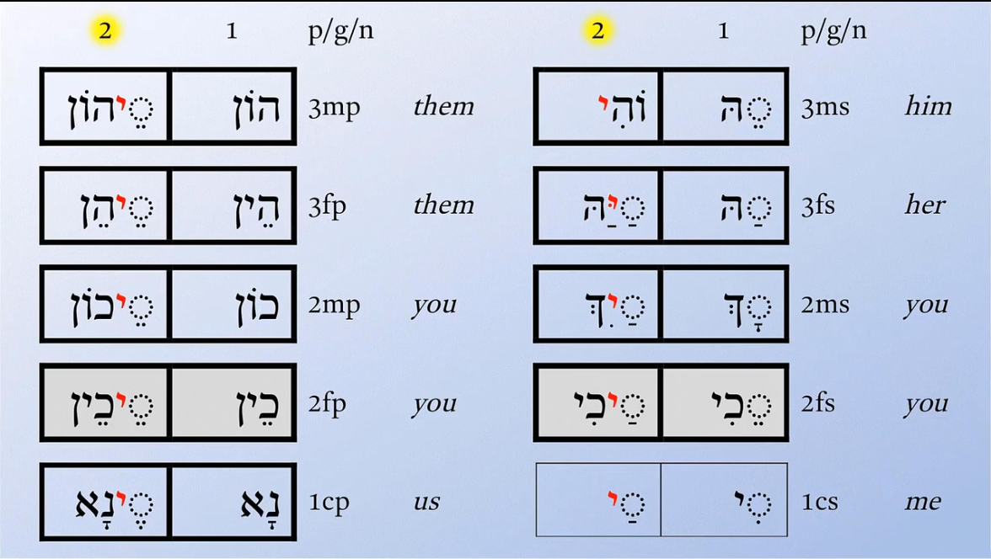

Adjectives.

Numerical.

Verb

The Main Verb Typologies (The Core Meaning of verb)

Static verbs.

Existence: be, exist, remain

State: know, believe, own
Continuous Tenses: True state verbs cannot be used in continuous (-ing) tenses. For example, you say "I know the answer," never "I am knowing the answer."
Dual-Nature Verbs: Many verbs change from stative to dynamic (action) depending on the context. For example: Stative: "I have a car." (Possession) Dynamic: "I am having lunch." (An action/activity)

1. Thoughts and Opinions (Mental States).
These verbs describe mental processes, beliefs, and intellectual states. Examples: Know, believe, understand, remember, forget, think (meaning to have an opinion), agree, disagree, suppose, realize.

2. Feelings and Emotions.
These verbs communicate emotional states, desires, preferences, and attitudes. Examples: Love, hate, like, dislike, want, need, prefer, adore, care, value.

3. Senses and Perception.
These verbs map how we perceive the world physically and mentally. Examples: See, hear, smell, taste, feel, sound, seem, appear, look (meaning to resemble). Look, Taste, Smell, Sound, Feel, Become, Talk, Remain, Appear.

4. Possession and Lifespan.
These verbs denote ownership, inclusion, and the structural makeup of something. Examples: Have (meaning to possess), own, belong, possess, include, contain, consist, lack.

5. Prices, Measurements, and Conditions
These verbs describe stable attributes, values, or dimensions. Examples: Be, cost, weigh, measure, depend, matter, resemble, owe.

Dynamic Verbs.

Action: run, eat, write

1. Physical Action Verbs (Bodily Movements)
These verbs involve tangible, visible movements of the body or objects.
Examples: Run, jump, write, build, throw, kick, dance, hit, cook, drive.
Sentence: "She ran a marathon." / "He is building a house."

2. Mental Action Verbs (Cognitive Actions)
While these happen inside the mind, they are considered active processes rather than fixed states because they require deliberate focus or energy.
Examples: Think, calculate, ponder, memorize, evaluate, dream, solve, decide, analyze.
Sentence: "The team is calculating the budget." / "I pondered the decision all night."

3. Communication Verbs (Verbal Actions)
These verbs specifically deal with the expression of language, thoughts, and sounds to others.
Examples: Speak, whisper, scream, explain, argue, discuss, sing, chat, report.
Sentence: "The professor explained the formula."

4. Consumption and Bodily Functions
These verbs track physical processes related to taking in nutrients or biological reactions.
Examples: Eat, drink, swallow, breathe, sweat, cough, sneeze, digest.
Sentence: "He drank a glass of water."

5. Impact, Creation, and Destruction Verbs
These verbs describe actions that directly alter, create, or destroy the physical state of an object.
Examples: Break, smash, create, design, burn, paint, tear, demolish, invent.
Sentence: "They demolished the old building."

6. Activity / Operational Verbs
These are broad actions that describe engaging in a task, job, or structured recreational activity.
Examples: Work, play, study, practice, exercise, operate, manage.
Sentence: "We practiced the routine for hours."

Grammatical Division: Transitive vs. Intransitive
Every action verb falls into one of two structural buckets based on how it interacts with objects in a verb phrase:
Transitive Action Verbs: These actions must transfer to a direct object to make sense.
Example: "She kicked [the ball]." (You cannot just say "She kicked" without it sounding incomplete).
Intransitive Action Verbs: These actions do not take a direct object. The action stops with the subject.
Example: "The baby cried." / "The dog barked."

Inchoative Verbs or Scalar Verbs.
Most change-of-state verbs have a unique grammatical superpower: they can function both with an external cause (transitive) and without one (intransitive).
Intransitive (The state changes on its own): "The ice melted."
Transitive (An active force causes the change): "The sun melted the ice."

1. The Core Group (Linking Verbs)
A small, core group of foundational verbs is used in everyday English alongside an adjective to signal a transition.
Become: The weather became cold.
Get: She is getting tired.
Turn: The leaves turned red.
Grow: He grew old.
Go: The milk went sour.
Melt:

2. Verbs Derived from Adjectives (Infinite Potential)
English can convert almost any descriptive adjective into a change-of-state verb by adding suffixes like -en, -ify, or -ize, meaning the list is practically open-ended.
Size & Texture: Shorten, widen, lengthen, soften, harden, solidify.
Colors: Redden, blacken, whiten, yellow, pale.
Conditions: Purify, clarify, modernize, stabilize, dry.

3. Physical Transitions (Spontaneous Actions)
These verbs describe materials changing their physical structure or state of matter.
Examples: Melt, freeze, evaporate, dissolve, thaw, condense, burn, shatter, break, rot, decay, boil.

4. Life Cycles and Organic Growth
These verbs detail natural, biological progressions.
Examples: Age, mature, ripen, bloom, wither, wilt, die, heal.

Causative verbs.
Causative verbs are action verbs used to show that one person or thing causes another person or thing to do an action. Instead of doing the work yourself, you are responsible for making it happen through power, persuasion, payment, or permission.The Big Five Core CausativesThere are five primary causative verbs in English. Each carries a specific meaning and follows a strict grammatical pattern.

1. Make (Force / Compel)
Use make when you force someone to do something. They have no choice.Pattern: Subject + Make + Person + Bare Infinitive (verb without "to")
Example: "The teacher made the students clean the room."

2. Have (Assign / Pay / Responsibility)
Use have when you give someone the responsibility to do something, often because you are paying them for a service.
Pattern: Subject + Have + Person + Bare InfinitiveExample: "I will have the mechanic check my brakes."

3. Let (Allow / Permit)
Use let when you give someone permission to do an action.
Pattern: Subject + Let + Person + Bare InfinitiveExample: "My boss let me leave early today."

4. Get (Persuade / Convince / Trick)
Use get when you convince or persuade someone to do something. Because it implies effort, it requires a different grammatical pattern than make, have, and let.
Pattern: Subject + Get + Person + To-InfinitiveExample: "She got her brother to help her move."

5. Help (Assist)
Use help when you assist someone in doing a task. It is unique because the "to" is completely optional.
Pattern: Subject + Help + Person + Bare OR To-InfinitiveExample: "He helped me carry the boxes." (Or: "...helped me to carry...")Active vs. Passive CausativeYou must change the structure of the verb phrase depending on whether you want to focus on who did the action, or what was done.The Active CausativeUse this when the person performing the action is explicitly mentioned in the sentence.Formula: Subject + Causative Verb + Agent (Person) + Action VerbExample: "I had the painter paint my house."The Passive CausativeUse this when you want to focus strictly on the object and the result. The person doing the actual work is dropped or moved to the end. Only have and get work in this pattern.Formula: Subject + Have / Get + Object (Thing) + Past Participle (-ed/-en)Example: "I had my house painted." (By the painter)Example: "She got her hair cut."
Make: I made him study.
Have: I had the car fixed.
Let: She let them go.
Get: I got him to help.
Cause: The injury caused him to stop.
Force: They forced her to leave.
Allow/permit: The rules allowed us to enter.

The Auxiliaries for Verb (The Formators of main verb)
Auxiliary verbs do not express the primary action. They map out the time (tense), structure (aspect), or speaker's attitude (modality) of the verb phrase.
What they do: They join the subject to a subject complement (a noun or adjective that identifies or describes the subject). They express a state of being, not a physical action.The "Equal Sign" Test: You can replace a true linking verb with an equals sign (=) or a form of "to be," and the sentence will still make sense.Core Examples: Forms of To Be (am, is, are, was, were): "The weather is (=) beautiful."Sensory Verbs (look, taste, smell, sound, feel): "The soup tastes (= is) delicious."State of Being (become, seem, remain, appear): "He became (= is now) a pilot."

Primary Auxiliaries (Structural Engine)
These three foundational verbs help establish the grammatical tense, aspect (progressive/perfect), or voice of the sentence. They change form based on the subject and time.
They pair up with a main action verb to clear up when the action happens (tense) or how it happens (modality).
The Golden Rule: A helping verb must have a main verb next to it to form a complete verb phrase.
Be (Progressive / Passive): Am, is, are, was, were, been, being. Phrase: "They are playing." (Continuous) / "The window was broken." (Passive)
Have (Perfect Aspect): Have, has, had, having. Phrase: "He has finished." (Perfect)
Do (Emphasis, Negation, & Questions): Do, does, did. Phrase: "I do not know." / "Did you see it?"
Core Examples:
Primary Auxiliaries (be, do, have): "They have eaten dinner." / "I did not know."
Modal Auxiliaries (can, will, should, must): "You must stay." / "We will win."
The 4 Categories of Auxiliary Verbs [ AUXILIARY VERB(S) ] + [ MAIN VERB ] = COMPLETE VERB PHRASE
These three verbs change form based on the subject and tense to build foundational grammar structures.
- Be (Am, is, are, was, were, been, being)
  - Progressive Aspect: Adds an active, ongoing status.
    - Phrase: "They are running."
  - Passive Voice: Shifts the focus from the doer to the receiver.
    - Phrase: "The house was built."
- Have (Have, has, had, having)
  - Perfect Aspect: Indicates completed actions with current relevance.
    - Phrase: "She has written the report."
- Do (Do, does, did)
  - Negation, Questions, & Emphasis: Used when no other auxiliary is present.
    - Phrase: "I did not know." / "Do you agree?"

Aspect/time: begin, continue, stop, finish
Aspect verbs—more commonly known in linguistics as aspectual verbs or phasal verbs—are a specific class of verbs that indicate the phase of an action. Instead of describing the action itself, they tell you whether an action is starting, continuing, repeating, or finishing [1]. They almost always require a second verb (in the form of an infinitive or a gerund) to complete their meaning (e.g., "start running", "keep talking").

1. Inceptive / Initiative (The Beginning)
These verbs signal the absolute start or onset of a situation or activity.
Core Verbs: Begin, start, commence, initiate, set about.
Examples:"She started to read the book.""The rain commenced falling."

2. Continuative / Progressive (The Middle)
These verbs show that an action is currently ongoing, being maintained, or kept in motion.
Core Verbs: Continue, keep, go on, carry on, maintain, proceed.
Examples:"He kept talking during the movie.""Please continue to write."

3. Cessative / Terminative (The End)
These verbs indicate that an action has stopped, concluded, or paused.
Core Verbs: Stop, quit, cease, finish, end, give up, leave off.
Examples:"They ceased fire.""I quit smoking last year."

4. Resumptive (The Restart)
A smaller group of verbs used when an action stops temporarily and then starts up again.
Core Verbs: Resume, restart, return to.
Examples:"The court resumed sitting after lunch.""She returned to painting her mural."
3 Rules for Using Aspect VerbsGerund vs. Infinitive: Most aspect verbs can take either a gerund (-ing) or a to-infinitive, but the meaning can subtly shift. "He stopped smoking" means he quit the habit. "He stopped to smoke" means he paused what he was doing in order to have a cigarette.
They Act Like Auxiliaries: Semantically, aspect verbs behave a lot like auxiliary (helping) verbs because they modify the main action verb rather than acting alone.
Passive Voice Limits: You cannot easily flip sentences with aspectual verbs into the passive voice if the subject is performing a deliberate action. For example, you cannot turn "John started to build the house" into "The house was started to build by John."

Modal Auxiliaries verbs.
Strict Rules for Building the Verb PhraseThe Bare Infinitive Rule:
True modal verbs (must, should, can) must always be followed by a bare verb (no "to").Correct: "You must study."Incorrect: "You must to study."
The "One Modal" Rule: You cannot stack two true modals next to each other in Standard English. Incorrect: "I will can go tomorrow." Correct (Use a semi-modal instead): "I will be able to go tomorrow."

1. Безличные модальные слова (Используются только в одной форме)

These verbs express the speaker's attitude toward the action. Modals never change their form (no -s, -ed, or -ing). | Эти слова не меняются по родам и числам. После них всегда идет инфинитив глагола (с приставкой -ל). В предложении они выполняют роль сказуемого:
Permission: Can, could, may, might (e.g., "You may leave.") | אפשר (эфша́р) — можно / возможно.  Пример: אפשר להיכנס? (эфша́р леиканэ́с?) — Можно войти?  אי אפשר (и эфша́р) — нельзя / невозможно.  Пример: אי אפשר לדעת (и эфша́р лада́ат) — Нельзя знать.  אסור (асу́р) — запрещено / нельзя.  Пример: אסור לעשן (асу́р леашэ́н) — Запрещено курить.  מותר (мута́р) — разрешено.  Пример: מותר לצלם (мута́р лецалـֵּם) — Разрешено фотографировать.
Obligation: Must, should, ought to (e.g., "We must go.") | כדאי (кэда́й) — стоит / целесообразно.  Пример: כדאי לבדוק (кэда́й ливдо́к) — Стоит проверить.
Ability/Possibility: Can, could, may, might, will, would, shall (e.g., "I can swim.")
Probability
Intent
Necessity

2. Изменяемые модальные слова (Меняются по родам и числам)
Эти слова согласуются с подлежащим. Они ведут себя как существительные или прилагательные (имеют 4 формы: м.р, ж.р, мн.ч. м.р, мн.ч. ж.р.):
צריך (цари́х) — должен / нужно / обязан.
Формы: צריך (цари́х) / צריכה (цриха́) / צריכים (црихи́м) / צריכות (црихо́ת).
Пример: אני צריכה ללכת (ани цриха́ лалـֵּхет) — Я (женщина) должна идти.
חייב (хайа́в) — обязан / абсолютно должен (более категорично, чем царих).
Формы: חייב (хайа́в) / חייבת (хайэ́вет) / חייבים (хайави́м) / חייבות (хайаво́ת).
Пример: אנחנו חייבים לדבר (анахну хайави́м ледабـֵּר) — Мы обязаны поговорить.
מסוגל (мисуга́ль) — способен / в состоянии (физически или морально).
Пример: הוא לא מסוגל לעשות את זה (ху ло мисуга́ль лаасо́т эт зэ) — Он не способен сделать это.

3. Обычные глаголы в роли модальных
Многие модальные значения выражаются стандартными глаголами в настоящем или будущем времени, после которых также ставится инфинитив:
רוצה (роцـֶּה / роца́) — хотеть (רוצה לישון — хочу спать).
יכול (йахо́ль / йехола́) — мочь / иметь физическую возможность (яхоль לעזור — может помочь).
מבקש (мевакـֵּש / мевакـֵּשת) — просить / стремиться.

Semi-Modals (Phrasal Modals)
These are multi-word expressions that function exactly like modal verbs to express obligation or permission, but they can change their form based on tense and subject.
Examples: Have to, have got to, be allowed to, be permitted to, be supposed to.
Verb Phrase Example: "She has to work tomorrow." / "They were allowed to enter."

Complex (Stacked) Auxiliaries
To express complex times and attitudes simultaneously, you can chain multiple auxiliary verbs together in a strict, specific order.
Order: Modal \ Have \ Be \
Main Verb Phrase Examples:
"He should have been working." (Modal + Have + Be + Main)
"The work must have been completed." (Modal + Have + Be + Passive Main)

Adverbs
How, when, where, why, how often, how much, or under what condition.

Before verb to emphasis it (surely, certainly, definitely)

After verb to show continuity.

Benianim.

Properties Прилагательные
Opinion adj, + descriptive adj. + noun
for noun (Adjective): | quick, slow, careful.
for verbs (Adverb): -ly | quickly, slowly, carefully.
Comparative (verb/noun): -er than, more + 2 > syllables, | quicker, slower, bigger, more interesting.
Superlative (verb/noun): the + -est, most + 2 > syllables, | quickest, slowest, biggest, most interesting.
Irregular opinion | good- better -the best,  fast – faster – the fastest,  far – farther/further – the farthest

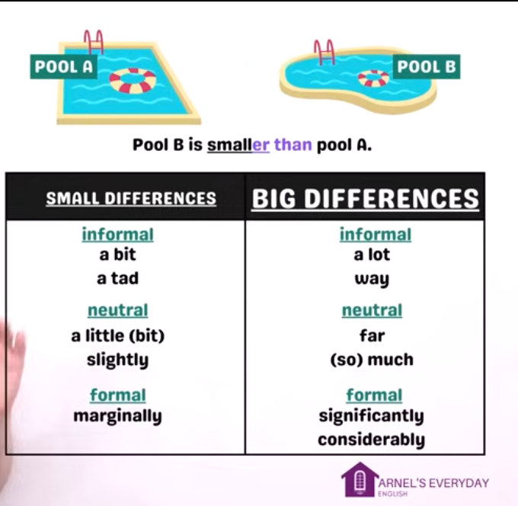
Attributive adjective and Predicate adjective

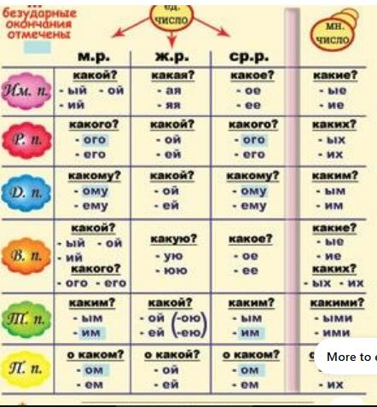

Opinion + size + physical observation + age + shape + color + origin + material + purpose + noun.

1. Descriptive Adjectives
- Describe the qualities or characteristics of a noun. Example: "The beautiful sunset." (beautiful describes the sunset.)

2. Coordinate Adjectives
- Two or more adjectives of equal importance modifying the same noun, often separated by commas or "and." Example: "The long, winding road." (long and winding are coordinate.)

3. Cumulative Adjectives
- Adjectives that build upon one another but do not require commas. The order matters! Example: "A small wooden table." (small modifies wooden table as a whole.)

4. Compound Adjectives
- Formed by combining two or more words, often linked with a hyphen. Example: "A well-known author." (well-known is a single unit modifying author.)

5. Proper Adjectives
- Derived from proper nouns and usually capitalized. Example: "The Japanese culture." (Japanese is derived from Japan.)

6. Demonstrative Adjectives
- Point to specific nouns. Examples: this, that, these, those.
  - "I like this book."

7. Distributive Adjectives
- Refer to each member of a group individually. Examples: each, every, either, neither.
  - "Each student received a prize."

8. Indefinite Adjectives
- Give a non-specific quantity or identity of a noun. Examples: some, few, many, several.
  - "There are some apples in the basket."

9. Interrogative Adjectives
- Used in questions to modify nouns. Examples: which, what, whose.
  - "Which color do you prefer?"

10. Possessive Adjectives
- Show ownership or possession. Examples: my, your, his, her, their, our, its.
  - "Is this your book?"

11. Predicate Adjectives
- Follow a linking verb and describe the subject. Example: "The cake smells delicious." (delicious describes the cake.)

12. Quantitative Adjectives
- Indicate the quantity of something (how much or how many). Examples: few, several, much, little, some.
  - "She has three pets."

13. Attributive Adjectives
- Directly modify a noun and appear before it in the sentence. Example: "A happy dog barked." (happy is an attributive adjective.)
Descriptive Adjectives | Coordinate Adjectives | Cumulative | Proper | Demonstrative | Distributive | Indefinite | Interrogative | Possessive | Predicate | Quantitative | Attributive

Adpositions

Postpositions

Circumpositions

Ambipositions

Prepositions

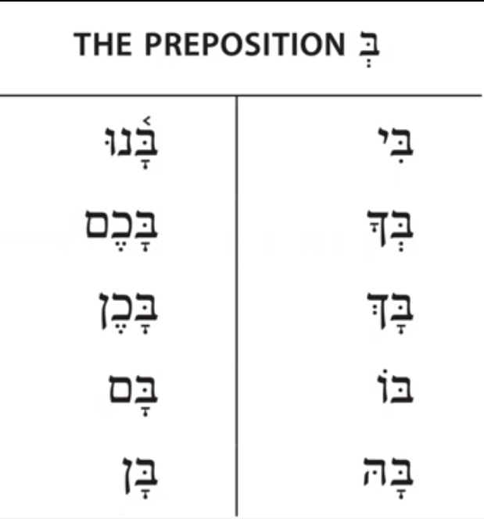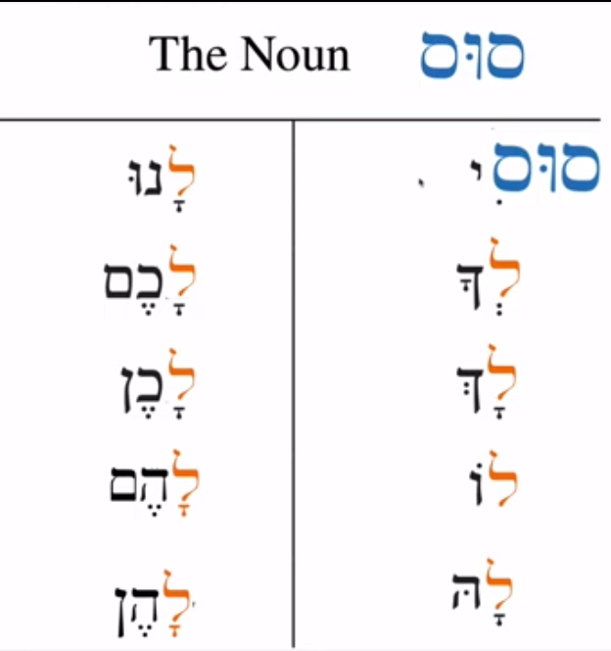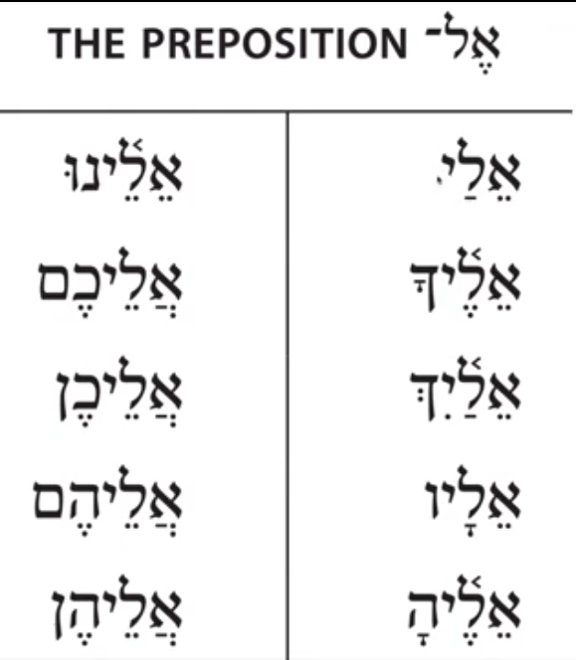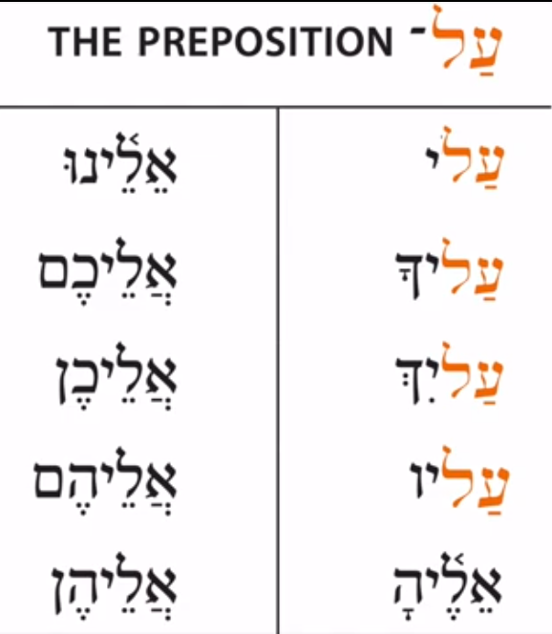

Time
Указывают, когда происходит действие.
Примеры: yesterday (вчера), soon (скоро), always (всегда).

Duration, Frequency:
Briefly: | בקצרה (B'kitzara)
Forever: | לנצח (Lanetzach)
Forever: | לתמיד (Latamid)
Always: | תמיד (Tamid)
Sometimes:
Rarely:
Never:
Ever:
Often: | לעיתים קרובות (Le'itim Krovot)
Rarely: | לעיתים נדירות (Le'itim N'dirot)

Probability
Probably: | כנראה (Kanir'eh)
Possibly: | ייתכן (Yitachen)
Certainly: | בוודאות (Bevada'ut)
Possible: | אפשרי (Efshari)
Probable: | סביר (Savir)
Likely: | סביר (Savir)
 | יש סיכוי (Yesh Sikui)
Unlikely: | לא סביר (Lo Savir)
Certain: | בטוח (Batuach) for masculine
 | בטוחה (Betucha) for feminine
Doubtful: | מוטל בספק (Mutal B'safek)

Necessary
Can: | יכול (Yachol) for masculine,
 | יכולה (Yechola) for feminine,
Could: | יכולתי (Yachalti) for masculine,
 | יכולתי (Yachalti) for feminine,
May: | ייתכן (Yitachen)
Might: | עלול (Alul) for masculine,
 | עלולה (Alula) for feminine,
Must: | חייב (Chayav) for masculine,
 | חייבת (Chaye'evet) for feminine,
Shall: | אעמוד (E'amod)
 | אעשה (E'eseh) more commonly in modern Hebrew,
Should: | כדאי (K'dai)
Will: | יהיה (Yihiye) for masculine,
 | תהיה (Tihiye) for feminine,
Would: | יהיה (Yihiye) for masculine,
 | תהיה (Tihiye) for feminine,

Location

Direction

Movement

Place
Описывают, где что-то происходит.
Примеры: here (здесь), there (там), everywhere (повсюду).

Property

Degree
Very: | מאוד (Me'od)
Quite: | די (Dai)
Almost: | כמעט (Kim'at)
Too: | יותר מדי (Yoter Midai)
Just: | בדיוק (B'diyuk)
Only: | רק (Rak)
Really: | באמת (Be'emet)
Extremely: | בצורה קיצונית (B'tzura Kitzonit)
Fully: | במלואו (Bimlo'o)
Partly: | חלקית (Chelkit)
Barely: | בקושי (Bekoshi)
Sufficiently: | מספיק (Maspik)

Color:
colorful

Sound
loud

Emotions:

Appearance:
Beautiful
tall

Personality

Proper: American, Shakespearean, Mexican.

Classifiers

Copulas

Complementazers

Conjunction.
Частицы соединяют words, phrases, clauses, sentences, paragraphs.
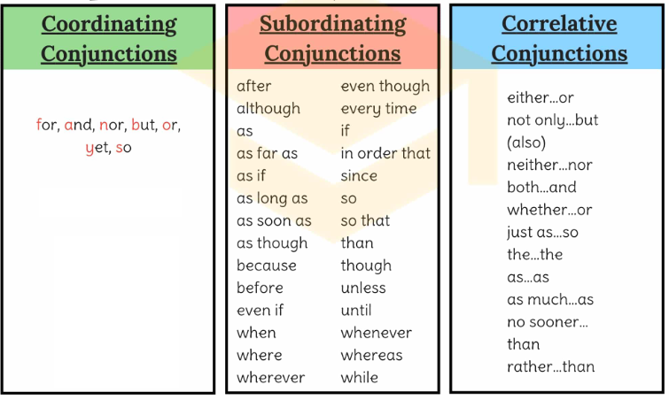
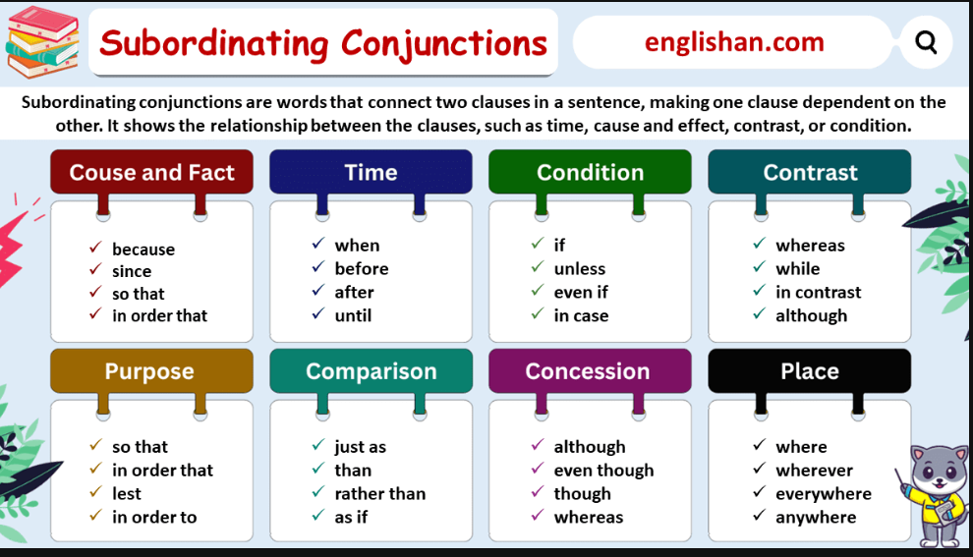

1. Глаголы-связки (всего 6 главных слов)
В русском языке чаще всего используются три типа связок:
Быть (в настоящем времени она обычно опускается: «Он [есть] врач», а в прошедшем и будущем появляется: «был врачом», «будет врачом»).
Стать / Становиться («стал взрослым»).
Являться («является примером»).
Казаться («кажется странным»).
Называться («называется вершиной»).
Считаться («считается экспертом»).

2. Частицы для членов предложения (всего 9 главных слов)
Вам пригодятся только те частицы, которые влияют на форму глагола или выделяют слова:
Для сказуемого (формы глагола): бы (б), пусть, пускай, давай, да. (Пример: «Пусть поёт», «сделал бы»).
Для отрицания: не, ни. (Пример: «не знал»).
Для точного указания (на дополнение или обстоятельство): только, лишь. (Пример: «только вчера», «лишь маме»).

Manner (how, like)
- After: Describes an action that occurs later than another action or event.
Example: After I finish my homework, I will watch TV.
Usage: Use “after” to show that one action happens subsequently to another.
- Altohough: Indicates a contrast or unexpected situation.
Example: Altohough it’s raining, we will go for a walk.
Usage: Use “although” to present a contradiction or a surprising fact compared to what’s expected.
- As: Indicates a reason or a simultaneous action.
Example: She sang as she walked home.
Usage: Use “as” to show the reason behind an action or to describe two actions happening together.
- As if: Describes something that appears true but might not be.
Example: She looked as if she had seen a ghost.
Usage: Use “as if” to describe an appearance or behavior that suggests a certain situation, even if it might not be true.
- As long as: Specifies a condition that must be fulfilled.
Example: You can go out as long as you finish your chores.
Usage: Use “as long as” to set a condition that needs to be met for something else to happen.
- As soon as: Describes something happening immediately after something else.
Example: I’ll call you as soon as I arrive.
Usage: Use “as soon as” to indicate that an action will happen immediately after another action is completed.
- As much as: Indicates the degree of likeness or comparison.
Example: I like you as much as I like her.
Usage: Use “as much as” to compare things and show an equal degree of preference, likeness, or quantity.
- Because: Gives a reason or an explanation for something.
Example: I am happy because I passed my test.
Usage: Use “because” to introduce the cause or reason behind an action or a feeling.
- Before: Describes an action happening earlier than another event.
Example: I will eat breakfast before I leave for work.
Usage: Use “before” to indicate that one action occurs prior to another action or event.
- Even if: Indicates a hypothetical situation or a possibility.
Example: Even if it rains, we will have a picnic.
Usage: Use “even if” to express that something will happen or be true despite other circumstances.
- Even though: Indicates a contrast or opposition to what might be expected.
Example: Even though it’s cold, I’ll go outside.
Usage: Use “even though” to introduce a statement that goes against what might be expected in a situation.
- If: Describes a condition that must be met for something else to happen.
Example: If it’s sunny, we’ll go to the beach.
Usage: Use “if” to present a condition that needs to be fulfilled for an action to take place.
- In order that: Expresses purpose or intention.
Example: She studied hard in order that she could pass the exam.
Usage: Use “in order that” to explain the purpose or intention behind an action.
- In case: Describes something done as a precaution.
Example: Take an umbrella in case it rains.
Usage: Use “in case” to prepare for a possible situation or eventuality.
- Insofar as: Indicates the extent to which something is true.
Example: I’ll help insofar as I can.
Usage: Use “insofar as” to express the limit or extent to which something is applicable or true.
- Now that: Indicates something happening because of a present situation.
Example: Now that she’s here, we can start.
Usage: Use “now that” to show that one action or situation causes another to occur.
- Once: Describes an action happening after a particular time or event.
Example: Once you finish your work, you can go play.
Usage: Use “once” to indicate that an action will happen after a specific event or time.
- Provided that: Specifies a condition that must be met for something else to happen.
Example: You can go, provided that you finish your homework.
Usage: Use “provided that” to set a condition that needs to be fulfilled for another action to occur.
- Since: Indicates a reason or a specific point in time.
Example: Since it’s late, we should go home.
Usage: Use “since” to introduce the reason behind an action or to refer to a specific time in the past.
- So that: Expresses purpose or intention.
Example: She studies hard so that she can get good grades.
Usage: Use “so that” to explain the reason or purpose behind an action.
- So long as: Indicates a condition that must be met.
Example: You can use my car so long as you bring it back by 5.
Usage: Use “so long as” to specify a condition that needs to be fulfilled for something else to happen.
- Supposing: Indicates a hypothetical situation.
Example: Supposing it snows, what will we do?
Usage: Use “supposing” to introduce a hypothetical scenario or situation.
- Than: Indicates comparison between things or actions.
Example: He is taller than his brother.
Usage: Use “than” to compare and show a difference in degree between two things or actions.
- That: Often introduces clauses, connecting ideas or thoughts.
Example: I know that she’s coming.
Usage: Use “that” to introduce clauses or thoughts related to the main statement.
- Though: Indicates a contrast, similar to “although”.
Example: Though it’s hot, she wears a sweater.
Usage: Use “though” to introduce a contrasting idea or situation.
- Till: Describes something happening up to a specific time.
Example: Wait here till I come back.
Usage: Use “till” to indicate the duration of an action until a specific time or event occurs.
- Unless: Indicates a condition that, if not met, has consequences.
Example: You can’t go unless you finish your homework.
Usage: Use “unless” to express a condition that needs to be met; otherwise, there will be consequences.
- Until: Describes something happening up to a specific time.
Example: I’ll wait here until you come.
Usage: Use “until” to indicate the duration of an action until a specific time or event occurs.
- When: Describes a specific time or situation.
Example: I will call you when I reach home.
Usage: Use “when” to indicate a specific time or situation in which an action will happen.
- Whenever: Describes any time or situation.
Example: Whenever he is sad, he listens to music.
Usage: Use “whenever” to indicate any time or situation in which a particular action or event occurs.
- Where: Describes a place or situation.
Example: This is where I used to live.
Usage: Use “where” to refer to a specific place or situation in which something occurs or occurred.
- Whereas: Indicates a contrast between two things.
Example: She likes tea, whereas he prefers coffee.
Usage: Use “whereas” to show a contrast or difference between two things or ideas.
- While: Indicates a contrast or something happening at the same time.
Example: She reads while he watches TV.
Usage: Use “while” to show a contrast between two actions or to describe actions happening simultaneously.
- Whichever: Indicates a choice between alternatives.
Example: Choose whichever dress you like.
Usage: Use “whichever” to present a choice between two or more alternatives.
- Who: Refers to a person.
Example: The person who called left a message.
Usage: Use “who” to refer to a person or people in a sentence.
- Whoever: Refers to any person, no matter who.
Example: Whoever wants to join can come along.
Usage: Use “whoever” to refer to any person, without specifying a particular individual.
- Whose: Indicates possession by a person.
Example: The girl whose bag was lost is upset.
Usage: Use “whose” to show possession or ownership by a person.
- Whomever: Refers to any person, as an object.
Example: Give the book to whomever you like.
Usage: Use “whomever” when referring to any person as the object of an action.
- Why: Indicates a reason for something.
Example: I don’t know why she’s upset.
Usage: Use “why” to inquire about or explain the reason behind something.
- Whether: Indicates a choice between alternatives or if something is true.
Example: I don’t know whether I should go or stay.
Usage: Use “whether” to introduce a choice between options or to express doubt about two possibilities.

Coordinating Conjunctions:
These connect words, phrases, or clauses that are equal in structure.

And (ו - "Ve")
Example: אני אוהב תפוחים וענבים. (Ani ohev tapuchim ve-anavim.)
Translation: I like apples and grapes.

But (אבל - "Aval")
Example: רציתי ללכת, אבל ירד גשם. (Ratziti lalechet, aval yarad geshem.)
Translation: I wanted to go, but it rained.

Or (או - "O")
Example: אתה רוצה תה או קפה? (Ata rotze te o kafe?)
Translation: Do you want tea or coffee?

Nor (לא... וגם לא - "Lo... Ve-gam Lo")
Example: הוא לא אוכל תפוחים וגם לא ענבים. (Hu lo ochel tapuchim ve-gam lo anavim.)
Translation: He eats neither apples nor grapes.

Yet (אך - "Ach") or (אבל - "Aval")
Example: עייפתי, אך אני ממשיך לעבוד. (Ayafeti, ach ani mamshich la'avod.)
Translation: I’m tired, yet I continue working.

So (לכן - "Lachen")
Example: ירד גשם, לכן לא יצאתי. (Yarad geshem, lachen lo yatza'ti.)
Translation: It rained, so I didn’t go out.

For (כי - "Ki") for, that, but, when, because, if, through, so that.
Example: אני אוכל כעת כי אני רעב. (Ani ochel ka'et ki ani ra'ev.)
Translation: I’m eating now, for I’m hungry.

Correlative Conjunctions:
These work in pairs to join words or phrases that have equal importance.
Example: Either you start now, or you'll miss the deadline.
include both...and,
either...or
neither...nor
not only...but also.

Subordinating Conjunctions (Subjunction):
Cause/Reason: These connect a dependent clause (subordinate clause) to an independent clause (main clause).
Example: She stayed home because she was feeling sick.
because of
due to
owing to
because
although
while
since
if
unless.

Adverbial Conjunctions:
These are used to connect independent clauses and often provide a transition between ideas.
Example: He didn’t study for the exam; therefore, he didn’t pass.
However
Therefore
Moreover
Consequently
Hence
Thus

Vav-Consecutive

Disjunctions

Interjunctions

Register: formal, informal, technical.

Pragmatics: tone, politeness, prosody, context use.

Phonology, Prosody & Linguistic–Musical Lines

Phonology.

Intonation of Melodic line.

LeitMotif.

Motif.
Like a subject with different verbs.
Мотив – это повторяющаяся тема предложения. (Как так произошло, что мы очутились здесь. Как так произошло, чтобы выйти нам отсюда.).
See document(s): Developing Motifs.mhtml
Most motifs focus on just one or two at a time.
Contain 2 to 8 notes.
Мотиф начинается за тактом и окатчивается в такте как одно целое и не делимое на слух. Имеет начало середину и конец как опорные точки. эти три точки играются громче остальных. (Цезура)

Licks.

Lick
See document(s): Writing Guitar Licks - Cyberfret.com Guitar Songwriting Lesson.mhtml

Riffs.
1. It is how you will color the chord progression in rhythm part.

Big open chords

1st position

Bends

Power chords

arpeggio

Hammer-on / Pull-off

Tapping

Altoernate picking

Sweep picking

Hybrid picking

fast legato

Modes riffing
Runs - Resolve CSus4 or C Sus2 to Cmajor
Move from Csus4 > C maj > Csus4 > C maj > Csus2 > Cmaj.
Omit the close note like FG if the stay close, use inversions.
Add notes from minor scale

Bloozy

Chuggy

Tremolo picking

string skipping

Jent

Odd time signatures

Fills.

Prosody and Melodic Phrases.
Melodic is story telling. Leaps is stress on word. “I warn YOU!” or “I WARN you!”.
Phrase is not complete idea.
See document(s): Types of Melodic Phrases - Music Composition Tutorial.mp4
*Contour - single focal point (only one most top note). make arch line of notes.
*Leaps -Conjunct vs disjunct. No augmented, 7th, no more then octave.
When you leap you step back one point back (sounds resolved to ear) or make multiple leaps then must outline your triad.
*Tendency is like gravitation pull. 7 goes to 1.

Ideas.
Idea is one or more different motives.

Etudes.
Etudes are variations of arrpegiation.

Phrase made of any combination of Motif: Presentation / Repetition / Variation / Deconstruction.

Presentation of motifs.

Repetition of motif.

Grace Tones.
Preparation-> Non-Chord-Tone->Resolution

Pedal note
note of a scale in every chord

Passing note

In/Out by step

Passing Tones
Approach by step, resolve by step in same direction. Ascending or disceding

Neighbor Tones
Approache by step, resolve by step in the opposite direction. Upper or lower. Diatonic or chromatic.

Upper neighbor

Lower Neighbor

Incomplete Neighbor

Double Passing

Out by leap, resolve by step

Appoggiatura
Approached by leap, resolved by step.
Typecally resolves in the opposite directon.
Often occurs on strong beats.
1. Melody goes up.
2. Place Appoggiature note on strong beat.
3. Appogiature note one step higher than chord note.

Suspention
Approached by common tone.
Resolves down by step.
"Changes too late"

Out by step, resolve by leap

Double Neighbor
Includes steps to both an upper and lower neighbor, connected with a leap.

Escape Tone
Approached by step, resolved by leap.
Typically resolves in the opposite direction.

In by step

Anticipation
Typecally arrpoached by step, resolves by common tone.
NCT that arrives at the next chord "too early".

Retardation
Approached by commin tone, resolves by common tone.
NCT that arrives at the next chord "too early".

Grace notes

appoggiaturas

acciaccaturas

Triplet / trill note

Slurs

Glissando

Slide

Mordent

Turn

Nachschlag

Variation of motif.
Mirroing
Invertion
Retrogration
Invertion Retrogration

Simple Melodic Variation
1. Viggle: Main note-One up one down to main.
2. Treel: Main-up-main-up-main-up

Sequence
Maintain sequence
Vary the sequence More notes
Vary the sequence Fewer notes
Discard sequence

Melodic Inversion
Retrograde

Fragmentation

Expansion & Contraction

Embellishment & Reduction

Reconstruction
Phrase length
Extend
Shorten
Maintain
Non-sequentur
Simple rhythmic variation
March
Sencopation
Dynamics
Articulation
Intonation
Expressive
Tempo
Harmony
Modulate
Multi-tonic
Re-harm
Picardy 3rd
Sequence Changing the pitches used in motif.
Real sequence Keeping the same exact intervals between your notes.
Tonal sequencing Changing the intervals slightly to fit the key you're playing in.
Instrument transposition
*Transpossed/written key to instrument key
*Clef
*Octave
*Range
Augment Stretching the notes in your motif to make them sound slower.
Dimunation Shorteing the notes in motif to make them sound faster
Expand Adding additional notes to motif.
Contract Taking notes out of motif.
Divide Dividing motif into segments and repeating them in some sort of AABB fashion.
Interval metamorphosis Changing the intervals and pitches of motif, but keeping the same rhythm.
Invert Turnig motif upside down.
Retrograde Playing motif backwards.

Repetition.

Augmentation.

Diminution.

Inversion.

Retrograde.

Sequences.
In music theory, a sequence refers to a repetition of a musical idea (usually a melody or a harmonic progression) at a different pitch level. Sequences are commonly used to provide variety and development in a piece of music. There are several types of sequences, each with its own characteristics and rules of application. Here are the main types of sequences:

1. Direct (or Exact) Sequence
In a direct (or exact) sequence, the same melodic or harmonic pattern is repeated exactly at a different pitch, with no alteration in the intervals between the notes.
Example: A sequence might involve a melody starting on C, then moving to D, E, and F, and repeating the same pattern starting on D, E, F, and G.
Characteristics:
Exact repetition.
No changes in interval relationships.
Often used in both melodies and harmonies.
Example (melodic direct sequence):

C-D-E-F → D-E-F-G → E-F-G-A → F-G-A-B

2. Modulating (or Tonal) Sequence
A modulating sequence is one in which the repeated pattern shifts to a new key or tonality. Unlike a direct sequence, the sequence involves some degree of modulation as it moves from one key to another.
Example: A melody that starts in C major and then modulations to G major while maintaining the same intervallic pattern.
Characteristics:
The intervallic structure is maintained, but the tonal center changes.
The modulation can be a smooth or abrupt shift in tonality.
Common in Classical and Baroque music, especially in development sections.
Example (harmonic modulating sequence):

C major → G major → D major → A major

3. Contrary (or Inverted) Sequence
In a contrary sequence, the direction of the pattern is reversed (i.e., the intervals are inverted). Instead of ascending or descending by a fixed interval, the direction is flipped. This type of sequence can add variety and contrast to a melody or harmonic progression.
Example: A melodic pattern like C-D-E-F (ascending) could be repeated as C-B-A-G (descending, with the intervals reversed).
Characteristics:
The pattern is inverted, meaning that ascending intervals become descending ones (and vice versa).
Involves an inversion of the original intervals.
Example (melodic contrary sequence):

C-D-E-F → B-A-G-F → A-G-F-E → G-F-E-D

4. Ascending (or Descending) Sequence
This type of sequence is defined by whether the repeated pattern moves in an ascending or descending direction. In an ascending sequence, the repeated pattern moves up in pitch, while in a descending sequence, the repeated pattern moves down in pitch.
Example: An ascending sequence might involve starting with C and ascending to D, E, F, then moving the pattern up starting from D, E, F, G.
Characteristics:
Ascending Sequence: Repetition of a pattern at a higher pitch level.
Descending Sequence: Repetition of a pattern at a lower pitch level.
Example (ascending sequence):

C-D-E-F → D-E-F-G → E-F-G-A
Example (descending sequence):

G-F-E-D → F-E-D-C → E-D-C-B

5. Harmonic (or Harmonic Progression) Sequence
A harmonic sequence involves the repetition of a chord progression at different pitch levels. This sequence may involve a simple harmonic movement that is repeated in different keys or at different chord positions.
Example: A sequence of I-IV-V-I might be repeated starting from a different chord, like starting on the IV chord and moving to the V and I in the new key.
Characteristics:
Involves repeating harmonic progressions (rather than melodic patterns).
Often used to create harmonic motion and tension.
Example (harmonic sequence):

I-IV-V-I → IV-V-I-IV → V-I-IV-V

6. Scale (or Diatonic) Sequence
A scale sequence is a form of sequence where a scale or a portion of a scale (like a diatonic scale) is repeated at different pitch levels.
Example: A portion of a scale, such as C-D-E-F, is repeated starting on D-E-F-G, and so on.
Characteristics:
Usually involves diatonic (scale-based) intervals.
Often creates smooth melodic motion through the use of scale steps.
Example (diatonic sequence):

C-D-E-F → D-E-F-G → E-F-G-A

7. Rhythmic (or Temporal) Sequence
A rhythmic sequence focuses on the repetition of a rhythmic pattern, rather than a melodic or harmonic one. This type of sequence emphasizes rhythm rather than pitch, and the pattern is repeated at different times, either in the same or different pitches.
Example: A rhythmic pattern like quarter-note, eighth-note, quarter-note is repeated, but with a slight variation in the pitches of the notes.
Characteristics:
Involves the repetition of rhythmic elements.
May or may not involve pitch changes.
Example (rhythmic sequence):

(Quarter-note, eighth-note, quarter-note) → (Eighth-note, quarter-note, eighth-note)

8. Chromatic Sequence
A chromatic sequence involves the repetition of a melodic or harmonic pattern with chromatic alterations. The pattern may ascend or descend in half-step intervals.
Example: A sequence like C-D-E-F could become C#-D#-F-G, moving chromatically up.
Characteristics:
Involves chromatic (half-step) movement.
Typically adds tension and color to the music.
Example (chromatic sequence):

C-D-E-F → C#-D#-F-G → D-E-F#-G
Conclusion
In summary, sequences are an important tool for development and variation in music. They allow composers to create unity and contrast by repeating motifs at different pitch levels, sometimes with modulations, inversions, or chromatic alterations. The most common types include direct, modulating, contrary, ascending/descending, harmonic, and chromatic sequences, each contributing to different aspects of musical form and expression.

Harmonic Sequence
This is a repetition of a series of chords.

Melodic Sequence
This is a repetition of a motif on different levels.

Tonal Sequence

Real Sequence

Mixed Sequence

Deconstruction of motif.
Intervallic Pattern of the scale
Conclude with punctuation

Phrase Groups.

Phrase Groups.
Groups of phrases that end with weak cadences H.C. or I.A.C. (Transitional or Development functions).
See attached file(s): Phrase Groups and Phrase Chains.mhtml

Cadential Phrase Groups
Are Groups of phrases that end primarily with P.A.C. (cadential function)

The Elision.
Is The cadence point of one phrase becomes the beginning of the next phrase (overlap or dovetail).
See attached file(s): The Elision.mhtml

Harmonic Phrases.
Harmony Is tension between voices.

Cadences are release of tensions.

Perfect or Authentic cadence - V - I - final landing

"!" Perfect cadence (*both chords in root position. * Soprano in scale degree 2->1 / 7->1
V–I
Both chords in root position
Tonic scale degree (1) in the highest voice of the tonic chord

"." Imperfect cadence - I-V and II-V
Root position of soprano is no in scale degree 2->1 / 7->1
one or more chords in inversion
Leading-tone is sub Viidim6 for V

Plagal cadence - IV-I -soft landing

“?” Imperfect or Half cadence *-V is question?

Interrupted or Deceptive cadences such as V-VIm and V-IV

The Picardy 3rd Cadence
A major chord at the end of piece or section of music in the minor key.
It is achieved by raising the third of the expected minor triad by a semitone.

Phrygian half iv6-V (minor key)

Andalusian - i-bVII-bVI-VorV7- (minor-major-major-major) Use harmonic minor scale for this cadance

Mediant-Supertonic-Tonic

Mediant Cadence iii-I

Phrases as Cases of parts of speech.
A phrase is a group of words that answers one question with modifiers and act as a one unit. It cannot stand alone as a sentence. : Who, Whose, Whom, Which, Where, When, How, Why, What for, How many/much,

Phrases, Verbs, Sentences & Poetics
Examples of phrases:
- Noun phrase – acts like a noun.
  - “The tall, green tree”
- Verb phrase – main verb + helping verbs.
  - “is running quickly”
- Prepositional phrase – starts with a preposition.
  - “Under the old bridge”
- Adjective or adverb phrase – modifies something.
  - “Very quickly,” “Full of hope”

Form: exact wording
Type: noun phrase, verb phrase, adjective phrase, adverb phrase, prepositional phrase, etc.
Structure: internal pattern of parts
Head: main word the phrase is built around
Modifiers: words that add detail
Function: role in the sentence
Meaning: overall sense of the phrase
Other: tense, number, definiteness, style, tone, collocation

Noun phrase: The Teacher is coming to the classroom.

Verb Phrase: She has left her puppy at home.

A Verb phrase has Typical structure in English: (modal auxilary) + (active/passive) + adverb + main verb (lemma, gerund, participle, infinitive).
Lexeme / lemma: do, go, eat.
Form:
Imperative Form: do
Past form: did
Infinitive: to do
Gerund Form: doing
Participle Form: done
Tense: past, present, future
Aspect: simple, progressive, perfect, perfect progressive, habitual, etc.
Modality: ability, obligation, possibility, certainty, permission,
Mood: indicative, imperative, subjunctive, conditional
Voice: active, passive
Agreement: person, number
Polarity: affirmative, negative
Evidentiality: source of information
Causativity: make/have/get/let constructions
Semantic roles / event structure: agent, patient, experiencer, cause, instrument, transitive, intransitive, ditransitive, causative
Intransitive VP: slept
Transitive VP: ate the cake
Ditransitive VP: gave her a book
Copular/Linking VP: is happy
Auxiliary verb group: has been working
Passive VP: was seen by many people
Modal VP: can swim

A compact way to think of it is:

lemma → form → tense/aspect/mood/voice → clause features → meaning
Examples:
can eat → modal + main verb
has eaten → perfect + main verb
is eating → progressive + main verb
has been eaten → perfect + passive + main verb
will have been working → modal + perfect + progressive + main verb

Form | Example | Notes
Base | do | dictionary form
Infinitive | to do | non-finite
Present 3sg | does | he/she/it does
Past | did | simple past
Present participle | doing | used in progressive forms
Past participle | done | used in perfect/passive forms
Imperative | do! | command
Simple present | I do | tense
Simple past | I did | tense
Future | I will do | tense/future marking
Progressive | I am doing | aspect
Past progressive | I was doing | aspect + tense
Perfect | I have done | aspect
Past perfect | I had done | aspect + tense
Future perfect | I will have done | aspect + future
Perfect progressive | I have been doing | aspect
Passive | It is done | voice
Causative | I made him do it | valency / causative construction
Modal | I can do it | modality
Negative | I do not do it | polarity
Subjunctive-like | I insist that he do it | mood

Voice (Залог)
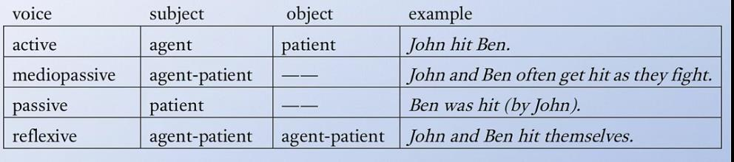

Active
Па’аль (פָּעַל) – Simple Active Voice
Пи’эль (פִּעֵל) – Intensive Active Voice
Хиф’иль (הִפְעִיל) – Causative Active Voice

Mediopassive

Passive
Ниф’аль (נִפְעַל) – Simple Passive Voice
Пу’аль (פֻּעַל) – Intensive Passive Voice
Хуф’аль (הֻפְעַל) – Causative Passive Voice

Reflexive
Хитпа’эль (הִתְפַּעֵל) – Reflexive Voice

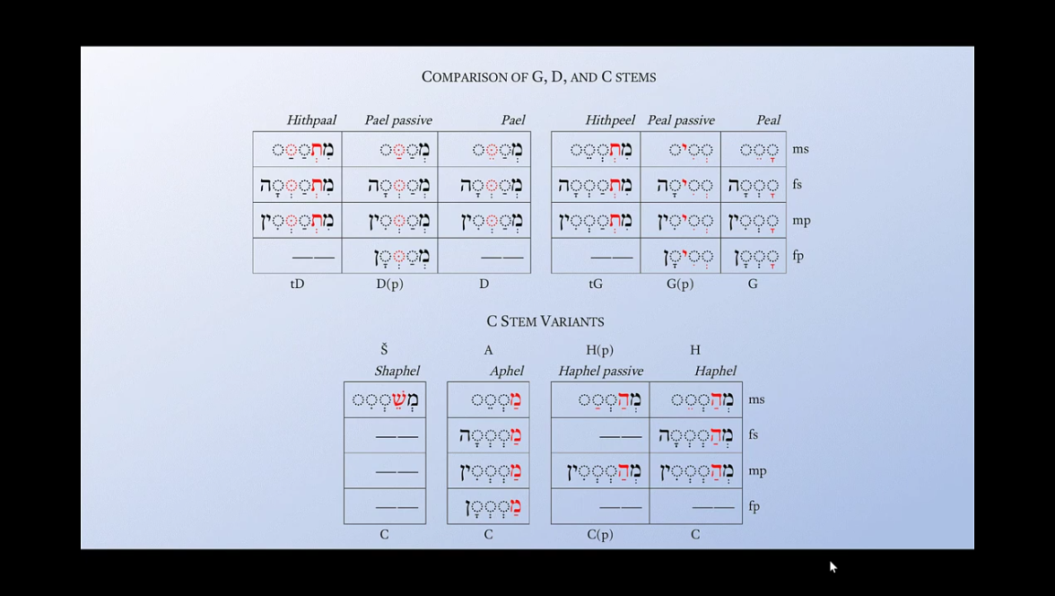

Imperative

Active Voice

State of matter.

Action.
Result
Habbit

Active intensive Voice

Passive Voice

Passive intensive Voice

Reflexive Verb Phrase.
The subject acts on itself.
She dressed herself.

Reciprocal Verb phrase.

Causative Voice Phrase.

Action done somehow.
Have(formal)/get(less formal) + something +Verb 3 (past participle)
I have my shirts ironed every week (somebody iron my shirts).

Ask / convince / persuade to do
Have(formal)/get(less formal) + someone + Verb 1 (Ask to do)
Have(formal)/get(less formal) + someone + infinitive (Convince to do)

Force to do
Make + someone + verb 1

Permission
Let + someone + verb 1

Help
Help + someone + infinitive

Verb complementation constructions:

Verbs + gerund
Admit
Anticipate
Avoid
Can’t help
Consider
Deny
Feel like
Involve
Mention
Practice
Recommend
Resume
Risk
Suggest
Understand

Verbs + infinitive
Agree
Ask
Decide
Deserve
Expect
Hope
Learn
Manage
Need
Threaten
Wait
Want
Volunteer
Offer
Plan
Promise
Refuse
Seem
Struggle

Verbs + object + infinitive
Ask
Expect
Hire
Invite
Order
Remind
Require
Teach
Tell
Urge
Warm

Verb + gerund OR infinitive
Like
Love
Hate
Prefer
Begin
Can’t bear
Can’t stand
Continue
Propose
Start
I can’t stand seeing you sad.
I can’t stand to see you sad.

Verbs + gerund OR infinitive (big change in meaning)
Remember
Forget
Try
Stop
regret

Modal Constructions:

Past modal verbs
Used to
Used to/ didn’t use to + noun/gerund
Be used to+ noun/gerund

Could + have + V3 (past possibility)
May + have + V3 (may guessing)
Might + have + V3 (I don’t have all information)
Could/might + have been + V3 (something didn’t happened)
Should + have + V3 (expectation, regret)

Present modal verbs

Can:
Expresses ability or possibility.
Example: I can swim. (ability)
Example: It can rain later. (possibility)

Could:
Expresses past ability or possibility.
Example: When I was young, I could run very fast. (past ability)
Example: We could go to the park if it stops raining. (possibility)

May:
Expresses permission or possibility.
Example: May I borrow your pen? (permission)
Example: It may snow tomorrow. (possibility)

Might:
Expresses possibility, often with less certainty than "may."
Example: She might come to the party. (possibility)

Must:
Expresses obligation or necessity.
Example: You must wear a seatbelt. (obligation)
Example: We must leave now. (necessity)

Shall:
Used to express future actions or to offer suggestions (primarily in British English).
Example: Shall we go? (suggestion)
Example: I shall return. (future action)

Should:
Expresses advice or expectation.
Example: You should see a doctor. (advice)
Example: They should arrive by now. (expectation)

Will:
Expresses future actions or willingness.
Example: I will call you tomorrow. (future action)
Example: Will you help me with this? (willingness)

Would:
Used to express a hypothetical situation or a polite request.
Example: If I had a car, I would drive to the beach. (hypothetical situation)
Example: Would you mind helping me? (polite request)

Verb phrases conjugations
Verb forms | Infinitive Bare form | Do
 | Infinitive Absolute form | To do
 | Past Participle | Done
 | Present Participle or Gerund | Doing
Imperative | Cohortative | Let me do
 | Imperative | Do
 | Jussive | Let him do
 |  |  |  | Active |  |  |  |  | Passive
Indicative | State of matter |  |  | Simple (State) | Intensive action | Perfect (Result) | Continous (Action) | Perfect Continious (Activity) | Simple (State) | Intensive action | Perfect (Result) | Continous (Action) | Perfect Continious (Activity)
 |  | Past | Single  First person Musculine / First person Feminine /  Second person Musculine / Second person Feminine / Third person Musculine / Third person Feminine / | Was /  Wasn’t / |  | Been | Being | Have being | Be being |  |  | Have be being
 |  |  | Plural form  First person Musculine / First person Feminine /  Second person Musculine / Second person Feminine / Third person Musculine / Third person Feminine / | Were / weren’t
 |  | Present | Single  First person Musculine / First person Feminine /  Second person Musculine / Second person Feminine / Third person Musculine / Third person Feminine / | Be/  Am/  Are/  Is/
Plural form
First person Musculine / First person Feminine /
Second person Musculine / Second person Feminine / Third person Musculine / Third person Feminine /
 |  | Future | Single  First person Musculine / First person Feminine /  Second person Musculine / Second person Feminine / Third person Musculine / Third person Feminine / | Will / shall
Plural form
First person Musculine / First person Feminine /
Second person Musculine / Second person Feminine / Third person Musculine / Third person Feminine /
 | Action | Past | Single  First person Musculine / First person Feminine /  Second person Musculine / Second person Feminine / Third person Musculine / Third person Feminine / | did | Did run | Did had run
 |  |  | Plural form  First person Musculine / First person Feminine /  Second person Musculine / Second person Feminine / Third person Musculine / Third person Feminine / | did
 |  | Present | Single  First person Musculine / First person Feminine /  Second person Musculine / Second person Feminine / Third person Musculine / Third person Feminine / | Do  Does | Do do | Have done | Have doing | Have been doing
 |  |  | Plural form  First person Musculine / First person Feminine /  Second person Musculine / Second person Feminine / Third person Musculine / Third person Feminine / | does |  | Has done | Has doing | Has been doing
 |  | Future | Single  First person Musculine / First person Feminine /  Second person Musculine / Second person Feminine / Third person Musculine / Third person Feminine /
Plural form
First person Musculine / First person Feminine /
Second person Musculine / Second person Feminine / Third person Musculine / Third person Feminine /
Modality | possibility | Past |  | Could |  |  |  |  | Can be / Could be
 |  |  |  | Wanted |  |  |  |  | Would be
 |  | Present |  | Can / Could |  |  |  |  | Shall be
 |  |  |  | Want / Would |  |  |  |  | Should be
 |  |  |  | Shall / Should |  |  |  |  | Must be/ Might be/ May be
 |  |  |  | Must / May /Might |  |  |  |  | be able to
 |  | Future |  | Will / would
 |  |  |  | Goint to
Causative
(Make, Have, Let, Get, help)
 | Reflexive
Conditional
Subjunctive

Prepositional phrase: The computer is placed on the table.
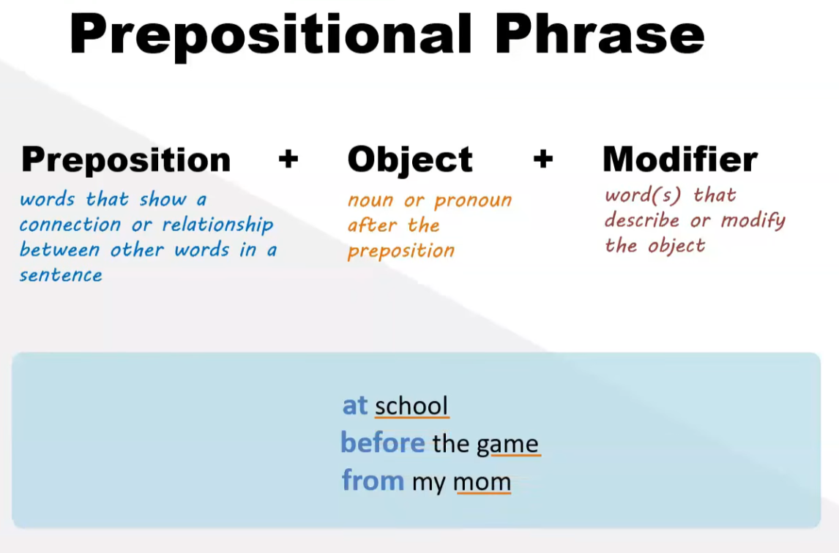
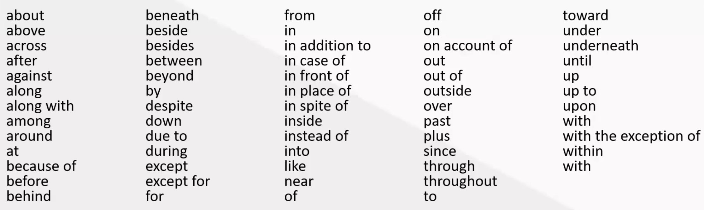

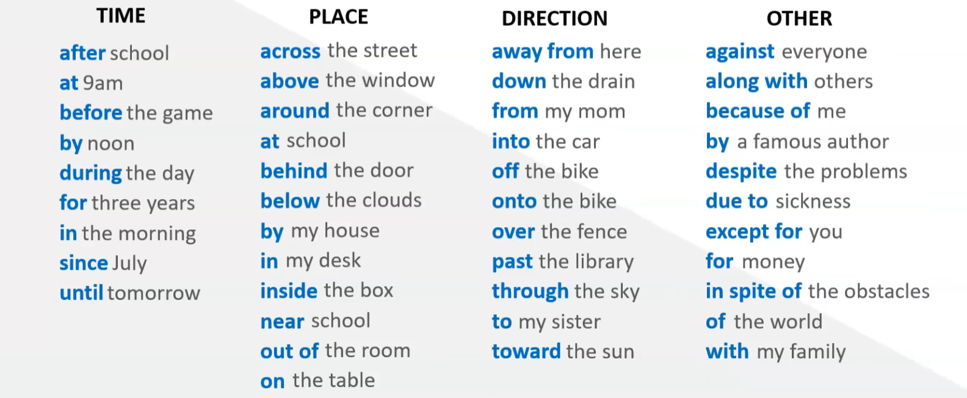

Gerund Phrase: Crawling down the stairs is dangerous.

Gerund

Gerund as noun.
(action as noun. Subject of the sentence)
-ed, -ing

Infinitive phrase: I like to crawl in the whole room.

Infinitive

Infinitive.
(action on subject, showing purpose, giving intsructions)

Bare infinitive as command.

Absolute infinitive form. (pattern O A)

Construct infinitive form.

Participle phrase: Washed nicely, the entire room is shining.

Participle

Participle.

Present Perfect

Past Perfect

Appositive Phrase: My favorite bike, Harley Davidson.

Absolute phrase: The race finished, my friend came first.

Level.

Syntax/function/question: subject, object, predicate, modifier, etc.
Syntax is the study of how words and morphemes combine to form well-formed larger units such as phrases, clauses and sentences.

Sentences.
Sentences are built from syntactic structures.
Sentence describes what actions happened in one moment of time.
Lines refer to the continuous, horizontal progression of elements over time. They create structure, meaning, and flow in both music and language.

Form: exact wording
Meaning: overall message
Type: simple, compound, complex, or compound-complex
Subtype/meaning: conditional / relative / interrogative / etc.
Function: statement, question, command, exclamation
Punctuation:
Structure: how clauses are arranged.

Clauses.
Form: exact wording
Type: independent/main clause or dependent/subordinate clause
Structure: internal pattern
Subject: who/what the clause is about
Predicate: what is said about the subject
Function: sentence role
Meaning: the idea expressed
Other: tense, finiteness, mood, voice, register

Clauses are parts of sentences.
A clause is a group of words that always has a subject and a predicate (verb). Clauses can sometimes stand alone as a sentence, or they can be part of a bigger sentence.
Types of clauses:

Independent clause – can stand alone as a sentence.
  - Example: “She runs every morning.”
    - She = subject
    - runs every morning = predicate

Dependent (subordinate) clause – cannot stand-alone; depends on another clause.
  - Example: “Because she runs every morning…”
    - Needs more to complete the thought, e.g., “…she feels energized.”

Linguistic and Poetic Lines

Semantic Line: The overarching thread of meaning and conceptual logic that runs through a text. It ensures narrative or argumentative continuity.

Semantic line – the thread of meaning across the sentence.

Rhythmic Line: The patterns of stressed and unstressed syllables in speech or verse. It creates the natural cadence, pace, and bounce of spoken language.

Rhythmic line – stress patterns, timing, flow.

Stress balance

Syllabic regularity
Big chord is most stressed syllable, silence is least stressed syllable.

Counting syllables carefully.
Line:
“the ginger fatty cat sitting on the tree”
- Count carefully: the / gin- / ger / fat- / ty / cat / sit- / ting / on / the / tree → 11 syllables, not 9.
Ah! That’s important—earlier I miscounted. So, we need 11 syllables, not 9.

Grouping over 4/4
If we phrase it over 4/4 time, a natural grouping could be (approx. 2–3 syllables per beat):
Beat | Syllables | Strong/Weak | Notes idea
1 | the gin- ger | strong-weak | chord → passing
2 | fat- ty cat | strong-weak-strong | Chord Tone → Passing Tone → CT
3 | sit- ting on | strong-weak-weak | CT → PT → PT
4 | the tree | weak-strong | PT → CT
- Strong beats → chord tones
- Weak beats → passing tones
Therefore, everything lines up with syllable count, beats, and chord/passing tone placement.

Cadance

Pause distribution.

Rhyme Line (Rhyfmic/Rhymic): The structural alignment of matching terminal sounds at the end of verses. It links poetic lines together phonetically.

Rhyming line – sound correspondences, mainly relevant in poetry.

Additional Linguistic and Dramatic Lines

Thematic Line: The recurring motif, central idea, or moral thread running through a work. It unifies different chapters or movements under one concept.

Subtextual Line: The unspoken meaning, hidden motives, or emotional truths running beneath the literal words. It dictates how actors deliver dialogue.

Syntactic Line: The structural flow of sentence complexity. It alternates short, punchy sentences with long, flowing clauses to control the reader's breath.
Syntactic line – arrangement of words into phrases, clauses and sentences. (Sentence structure).

Sentence elements.

Subject.

Verb.

Object.

Correctness of words cases (tense, number, agreement).

Types of sentences.

Simple.
Simple sentences are one independent clause.

Complex.
Complex sentences use dependent and independent clauses.

Combined.
Combined sentences are two independent clauses connected by link word.

Mixed.

Types of sentence mood.
Declaration.
Question.
Exclamation.
Command.

Types of sentences devices.

Metaphor.
Equals two different things.
Jim is a giraffe.

Simile.
Compares two different things.
Jim is as tall as a giraffe.

Onomatopoeia.
A word that sounds like what it describes.
The water went splash when I jumped into it.
The lion roared loudly.

Personification.
Assign human qualities to something that isn’t human.
The tree is dancing in the wind.
The stars winked in the night sky.

Idiom.
A group of words that have a different meaning from the literal meaning.
The exam was a piece of cake.

Alliteration.
The repetition of the same letter or sound at the beginning of the words.
The sly snake slithers slowly in the sand.

Hyperbole.
An exaggerated statement.
They were dying of laughter.

Assonance.
The repetition of the same vowel sound in a sentence.
Sam claps his hands and stamps his feet.
The rain in Spain falls mainly on the plain.

Oxymoron.
A sentence or phrase with two opposite or contradicting words.
The chair is pretty ugly.
Alex is seriously funny.

Pun.
A humorous use of words that convey another meaning.
I like kids, but I don’t think I could eat a whole one.

Grammatical Line: The syntactic structure and rules governing word order. It forms cohesive clauses and sentences to make text readable.
Grammatical line – rule-governed linguistic structure (often encompassing morphology and syntax).

Sentences Mood constructions:
Main phrase / subjunctive phrase.
Наклонение (mood) – это грамматическая категория, которая указывает на отношение говорящего к действию, выражаемому глаголом.

Члены предложения.

Главные члены предложения.

Подлежащее — о ком или о чём говорится в предложении. Отвечает на вопросы Кто? Что? Подчёркивается одной чертой.

Сказуемое — что говорится о подлежащем. Отвечает на вопросы Что делает? Каков он? Подчёркивается двумя чертами.

Второстепенные члены предложения.

Дополнение — предмет, на который направлено действие. Отвечает на вопросы косвенных падежей (Кого? Чего? Кому? Чему? и т.д.). Подчёркивается пунктиром (- - -).

Обстоятельство — место, время, причина или способ действия. Отвечает на вопросы Где? Когда? Куда? Как? Зачем? Подчёркивается пунктиром с точкой (_._._).

Как отделять члены предложения (взаимосвязь)
Чтобы найти и отделить один член предложения от другого, нужно задавать вопросы от главных слов к зависимым.
Подлежащее и сказуемое связаны друг с другом: Мальчик (что делает?) бежит.
Дополнение зависит от сказуемого: Бежит (куда? во что?) в школу (обстоятельство) или читает (что?) книгу (дополнение).
Обстоятельство зависит от сказуемого: Бежит (как?) быстро.

Когда между ними всё-таки ставятся запятые
Обычные члены предложения (подлежащее, сказуемое, дополнение, обстоятельство) запятыми не разделяются. Запятая ставится только в трёх случаях:
Однородные члены: если в предложении несколько одинаковых членов. «Он купил (что?) книгу, ручку и тетрадь» (однородные дополнения).
Обособленные члены: если обстоятельство или определение выражено особым оборотом. «Бегая по двору, мальчик громко смеялся» (обстоятельство выражено деепричастным оборотом).
Сложные предложения: если в тексте несколько грамматических основ. «Мальчик бежит, а девочка идёт».

Конструкции предложений

1. Определение типа предложения
- Утвердительное: "Я читаю книгу."

Indicative Mood
Изъявительное/Утвердительное наклонение используется для описания реальных событий, фактов и действий.
Примеры:
Русский: Он читает книгу.
Английский: She is reading a book.

Question Mood.
- Вопросительное: "Ты читаешь книгу?"

Cleft sentences.
It sentences
Wh- sentences
All sentences

Inversion Mood.
Little did I know.

Negation Mood.
- Отрицательное: "Я не читаю книгу."

Volitional Mood

Imperative Mood Повелительное наклонение
используется для выражения команд, просьб или запретов. Примеры:
Русский: Читай книгу!
Английский: Read the book!

Прямая команда (Direct command): Направлена непосредственно к собеседнику. Например, "Сделай это."
- Побудительное: "Читай книгу!"

Непрямая команда (Indirect command): Используется в косвенной речи или обращении к группе людей через третье лицо. Например, "Он сказал, чтобы вы сделали это."

Formal mood.
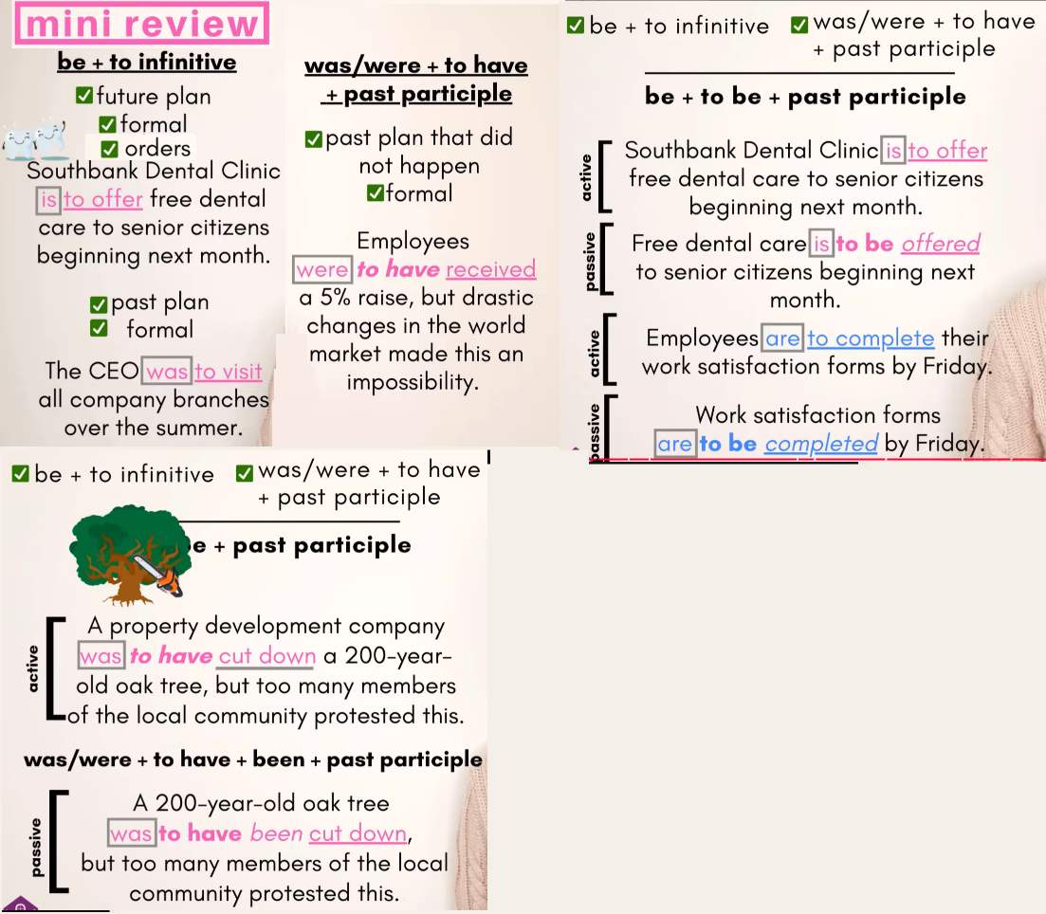

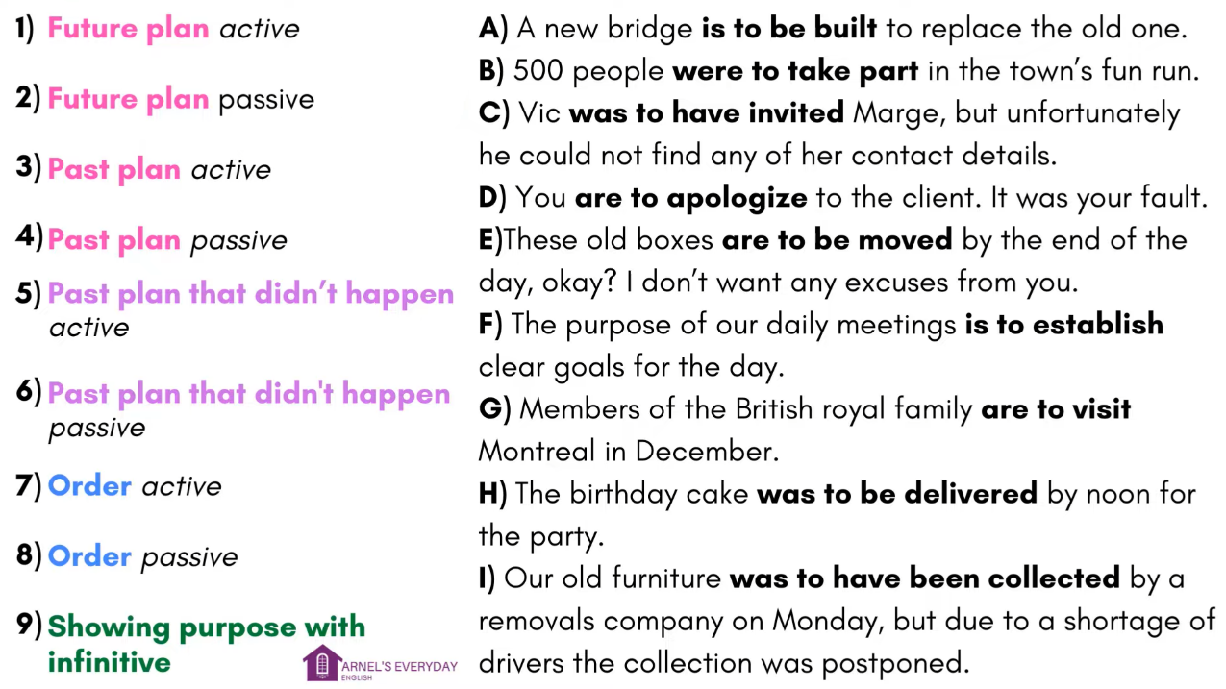

Conditional Mood Условное наклонение
выражает действия, которые могут произойти при выполнении определённых условий. "would," "could," or "might." Примеры: Русский: Если бы у меня было время, я бы поехал в отпуск. Английский: If I had time, I would go on vacation.

0. Wish/If Only
These structures are used to express regrets or wishes about the present or past.
Present wish: "I wish I were taller."
Past wish: "If only I had studied harder."

0. Conditional Conjunctions
Conditional conjunctions are words used to introduce conditional clauses. These include "if," "unless," "provided that," "as long as," "on condition that," and more.
"You can come to the party if you finish your homework."
"I'll go for a walk unless it rains."

1. Zero Conditionals
Zero conditionals are used to express general truths or facts. The structure is: If + present simple, present simple.
"If you heat water to 100°C, it boils."

2. First Conditionals
First conditionals are used for real or likely situations in the future. The structure is: If + present simple, will + base verb.
"If it rains, I will stay home."

3. Second Conditionals
Second conditionals are used for hypothetical or unlikely situations in the present or future. The structure is: If + past simple, would + base verb.
"If I were rich, I would travel the world."

4. Third Conditionals
Third conditionals are used for hypothetical situations in the past that did not happen. The structure is: If + past perfect, would have + past participle.
"If I had known about the meeting, I would have attended."

5. Mixed Conditionals
Mixed conditionals are used to describe situations where the time in the "if" clause is different from the time in the main clause.
"If I had studied harder (past), I would be more confident now (present)."

6. Inverted Conditionals
Inverted conditionals use inversion to create a more formal or literary tone.
"Had I known about the traffic, I would have left earlier."
"Were I in your position, I would do the same."

Jussive Mood (просьба)
используется для мягкого выражения просьб или инструкций в третьем лице. Формально совпадает с будущим временем, но смысл определяется контекстом.
Пример: יָבוֹא (yavo) — "Пусть он придёт."

Emphatic Mood (неизбежность)
Для усиления действия использоваться инфинитив абсолют или повторение глагола. Это подчёркивает необходимость или неизбежность действия.
Пример: אָכוֹל תֹּאכַל (achol to'chal) — "Ты обязательно будешь есть!"

Cohortative Mood (Намерения, желания, просьба)
используется для выражения намерения, желания или мягкой просьбы. Обычно используется в первом лице и выражается при помощи будущего времени с добавлением частички נָא (на) для придания оттенка вежливости.
Пример: אֵלֵכָה נָא (elecha na) — "Я пойду, пожалуйста."

Subjunctive Mood (when you want something from others)
Object + verb + that + subject + sub.ver(be absolute infinitive)
Object + adjective + that + subject + sub.ver(be absolute infinitive)

Suggest
Recommend
Insist
Ask
Request
Demand
Command
Order
Propose

Potential Mood Потенциальное наклонение
указывает на возможность или вероятность действия. В некоторых языках это может быть выражено особыми формами или конструкциями. Примеры: Латинский: possim (я могу).

сомнительных действий
Maybe, should / ought to, would, perhaps + absolute infinitive.

Использование модальных глаголов:
В русском языке: "может быть", "возможно", "вероятно". Пример: "Он, возможно, придёт на встречу."
В английском языке: "might", "may", "could". Пример: "He might come to the meeting."

Использование наречий сомнения:
В русском языке: "возможно", "наверное", "видимо". Пример: "Видимо, он заблудился."
В английском языке: "probably", "possibly", "apparently". Пример: "Apparently, he got lost."

Planing Moods.

Past plans
Was/were + infinitive (past official). The CEO was to visit all company branches over the summer.
Was/were + to infinitive (plan did happened). A property development company was to cut down a 200-year-old oak tree.
Was/were + to have + past participle (plan did not happened, official, active). A company was to have cut down a 200-year-old oak tree, but too many members of the local community protested this.
Was/were + to have + been + past participle (passive voice) A 200-year-old oak tree was to have been cut down, but too many members of the local community protested this.

Future plans
Be + gerund + infinitive (future plans). New students are going to meet their teachers next week.
Be + infinitive (official mood, orders, active) New students are to meet their teachers next week.
Be + infinitive (official news) The president’s convoy is to pass thought Richmond Avenue at noon tomorrow.
Be + gerund + infinitive (less official) The president’s convoy is going to pass thought Richmond Avenue at noon tomorrow.
Be + infinitive (active voice) Southbank Dental Clinic is to offer free dental care to senior citizens beginning next month.
Be + to be + past participle (Passive voice of plan). Southbank Dental Clinic is to be offered to senior citizens beginning next month.

Future plan active. Members of British royal family are to visit Montreal in December.
Future plan passive. A new bridge is to be built to replace the old one.
Past plan active. 500 people were to take part in the town’s fun run.
Past plan passive. The birthday cake was to be delivered by noon for the party.
Past plan that didn’t happen active. Vic was to have invited Marge, but unfortunately, he could not find any of her contact details.
Past plan that didn’t happen passive. Our old furniture was to have been collected by a removals company, but due to a shortage of drivers the collection was postponed.
Order active. You are to apologize to the client. It was your fault.
Order passive. These old boxes are to be moved by the end of the day, ok? I don’t want any excuses from you.
Showing purpose with infinitive. The purpose of our daily meeting is to establish clear goals for the day.

Inversion or inverted sentence. (Object Subject)
Advervial + auxiliary word + subject + main verb!
Adverbial:
- Rarely
Seldom
- At no time
Not once
- No sooner…then
Hardly…when
Scarcely…when
Barely…when
- On no account
Under no circumstances
- Not only…but
- Only then
Only later
Only in + place / season
- Not until
Not since
Only after
Only when

Inversions with conditionals

2. Составление простого предложения
Простое предложение состоит из:
- Субъекта (кто делает действие): "Я", "Он", "Они".
- Сказуемого (действие или состояние): "читаю", "говорит", "сидят".
- Дополнительно могут быть дополнения или обстоятельства: "в саду", "книгу".
Пример: "Кот спит на диване."

3. Расширение с помощью второстепенных членов
Дополняем предложение деталями, такими как:
- Объект: "Он написал письмо."
- Обстоятельство: "Она гуляет утром в парке."
- Определение: "Красивая девушка поёт песню."

4. Использование союзов для сложных предложений
Чтобы строить сложные конструкции, используются союзы:
- Сложносочинённое предложение: Соединяет равные части (и, но, или, а). Пример: "Солнце светит, но ветер холодный."
- Сложноподчинённое предложение: Имеет главное и зависимое предложение (потому что, если, когда). Пример: "Я останусь дома, потому что идёт дождь."

5. Уточнение смысла и стиля
Предложения можно сделать более выразительными с помощью:
- Эпитетов: "Тёплый весенний вечер был незабываем."
- Инверсии: "На столе лежала книга."
- Интонации: "Какая прекрасная погода!"

Other Notable Lines

Visual line – the imagery evoked as the sentence unfolds.

Graphic / Structural Line (Typography): The literal physical or visual row of text on a page. It forces the eye to track from left to right.

Intonation Line (Phonetics): The rise and fall of pitch in spoken voice. It alters the meaning or emotional tone of a sentence without changing the words.

Alliterative line.
Alliterative line – repetition of initial sounds.

Phonological line.
Phonological line – sound patterns and systems within a language.

Phonetic line.
Phonetic line – physical speech sounds articulation, acoustics, and perception.

Phonetic line – the sound quality, alliteration, assonance, consonance.

Polyphonic / Contrapuntal Line: Independent musical voices playing simultaneously. They weave together to create complex, multi-layered textures.

Narrative Line (Plotline): The chronological or logical sequence of events in a story. It drives the arc from introduction to resolution.
Tension Line: The gradual buildup and release of emotional or structural anxiety. In music, it uses dissonance moving to consonance. In literature, it builds suspense toward a climax.
Dynamic Line: The trajectory of volume, intensity, and power. In music, it maps the shifts between piano (soft) and forte (loud). In writing, it governs the energy level of a scene.

Musical Lines

Prosodic line.

Prosodic line.
Prosodic line – stress, rhythm, intonation, timing, pauses.
Scales belong to intonation.

Stress.

Rhythm.

Intonation.
Inflection.

Timing.

Pauses.

Dynamic.
The volume and intensity of noise, showing contrasts between loud and soft.
Dynamics – how loud/quiet the noise is (either the overall sound or of individual notes/instruments within it)

Sound intensity
alarms intense by association.

Adaptive audio.
Define when each instrument is playing.
1.Event=> React with sound.
2.Event=>Game variable=>Replace or modify sound=> React with sound.
3.Event=>Game variable X=>Replace or modify sound=>Variable Y=> Change X, change tempo=> React with sound.
Reactive
input-sensitive

Energy

Loudness.

Tension line.
Stables tones to Tension tones to Release/Cadences tones.
In circle of fifth moving right creates tension and moving left resolve tension.

Melodic Line: The sequential succession of single pitches that the listener perceives as a single entity. It represents the horizontal aspect of music (the tune).

Melodic line – intonation and pitch movement in speech.

Stepwise vs. Leap Motion of melody.

Leaps

Conjunctions.

Disjunctions.

Balance leap with step back.

Rising-falling contour balance

Closure intonation

Emotional pitch consistency

Melodic line Stable tones are the pitches that form the scale

1st Stable tone is Tonic
Those that suggest finality

2nd Stable tone is Dominant
Those that suggest a temporary repose

3rd Stable tone is Mediant
Those that suggest a temporary repose

Other are not stable
Those that suggest continuation

Summary Map
Theory | Core Principle | Type of Relation | Example
Tonal | Functional hierarchy | Circle of fifths | I–IV–V–I
Bartók / Axis | Symmetry | Minor-third cycles | C–E–A♭
Neo-Riemannian | Minimal voice motion | Triadic transformations | C–A♭–E–C
Set Theory | Pitch-class structure | Intervallic similarity | (0,1,4) = minor triad
Serialism | Ordered pitch series | Transformations | P, R, I, RI
Modal | Scalar color | Stepwise & modal | Dorian → Mixolydian
Spectral | Acoustic resonance | Frequency ratios | Overtone-based
Jazz Tonal | Modal + functional blend | Chord–scale relationships | Lydian dominant, etc.

Melodic line.
Melodic line – pitch contours and intonational movement.

Harmonic line.
Harmonic line – relationships among simultaneous tones.

Harmonic Line: The progression of underlying chord structures or voices (like a bass line) that support the melody. It establishes the piece's tonal center.
See attached file(s): Cadences Table.png, Cadences Table1.png, Cadences Table2.gif
The cadence is an element of the syntactic structure and occurs after the dynamic harmony of the closing section. In tonal music, it is usually composed of chord V followed by chord I. These chords in turn can be further elaborated by appoggiatura chords or static harmony.
Authentic cadence - V - I - final landing
Perfect cadence (*both chords in root position. * soprano in scale degry 2->1 / 7->1
Imperfect cadence - I-V and II-V (*root position inverted
Deceptive cadences such as V-VIm and V-IV
Half cadence
Plagal cadence - IV-I -soft landing
Interrupted (Deceptive)
Andalusian - i-bVII-bVI-VorV7- (minor-major-major-major) Use harmonic minor scale for this cadance
Cadance is the ending of hole story.
Each chord is the question (if goes up the scale) and answer (if goes down the scael).

Summary of Functional Groups.
Function Type | Common Roots | Example in C Major
Tonic | C, A (vi) | Cmaj7, Am7
Pre-dominant | D, F, D♭, A♭ | Dm7, Fmaj7, D♭maj7 (N⁷)
Dominant | G, B, F# | G7, B7, F#7
Borrowed / Modal | ♭III (E♭), ♭VI (A♭), ♭VII (B♭), iv (F minor) | E♭maj7, A♭maj7, B♭maj7, Fm7
See document(s): Linear Progressions.mhtml, Chord Progressions in Musical Phrases.mhtml
Patterns
T-T
T-D
T-Pd-D
D-T-D
D-D

Major & Minor Triads Built on Each Note (C Major Context)
Root | Major Chord | Function | Minor Chord | Function
C | C major (I) | Tonic | C minor (i, modal) | Borrowed
C#/D♭ | D♭ major (♭II, Neapolitan) | Pre-dominant | C# minor (vii/ii or chromatic) | Secondary
D | D major (V/V) | Secondary dominant | D minor (ii) | Pre-dominant
D#/E♭ | E♭ major (♭III) | Borrowed | D# minor (rare) | Chromatic
E | E major (V/vi) | Secondary dominant | E minor (iii) | Mediant
F | F major (IV) | Subdominant | F minor (iv, borrowed) | Modal mixture
F#/G♭ | F# major (V/V/V) | Secondary dominant | F# minor (vii/V) | Chromatic
G | G major (V) | Dominant | G minor (v, modal) | Borrowed
G#/A♭ | A♭ major (♭VI) | Borrowed / pre-dominant | G# minor (vii/vi) | Chromatic
A | A major (V/ii) | Secondary dominant | A minor (vi) | Submediant
A#/B♭ | B♭ major (♭VII) | Borrowed / Mixolydian | A# minor (rare) | Chromatic
B | B major (V/iii) | Secondary dominant | B minor (vii of V) | Chromatic

Bartók / Axis System (Symmetrical Harmony) (20th century)
Founders: Béla Bartók, Ernő Lendvai
Main idea: Symmetry replaces hierarchy — notes/chords are related by minor thirds and tritones.
Key features:
- 12-tone universe divided into 4 axes (each with 3 pitches)
- C–E–A♭ as tonic equivalents (axis of symmetry)
- Opposite axes form polar relationships
- Used for modal, folk, and symmetrical compositions
Used by: Bartók, Kodály, Stravinsky (sometimes), modern film composers

Chords Functions Bartok "Pitch axis theory”.

🎼 In Traditional Tonal Theory
In common-practice tonal harmony (Bach, Mozart, Chopin, etc.):
- The Tonic Family includes C major, A minor, E♭ major, F# diminished, etc.
- These are “close” to C because they share many common tones or appear naturally in its key system.
For example:
Chord | Relationship to C | Why “close”
A minor (vi) | Relative minor | Shares 2 tones (C, E)
E♭ major (♭III) | Borrowed mediant | Shares 1 tone (G)
F#° (vii°/V) | Secondary leading tone | Half-step voice-leading
F major (IV) | Subdominant | Shares 2 tones (C, A)
So yes — in tonal theory, these are functionally close because of the circle of fifths and common tones.

🎡 In Bartók’s Axis System
Bartók replaces the hierarchical tonic–dominant–subdominant model with symmetry around a central pitch.
His system groups notes into axes spaced by minor thirds (a symmetrical division of the octave).

The “Tonic Axis” (for C)
C – E – A♭
These three are equal tonic substitutes — not “borrowed” or “secondary,” but structurally equivalent.
- C major/minor → central tonic
- E major/minor → bright variant (chromatic mediant)
- A♭ major/minor → dark variant (borrowed mediant)
They form a triangle of tonic function — all equally stable in Bartók’s symmetrical world.
In Bartók’s system, C, E, A♭ are close and tonic-functionally related.

⚙️ How They Compare
Concept | Tonal Theory | Bartók’s Axis Theory
Organization | Circle of Fifths | Circle of Minor Thirds
Tonic Relatives | C, A, E♭, F# | C, E, A♭
Basis of Closeness | Shared tones, fifth relations | Symmetry (minor-third cycles)
Function | Hierarchical (I–IV–V) | Polar (axis pairs)
Cadence goal | Resolution (V → I) | Balance between axes

🧩 Visualizing It
If we draw it as a “wheel” of minor-thirds:
C – E – A♭ – (back to C)
That’s Bartók’s tonic symmetry.
In tonal terms, that same motion (C → E → A♭) would sound like chromatic mediant progressions — colorful, distant, yet smooth.

🎯 Summary
Theory | Tonic-like Centers Around C
Tonal (Functional) | C, A, E♭, F# (based on circle of fifths & relative keys)
Bartók (Symmetrical) | C, E, A♭ (based on axis symmetry & equal spacing)
Both describe “closeness,” but they define it in different dimensions:
- Tonal = harmonic gravity (resolution)
- Bartók = geometric symmetry (balance)

Harmonic Flowchart in Major

Harmonic Flowchart in Minor

Chords Progressions Syntactic Structure.

Emotional line – the emotional arc or intensity across the sentence, effects.

Consistent mood.

Controlled emotional contrast

Resolution of tension.

Rhythmic line.
Rhythmic line – temporal patterning and beat structure.

Rhythmic Line: The organized pattern of durations, accents, and silences over time. It dictates the groove, pulse, and tempo without needing pitch.

Rhyme line.
Rhyme line – rhyme schemes, sound correspondences, end-rhymes, internal rhymes.

Rhyme line.

Разноударная
Разноударная рифма — это рифма, в которой ударение в рифмующихся словах падает на разные слоги.
Такая рифма считается менее точной, чем одноударная.
📌 Пример:
Я слышу шум — в нём голоса,
И он скользи́т сквозь небеса...
– «слы́шу» и «скользи́т» — ударение на разных слогах → разноударная рифма.

Консонансная
Консонансная рифма (от лат. consonare — "звучать вместе") — это вид рифмы, при которой совпадают только согласные звуки в конце слов, а гласные могут различаться.
📌 Пример:
Крик раздался вдруг,
С ветром в дальний луг.
– «вдруг» / «луг» — гласные разные ([у]/[у]), но согласные в финале совпадают: [г] — это консонанс.
Консонанс может использоваться и внутри строки как звуковой приём для усиления звучности, особенно в поэзии.

Йотированная
Йотированная рифма — это рифма, в которой используется йотированный гласный (то есть гласный, начинающийся с [й]: я, е, ё, ю, и), особенно в качестве повторяющегося элемента.
📌 Пример йотированной рифмы:
Я жду тебя у мая,
Где в небе светит яркая звезда...
— повтор йотированных звуков [йа], [йу] и т.п.
Также это может относиться к рифмам, где происходит игра на сочетании звуков с начальным [й].

Ассонансная
Ассонансная рифма (от лат. assonare — "созвучать") — это рифма, в которой совпадают гласные звуки, а согласные могут отличаться.
📌 Пример:
Лето — светом
Где-то — это
Здесь повторяются гласные [е], [о], [а], и создаётся звучание, основанное на гласных — это и есть ассонанс.
Ассонанс часто используется в поэзии как средство мягкой рифмы или музыкальности.

Textural Line: The changing density of a piece over time. It tracks how a song moves from a single instrument to a massive, multi-layered wall of sound.

Timbral Line: The progression and morphing of sound color. An example is a musical phrase that starts on a warm cello and seamlessly transitions to a bright trumpet.

Bass Line: The lowest melodic line in a piece of music. It drives the rhythm and provides the foundational harmonic framework for all other voices.

Level.

Paragraphs.
Paragraph is a collection of sentences about one period of time or Object description, sequentially connected.
Paragraph has complete “period of time” with any number of cadences and ends with perfect cadence.
Each Paragraph (or section) consist of Theme and its variations of theme.
Элементы абзаца — это его составные части, которые помогают структурировать текст и донести мысль автора. Каждый абзац должен быть логически завершённой единицей, содержащей определённую идею или тему. Вот основные элементы абзаца:

1. Тема
- Каждому абзацу соответствует основная идея или тема, вокруг которой строится его содержание. Она задаёт цель абзаца.
- Обычно тема выражается в тезисном предложении, которое вводит ключевую мысль. Пример: "Чтение книг помогает развивать воображение и мышление."

2. Развитие мысли
- Это основная часть абзаца, где автор раскрывает тему с помощью объяснений, примеров, описаний или аргументов.
- Включает доказательства, факты, сравнения или пояснения. Пример: "Читая произведения классической литературы, человек сталкивается с богатым языком, сложными персонажами и глубокими моральными вопросами, что помогает ему лучше понимать мир."

3. Переходное или заключительное предложение
- Завершает абзац, подводя итог изложенному. Иногда оно связывает текущий абзац с последующим, создавая плавный переход между идеями. Пример: "Таким образом, чтение — это важный инструмент для личностного роста."

4. Ясность и логика
- Все предложения в абзаце должны быть связаны друг с другом, логически следовать одно из другого.
- Избегайте избыточных и отвлечённых предложений, чтобы читатель не терялся в тексте.

Пример абзаца:
Тезис: "Правильное питание — залог здоровья человека."
Развитие: "Употребление свежих фруктов и овощей снабжает организм необходимыми витаминами и минералами. Белки в рационе укрепляют мышцы, а здоровые жиры помогают работе мозга. Избегая излишнего потребления сахара и соли, человек может снизить риск многих заболеваний."
Заключение: “Следовательно, сбалансированная диета играет решающую роль в поддержании здоровья и энергичности."

Advanced Harmony, Voice Leading & Counterpoint

Periods.
Period is the Dialogue in one Key.
See document(s): Summary of Phrases in Combination.mhtml

Anscendent phrase -> Conssequent phrase.

Anscendent phrase (Section 1)

Question: Basic idea/Motive (2 measures)

Tonic prolongation

Define the heist and the lowest note of melody.

Answer: Contrasting idea (2 measures) with any weak cadence.

Consequent phrase (Section 2)

Question repeated: Basic idea/Motive (2 measures)

Tonic prolongation

Climax of the melody

Answer: Contrasting idea / Conclusion (2 measures) with strong (PAC) cadence.

Period Types.

The Compound Period The first phrase (the antecedent) ends with a half cadence: The Imperfect Authentic Cadence The second phrase (the consequent) ends with a stronger cadence: The perfect authentic cadence.

The Parallel period A period in which the two phrases at least begin with the same or similar material.

The Cadential extension. The addition of musical material beyond the point at which a cadence is expected.

Parallel interrupted period Basic Idea/Motive->Answer/Contrasting IdeaHC to Basic Idea/Motive Repeated->Conclusion/Cadential Progression PAC

Similar Period Basic Idea/Motive->Answer IAC to Basic Idea/Motive up a 3rd->Conclusion/Cadence PAC

Contrasting Period Basic Idea/Motive->Answer Half cadence to Contrasting idea/Motive->Conclusion/Cadence PAC

The Asymmetrical period Consequent phrases are often longer than antecedent. Sometimes expanded from middle / end of Consequent.
Asymmetrical periods consist of three or five phrases. In an asymmetrical period, there will be an unequal number of antecedents and consequents, hence the “asymmetry.”

Cadence evasion: Expected tonic triad is withheld or undermined.

Cadencial extension: Music following evasion. resumes push toward closure.

The symmetric period A period in which the phrases are the same length.

The Double Period Consists of two sentences. Phrase I (a) IAC Phrase II (b) HC Phrase III (a') IAC Phrase 4 (b') PAC
See attached file(s): The Double Period.mhtml

Modulating Period Antecedent Phrase IAC in FM to Consequent Phrase PAC in CM

Tree-phrase period Phrase I (a) HC Phrase II (a') HC Phrase III (b) PAC

Modulation
Modulation is a key change and used for separation of one period from another.
Modulation
Tonicization versus Modulation
Key Relationships
Modulations with Diatonic Pivot Chords
How to Recognize a Key After a Modulation
Modulations with Chromatic Pivot Chords
Modulations Without Pivot Chords

Harmonic Modulation
If both keys have common chords.

1. Chord progression made of Scale Mode's chords.
2. Chord Progression moves from "Characteristic chord" to "Home chord".

Tonic-to-Tonic
See document(s): Tonic to Tonic Modulation.mhtml

In Dynamic Harmony
See document(s): Modulation using Dynamic Harmony.mhtml

Using Diatonic Chords

1. Pivot chords: in both keys. 2. Cadence: affirms a new key: IV-V7-I or IIm-V7-I.

Using Chromatic Chords
See document(s): Modulation using Chromatic Chords.mhtml

Near/Parallel Key Modulation

Common-Chord

Through Diminished / Augmented chord modulation.

Remote Modulation.

Moderately distant Modulation.

Sequential modulation.

Phrase Modulation/Abrupt Modulation Sudden change at verse or chorus.

One-step up in final chorus.

Chromatic mediant (disney songs)

No suspention

E+ to C

with suspention

E+to E to C

Common tone / Enharmonic Modulation
If no common chords.

The V7 and Ger+6 as Pivot Chords

The Fully Diminished Seventh as Pivot Chord

Neapolitan sixth chord or Tritone modulation

altered scale

Dissonant chords

Deceptive cadences

Direct / phrase modulation

Sequantial modulation / rosalia

Chain modulation

Dialogs.

Harmony of Voices Leading.

Voices leading.
See document(s): I_Dubovskiy_-_Uchebnik_Garmonii.pdf, Voice leading rules.pdf
Harmony – the relationship between 2 or more simultaneously sounding notes.
Modal - modes has no gravity. They are note resolve the progression to tonic. All chords are equal. Avoid the dominante chords and tritone as the resolve to tonic. Play the characteristic note for the mode. Use the tonic repeatedly so the ear used to this tonic. Don't use too many chords. Pedal tone is the best.
Diatonic harmony is Tonal, describes the use of notes that belong to the major/minor key being used. A piece that is strictly diatonic will have no accidentals at any point.
Chromatic harmony is Polytonality, defined as harmony which uses notes that do not belong to the major/minor key being used at any given time. The use of such chromatic notes is a crucial tool for changing key. (Bebop scale)
Dissonant harmony (also known as discord or dissonance) , Atonal describes a chord or interval that is “restless” or “disturbing” to the ear – it sounds like it needs to move on to another chord/interval to be resolved to a concord (or consonance).(Bitonality/Polytonality/Atonality).
Both melodic and harmonic scales provide coherent frameworks that enable you to write of infinite variety without sacrificing unity. Ultimately, that's why songwriters and composers use scales of any description, melodic or harmonic.

The Circle of Fifths does not work as a chord progression device. That's the job of the harmonic scale-which also happens to be circular in shape, but has no function relationship with the Circle of Fifths.

Tonal chord are stable. other notes wants to be resolve. That's why music has to be resolve to tonic. As D, F, A, B. are not stable and pulls to tonic.

*Complete chord
*Double the root in root position for better clarity
Do not double leading tone or 7th of chord
*Every chord needs a root and a third for better clarity
Normaly each chord will include all members(complete), but the fifth can be omitted in certain circumstances (incomplete)
root+root+3rd
Exceptions:
* Final(Last) chord is triple root + third
*Deceptive resolution V-vi(VI) double third of vi(VI) chord.

Steps:
*Roman numerals analysis
*Write letter names E E G# B
*Look for common tones between chords.
*move by step #num of leaps. Steps are better.
The upper voices jump not more than M6.
*Double root position triad except vi(VI) in deceptive resolution
Consecutive 5th or 8th by contrary motion.
*Overlapping. No voice crossing. Melodic leap of an augmented interval.
Double bass in second inversion triad.
Vii in first inversion only.
2nd inversion triads must function as a neighbor, passing or cadential chord.
Voice leading for 2nd inversion triad . approach and resolve of voices by step or common tone (cadential approach may have leap).
*Never double the leading tone.
Resolve L.T. up to tonic if in outer voice
Spacing - The distance between voices not more than the octave, exept bass.
*Open or close space between voicings to each other(just observation).
Resolve 7th of chord resolve down by step.

Voice Range
Soprano
Alto
Tenor
Bass

Doubling

Root 3rd 5th

Not the leading tone the 7th note in tonality, like B

Voices:
Open/Close position of chord
Distance between 3 upper voices not more then octave
Generally, the upper three voice parts (soprano, alto, and tenor) are kept close together. The general rule of spacing is to keep the distance between soprano and alto as well as the distance between alto to tenor within an octave of each other. Allowing a distance greater than an octave between soprano and alto (or between alto and tenor) is considered spacing error. The distance from the bass to the tenor can be greater than an octave.
No voice crossing
Leap Small leap more melodic
Make a consonant leap
Perfect Consonance leap: Unison, 5th , 8th.
Imperfect Consonant leap: 3rd, 6th, 10th.
Perfect Dissonant leaps: 2nd, 4th, 7th, aug./dim., >8th
Imperfect Dissonant leaps: sharps and flats
Leap larger than a 4th and leaps of diminished intervals should change direction after the leap
Consecutive leaps should outline a triad.

Types of Motion
Voicing: SATB (soprano/alt/tenor/bass)
*Ranging of Soprano(C4-G5)/Alto(G3-D4)/Tenor(C3-G4)/Bass(E2-C4).

Movement : Size and Directinal.
Size: Conjunct=movement 2nds., Disjunct=movement larger then a 2nd and Mixed.
Direction: Accending or Dissending.
Melody containce both.

Motion by invertion of the next chord.
*Static - same.
*Oblique- one goes up.
*Similar - both goes same way (up/down) but differen leap.
Avoid:
Direct/hidden 5th and 8th (only between Soprano and Bass no 5th or 8th);
Unequal 5th between B and other voice. dim5 to perfect5th.
*Contrary - one up, one down.
Avoid: parallel unison perfect 5th or perfect 8th
*Parallel - both together.
Avoid: parallel unison perfect 5th or perfect 8th

You have to examen: B-T;B-A;B-S;T-A;T-S;A-S

Melody made from pentatonic without tension to progression.

Intervals made melody giving it mood and color.

Don't use Same inversions twice 1,2,3

Tendency tones (scale degrees 2. 4. 6. 7 ) should resolve Mix all tree in one melody Stable notes Unstable notes go to stable. 2->1 / 4->3/ 5->5 / 6->5 / 7->1 Jump to some were and resolve.

Objectionable Parallels. When writing in three or four parts, avoid having any two voices move in parallel fifths or parallel octaves (and their octave equivalents—parallel twelfths and parallel unisons). In the Renaissance, Baroque, Classical, and Romantic eras, these objectional parallels were thought to destroy the independence of the voices. Parallel 3rds, 4ths, and 6ths were considered acceptable. Parallel 2nds and 7ths generally were not used.

OPTIMIZING UNITY AND VARIETY IN CHORD PROGRESSIONS
See document(s): Emotional Impact of Chords and Chord Progressions - How Music Really Works.mhtml

Chord inversions
See document(s): Chord inverions.png

Voice Leading Root Position Triads in Four Parts
See document(s): Voice Leading Root Position Triads in Four Parts.mhtml

Voice Leading First-Inversion Triads
See document(s): Voice Leading First-Inversion Triads.mhtml

Voice Leading Second Inversion Triads
See document(s): Voice Leading Second Inversion Triads.mhtml

Special Situations
See document(s): Special Situations.mhtml

Types of Six-Four Chords
See document(s): Types of Six-Four Chords.mhtml

Summary of Doubling Rules for Triads
See document(s): Summary of Doubling Rules for Triads.mhtml

Voice Leading Seventh Chords
There is one general rule for voice leading any seventh chord: resolve the 7th of the chord down by step. All other voices should move smoothly to the nearest chord tone in a voicing containing the appropriate doubling.

Voice Leading with Non-chord tones

Voice Leading With Non-Chord Tones.mhtml
See document(s): Voice Leading With Non-Chord Tones.mhtml

Avoiding Objectionable Parallels.mhtml
See document(s): Avoiding Objectionable Parallels.mhtml

Adding Non-Chord Tones to a Chord Progression.mhtml
See document(s): Adding Non-Chord Tones to a Chord Progression.mhtml

Voice Leading Chromatic Harmonies

Voice Leading Secondary Chords
See document(s): Voice Leading Secondary Chords.mhtml

Voice Leading Borrowed Chords
See document(s): Voice Leading Augmented Sixth Chords.mhtml

Voice Leading the Neopolitan Chord
See document(s): Voice Leading the Neapolitan Chord.mhtml

Voice Leading Augmented Sixth Chords
See document(s): Voice Leading Secondary Chords.mhtml

Figured Bass
Форма записи. Басовая линия и под нотами басса пишутся интервалы над басом как 4/6 или 6.

Figured Bass Inversion Symbols

The Cadential Six-Four Chord

Other Occurrences of Six-Four Chords

Imposing.

Superimposing.

PolyTonality

PolyModality.

Harmonic line – How mood is change in every stressed syllable or hall melodic/story line.
the ginger fatty cat sitting on the tree,
the ginger fatty cat looking at the sea.
ii V I V/IV IV,
ii V I V I.

Tonal center.

Tonal harmonic line.
- Based on a key center (tonic) — first pitch feels like “home.”
- Chords and scales have hierarchies: tonic, dominant, subdominant, etc.
- Example: Classical harmony, pop songs, most Western tonal music.

Tonal Functional Theory (17th–19th century)
Founders: Rameau → Riemann → Common-practice theory
Main idea: Hierarchical functions — Tonic, Subdominant, Dominant — built from the overtone series and circle of fifths.
Key features:
- Based on diatonic scales and functional tension–resolution
- Uses Roman numerals (I, IV, V)
- Defines modulation (change of key) via pivot chords
- Closeness determined by number of shared tones or fifth relations
Used by: Bach, Mozart, Beethoven, Chopin, Brahms

Chord Functions in Tonal theory
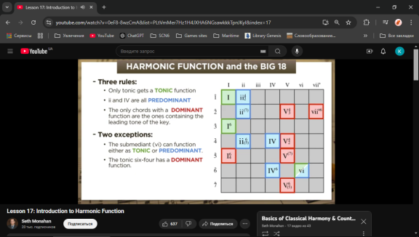

Tonic center
Tonic function (abbreviated “ton.”): The I
chord has tonic function, which is a state of stability and rest. Tonic chords do not demand progression to other chords.
Tonic Chords: I, iii-, vi-
A tonic chord contains the stable third of the key and at least one other note from the I chord. Clearly the I chord is a tonic chord, but so is the third chord: Emin contains the tones E and G, both from the tonic chord. Amin contains the third as well as the tonic note itself. Both of these chords sound similar to the tonic chord. We’ll call the three chord iii-, the lowercase numerals and minus sign indicating that it is a minor chord. We’ll call the six chord vi-.

Predominant
See document(s): Pre_dominant chord variants.xlsx, Chromatic Pre-Dominant Chords.mhtml
A predominant chord is any chord which normally resolves to a dominant chord.
Examples of predominant chords are the subdominant, supertonic, Neapolitan sixth and German sixth. Other examples are the secondary dominant and secondary leading tone chord.

Supertonic

Subdominant
Pre-dominant function (abbreviated “pre-dom.”): The IV and ii
(chords containing the subdominant 4 and submediant 6 ) tend to progress to chords of dominant function.
Subdominant Chords: IV, ii-
The subdominant chords both contain the note “F”, significant because that note creates a gravitational pull away from the tonic chord. They also both do not contain the tone “B”, which is a strong tone that tends to create the expectation of resolving up to C. These chords have a stronger pull than tonic chords, but a less-stronger pull than dominant chords. When one of these chords appears, it is possible that a dominant chord is approaching; however, sometimes a subdominant chord will appear and then return to the tonic. These chords are stable enough to go almost anywhere. This is especially true of the IV chord, which often resolves back to I without a dominant chord.

The Secondary Dominant Chords V/ii The Dominant of that note where you move
It is only Maj or Mmin7

Secondary Dominants in Major and Minor

Major: ii, iii, IV, V

Minor: III, iv, V,VI, VII

Writing Secondary Dominants

Insert it before next chord

Chain them

Irregular Resolutions of Secondary Chords

The Secondary Diminished Chords Vii/ii
See document(s): Diminished chord resolution.jpg

Augmented Sixth Chords or Tritone substitution

Italian augmented sixth chord

Franch augmented sixth chord

German augmented sixth chord

Dominant
Dominant function (abbreviated “dom.”): The V
and vii (chords containing the leading tone 7 and supertonic 2 ) tend to progress to tonic (I). Special note: The I/5th chord has dominant function when it resolves to the V chord, as in the third chord from the end of the “Star-Spangled Banner.”
Dominant Chords: V7, vii˚
Both of these chords contain the tones “F” and “B”, and therefore have the maximum amount of conflict and tension. These two tones want to resolve to the tones “E” and “C” respectively, tones in the tonic chord. This expectation is the reason why the chord will often be followed by a tonic, which will contain the expected notes and complete the resolution. The V chord is used much more often than the vii˚ chord is, for reasons we won’t explore here.

The Subtonic VII major chord

Strengthening Endings with V7

When you in Aminor tonality to make cadance use E7 insted of Em.

Strengthening Endings with Strong Predominants

Strengthening Endings with Cadential 6/4

The Neapolitan sixth chord is bII=>V7 in minor key
Is a chromatic chord built on the flattened supertonic of the key. (bII)
It is predominantly written in its 1st inversion and has a very distinctive sound.
Is usually found in minor keys.

The Non-Functional chords for Prolongation of functional chords on weak beat.
That non-functional chords are made up from auxiliary notes, passing notes or appoggiaturas (i.e. voice leading patterns) whereas functional chords are not.

Prolongation Chords
Common note prolongation.
Tonic prolongation function (abbreviated “ton. prol.”): The vi and iii (chords that share two common tones with 1-2 3-5 from the tonic triad) tend to occur after the tonic chord and progress to chords of pre-dominant function.
They are three chords long
The first and last chords are I or I6
The middle chord is V6 or an inverted V7
The V6 or inverted V7 resolves using the same principles we learned in Strengthening Endings with Cadential 6/4.

Auxiliary Chords
See document(s): Functional Harmony Auxiliary Chords.mhtml

Passing Chords
See document(s): Functional Harmony Passing Chords.mhtml

"Borrowed chord"
See document(s): Modal Interchange & Borrowed Chords - The Jazz Piano Site.mhtml
Chord out of key.

The Approaching Chord
Approach chords may thus be a semitone or a fifth or fourth from their target.
Approach chords create the harmonic space of the modes in jazz rather than secondary dominants.

Suspended Chords
Sus2 or Sus4

Appoggiatura Chords.
See document(s): Functional Harmony Appoggiatura Chords.mhtml

Substitution Chords.
See document(s): Chord Substitution - The Jazz Piano Site.mhtml

Negative Harmony

Use negative harmony to add chords in between for half bar and get back
from C | Dm | G | C |
To C C| Dm Bb | Fm G | C

TRISTAN chord
F B D# G#
Resolves to V or to I in 2nd inversion.

Extentions within the Basic Structure
See document(s): Musical Syntactic Phrase Structure.mhtml

The Dominant Prolongation
See document(s): Musical Phrase Dominant Prolongation.mhtml

The Static Coda
See document(s): Musical Phrase Static Coda..mhtml

The Dynamic Introduction
See document(s): Musical Phrase Dynamic Introduction.mhtml

Non-tonal harmonic line .
- Simply means not based on traditional tonal hierarchy — no clear tonic or key center.
- It’s an umbrella term that includes several approaches, such as:
  - Atonal music
  - Modal music (sometimes considered non-tonal if it avoids functional harmony)
  - Planing (parallel chord movement)
  - Quartal/quintal harmony
  - Polychords, clusters, synthetic scales, etc.
- So: “Non-tonal” just means outside functional tonality — it doesn’t tell you how the music is organized instead.

Modal & Church Modes / Neo-Modal Theory
Revived by: Debussy, Vaughan Williams, Messiaen, jazz harmony
Main idea: Return to modal centers rather than tonal functions.
Key features:
- Built from ancient scales (Dorian, Lydian, Mixolydian, etc.)
- Centered around a final (tonic) but no strong dominant pull
- Color through mode mixture
- Harmonic relations often by step or common tone
Used by: Debussy, Ravel, Messiaen, Miles Davis (“So What”), modal jazz

Jazz / Extended Tonal System
Developed by: Jazz theorists, George Russell’s Lydian Chromatic Concept
Main idea: Tonal centers expanded by modal interchange, extended tertian harmony (9ths, 13ths), and non-functional chords.
Key features:
- Modal and tonal simultaneously
- Chords relate by scales, colors, and function mix
- Functional resolution optional, not mandatory
Used by: Jazz harmony, film music, fusion, modern pop

Atonal harmonic line (effects, percussion).
- A specific type of non-tonal music that avoids a sense of key or tonic entirely.
- All 12 pitch classes are treated as equal — no pitch has special priority.
- Developed by composers like Schoenberg, Webern, Berg.
- Often leads into 12-tone (serial) or set-theory techniques.

Set Theory (Pitch-Class Theory) (20th century)
Founders: Allen Forte, Milton Babbitt
Main idea: Music is organized by unordered sets of pitch classes rather than tonal functions.
Key features:
- Every note = one of 12 pitch classes (C–B)
- Chords/scales treated as collections (sets) with interval patterns
- Relationships measured by set-class similarity
- No tonality or functional direction
Used by: Schoenberg, Webern, Babbitt, post-tonal analysis

Acoustic / Spectral Theory
Founders: Gérard Grisey, Tristan Murail (1970s)
Main idea: Harmony derived from natural overtone series (acoustics), not tonality or symmetry.
Key features:
- Uses partials of a fundamental to build chords
- Emphasizes timbre and resonance
- “Consonance” = frequency closeness, not functional logic
Used by: Grisey, Murail, Saariaho, modern spectral composers

Twelve-Tone / Serial Theory
Founder: Arnold Schoenberg (1920s)
Main idea: All 12 notes are equal — organized through a tone row (ordered sequence).
Key features:
- No key center or hierarchy
- Row transformations: Prime, Inversion, Retrograde, Retrograde Inversion
- Vertical (harmonic) and horizontal (melodic) unity
- Absolute symmetry and equality
Used by: Schoenberg, Berg, Webern, later serial composers

Neo-Riemannian Theory
Founders: Hugo Riemann (basis), 1990s revival by Cohn, Douthett, Lewin
Main idea: Chords move by parsimonious voice-leading (minimal pitch changes), often in chromatic mediant cycles.
Key operations:
- P (Parallel): C major → C minor
- L (Leading-tone exchange): C → E minor
- R (Relative): C → A minor
Creates: Smooth chromatic progressions like C → A♭ → E → C (the “hexatonic cycle”)
Strong link: Between Neo-Riemannian and Bartók’s symmetry (both use minor-third cycles!)
Used by: Wagner, Liszt, film scores, post-tonal and neo-tonal music

Harmonic motion.
Intervals between chords can be measured in two different ways, depending on context, and it’s important to be clear which one you mean:
- From the first chord (root-to-root from a reference point)
  - Here, you measure the interval between each chord and a fixed “home” chord, usually the tonic or the first chord of the progression.
  - Example in C major: C → E minor → G → A minor.
    - C → E minor = major 3rd
    - C → G = perfect 5th
    - C → A minor = major 6th
  - This is common in theoretical analysis or when mapping chord functions relative to a tonic.
- From the previous chord (stepwise or sequential)
  - Here, you measure the interval from the last chord to the next chord.
  - Example C → E minor → G → A minor:
    - C → E minor = major 3rd
    - E minor → G = minor 3rd
    - G → A minor = major 2nd
  - This is common in voice leading, arranging, or harmonic movement analysis, because it reflects the actual motion between chords.
✅ Rule of thumb:
- If analyzing progression relative to tonic, measure from the first chord.
- If analyzing movement or voice leading, measure from the previous chord.

Dynamic Progressions.

Constant Progressions.
Example
Maj7Chords/ up / m3rds makes:
Cmaj7 Ebmaj7 F#maj7 Amaj7 Cmaj7
7sus Chords down Mnds makes
C7sus Bb7sus Ab7sus Gb7sus E7sus D7sus C7sus
Constant structure may exist in Functional hurmony.

Chromatic Mediant / Submediant progression.

interval M2/m3/M3 up/down.

M2 - C, D, E,F#, G#, A#

m3 - C. Eb, F#, A

M3 - C, E, G#

The Circle of Fourth progression

The Circle of Fifths Progression

Harmonic harmony Chord progression Use Harmonic Circle I/7-IV-VII-III7-vi-ii-V7-I
See document(s): What chord progressions characterize different styles of music_ - Quora.mhtml, chord-progression-map.png, Chase Charts of Great Songs without Modulation or Chromatic Chords - How Music Really Works.mhtml, Chord Progression Guidelines - How Music Really Works.mhtml
first establish the tonality. Brain will have context in which to process subsequent sonic information.
The V7th help great to make tension and resolve it to I, establishing the tonality.
In minor, the iiim7 goes to VIm establishing the tonality. (Wayne Chase reg. 6.7.4 p.367)
There are five basic rules to follow when writing a chord progression.
1. Work out the primary chords of the key you are writing in (these are chords 1, 4 and 5 of the scale and are written in Roman numerals – I IV V). For example, if you are writing in C major the primary chords are C F and G. If you are writing in A minor the primary chords are A minor, D minor and E.
2. Choose a chord progression. A chord progression is simply the order in which you choose to change chords. I suggest that you start by writing a chord progression over 4 or 8 bars. Make sure you start and end on chord I. Other than that, simply try experimenting to work out which sounds “best” where.
3. Play your chord progression on the piano using your left hand. Once you can play the chord progression you are ready to improvise a melody over the top.
4. Improvise a melody – Play the 3 notes of each chord one after another in the right hand (this is called a broken chord) at the same time as you are playing the chord in the left hand. In other words, if you are playing a C major broken chord you would play C – E – G. Try mixing up the order you play them in (you could play G then C the E). Maybe play 2 of one of the notes (G-G-C-E), etc.. Also, try varying the rhythm of the notes you are playing.
You will soon find that melodic ideas come and “work” with the chord progression you have chosen.
5. To prepare ear to stay in this key, you have to play the root for longer measures.
Minor:
i-VI-iii-VII - Sensitive female chord progression (SFCP). Many girls using this C.P.
i-VII-VI-VI- Used by Led Zeppelin (to heaven)
Tips:
*VII chord is used in first inversion only.
*2nd inversion triad must function as neighbor, passing or cadential chord.
*Voice leading for 2nd inversion triad; approach and resolve of voices by step or common tone (no leap approach)
*Never, double the leading tone.
*Resolve leading tone up to tonic if in outer voice.
*spacings not more than octave between upper voice. Bass can.
*Resolve 7th of chord down by step.

Shorter Progressions from The Circle of Fifths

The Pachelbel Progression

Database of progressions

Diatonic Chord Progressions: Two Chords (6 possibilities)
See document(s): 2 Chord Progressions.png

Diatonic Chord Progressions: 3 Chords (30 possibilities)
See document(s): 3 Chord Progressions.png

Diatonic Chord Progressions: 4 chords
See document(s): 4 chord progressions.png

Chromatic medient progressions
See document(s): Chomatic mediant chord progression.jpg
From Root to Maj3 or minor3 up or down.

"Neo Soul" chord progression

Arrangement voices line.
How chord notes are arranged in voices.

Counter Point technique.
Connect two or more melodies so they sound together.

Counter-melody.

Counter-Point
See attached file(s): Counterpoint - Wikipedia.mhtml
Counter-point is a melody that sounds good with the Question melody.

Intervals makes Motion/Flow of melody

Perfect consonances / no flow
Unison, 5th, 8ve
Unison is strongest used iin begining or end.

Imperfect consonances / flow
3rd, 6th,10th. of diatonic scale.

Dissonances / separate flow
2nd, 4th, 7th of diatonic scale.
Voice leadin gindependent in flow.

Dissonant passing tone Must occur on the upbeat.
Dissonant passing tone must approached and left by step in the same direction.

Upbeat leaps can improve the melodic line.

Perfect unisons are allowed on the upbeat

Embellishing Tone
6-3-6 interval
or 5-3-5 interval

Movement relative on another

Contrary motion is independence

Oblique motion is less independent
One voice moves, the other remains stationary.
Attention to one of melodice occur.

Same/Direct motion is together, no independence.

Parallel motion
Parallel motion is Direct motion by the same interval

Similar motion
Similar motion is Direct motion by a different interval.

No Dissonant Harmonic Intervals. No Direct Motion to Perfect Consonance. Consonances on Any Beat Dissonant Passing Tones on Beats 2 or 3 Dissonant Neighbor Tones on Beat 2 Cadential Formulas: from top 6568 or 3568 Front bottom 5431 or 3431

Imitational counterpoint

Composition, Songwriting, Narrative & Worldbuilding

Round

Canon

Fugue

Counter-Question
Counter-Question is the question melody that sounds good under the Answer melody.

Imitation

Dialogues.

Formal

Casual

Slang

Period-accurate

Fantasy-specific

Anything special about character speak?

Level.

Text
Элементы текста — это составляющие, которые формируют его структуру, делают текст логически последовательным и ясным для восприятия. Каждый элемент выполняет свою функцию и служит определённой цели. Вот основные элементы текста:

1. Тема текста
- Это основная идея или главная мысль, вокруг которой строится весь текст.
- Тема может быть явно выражена или подразумеваться. Пример: "Влияние технологий на современное общество."

2. Цель текста
- Определяет, зачем текст создаётся: проинформировать, убедить, описать, объяснить или развлечь. Пример: В научной статье — проанализировать исследование, в рассказе — вызвать эмоции.

3. Композиция текста
- Введение: Задаёт тон и вводит в тему. Обычно привлекает внимание читателя. Пример: "В современном мире технологии стали важной частью нашей повседневной жизни."
- Основная часть: Раскрывает тему, включает аргументы, примеры, факты. Пример: "Современные смартфоны не только упрощают общение, но и предоставляют доступ к важной информации."
- Заключение: Подводит итог, делает вывод, оставляет читателя с основной мыслью. Пример: "Таким образом, технологии имеют огромный потенциал, но требуют ответственного подхода к их использованию."

4. Связь между частями текста
- Плавные переходы между абзацами и предложениями обеспечивают связность.
- Используются связующие слова и фразы:
  - Для перечисления: "во-первых", "затем", "кроме того".
  - Для вывода: "в результате", "таким образом".

5. Средства выразительности
- Лексика: Использование слов для передачи точного значения и стиля.
- Образность: Метафоры, эпитеты, сравнения для усиления впечатлений. Пример: "Город зажёгся миллионом огней, словно звёздное небо."
- Тональность: Эмоциональная окраска текста (официальный, дружелюбный, юмористический и т. д.).

6. Функциональность текста
- Текст выполняет определённую функцию в зависимости от его жанра:
  - Информативный: Передача знаний.
  - Оценочный: Выражение мнения.
  - Развлекательный: Привлечение интереса и удовольствия.

Topics:
Topics:
Basic Vocabulary:
Greetings: Hello, good morning, good day, good afternoon, good night, goodbye, etc.
Common Phrases: How are you?, Thank you, Please, Yes, No, etc.
Common Actions: See, Talk, Hear, Take, Ask, Say, Taste, Sniff, Give, Go, etc.
Time, Days, Week, Month, Year: Talking about time, dates, and scheduling events.
Telling Time: Hours, minutes, etc.
Days, Weeks and Months: Days of the week, months of the year.
Scheduling: Making appointments, planning events.
Days at home:
Who am I, body, emotions, actions:
Body parts:
Basic Actions:
Emotions:
Family and Relationships: Vocabulary related to family members and relationships.
Family Members: Mother, father, siblings, grandparents, etc.
Birthday: Vocabulary, Common birthday phrases and well wishes.
Home and Furniture: Describing the home and furniture.
Rooms in the House: Kitchen, bedroom, etc.
Furniture Items by Rooms (objects): Chair, table, etc.
Home Activities (actions): Cooking, cleaning, etc.
Daily Routine: Describing daily activities and routines.
Morning Routine: Wake up, breakfast, etc.
Day Routine: Cleaning, washing, helping, caring.
Evening Routine: Dinner, relax, etc.
Food and Drink Basic: Common vocabulary and phrases used in kitchens.
Meals and Courses: Breakfast, lunch, dinner, etc.
Food Items: Fruits, vegetables, grains, etc.
Drinks: Water, juice, coffee, etc.
Weather and Seasons: Vocabulary related to weather conditions and seasons.
Weather Conditions: Rainy, sunny, windy, etc.
Seasons: Spring, summer, fall, winter.
Weather-Related Activities: What to do in different weather.
Directions and Locations:
Travel Phrases:
Modes of Transport: Bus, train, car, etc.
Buying tickets.
Asking and Giving Directions:
Phrases for navigating.
Asking for and giving directions, names of places, and location phrases.
Common Places: Schools, parks, stores, etc.
Parks, sightseeing and attractions:
Park areas:
Park objects:
Park activities:
Shopping and Money: Vocabulary for shopping, prices, and handling money.
Shopping Phrases: Asking for prices, sizes, etc.
Money and Payments: Currency, paying methods, etc.
Buying Items: Clothes, groceries, etc.
Occupations and Work: Vocabulary related to jobs, professions, and workplaces.
Work/School Routine: Activities during work or school.
Common Jobs: Teacher, doctor, etc.
Workplace Vocabulary: School, Office, tools, etc.
Job Descriptions: Duties, skills, etc.
Health and Body: Vocabulary related to body parts and health.
Body Parts: Head, arms, legs, etc.
Health Conditions: Common illnesses, symptoms.
Doctor Visits: Phrases used in medical appointments.
Hobbies and Interests: Vocabulary related to hobbies, sports, and activities.
Common Hobbies: Reading, painting, etc.
Sports: Soccer, basketball, etc.
Entertainment: Movies, music, etc.
Holidays:
Dining Out: Phrases used in restaurants.

Paragraph:

Writings.

Article.

Essay.

Report.

Level.

Dramaturgy

Role assignment.

Orchestration line.
To which instrument the notes are assign.

Voice leading. Interaction of Voices on scene.

Theme / Idea.

Variations of Theme.
Creating contrast usually involves varying one or more of the “Elements of Music,” which are listed and explained below.

Melody
We all know what melody is, but don’t confuse melody with ostinato! Melody lives, breathes, and has variety.

Harmony
In this section, we will associate harmony with key and mode (major versus minor).

Rhythm
What the most common rhythmic value is in a section.

Timbre
The different tone colors of different instruments and the different tone colors an individual instrument can produce.

Texture
Described in the previous chapter as existing in the vertical plane (the number of voices) and the horizontal plane (rhythmic activity of the various voices).

Articulation
Staccato versus legato, or short, clipped notes versus long, sustained or connected notes.

Dynamics
Loud versus soft.

Register
High versus middle versus low.

Modulation, Emotion of every Scene.
Section can describe one Topic in deferent moods. As pros and cons of an object.

Group 1: Songs without modulation or chromatic chords (Fifth progressions, up and down).

Group 2: Songs without modulation, with chromatic chords (Third progressions, up and down).

Addition

2-5-1 technique
2-5-1 is the way to next chord.
Progression is C---F---G---
You insert C-Gm-D->F---G---.
2-5-1
#min-#maj-#maj
#min7-#maj7-#maj

Modal Interchange (Borrowed chords) - borrow chord from other key. Play progression in on key and insert chord from another mode.

Passing Chord

Tonicization
Progression C---Am---F---G----
add perfect 4th before next chord.
C7 and E7 are added.
E7 is perfect 4th of Am.
C7 is perfect 4th of F.
C-E7-Am-C7-F---G---

Secondary dominant
Play progression C-G-F. after you play C you can enter secondary dominant of the G and then G.
Use 5th diatonic note after G its D7-it is D major 7th chord, hole step below the root.
If progression C-F, find 5th after F is C7.

Secondary dominant - you can play chords out of the key.
It give more tention to the next chord. So, use the fifth chord. Example: C-G-E7-Am. E7 is the secondary dom. of Am.

Substitutions
See document(s): Chord Substitution - The Jazz Piano Site.mhtml

Chord Family
Chord can share note from another chord of Diatonic scale.
Notes of melody and chord are the same but chord changed. C->E or to A depend from melody.

Chord Substitution:
1. In minor chord progression you can substitute v to V or V7 to bring more tention back to i. (V7 used many in flamenco style) 2. In minor chord progression you can substitute diminished chord with min7b5 to stay in the key.

Negative Harmony
It keep all tentions in melody the same, but give new flawor.
Take chords of key C and Cm. Mix tham. they have same chord minin gs.
CAn be used to add/substitute any chords in progression.

Triton Substitutions

Series Substitution

Polytonal Substitution

Picardy Third
Resolve minor key to major at the end of melody to gave happy resolution to an otherwise darker and sadder song. It is like a “happy ending” in a film, expressed through music.

Am-Fmaj-Dm-Am-Cmaj-Em-AMaj

Group 3: Songs with modulation, without chromatic chords (Second Progressions, up and down)
Near/Parallel Key Modulation. Near key of one scale.
Remote all other keys out of scale.
Moderately distant Modulation

Book p.439

Brings brigther or darker the ending.

Group 4: Songs with modulation and chromatic chords (Chromatic progressions, exiting and returning)

Layering

Basic chords

Detuned layer

Root Base layer

Lead Layer

Ear candy nnotes

Rhythmic layer

Scenes.
Place description or collection of paragraphs.

Scene Types.
Scene is a collection objects and actions.

Exposition scene: Introduces the world, characters, and initial conflict.
Early scenes introduce the setting, characters, and primary conflict.
They might show the status quo of the protagonist's world before the main plot begins.
Example: In The Hunger Games, early scenes show Katniss's life in District 12 and her relationship with her family before the Hunger Games begin.

Inciting Incident scene: The event that starts the main conflict.

Conflict Scene
Moves the story forward by introducing or escalating conflict between characters or forces.
Develops characters' goals, desires, and relationships.

Transition Scene
Acts as a bridge between larger plot points, often changing the location or timeline.
These scenes might not have heavy action but help to move the story from one major event to another.

Action Scene
High-energy, often involving physical activity, danger, or a moment of intense change in the plot.
Example: Car chases, battle sequences, or any scene that heightens tension.

Reveal Scene
Reveals information that changes the direction of the plot, like a plot twist or a character’s secret being exposed.
Example: In The Sixth Sense, the reveal scene where we discover the truth about Bruce Willis's character.

Emotional/Character Development Scene
Focuses on a character's internal struggle or emotional growth.
These scenes often provide insight into the protagonist’s mindset, motivations, or relationships.

Rising Action scene: The conflict develops and tension builds.
Scenes build on each other, gradually intensifying the conflict and developing the characters. This is where the plot thickens.
Characters are put in situations where they have to act, make choices, or change their perspectives.
Example: In Harry Potter, scenes in The Sorcerer's Stone show Harry learning about magic, discovering the secret of the stone, and facing various challenges.

Twist or Surprise (optional)

Climax scene: The peak of the story, where the conflict reaches its most intense point.
The climax is often a single scene (or series of closely linked scenes) where the story reaches its most intense conflict or turning point. The protagonist faces a major decision or battle.
Example: In The Lord of the Rings, the final scene in Mount Doom where Frodo and Sam must destroy the One Ring is the climax.

Climax Scene
The peak of the conflict. The protagonist faces the most intense challenge and must make a choice or sacrifice.
Often leads directly into the final resolution.

Falling Action scene: The aftermath and consequences of the climax.
Following the climax, the scenes here begin to resolve the remaining conflicts and tie up loose ends.
Example: In The Great Gatsby, after Gatsby’s death, the later scenes focus on the fallout, Nick's reflections, and the closure of the story.

Resolution scene: The conflict is resolved, and the story ends.
The final scenes provide closure, showing how characters have changed or how the world has been altered by the events of the story.
Example: The last scene of The Wizard of Oz where Dorothy returns home, realizing she had the power to return all along.

Closing Notes
What do you want your reader to feel at the end?
Any message or call to action?
Conversations between characters that reveal their personality, advance the plot, or add depth.

Level.

Plot or Storyboard.
The sequence of events that form the backbone of the story—what happens, why, and how it unfolds. A scene is a distinct section of a story that typically takes place in one location and in a continuous time frame. It features specific characters interacting with each other or the environment in a way that moves the plot forward.
The plot arc is essentially the journey that the story takes from the inciting incident to the resolution. Each scene contributes a small piece to this arc, either by:

Advancing the plot:
Pushing the story forward, often by presenting new challenges or discoveries.

Developing characters:
Revealing their motivations, flaws, or growth, which will influence future events.

Setting up future scenes:
Scenes can set the stage for upcoming events by planting information, foreshadowing, or creating tension.

Chapter.
Few scenes to achieve one goal, climax.

Narrative Perspective.
The voice telling the story—first person, third person, omniscient, or others.

Emotion.
The feelings evoked through characters, events, and themes that resonate with the audience.
Tone.
Language.
Pacing.

Melodic Forms.

Melodic Form structure.

Beginning part.
Basic idea (2 measures)
Basic idea (2 measures)
I-I-_ I-_-V-I I-V-V-I I-ii/IV-V-I

Middle part.
Fragmentation
Basic idea (4 measures)
Fragment (2 measures)
Fragment (2 measures)
Fragment (2 measures)
Increase in harmonic rhythm (speed)
Basic idea (4 measures)
Fragment (2 measures)
Fragment (2 measures)
Sequential harmonies
indefinite sequence
Increase in surface rhythm
notes speed

Ending part.
V7-I

Binary, Ternary Forms.
Consist of two, three or more sections.

Period A - 3 question phrases and 2 answer phrases.

Period B - 1 question phrase and 4 answer phrase.

Classical Forms.

Sonata.

Exposition section dramatic section.

Development section, slow section

Recapitulation section Dance section.

Coda section Final, likely section.

Fugue

Fugue Structure

Exposition section

Recapitulation section

Coda section

Stretto

Variation Form

Rondo Form

Symphony

Suite

Concert

Waltz

String quartet

Opera

Cantata

Oratorio

Modern Forms.
See document(s): Big Chord Data Extraction and Mining _ Isophonics.mhtml

Blues

Jazz
1. Turn around. 1-6-2-5. all chords are 7th
2. Cycle of 5th. 6-2-5-1-4-7-3
3. Extended turn around 1-4-3-6-2-5-1
4. Minor Turnaround Im7-VIm7b5-IIm7b5-v7
5. Sentimental 1m-1m/7-1m/b7-1m/6
6. Misty Home key:1 4 Key: 2-5-1
7. Chromatic Walkup I-#Idim7-IIm7-#IIdimm7
8. Blues 1-4-1-1-4-4-1-1-5-4-1-5

Funk
16 beats
Syncopation

Flamenco

Serialism
https://www.musictheoryacademy.com/understanding-music/serialism/
Rules:
No note should be repeated until all 12 notes of the note row have been played
The order of the series remains the same throughout the composition, except for some allowed changes.
Notes can be played at any octave – this is why you will often see very large leaps in pitch in serialist compositions.
There are 3 ways in which the Note Row can be altered: Inversion, Retrograde, retrograde invertion

Metal
power chords

Song structure
1. How many syllables in each section.
2. Hit the chorus before 50 seconds.
3. No more that 3 or 4 parts.
There musn't be too much information in the sound stage. Clarity is something I'm struggling with a lot. There must be no new items coming in at the same time. One thing at a time, like in a movie. You can not present ten characters in the first scene. You want to get to know one before you are ready for the next one.
4. Melody Recycling. The Verse Melody = Chorus Melody.
5. Create balance. (If more in this part, less in next)
6. 6 word story. (Begin, middle, end)

Structure – the way in which an overall piece of music is arranged into similar and contrasting sections.

Song Sections:

Intro 4 bars
Verse 16 bars
Pre chorus 4 bars
Chorus 8 bars
Verse 8 bars
Pre 4 bars
Chorus 8 bars
Bridge 8 bars
Chorus 8 bars

Post-Chorus
Hook
Fill
Riff

Transition between sections: when they are not related/song whispering when one come out of other. Modulation is the best metod or rhytem.
Ostinato - is an Italian word meaning obstinate or persistent and is used in music to describe a musical phrase or rhythm that is repeated persistently. The repeated pattern could be a melody, a figure in the bass – called a basso ostinato or simply a repeated rhythmic idea. An ostinato may be played for an entire piece of music or just during one section. The key aspect to remember in the definition of an ostinato is that it is a pattern that is repeated persistently in a piece of music.
Imitation in music - Can you hear how Freddie Mercury sings a phrase and then the crowd sing exactly the same melody back to him
Rubato is a flexibility/freedom in the performance of a rhythm.
Augmentation and Diminution
INTERVALLIC AUGMENTATION AND DIMINUTION

Pop music.

Intro

Pre-chorus

Chorus
a5b6c8
a5b6d12
a5b6c8
a5b5d12 - may be slight variantion.

Verse
repeated Phrase 2 times followed by Contrasting Phrase.

Bridge

Fills.
Connection between the parts.
Fills:
Mordent-up and down
Turn-
Trill

Solo

Outro

Level.

Movements. Series. Parts.

Part is Chapters Arc:
Part is few Chapters to achieve Higher State of been.
Chapter 1. Character realize they are in danger.
Chapter 2. They try to leave but face obstacles.
Chapter 3. They seek allies.
Chapter 4. A confrontation.
Chapter 5. They escape – but at a cost.

Level.

Book of Stories.

Title.

Setting of a Story.
The time and place where the story occur. It provides context and atmosphere.

Tense.

Place.
Atmosphere/Mood (dark, hopeful, mysterious)

Main conflict in the world.

Characters.
The individuals in the story who drive the plot and engage the audience. They can be protagonists, antagonists, or supporting roles.

Protagonist.
Name.
Age.
Personal traits.

Main character Goal and Struggle.
The central challenge or obstacle that the characters face, creating tension and stakes.
Internal
External
Good vs. Evil
Love and Sacrifice
Coming of Age (Maturity)
Survival
Freedom vs. Oppression
Identity and Self-Discovery
Betrayal and Revenge
Power and Corruption
Justice and Injustice
Isolation and Alienation
Hope and Despair
Man vs. Nature
Fate vs. Free Will
Forgiveness and Redemption
Technology vs. Humanity
Greed and Ambition
Prejudice and Tolerance
Mortality and the Meaning of Life
Truth and Deception
Memory and the Past

Antagonist.
Name.
Age.
Motivation.
How they oppose the protagonist?

Theme.
The underlying message or idea that the story explores, such as love, survival, or freedom.

Genres.

Genre of music.
See document(s): https://www.musicgenretree.org/music-genre-tree.html

Genre of story.

Fantasy
dark fantasy
urban fantasy
high fantasy
low fantasy,

Science Fiction
Cyberpunk
Steampunk
space opera
hard sci-fi
Horror

Mystery

Thriller / Suspense

Romance

Drama

Adventure

Historical Fiction

Comedy

Tragedy

Crime / Detective

Western

Dystopian

Paranormal / Supernatural

Slice of Life

Mythology / Fairy Tale

War / Military

Political Fiction

Noir

Speculative Fiction (umbrella for sci-fi, fantasy, dystopian, etc.)

Text.

Grade levels.
Readability of text.

Text Vocabulary.
Basic English
Blunt English
Polite English
Formal English
Direct English
Witty English
Philosophical English
Upper class English
Royal English

The song structure is.
Each event is the block. Use comments to one theme word.
Each block is the act 1, 2, 3. Verse - past story. Chorus - present story.
Each Act is the scene 1, 2, 3.
Each scene is a story of 6 words.

Text Form of a songs.

Question – Answer.

Story – Beginning, Middle, Ending.

Abstraction of feelings.

Meter or "text setting."
Composers tend to align the expected stress of the lyrics syllable with strong metrical positions in the music.
The number of syllables.
A pattern of emphasis on syllables.

Stressed on On-beat.
Stressed on Off-beat.
Unstressed on On-beat.
Unstressed on Off-beat.

Stressed syllable Unstressed syllable

Unstressed off beat

Accented back beat

Meter types.

Simple meter

Compound meter

Combined meter

Irregular meter

Intonation.

Rising - not finished sentence. Falling - end of the sentence

Falling tone - "new" information Rising tone - "old" information I thought you will go and take some bread! How we gone make any sandviches If we don't have any bread?

Falling tone - you don't have an answer. Rising tone - You think you know the answer.

Types of Meters in Poetry.

one foot = monometer

two feet = dimeter

three feet = trimeter

Qualitative and Quantitative Meter.

Unrhymed Iambic Pentameter

Lambic Trimeter and Iambic Tetrameter

Dactylic Hexameter

Types of word meaning

Double entendre Something that can have a double meaning

PUN A single word that sounds the same but has a different meaning

Metaphor A figure of speech in which a word or phrase is applied to an object or action which is not literally applicable.

Simile When you use one thing to compare to another.

Double entendre Something that can have a double meaning

Punchline A line that hits the listener hard due to how funny, shocking, or deep it is.

Mind rhyme When you establish a rhyme scheme but purposely leave one of the rhymes out to make the listener fill it in.

Texture Level.
Texture – the way in which melody, rhythm and harmony are combined in a piece of music. What each part/instrument is doing at any given point.
When notes goes higher go louder and go down get quiter.
If the notes goes higher but the piece resolving go quieter.
Bring more interesting notes loader and if it resolve to quiter.
Pick one note in each phrase to be the "high point" and lead the phrase toward it.

Monophonic -A monophonic texture has a single line of melody without any harmony or any other form of accompaniment
Homophonic
Polyphonic - several parts or voices are combined together contrapuntally or in counterpoint
Heterophonic - a melody is varied by an additional voice/part at the same time as the original melody is being played.

Levels of complexity.
See document(s): Lyric Melody.jpg
1. One-Finger Melody
2. One-Finger Bassline(root in base)
3. Two-Finger Bassline(1/5)
4. Chord in base.
5. Arpeggio
6. Waltz forms (Funk,RUMBA, STRIDE) (Take root, skip second and go to third invertion. it makes Waltz)
7. Melody Embellishment (Add two or three finger in melody).
8. 2 - Voice (Polyphony)
9. 2 - Voice Melody-low
10. 3 - Voice Melody
11. 4 - beat rhythm
12. 5 - beat rhythm
13. Harmony change
14. Extended Harmony (Polytonality)
15. Melody manipulation (play Backwards or upside down, fragmented in different octavs/registers
16. All levels combine

Monophony

Homophony

Polyphony

Heterophony

Level.

Worlds.
World=Material+rules
Material determines actions, scenes, story,worlds.

Realistic world

Mythic world

Fairy-Tale world

Fantasy world

Science Fiction world

Dystopian World

Utopian world

Surreal / absurd world

Magical realist world

Horror world

Allegorical world

Hybrid world

Functional Layers.
A multi-dimensional model of musical story. All of these exist simultaneously at every level.
Tonal Function.
Tonal = “Where is home?” “What is the goal of the story?”
Harmonic Function
Harmonic = “How do we move?”
Melodic Function
Melodic = “What’s the story line?”
Rhythmic Function
Rhythmic = “How does time flow?”
Expression Function “How does it feel, sound, and unfold?”
Dynamic / Textural / Timbre / Formal / Emotional
Semantic Function

Dimension | Function / Description | How It Changes Across Levels
Dynamic Function | The use of volume, intensity, and articulation to shape energy. | Micro level: accent or emphasis on motive; Macro level: dynamic contour over whole sections or movements (e.g., crescendo → climax → release).
Textural Function | How many voices or layers are active — density and spacing. | Micro: single melodic line or simple accompaniment.  Macro: thick orchestration, counterpoint, or full ensemble texture.
Timbre / Orchestration Function | The color of sound — which instruments or registers are used. | Small scale: timbre supports motive identity (e.g., violin pizzicato).  Large scale: changes of color define sections and emotional shape.
Formal Function | The role a passage plays in overall structure — presentation, transition, development, closure, etc. | Micro: cadence or continuation functions.  Macro: exposition, development, recapitulation, bridge, chorus, etc.
Emotional Function | The psychological or narrative purpose (tension, release, arrival, calm, chaos). | Micro: a single dissonance or accent.  Macro: emotional trajectory across the entire work.
Text / Semantic Function (for vocal music) | Relationship between music and words. | Small: word-painting, syllabic rhythm.  Large: overall narrative tone or meaning.
Spatial / Registral Function | The vertical space in pitch — high/low balance. | Micro: contour of melody.  Macro: registral planning (low intro → high climax → return).
Motivic / Thematic Cohesion | How motives or themes recur and transform. | Micro: repetition within a phrase.  Macro: thematic transformation across sections or movements.

https://musictheory.pugetsound.edu/mt21c/VoiceLeadingFirstInversionTriads.html

See document(s): Wayne Chase - How Music Really Works _ The Essential Handbook for Songwriters, Performers, and Music Students -Roedy Black Publishing (2006).pdf

9 Ways Music Moves us:
Brain Stem Reflex
Rhythmic Entrainment
Evaluative Conditioning
Emotional Contagion
Visual Imagery
Episodic memory
Musical expectancy
Aesthetic Judgement

