CBScope help
CBScope is an application developed by Cyrille de Brébisson (Cyrille.de.brebisson@gmail.com) and designed to help you design/build a Dobsonian type telescope.
CBScope main features are basic scope values calculations (Radius of Curvature, Focal Length), more advanced ones such as focal plan illumination, mirror making logs, mirror cell and parabolization help.
Note: all units are assumed to be in millimeters and minutes!

The main UI (crap looking, I know) is divided in 3 main parts/panes.
On the top, you will see a drop down box that will let you choose any of the scopes definitions that you have created as well as a “New Scope” button that will add a new telescope to your list.
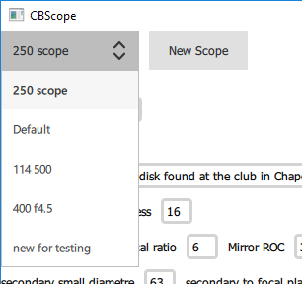
On the bottom you have a “page selector” that will let you navigate to the task that you are interested in.
“Scope” is where the generic data for your telescope will go.
“EP” will let you list the eye pieces that you want to use with your telescope
“Secondary” is a dual purpose page. It will help you select the secondary mirror for your telescope, but also give you a lot of information on how your scope will perform with your various EP.
“Hogging” is a page dedicated to tracking progresses in generating the curve when you are making a mirror.
“Parabolizing” is a page dedicated to performing Foucault measures when you are parabolizing a mirror
“Couder” will help you print Couder mask for your mirror
“Webcam” will also help with mirror parabolizing (Figure XP)
“Support” will help you design the mirror cell (Plop).
“COG” will help you calculate the center of gravity of your optical Tube Assembly
“Notes” is a basic text editor for takin notes.

The scope specification page
On this page you will enter all the basics of your scope. Name it (if you want, but if you leave the “default” and start creating more scopes, you will have a number of “default” in the selection box).
On the right of the scope name you will find the “Delete” button. Press there to delete the scope!Add comments if you want to (they can be multi line).
Enter the main mirror diameter and focal information. Note that you can enter the focal as a length, a F ratio or a RadiusOfCurvature. Internally, the focal is stored as a length. The system will automatically calculate the sagita and volume that needs to be removed from the mirror to make it spherical.
Enter the secondary small diameter and the distance from the secondary to the focal plane (ie, distance from the primary optical axis and the eyepiece). The system will automatically calculate the offset of the secondary toward the primary for perfect collimation.
Material density and the like are mostly useful for mirror cell calculations. Note that selecting one of the default material types will override your settings.
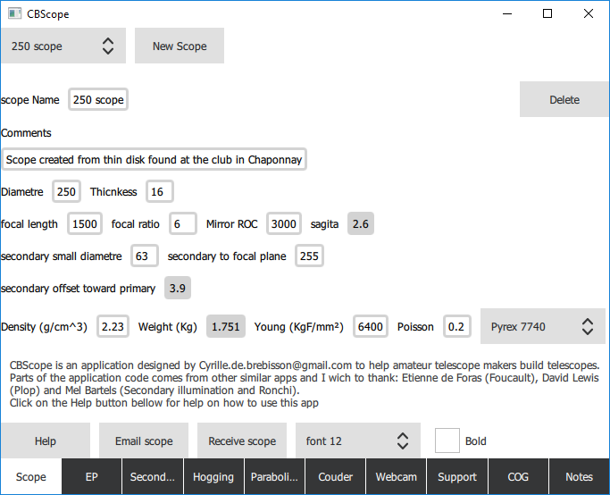
At the bottom of the page, you will see a “Help” button that will pop up this page. An “email scope” button that will start an email with this scope definition so that you can export the data to another CBScope program. “Receive Scope” will to the reverse and let you paste in a scope definition and import it.
Scope definitions are stored in a local “CBScopes.scopes” file in your “Documents” folder.
The font/bold controls allows you to change the program’s font.

The Eyepiece page
This page lets you specify your eyepieces.
Press on the “New eyepiece” to create a new eyepiece and fill up the name, focal and angle. All the rest will be auto calculated. Press on the “Delete” button to delete an EP.
You will see the zoom factor, the eyepiece real view angle as well as the field radius (see Secondary page for more info there) and the exit pupil.
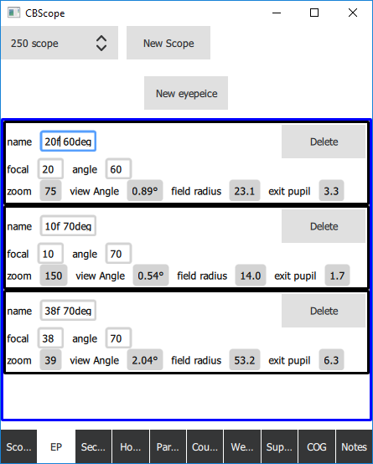

The secondary sizing page
This page is designed to help you select a secondary and contains a lot of information!
The first thing that you need to understand about a telescope is that it generates a “real” image at the focal plane. This image has a size (given as a diameter or radius centered around the optical axis). The role of the EP is to “send” a specific part of the image to your eye. Select a “small” part of the image and you zoom a lot. Select a large part and you zoom much less.
In this page, you will see on the horizontal axis the distance from the optical axis. As a diameter in mm on the right and as a sky view angle on the left.
On the top of the graph, you will see the field/radius/space which is imaged by your various EP (the EP name and horizontal lines match in color).
However, the “image” formed by the telescope on the focal plane gets less and less illuminated by the primary mirror as you go further and further from the optical axis. The vertical axis of the graph represent the % of illumination (as a % on the right and as magnitude drops on the left. Any drop of less than 0.4mag is barely noticeable to the eye).
On the top, enter the list of all the secondary sizes that you are considering for this scope (separate each entry by a space).
The graph will display a curve for each of the secondaries that are viable for this scope (secondaries that are too small will not be shown, secondary that are too large will also not be shown).
The curves (color coded with the secondary sizes displayed on the top left) will tell you, for each secondary size, how much light they put at a given distance from the optical axis. A small secondary will have a maximize the illumination, but only close the optical axis (ie at high zoom). A large secondary will be less illuminated at high zoom but will offer better wide views. Pick your poison!
Here, you can see that my 20mm70° EP will work provide pretty much max illumination if I use a 63mm secondary. A 50mm secondary would still however work but result in a much smaller fully illuminated field of view. Since I am more of a wide angle person, I will select to use a 63mm secondary.
The illumination calculation function has been “lifted” from Mel Bartel’s website.
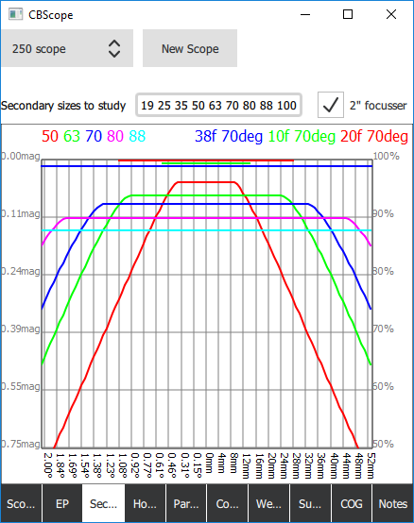

Hogging page
The hogging page is there to help you during the initial mirror grinding phase. The phase were you dig the sphere in your mirror. The sphere radius is here called ROC for Radius Of Curvature.
On the top, you can specify your home made spherometer parameters. Assuming that you have made a home made spherometer with 3 legs and a micrometer (in mm), calculate the average distance between the legs and enter them on the top. This will we be used to translate micrometer readings into radius when you enter text in the “end ROC spherometer” area.
Once again, click on “add measure” to add a new item in the list and “Delete” to delete an idem.
The aim of this page is to let you follow your progress while hogging the sphere. During the hogging process, each time you stop to do a reading, enter the time it took, the reading and the grit used. Type the spherometer reading in the “end ROC spherometer” area and the end ROC will be automatically calculated (ROC= h/2+L²/(6*h) where h is the reading and L the average distance between the legs).
One again, the system will automatically calculate a bunch of stuff for you. The amount of material hogged per unit of time (hog/time), and the end sagita. It will also calculate (at the bottom) an estimation of the amount of time left hogging if using the last “grit” (it does it by averaging the hog/time of all the hogging work using that same grit). It gives you a “done %” and tells you how much there is to hog total, and how much is left to hog.
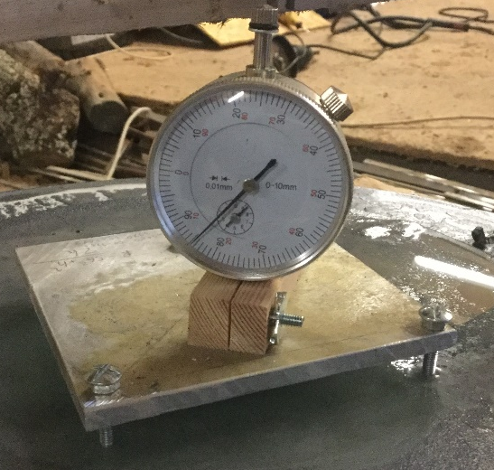
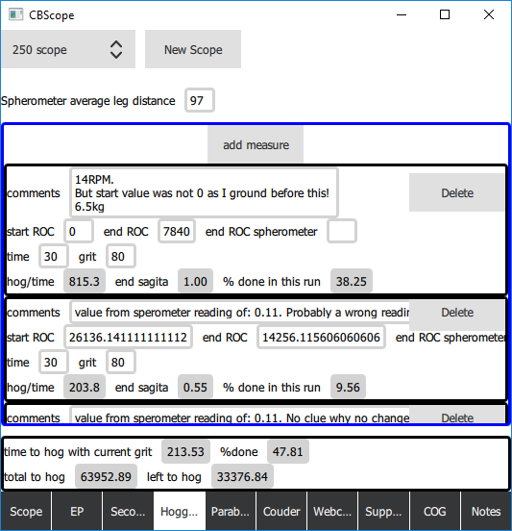

Parabolizing page
This page is there for you to follow on your progresses while parabolizing a mirror.
At the top you can select the number of zones (with the suggested number of zone displayed there) as well as the zones start and stop as a distance from the mirror center. If you have a “normal” mirror, the first number there will be 0 and the last on the mirror radius. If you have a hole in the mirror, the first number will be the radius of the hole. The “auto calc zones” button will use whatever you have placed as first and last numbers and calculate equi-sized zones for your mirror.
This is also where you specify if your light source is fixed or moving (slit is moving).
Press on the “add measure” button to create a new Foucault measure. You can then enter the measured values (in mm) in the appropriate boxes (as well as comments and the time that you spent doing the work). If you are taking multiple measures, you can enter the various measures for the same zone as a space separated string and the system will take the average. “1 2” for example will be averaged into a reading of 1.5.
The display will provide you with the curve that your mirror makes above the sphere. Color codding of the vertical axis (which is labelled in nano-meter) tells you how close you are to the ¼ wave target. The display will indicate the lambda value (you are looking for 4 or more), as well as the other classic measurements (and I have honestly no idea what they really mean!). Of interest if the volume of glass that still needs to be removed to finish the work. The curve has the optical axis on the left and the edge of the mirror on the right.
As always, press on Delete to delete an item from the list.
Note that the zones configuration are copied for each new measurement. This means that if you change the zones that you want to work with (you start parabolizing with 4 zones and then move to 6), it should still work ok. The zones associated with each measure are written at the bottom of the display. Click on “Large view” to enlarge the display.
The screen shot bellow is NOT up to date. In the latest version, the zones will be indicated with, in parenthesis between the zones the ideal reading for said zone.
The code that does the calculations has been “lifted” from Etienne de Foras “Foucault” program.
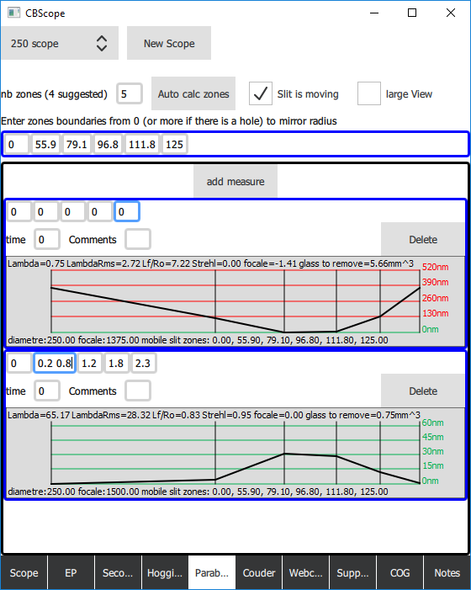

Couder page
This page has only one aim. Draw and let you print a Couder mask. The system offers 2 different type of masks and let you choose what you want to print or not. Press on “Print couder mask” to open the print dialog box.
The red zones are the “standard” Couder type mask. However, I personally prefer the “blue” type for the following reason.
On a “normal” mask, you have to compare the luminosity of 2 widely separated area of the mirror, with other area of the mirror in between clouding your judgement. Knowing how bad the brain is at that type of things (think about all the optical illusions on dark/light) and you will understand why this is a bad idea.
With horizontal zones (blue), you do not have the problem and you end up seeing things like this:
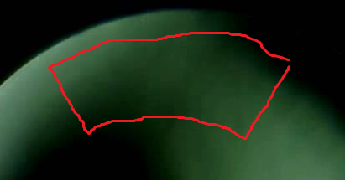
What you see is the shadow coming from the top right and bottom left. Where the meet tells you how center/not centered you are on your zone. This makes Foucault reading much easier in my opinion.
The zoom checkbox will do a zoom out if your mirror is large. However, the printing should be done “at scale”.
If you are using a laser cutter or something like that, you can set the black to just mark and the blue or red to cut, therefore creating your mask directly!
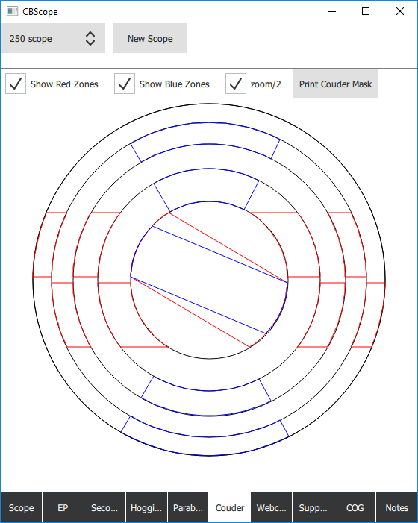

Webcam page
OK, this is another buzy “page”. It is designed to help you do your Foucault (and Ronchi) measurements.
In the first use of the page, you will select one of the camera connected to your computer and should see something like this.
Normally, it would not show “you”, but your mirror under Foucault! However, I do not have my setup… well setup at this point in time, so you get my face!
Use drag and drop and mouse wheel or zoom to move the scope zones display. You can also use the up/down/right/left/+/- buttons on the right for fine control.
One area of the mirror will be “grayed” out. This is the area under measure. On the top left of the picture, you will see 2 bar graphs. One for the right and one for the left side of the “zone”. The top of the bar graph represent dark pixels, the bottom light pixels. Here you can see that the left zone has a bunch or relatively light pixels while the right has 3 blocks of pixels. They are, respectively my hairs, my skin and the green area.
Should this be pointing at a mirror under Foucault, what you would see is a measure of the darkness/lightness of the mirror on the right and the left. Your Foucault tester is “on focal” for this zone if the right/left illumination are the same. Ie: if the right and left bar graphs are similar! This removes a lot of eye strain and makes Foucault testing a whole lot easier!
Once you have found the focal, enter the measurement on the Foucault reading at the top (it is the last reading from the “Parabolization” page. You will have to go back there and click on “Add measure” to create a new one when needed) and move on to the next zone by either clicking on it in the picture, or by selecting it on the drop down.
By default, the data measured by the bar graph is the luminosity, but you can change it to the average of R/G/B, or one of the 3 color channels. Press on the Pause button to pause the camera if needed.
Press on “Ronchi” to change from a Foucault to a Ronchi type test. Enter your grading in slit per mm!!!!! and the defocalization that you are at and it will draw the Ronchigram that you should see! The code to calculate the Ronchigram was lifted from Mel Bartels’ website.

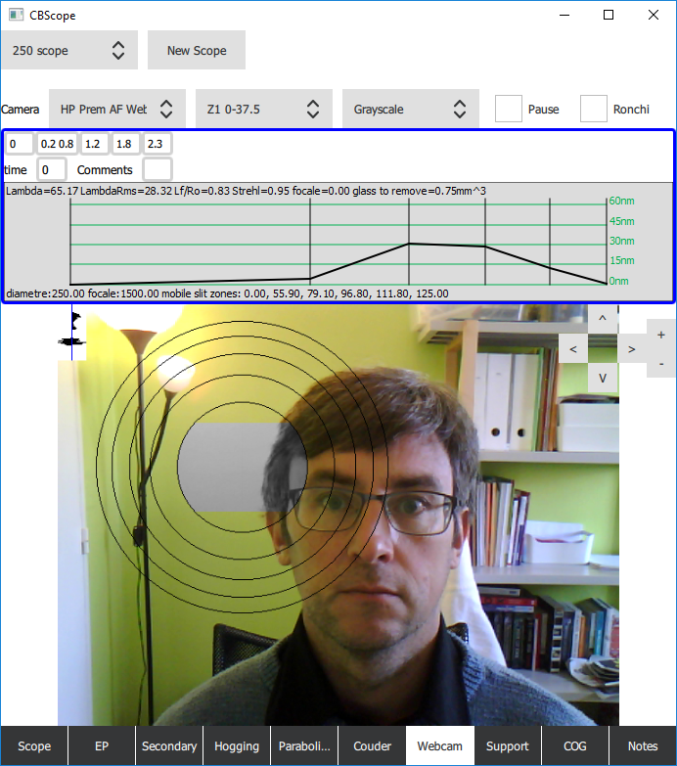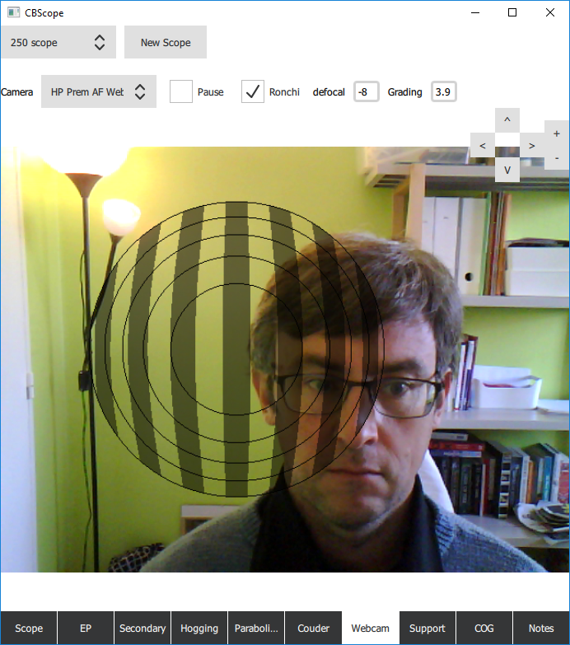
One last feature on this buzy page is the image drop! Drop an image file in the window and the image will replace the camera and let you work on a still picture.

Support page
The calculation code used here comes directly from PLOP. Thanks to David Lewis (and the long string of persons that came before him and created this code!)
The purpose of this page is to help you design your mirror cell. The structure that will support your mirror so as to minimize its deflections under its own weight. Only the worst case scenario is looked at here: when the mirror is horizontal and has the max amount of weight on the support with the minimum material thickness available to support it.
Assuming that you have enter the material properties in the first page, select the number of points that you want to use, press on Calc (this can be slow!) and here you go. You should get a result in a couple of seconds (minutes on slow machines).
Various check boxes will let you control what you see/do not see. Unchecking Forces and Mesh can speed things significantly on large cells.
This page generates 3 main outputs:
- P-V errors. This gives you the delta between the top and bottom parts of your deformed mirror (only the area that are visible are taken into account. The area hidden by the secondary will be ignored!). P-V and RMS errors are indicated both in nano-meters (green light is 555 nm) and in lambda or fraction of the green wavelength. For “Normal” folks, lam/20 is usually “good nough”… for those of you lucky enough to have l/20 Zambuto, get to at least l/40 or 80. Your mirror deserves it!
- RMS error. This is a much better measure. Let me explain why. A P-V of 1/2 length wave of light is bad (it means that the top cancels the bottom). However, if 90% of your mirror is at ‘0’, 5% at -¼ and 5% at ¼ (P-V=1/2) then you are only loosing 10% of your mirror surface, which is not “that bad”… RMS measurement takes into account not only the height, but the amount of surface at these heights. So, a bad P-V with a great RMS is better than an average P-V and average RMS as RMS “removes” the small outlier areas of the scope. Anyhow, ¼ wave is what is normally considered an OK mirror. If your cell has less than 1/20 wavelength (lambda or lam here), it means that the deformation to your mirror caused by the cell will be very small compared with the overall mirror quality and that there is no need to make the cell any more complicated.
- “Parts” (bottom left). Gives you the dimensions of the various parts of the cell (triangles and bars) as well as their Center of Gravity as a radius from optical center.
“Show Displacement” will color code the representation of the mirror and give you an indication of how the mirror will deform, where it will be low or high.
“Show Mesh” shows the meshing used by the finite element method calculation.
“Show parts” show the parts that will constitute the mirror cell as well as their COG.
“Show Supports” show where the mirror will be supported.
“Show secondary” show the shadow of the secondary on the mirror. There is no need to optimize the areas that are under the secondary as they do not contribute to the final image!
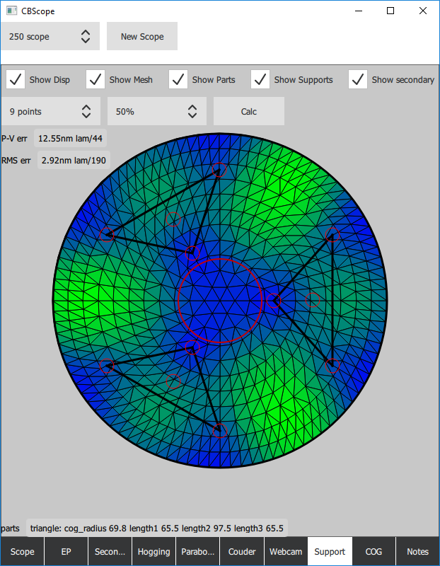

COG page
This is a center of gravity calculator. It is organized around 2 columns.
On the left, place (click on the add button) the weights at the bottom of the optical tube assembly. Text is “free type”. Weight is in Kg. Do the same for the top side.
“bottom/top len”, and weight(Kg)/mm allows you to enter the specs of the “tube” itself. Let us say that your tube is 50g/mm of length and that if extends 50mm bellow the mirror surface and 100 after the secondary center (the distance between the 2 being fixed at focal-secondary to focal).
The system will calculate the distance between the mirror front and the center of Gravity of your tube.
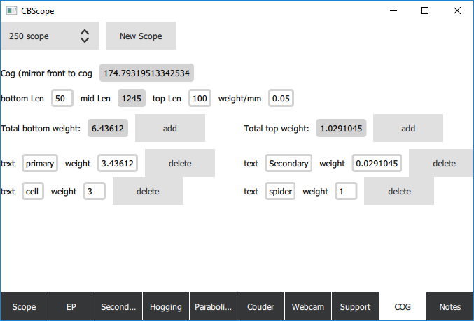

Notes page
Just to take notes!
