Ex1
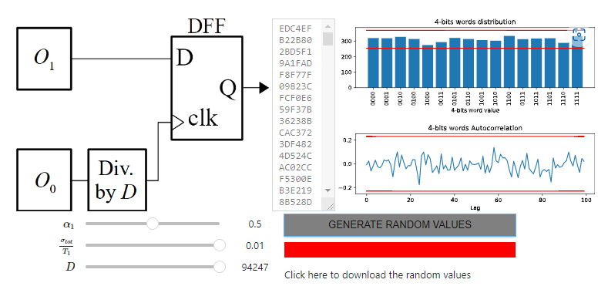
To have the best randomness, we’re playing with the variable alpha, Jitta and D. We found out that:
- we need a high Jitta to have less auto-correlation
- alpha must equal 0.5 to get a the most flat distribution
- D must be the highest???
As we can see blablabla…

Ex2
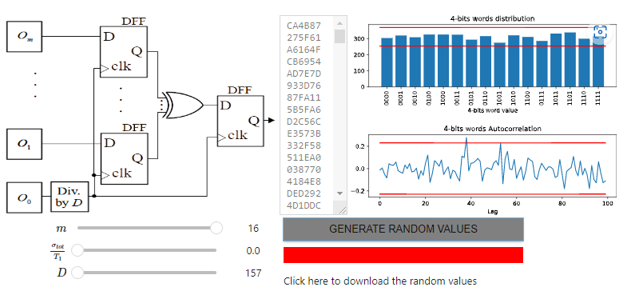
we can see that increasing m up to 16 gives us a really flat distribution and small correlation.
Increase bitrate: increase m or decrease D
No Jitta = D has no influence anymore
Increasing Jitta and D is expensive
For D
Exercice 3

Entropy = estimation of uncertainty
Big Jitta and D, no entropy
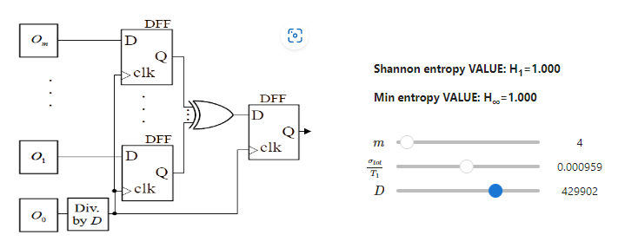
Ex 4

standard Tl= 9654 and TH=10346
We

