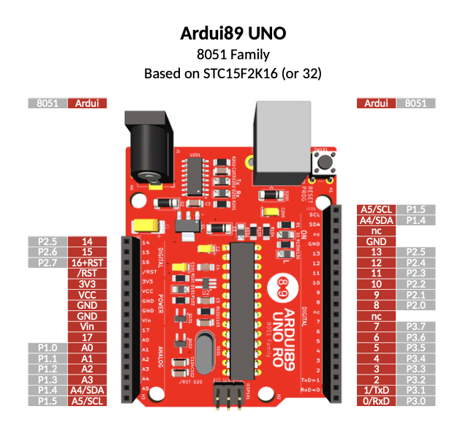
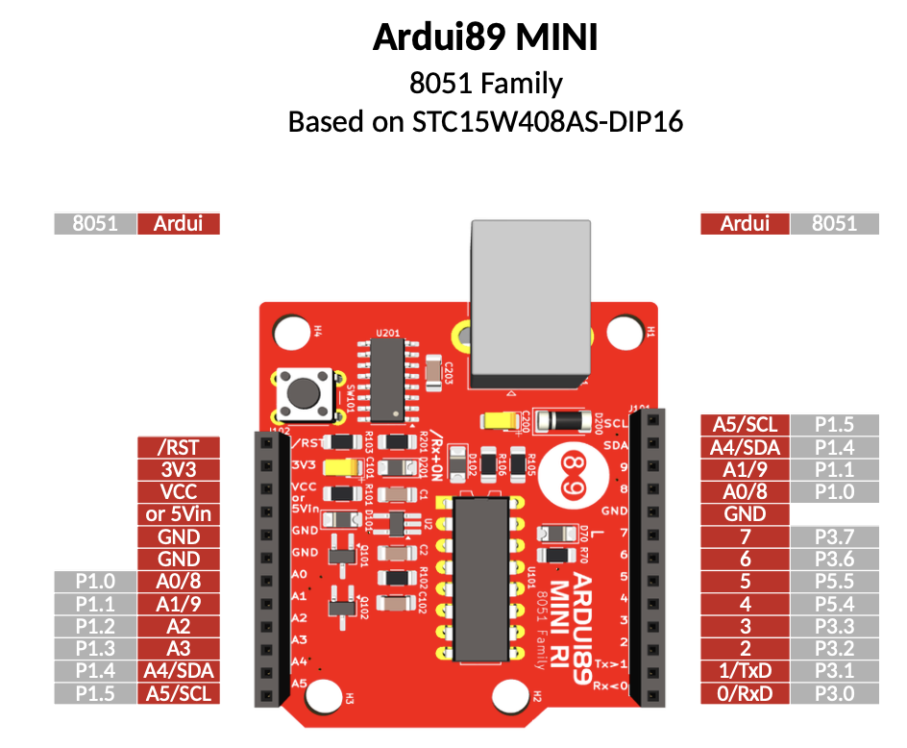
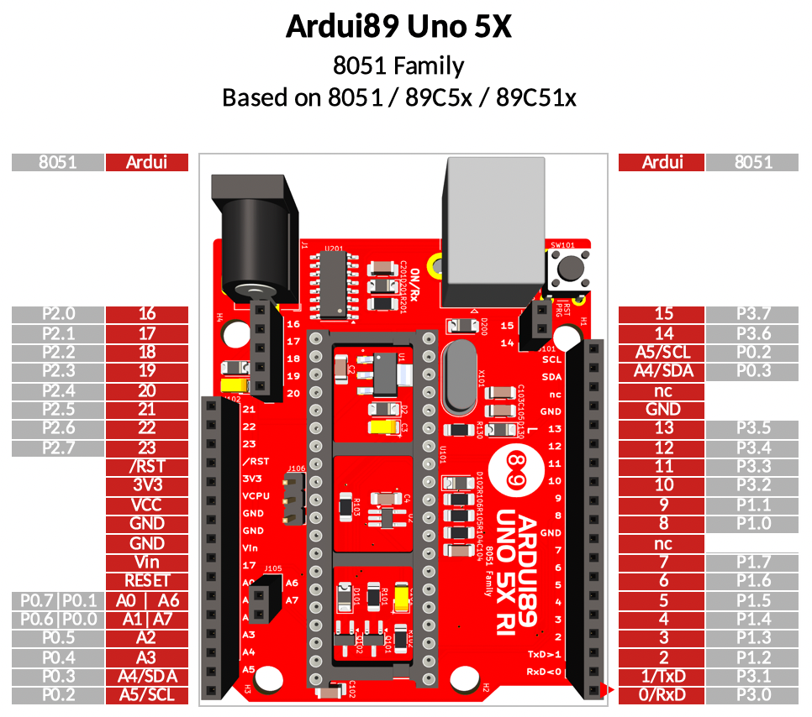
Arduino IDE®

1/ Donwload Arduino >= V1.8.19

2/ Launch Arduino

3/ In Arduino->Preferences->Additional Board Manager URLS
add

http://bacciel.com/tools/package_ardui89_index.json

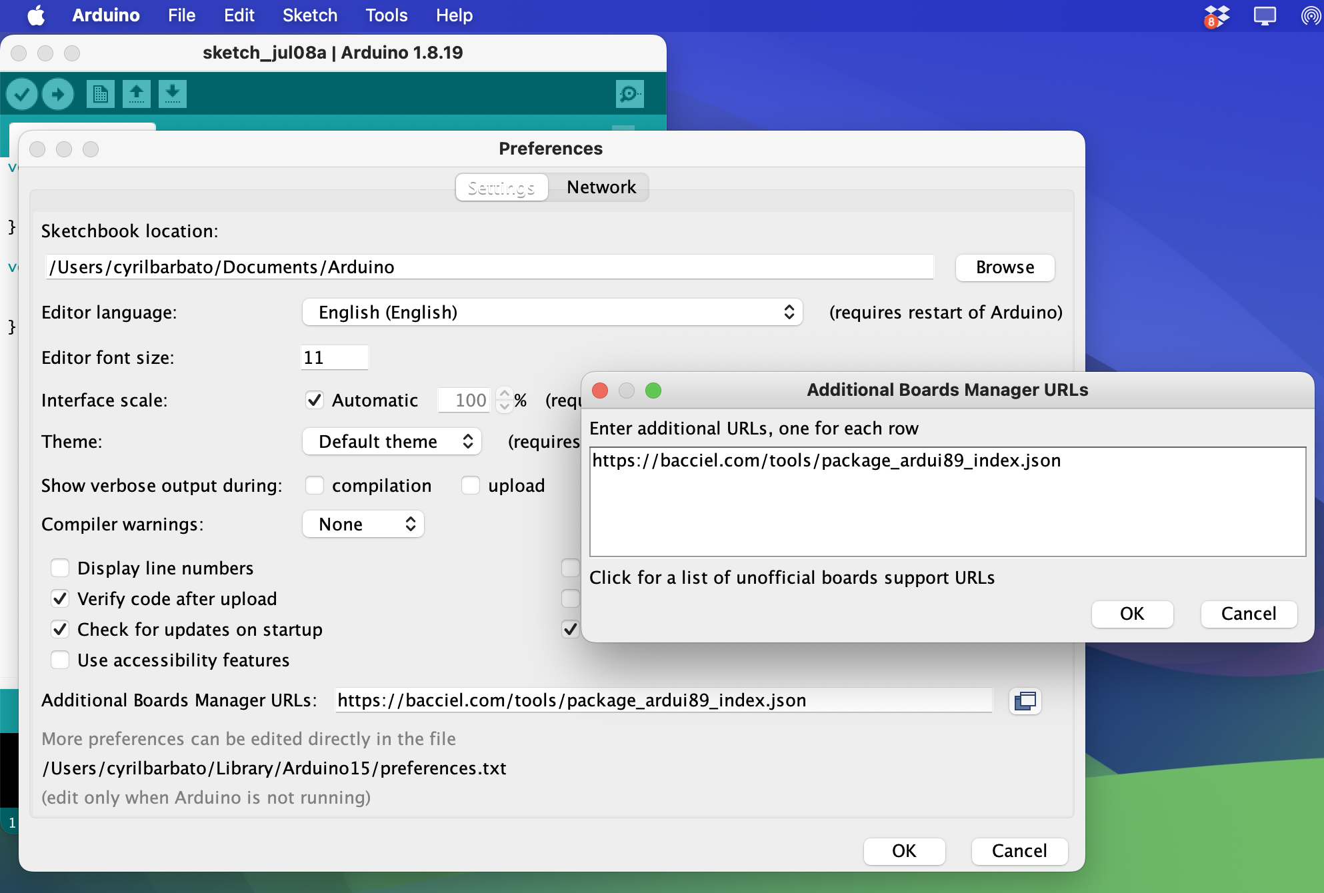

4/ In Tools->Boards:...->Board Manager
search "8051"
select and install "ardui89 8051 family Boards"
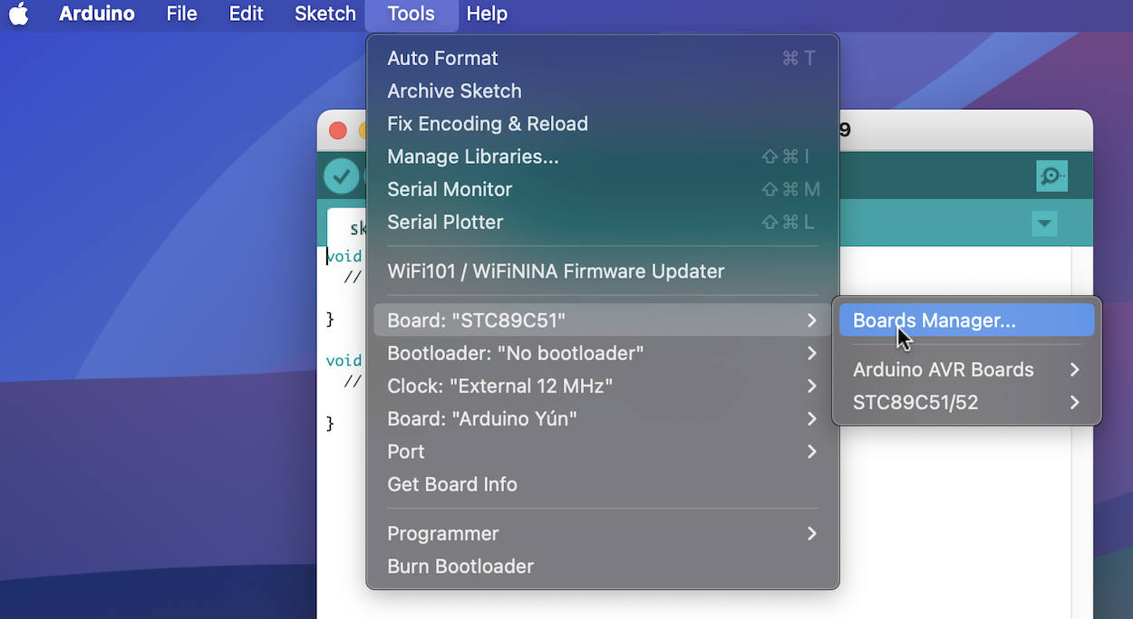

5/ In Tools->Board:...
select "Board : "STC89C51" "STC89C52" "....""

6/ Demos :
Use Blink.ino in basics examples or in Ardui89_demos path :
Hello.ino
Howareyou.ino
and build and upload !
Examples

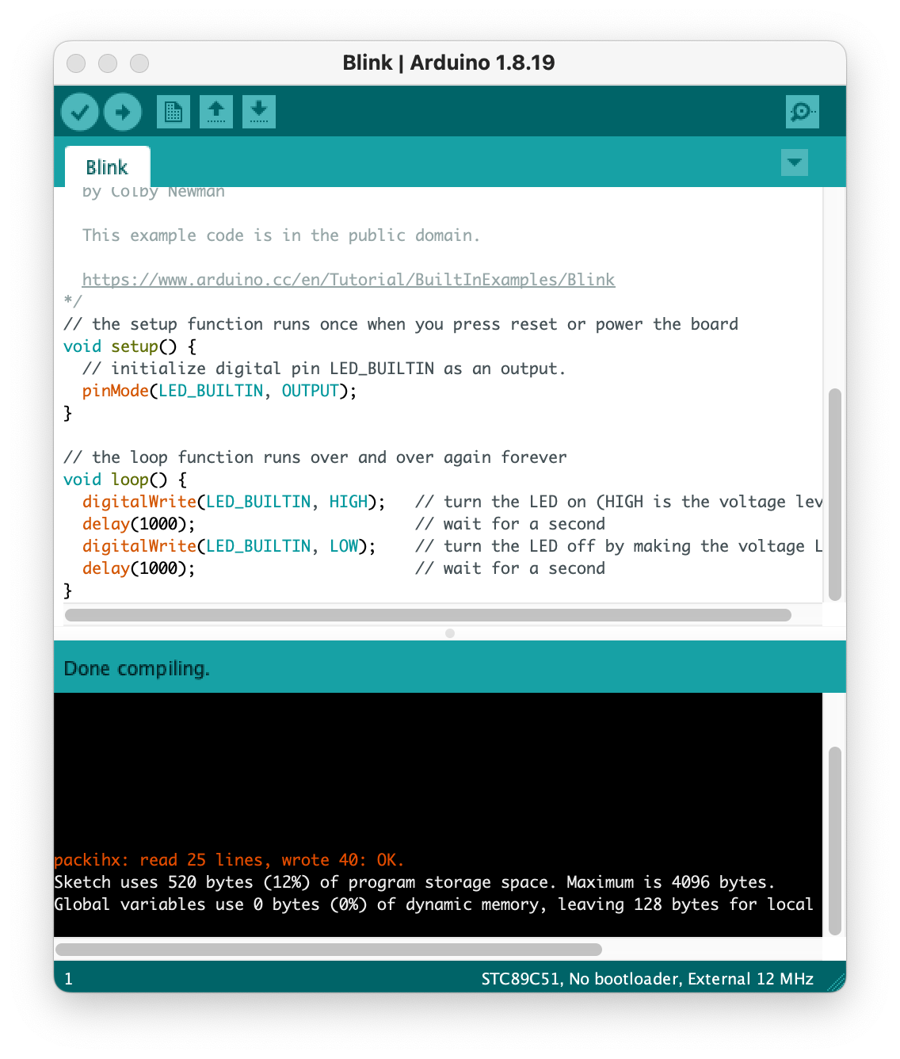

Functions Arduino / Ardui89

analogRead(pin) : not include, todo

digitalWrite(pin, state) : since 0.0.1

digitalRead(pin) : not include, todo

delay(ms) : since 0.0.1

delayMicroseconds(us) : since 0.0.1

int_to_string(int) : since 0.3.10, exclusively in C for 8051

memcpy_P(dest, src, size) : since 0.3.10

pinMode : since 0.0.1

PROMEM : since 0.0.1

8051/prgspace.h : since 0.3.10

Serial89Init() : since 0.0.1 exclusively in C for 8051 architecture. Mandatory for using Serial

Example :

// Serial port init
#if defined(ARDUINO_ARCH_8051)
Serial89Init(); // Serial 89 init
#endif

Serial.begin(9600); // Monitor init (F_CPU = 11.0592Mhz)

// Message
Serial.println("Hello, the world !");

Serial.begin(bauds) : since 0.0.1

Serial.print(data) : since 0.0.1 like printf in C, not Arduino C++

Serial.println(data) : since 0.0.1 like printf in C, with \n, not Arduino C++

tone(frequency (, duration)) : since 0.0.1

