Ardui89 MINI
8051 Family
Based on STC15W408AS-DIP16

 |  | 8051 | Ardui | 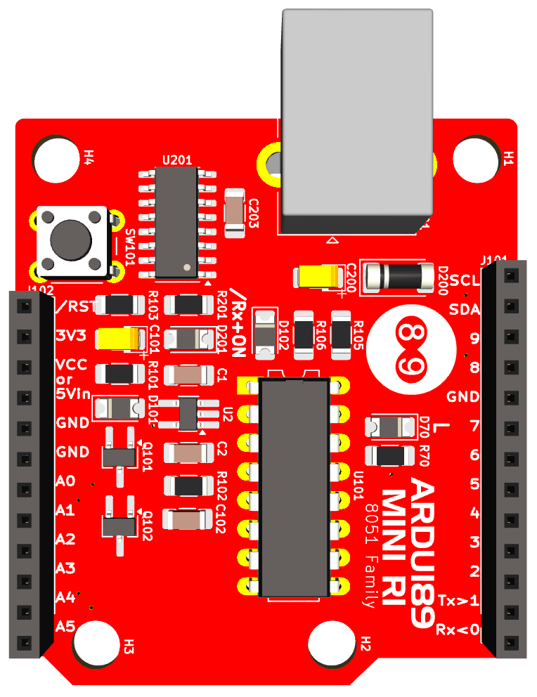 | Ardui | 8051
 |  |  |  |  | A5/SCL | P1.5
 |  |  | /RST |  | A4/SDA | P1.4
 |  |  | 3V3 |  | A1/9 | P1.1
 |  |  | VCC |  | A0/8 | P1.0
 |  |  | or 5Vin |  | GND
 |  |  | GND |  | 7 | P3.7
 |  |  | GND |  | 6 | P3.6
 |  | P1.0 | A0/8 |  | 5 | P5.5
 |  | P1.1 | A1/9 |  | 4 | P5.4
 |  | P1.2 | A2 |  | 3 | P3.3
 |  | P1.3 | A3 |  | 2 | P3.2
 |  | P1.4 | A4/SDA |  | 1/TxD | P3.1
 |  | P1.5 | A5/SCL |  | 0/RxD | P3.0

