Ardui89 STC15W408AS-DIP16
8051 Family

 |  | Pin | 8051 | Ardui | 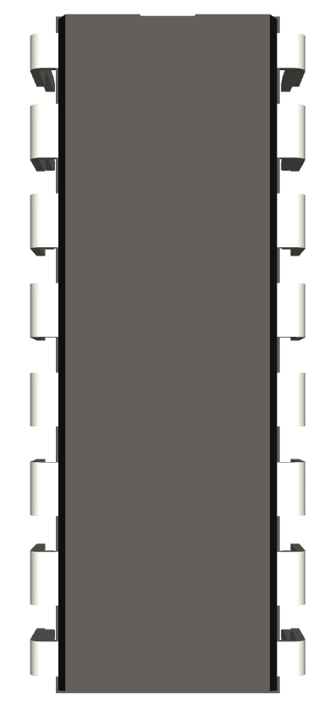 | Ardui | 8051 | Pin
 |  | 1 | P1.2 | A2 |  | A1/9 | P1.1 | 16
 |  | 2 | P1.3 | A3 |  | A0/8 | P1.0 | 15
 |  | 3 | P1.4 | A4/SDA |  | 7 | P3.7 | 14
 |  | 4 | P1.5 | A5/SCL |  | 6 | P3.6 | 13
 |  | 5 | P5.4 | 4 |  | 3 | P3.3 | 12
 |  | 6 | VCC |  |  | 2 | P3.2 | 11
 |  | 7 | P5.5 | 5 |  | 1/TxD | P3.1 | 10
 |  | 8 | GND |  |  | 0/RxD | P3.0 | 9

