Ardui89 USB Unversal Programmer
8051 Family
Self-Programmer for most STC micro-controllers
(STC89C5x/51x, STC15W..., STC32...)

 | PC | 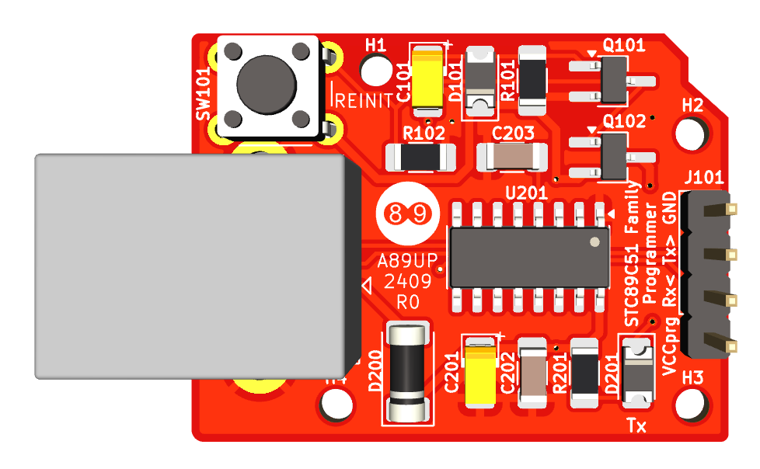 | Ardui
 |  |  | 15
 |  |  | 14
 | USB B |  | GND
 | USB B |  | Tx>
 | USB B |  | Rx<
 |  |  | VCCprog

