Ardui89 Uno 5X
8051 Family
Based on 8051 / 89C5x / 89C51x

 |  | 8051 | Ardui | 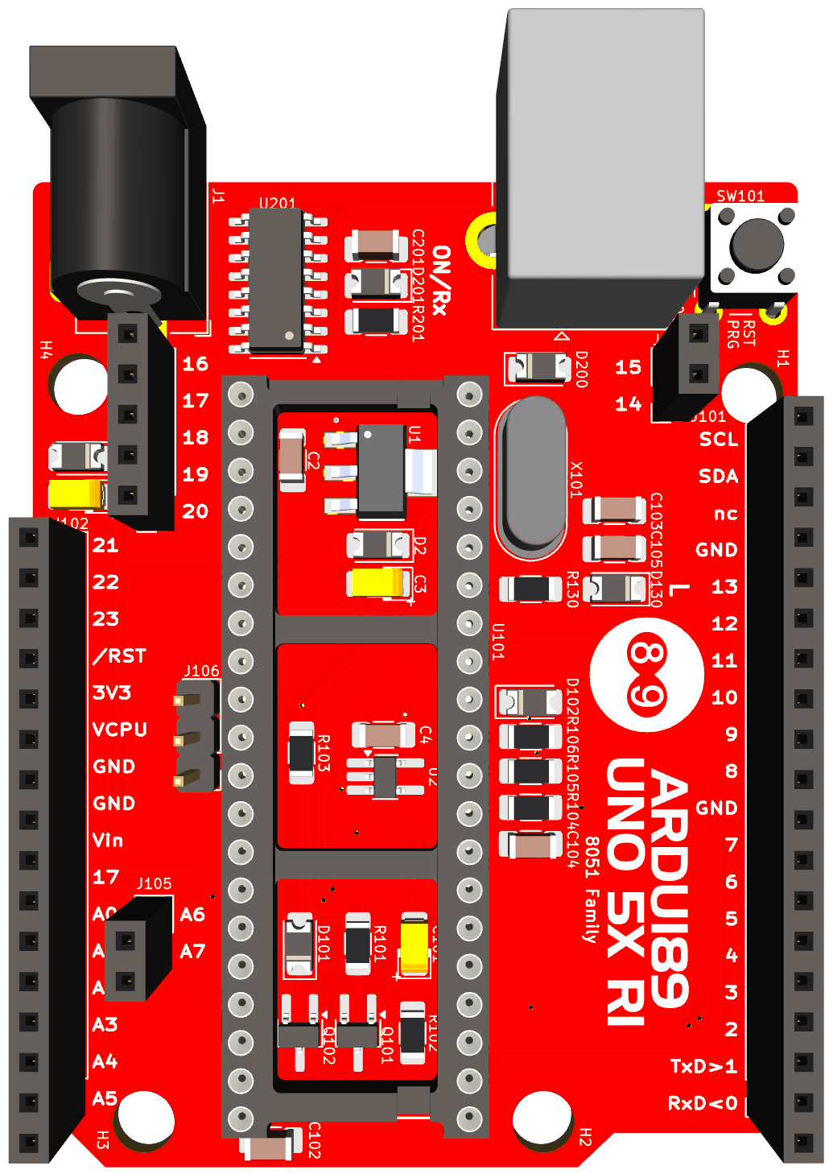 | Ardui | 8051
 |  | P2.0 | 16 |  | 15 | P3.7
 |  | P2.1 | 17 |  | 14 | P3.6
 |  | P2.2 | 18 |  | A5/SCL | P0.2
 |  | P2.3 | 19 |  | A4/SDA | P0.3
 |  | P2.4 | 20 |  | nc
 |  | P2.5 | 21 |  | GND
 |  | P2.6 | 22 |  | 13 | P3.5
 |  | P2.7 | 23 |  | 12 | P3.4
 |  |  | /RST |  | 11 | P3.3
 |  |  | 3V3 |  | 10 | P3.2
 |  |  | VCC |  | 9 | P1.1
 |  |  | GND |  | 8 | P1.0
 |  |  | GND |  | nc
 |  |  | Vin |  | 7 | P1.7
 |  |  | RESET |  | 6 | P1.6
 |  | P1.7|P0.2 | A0 | A6 |  | 5 | P1.5
 |  | P1.6|P0.1 | A1 | A7 |  | 4 | P1.4
 |  | P0.5 | A2 |  | 3 | P1.3
 |  | P0.4 | A3 |  | 2 | P1.2
 |  | P0.3 | A4/SDA |  | 1/TxD | P3.1
 |  | P0.2 | A5/SCL |  | 0/RxD | P3.0

