Ardui89 Cinque Uno
8051 Family
Based on 8051/89C5x/89C51x/90C51x

 |  | 8051 | Ardui | 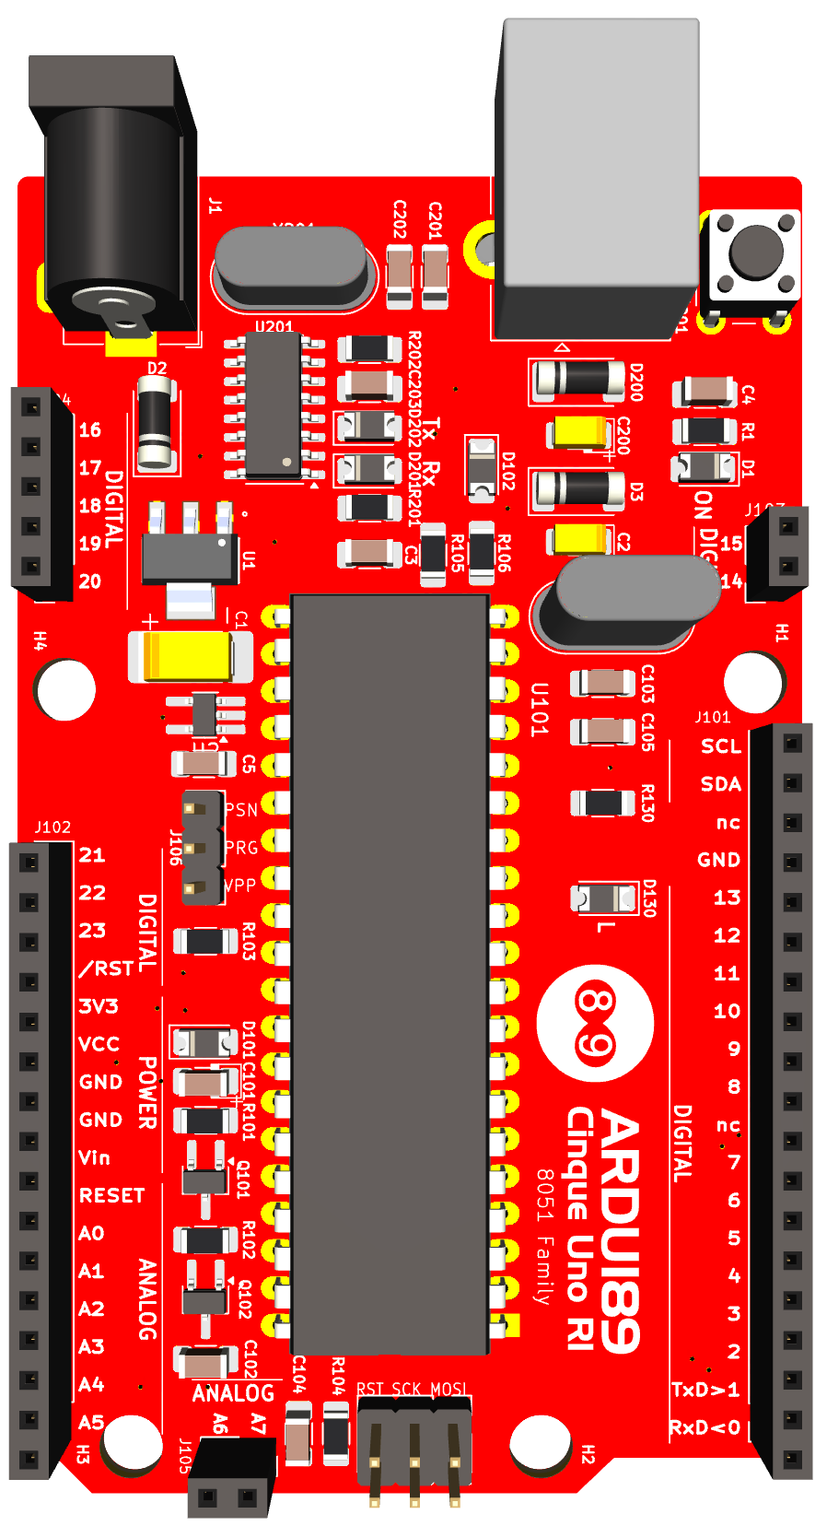 |  |  |  |  |  |  |  |  |  |  |  |  |  |  | Ardui | 8051
 |  | P2.0 | 16
 |  | P2.1 | 17
 |  | P2.2 | 18
 |  | P2.3 | 19 |  |  |  |  |  |  |  |  |  |  |  |  |  |  |  | 15 | P3.7
 |  | P2.4 | 20 |  |  |  |  |  |  |  |  |  |  |  |  |  |  |  | 14 | P3.6
 |  |  |  |  |  |  |  |  |  |  |  |  |  |  |  |  |  |  | A5/SCL | P0.2
 |  |  |  |  |  |  |  |  |  |  |  |  |  |  |  |  |  |  | A4/SDA | P0.3
 |  |  |  |  |  |  |  |  |  |  |  |  |  |  |  |  |  |  | nc
 |  | P2.5 | 21 |  |  |  |  |  |  |  |  |  |  |  |  |  |  |  | GND
 |  | P2.6 | 22 |  |  |  |  |  |  |  |  |  |  |  |  |  |  |  | 13 | P3.5
 |  | P2.7 | 23 |  |  |  |  |  |  |  |  |  |  |  |  |  |  |  | 12 | P3.4
 |  |  | /RST |  |  |  |  |  |  |  |  |  |  |  |  |  |  |  | 11 | P3.3
 |  |  | 3V3 |  |  |  |  |  |  |  |  |  |  |  |  |  |  |  | 10 | P3.2
 |  |  | VCC |  |  |  |  |  |  |  |  |  |  |  |  |  |  |  | 9 | P1.1
 |  |  | GND |  |  |  |  |  |  |  |  |  |  |  |  |  |  |  | 8 | P1.0
 |  |  | GND |  |  |  |  |  |  |  |  |  |  |  |  |  |  |  | nc
 |  |  | Vin |  |  |  |  |  |  |  |  |  |  |  |  |  |  |  | 7 | P1.7
 |  |  | RESET |  |  |  |  |  |  |  |  |  |  |  |  |  |  |  | 6 | P1.6
 |  | P0.7 | A0 |  |  |  |  |  |  |  |  |  |  |  |  |  |  |  | 5 | P1.5
 |  | P0.6 | A1 |  |  |  |  |  |  |  |  |  |  |  |  |  |  |  | 4 | P1.4
 |  | P0.5 | A2 |  |  |  |  |  |  |  |  |  |  |  |  |  |  |  | 3 | P1.3
 |  | P0.4 | A3 |  |  |  |  |  |  |  |  |  |  |  |  |  |  |  | 2 | P1.2
 |  | P0.3 | A4/SDA |  |  |  |  |  |  |  |  |  |  |  |  |  |  |  | 1/TxD | P3.1
 |  | P0.2 | A5/SCL |  |  |  |  |  |  |  |  |  |  |  |  |  |  |  | 0/RxD | P3.0
 |  | P0.1 | A6
 |  | P0.0 | A7

Arduino IDE®

1/ Donwload Arduino >= V1.8.19

2/ Launch Arduino

3/ In Arduino->Preferences->Additional Board Manager URLS
add

http://bacciel.com/tools/package_ardui89_index.json

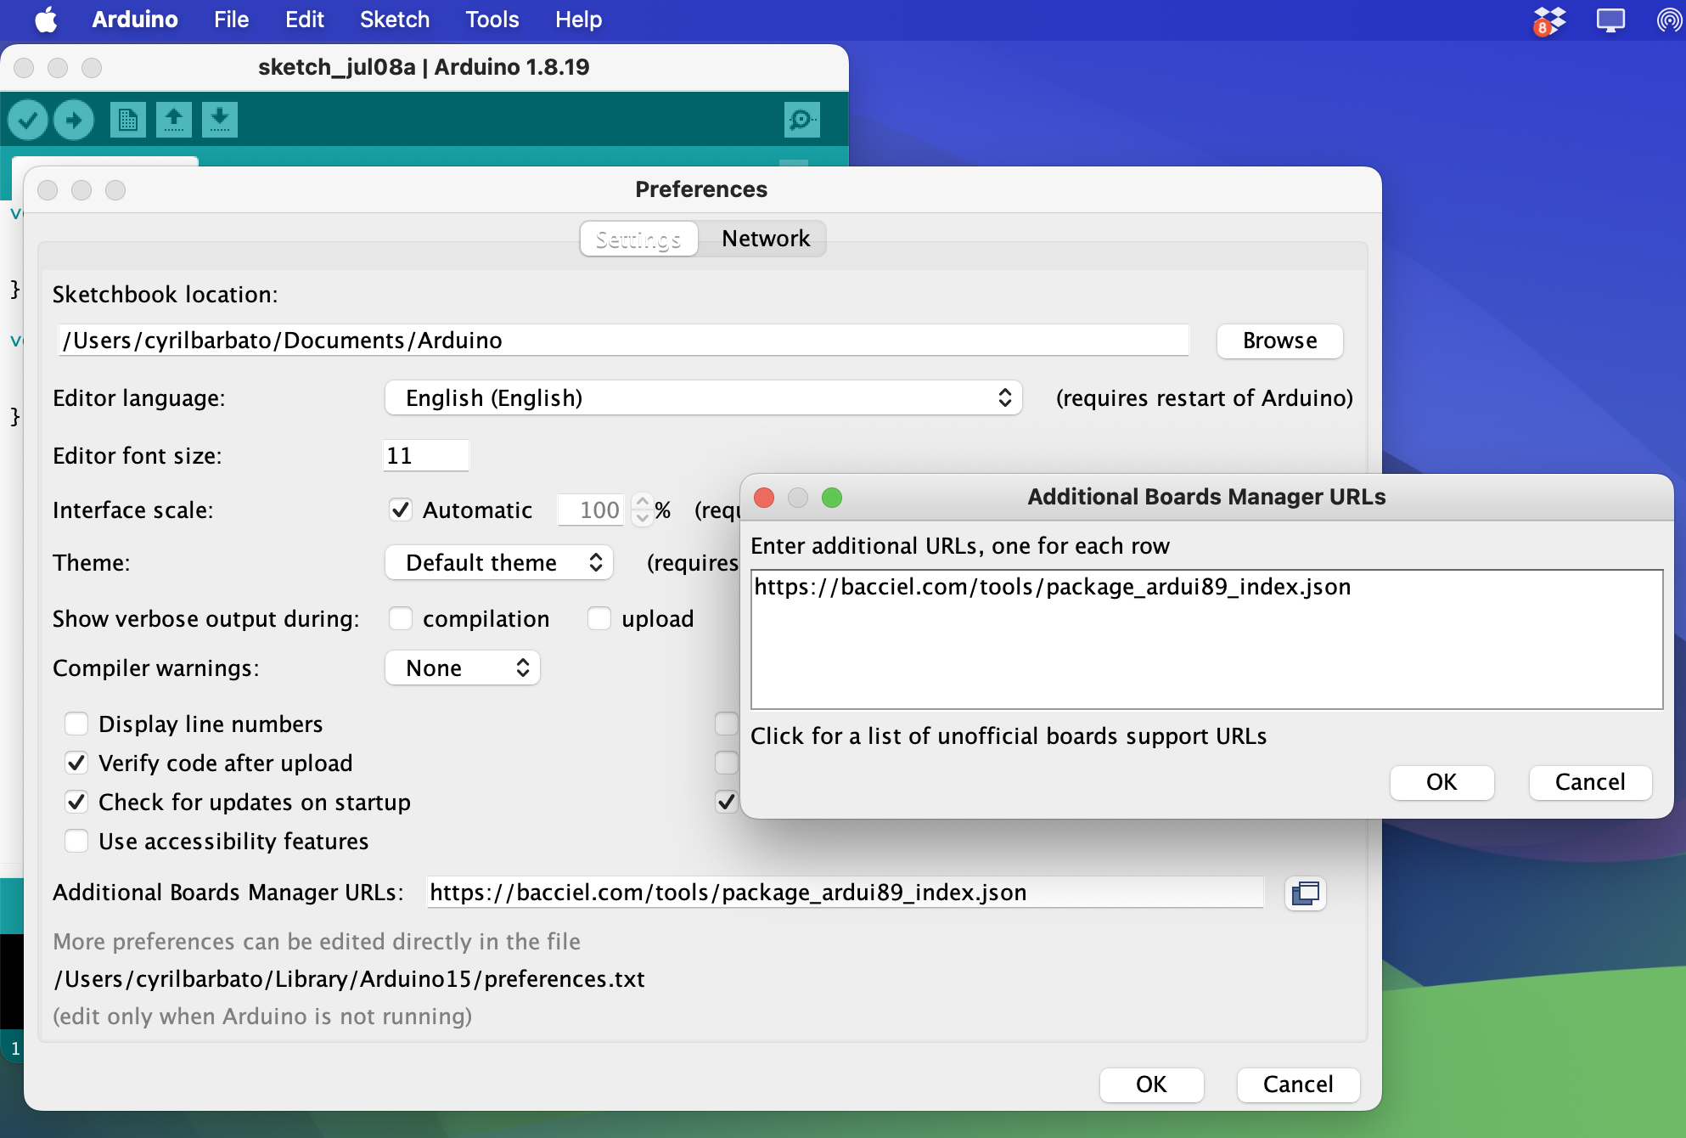

4/ In Tools->Boards:...->Board Manager
search "8051"
select and install "ardui89 8051 family Boards"
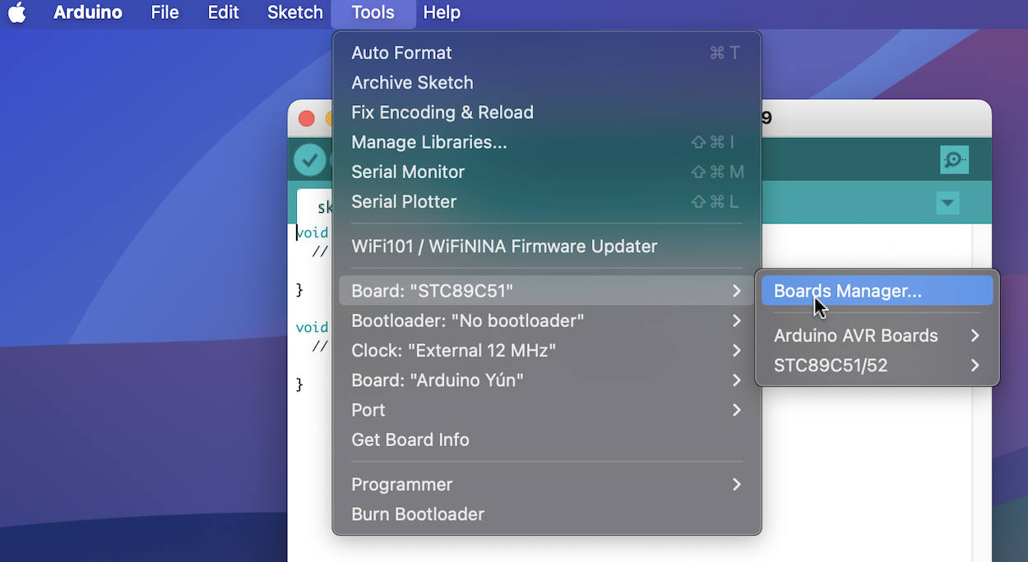

5/ In Tools->Board:...
select "Board : "STC89C51" "STC89C52" "....""

6/ Demos :
Use Blink.ino in basics examples or in Ardui89_demos path :
Hello.ino
Howareyou.ino
and build and upload !
Materials

Id | Référence | Empreinte | Quantité | Désignation
1 | X201 | Crystal_HC49-4H_Vertical | 1 | 12MHz
2 | J102 | Ardu89_Uno_Analog_Power_Connector | 1 | Conn_01x16
3 | R106,R105 | R_1206_3216Metric_Pad1.30x1.75mm_HandSolder | 2 | 330
4 | C101 | C_1206_POL_3216Metric_Pad1.33x1.80mm_HandSolder | 1 | 10µ
5 | H2,H3,H4 | MountingHole_4.3mm_M4_DIN965 | 3 | MountingHole
6 | J105,J103 | PinSocket_1x02_P2.54mm_Vertical | 2 | Extented Port
7 | U101 | DIP-40_W15.24mm_LongPads | 1 | 89C5x
8 | J106 | PinHeader_1x03_P2.54mm_Vertical | 1 | Conn_01x03
9 | D200,D3,D2 | D_MELF | 3 | SM34
10 | D102,D101 | D_1206_3216Metric_Pad1.42x1.75mm_HandSolder | 2 | 1N5819W
11 | U2 | TSOT-23-5_HandSoldering | 1 | LP2985-33DBVR
12 | X101 | Crystal_HC49-U-3PinB_Vertical | 1 | 11.0592MHz
13 | U201 | SOIC-16_3.9x9.9mm_P1.27mm | 1 | CH340G
14 | J101 | Ardu89_Uno_Digital_Connector | 1 | Conn_01x19
15 | R1,R202,R101,R104,R103,R130,R201 | R_1206_3216Metric_Pad1.30x1.75mm_HandSolder | 7 | 1k
16 | Q101,Q102 | TSOT-23_HandSoldering | 2 | MMBTA2907
17 | C104,C203,C102,C5,C3,C4 | C_1206_3216Metric_Pad1.33x1.80mm_HandSolder | 6 | 100n
18 | C202,C201 | C_1206_3216Metric_Pad1.33x1.80mm_HandSolder | 2 | 27p
19 | C1,C2,C200 | C_2512_Pol_Tantale_Trainning | 3 | 10µ
20 | SW101 | SW_PUSH_6mm | 1 | SW_Push
21 | D1 | D_1206_3216Metric_Pad1.42x1.75mm_HandSolder | 1 | LED
22 | ICSP101 | PinHeader_2x03_P2.54mm_Vertical | 1 | M20-9980346
23 | J104 | PinSocket_1x05_P2.54mm_Vertical | 1 | Extended Port
24 | D130 | D_1206_3216Metric_Pad1.42x1.75mm_HandSolder | 1 | BUILTIN_LED
25 | D201 | D_1206_3216Metric_Pad1.42x1.75mm_HandSolder | 1 | Rx LED
26 | D202 | D_1206_3216Metric_Pad1.42x1.75mm_HandSolder | 1 | Tx LED
27 | C105,C103 | C_1206_3216Metric_Pad1.33x1.80mm_HandSolder | 2 | 22p
28 | R102 | R_1206_3216Metric_Pad1.30x1.75mm_HandSolder | 1 | 4k7
29 | U1 | SOT230P700X180-4N | 1 | LD1117S50TR
30 | H1 | MountingHole_4.3mm_M4_DIN965 | 1 | Mounting Hole 4.3mm
31 | J201 | USB_B_Lumberg_2411_02_Horizontal | 1 | USB_TYPE_B
32 | J1 | BarrelJack_Horizontal | 1 | Jack-DC

Examples

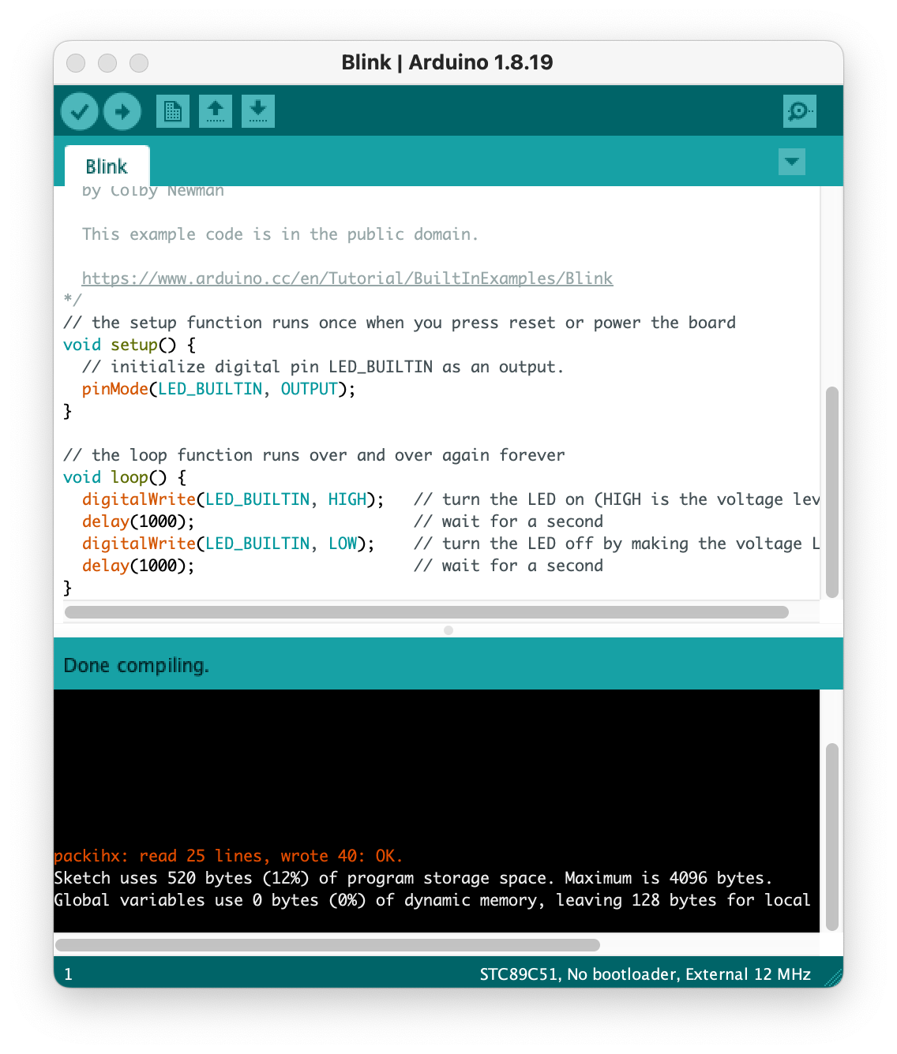

Functions Arduino / Ardui89

analogRead(pin) : not include, todo

digitalWrite(pin, state) : since 0.0.1

digitalRead(pin) : not include, todo

delay(ms) : since 0.0.1

delayMicroseconds(us) : since 0.0.1

int_to_string(int) : since 0.3.10, exclusively in C for 8051

memcpy_P(dest, src, size) : since 0.3.10

pinMode : since 0.0.1

PROMEM : since 0.0.1

8051/prgspace.h : since 0.3.10

Serial89Init() : since 0.0.1 exclusively in C for 8051 architecture. Mandatory for using Serial

Example :

// Serial port init
#if defined(ARDUINO_ARCH_8051)
Serial89Init(); // Serial 89 init
#endif

Serial.begin(9600); // Monitor init (F_CPU = 11.0592Mhz)

// Message
Serial.println("Hello, the world !");

Serial.begin(bauds) : since 0.0.1

Serial.print(data) : since 0.0.1 like printf in C, not Arduino C++

Serial.println(data) : since 0.0.1 like printf in C, with \n, not Arduino C++

tone(frequency (, duration)) : since 0.0.1

