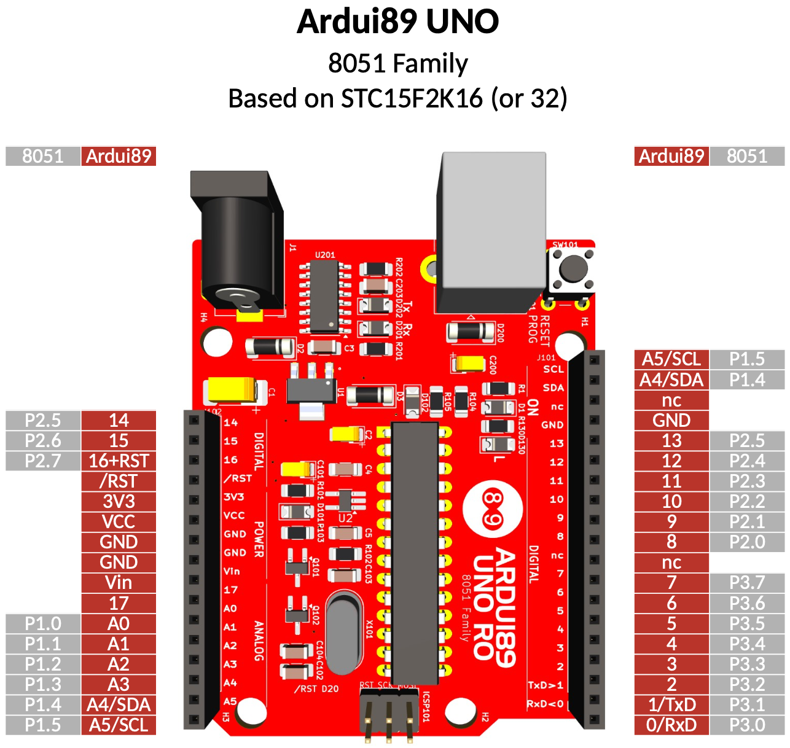
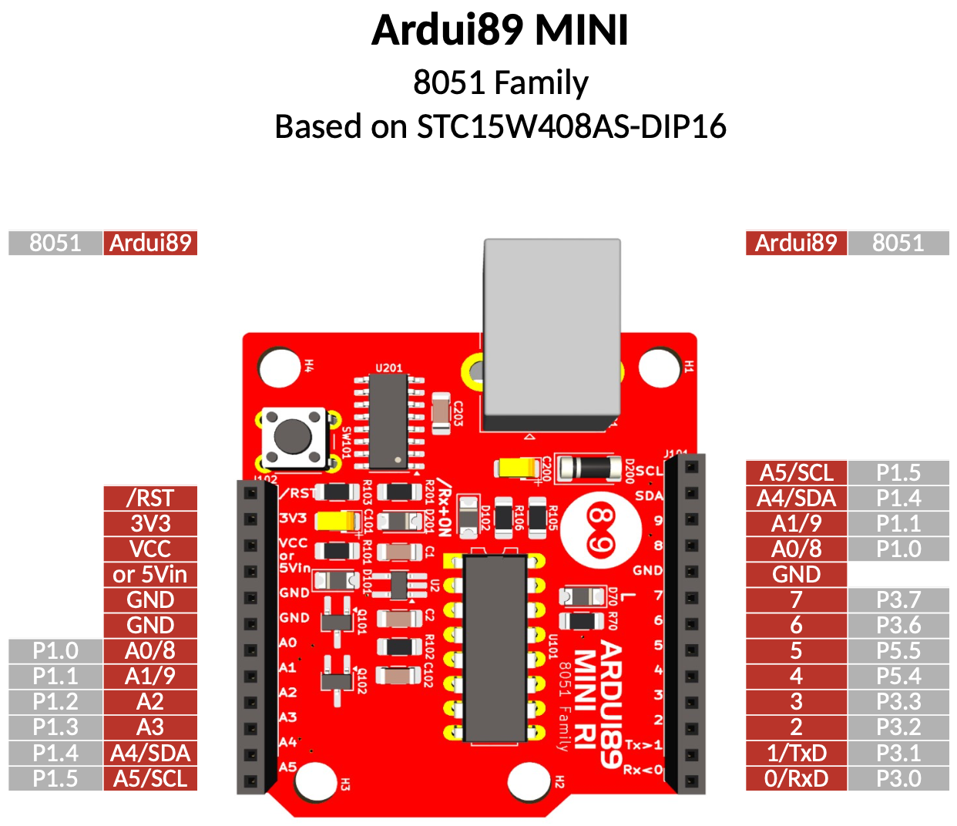
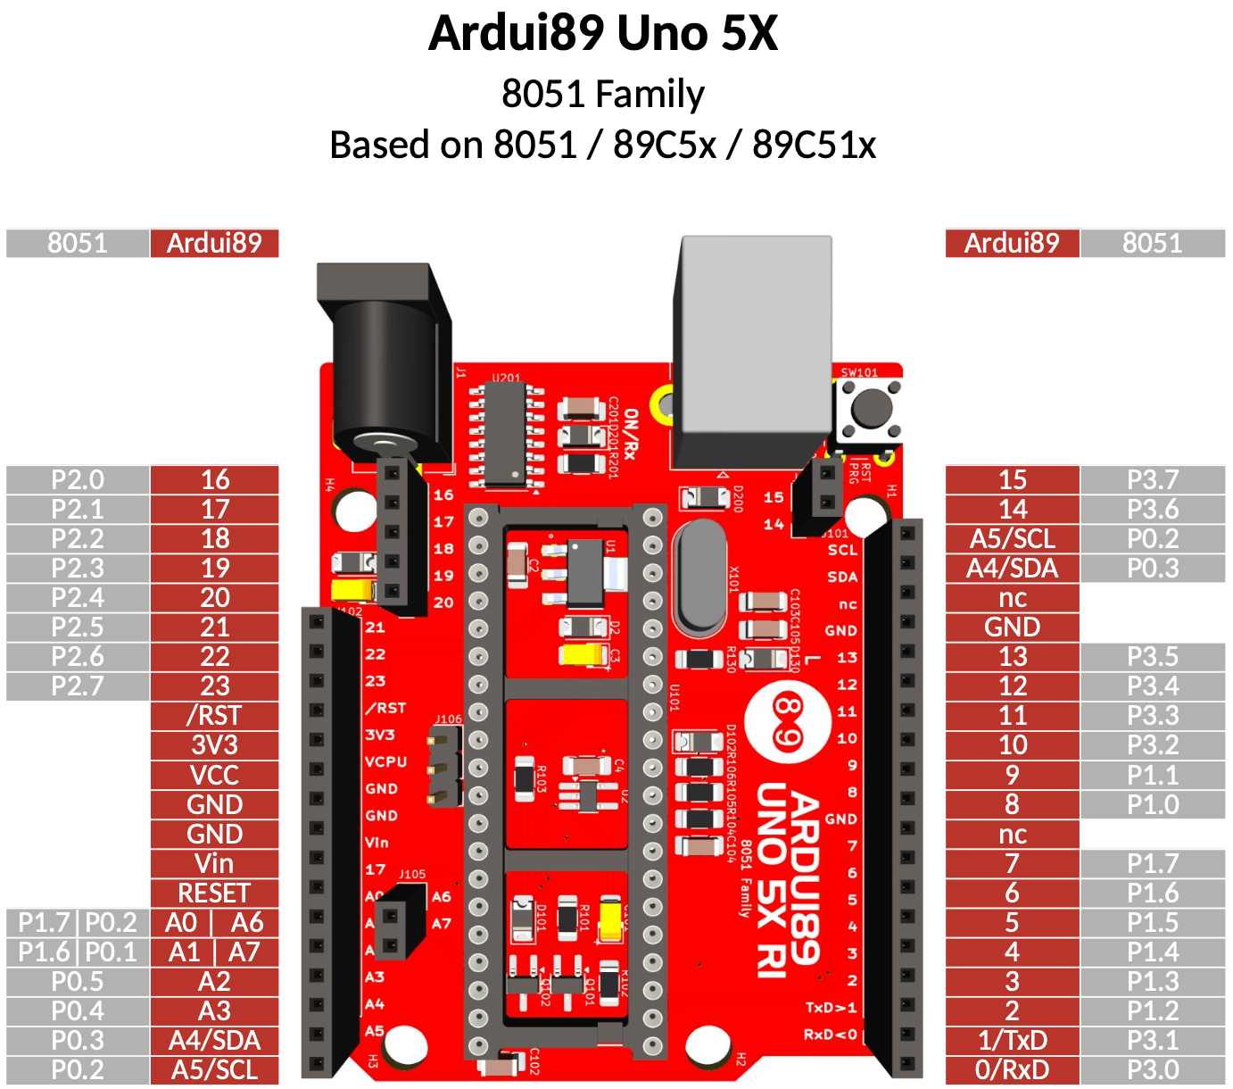
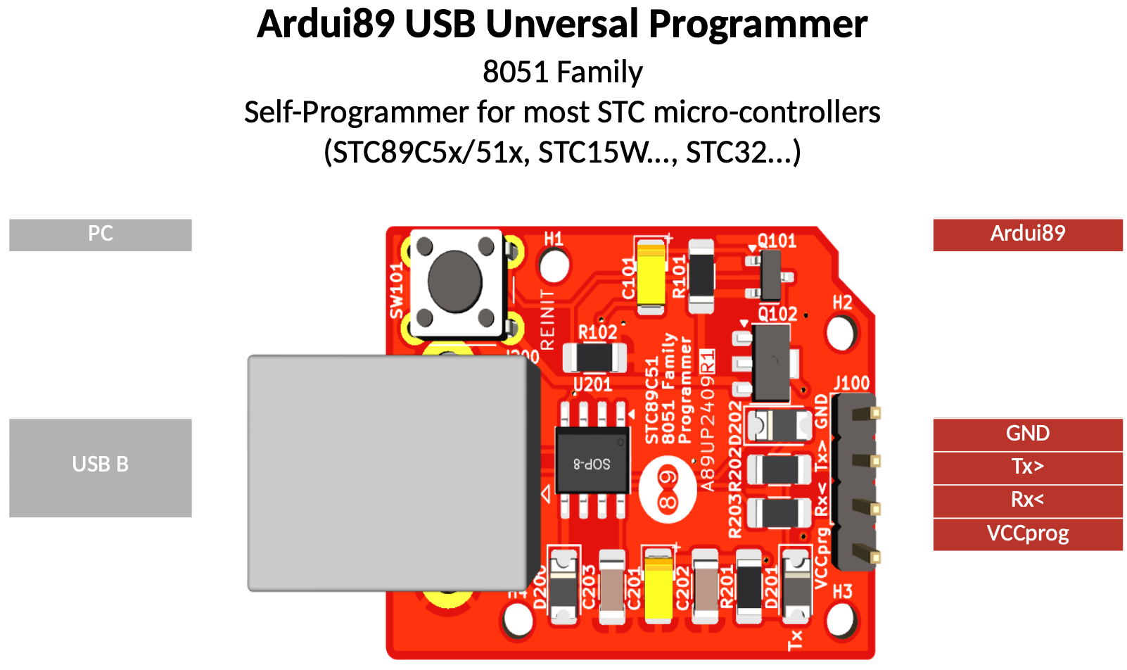
Arduino IDE®

1/ Donwload Arduino >= V1.8.19

2/ Launch Arduino

3/ In Arduino->Preferences->Additional Board Manager URLS

add for Arduino All Versions :

https://master.dl.sourceforge.net/project/stc89/packages/package_ardui89_index.json?viasf=1

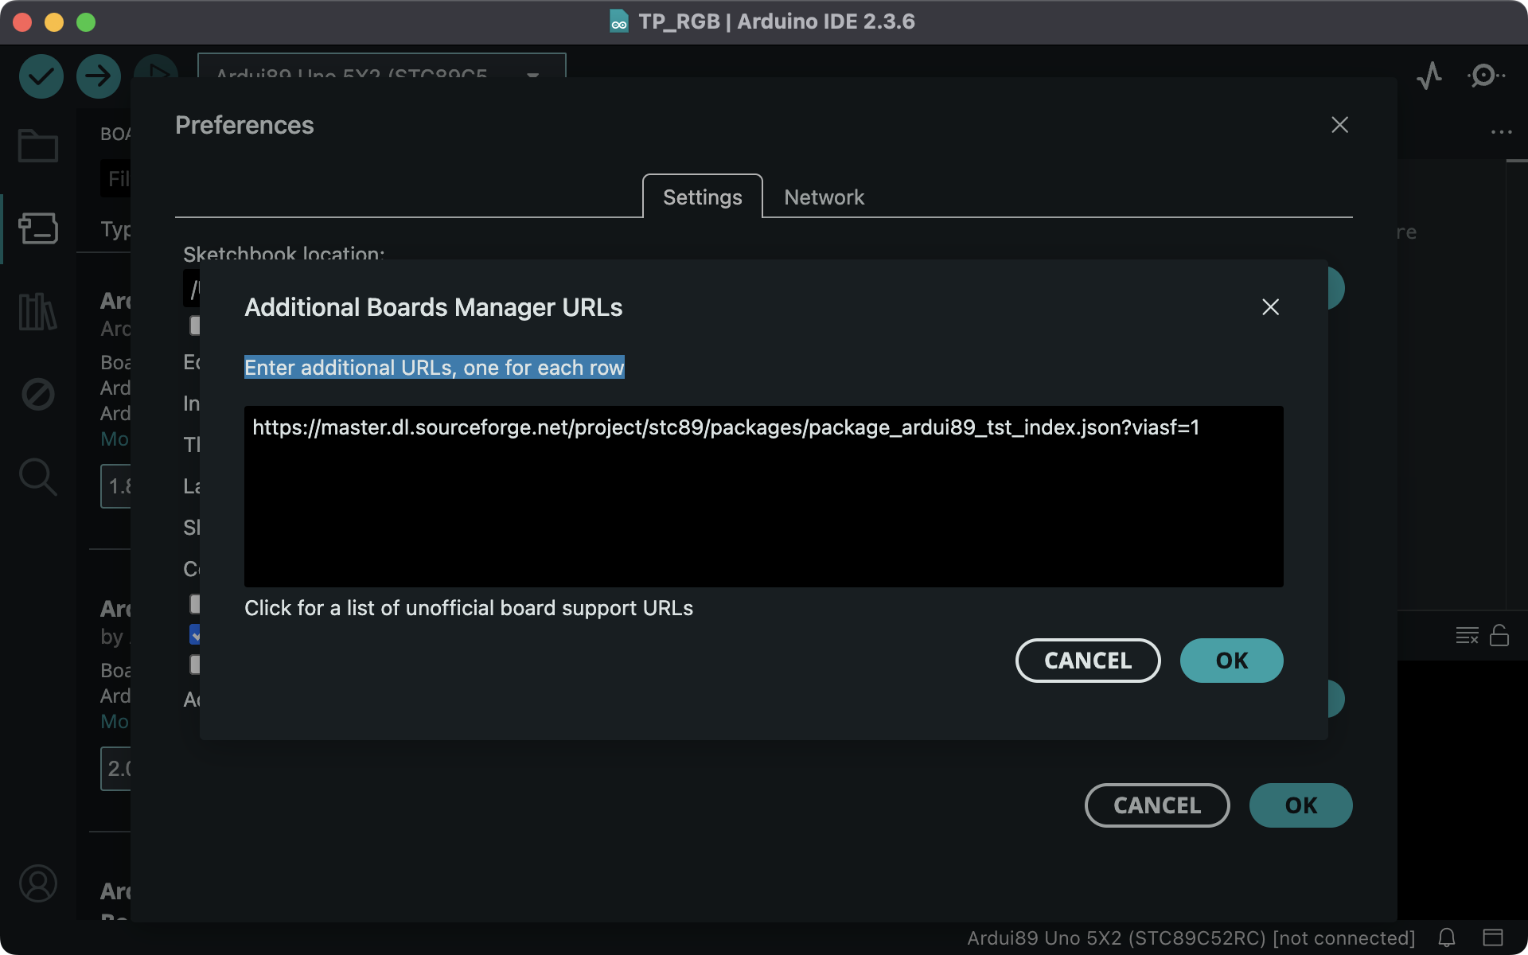

4/ In Tools->Boards:...->Board Manager
search "8051"
select and install "ardui89 8051 family Boards"

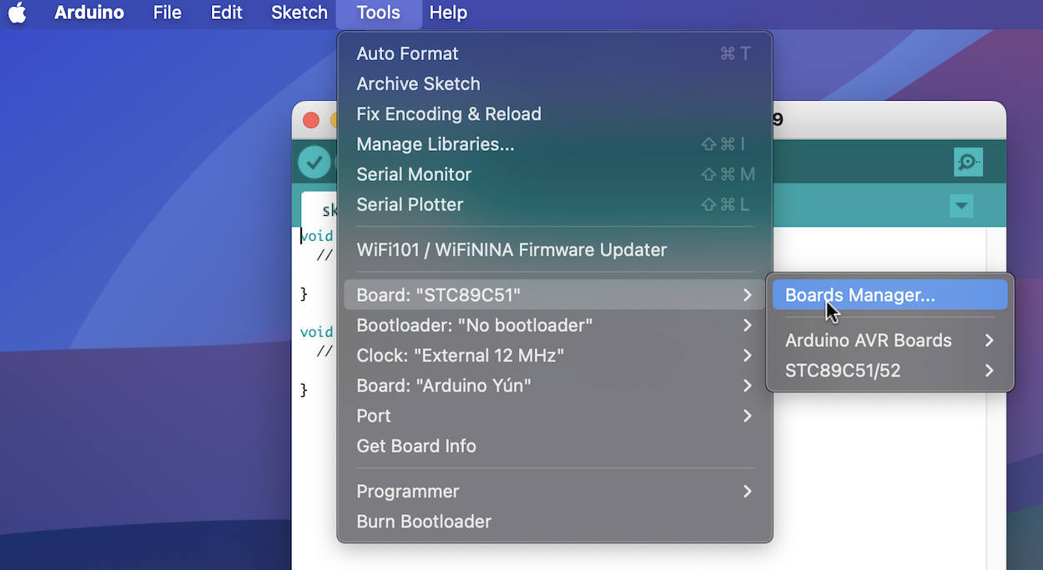

5/ In Tools->Board:...
select "Board : "STC89C51" "STC89C52" "....""

6/ Demos :
Use Blink.ino in basics examples or in Ardui89_demos path :
Hello.ino
Howareyou.ino
and build and upload !

Examples

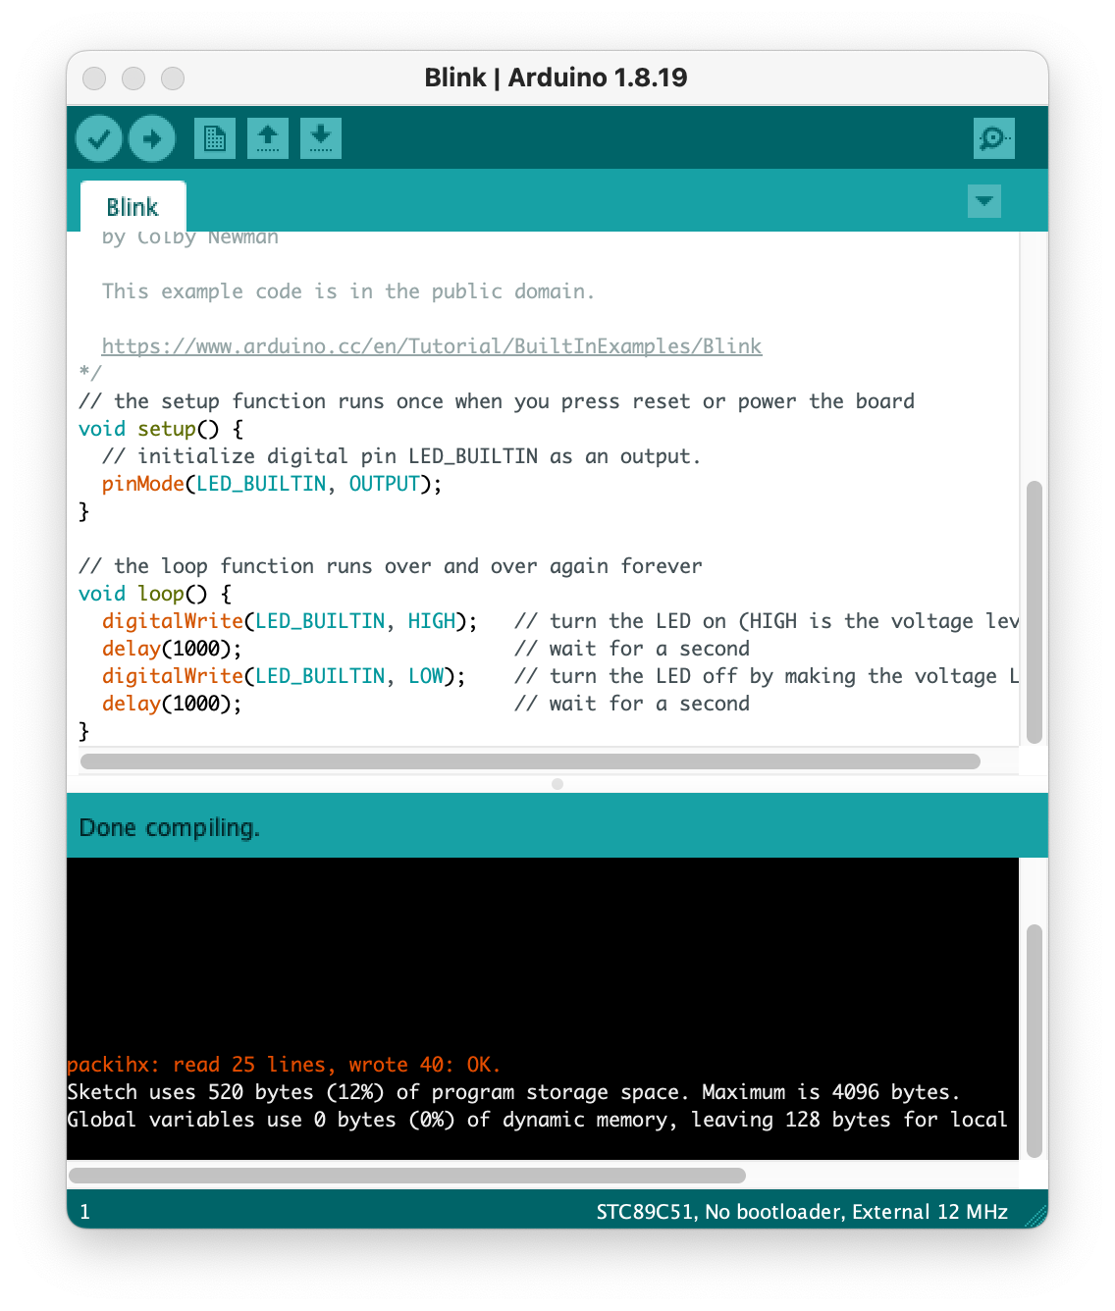

Functions Arduino / Ardui89

analogPin(pin) : since 0.4.2, optimized code that saves 200 bytes, configure a pin as analog input (A0, A1..)

or pinMode(pin, INPUT_ANALOG) : since version 0.4.2, Arduino style code, configure a pin as an analog input (A0, A1..) but with 200 more bytes.

analogRead(pin) : read analog value from analog pin channel (A0, A1...)

digitalWrite(pin, state) : since 0.0.1

digitalRead(pin) : since 0.3.7

delay(ms) : since 0.0.1

delayMicroseconds(us) : since 0.0.1

int_to_string(int) : since 0.3.10, exclusively in C for 8051

memcpy_P(dest, src, size) : since 0.3.10

pinMode : since 0.0.1

PROMEM : since 0.0.1

8051/prgspace.h : since 0.3.10

Serial89Init() : since version 0.0.1, exclusively in C for the 8051 architecture. Required for use of the serial connection.

Example :

// Serial port init
#if defined(ARDUINO_ARCH_8051)
Serial89Init(); // Serial 89 init
#endif

Serial.begin(9600); // Monitor init (F_CPU = 11.0592Mhz)

// Message
Serial.println("Hello, the world !");

Serial.begin(bauds) : since 0.0.1

Serial.print(data) : since 0.0.1 like printf in C, not Arduino C++

Serial.println(data) : since 0.0.1 like printf in C, with \n, not Arduino C++

tone(frequency (, duration)) : since 0.0.1

