Ardui89 UNO
8051 Family
Based on STC15F2K16 (or 32)

 |  | 8051 | Ardui89 | 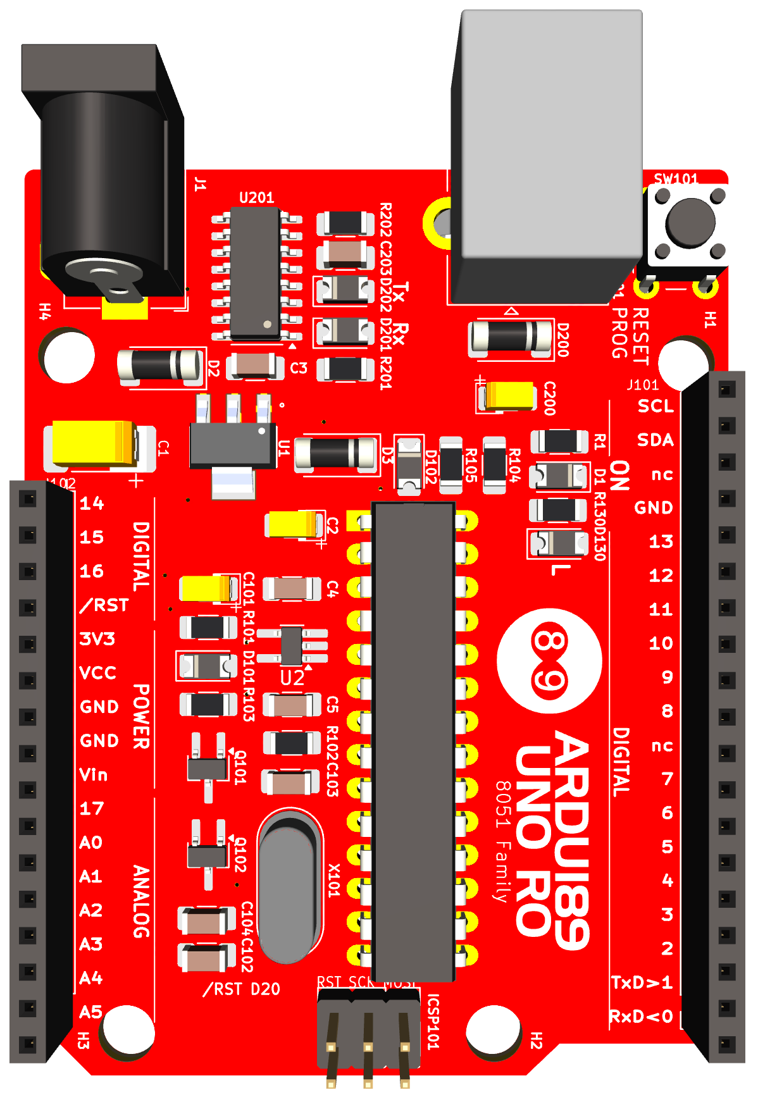 | Ardui89 | 8051
 |  |  |  |  | A5/SCL | P1.5
 |  |  |  |  | A4/SDA | P1.4
 |  |  |  |  | nc
 |  | P2.5 | 14 |  | GND
 |  | P2.6 | 15 |  | 13 | P2.5
 |  | P2.7 | 16+RST |  | 12 | P2.4
 |  |  | /RST |  | 11 | P2.3
 |  |  | 3V3 |  | 10 | P2.2
 |  |  | VCC |  | 9 | P2.1
 |  |  | GND |  | 8 | P2.0
 |  |  | GND |  | nc
 |  |  | Vin |  | 7 | P3.7
 |  |  | 17 |  | 6 | P3.6
 |  | P1.0 | A0 |  | 5 | P3.5
 |  | P1.1 | A1 |  | 4 | P3.4
 |  | P1.2 | A2 |  | 3 | P3.3
 |  | P1.3 | A3 |  | 2 | P3.2
 |  | P1.4 | A4/SDA |  | 1/TxD | P3.1
 |  | P1.5 | A5/SCL |  | 0/RxD | P3.0

