**Fundamentals of Computer Programming**

**ASSIGNMENT**

**IV**

**Prepared by: Razu Bhattarai**

**Shift: Morning**

**Roll Number: 16**

**BSc CSIT**

**Arrays and Strings:**

**1. WAP in C to initialize any 10 value in an array and display them.**

**Code:**

|  |
| --- |
| **#include <stdio.h>**  **#include <stdlib.h>**  **int main()**  **{**  **int a[10],i,j;**  **for(i=0;i<10;i++){**  **a[i]=i+2;**  **}**  **printf("The initilize value are:\n");**  **for(j=0;j<=9;j++){**  **printf("%d\t",a[j]);**  **}**  **return 0;**  **}** |

**Output:**

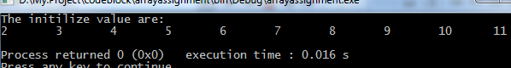

**2.WAP to input any 10 number by user and display them.**

**Code:**

|  |
| --- |
| **/\***  **Author:Razu Bhattarai**  **\*/**  **#include <stdio.h>**  **#include <stdlib.h>**  **int main()**  **{**  **int a[10],i,j;**  **printf("Enter any 10 number:\n");**  **for(i=0;i<10;i++){**  **scanf("%d",&a[i]);**  **}**  **printf("The input 10 numbers are:\n");**  **for(j=0;j<10;j++){**  **printf("%d\t",a[j]);**  **}**  **return 0;**  **} }** |

Output:

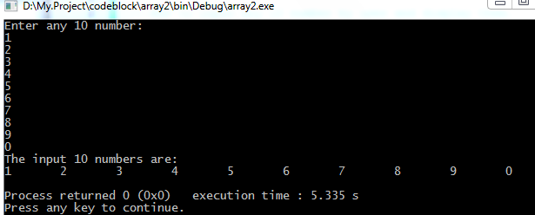

**3.WAP in C to input any 10 number in an array and print them along with the Total and average of that numbers.**

**Code:**

|  |
| --- |
| **Author:Razu Bhattarai**  **#include <stdio.h>**  **#include <stdlib.h>**  **int main()**  **{**  **int a[10],i,j,sum=0;**  **printf("Enter any 10 number:\n");**  **for(i=0;i<10;i++){**  **scanf("%d",&a[i]);**  **sum=sum+a[i];**  **}**  **float avg=sum/10;**  **printf("The input no along with total and average are:\n");**  **for(j=0;j<10;j++){**  **printf("%d\t",a[j]);**  **}**  **printf("\nThe Total is %d and average is %f\n :",sum,avg);**  **return 0;**  **}** |

**Output:**

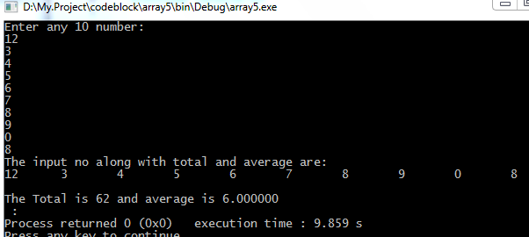

**4.WAP in C to input any 10 numbers in an array and count no. of ODD and EVEN and find out their sum and display them. Code:**

|  |
| --- |
| **Author:Razu Bhattarai**  **#include <stdio.h>**  **#include <stdlib.h>**  **int main()**  **{**  **int a[10],i,j,eve=0,odd=0;**  **printf("ENter 10 numbers:\n");**  **for(i=0;i<10;i++){**  **scanf("%d",&a[i]);**  **}**  **for(j=0;j<10;j++){**  **if(a[j]%2==0){**  **eve=eve+a[j];**  **}else{**  **odd=odd+a[j];**  **}}**  **printf("\nThe sum of even no is %d and odd is:%d\t\n",eve,odd);**  **return 0;**  **}** |

**Output:**

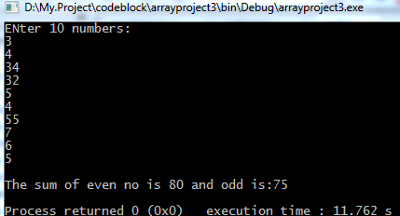

**5.WAP in C to input any 10 numbers in an array and search an element.**

**Code:**

|  |
| --- |
| **#include <stdio.h>**  **#include <stdlib.h>**  **int main()**  **{**  **int a[10],i,j,b,c=0;**  **printf("Enter 10 numbers:\n");**  **for(i=0;i<10;i++){**  **scanf("%d",&a[i]);**  **}**  **printf("Enter a no.to search:\n");**  **scanf("%d",&b);**  **for(j=0;j<10;j++){**  **if(a[j]==b){**  **c++;**  **} }**  **if(!c==0){**  **printf("There are %d element in an array:\t\n",c);**  **}else{**  **printf("There are no any element in an array:\n");**  **}**  **return 0;**  **}** |

**Output:**

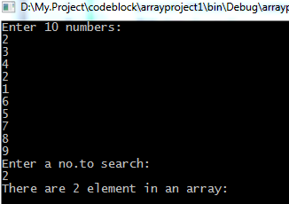 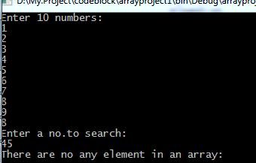

**6.WAP to input any 10 numbers in an array and find out the Maximum and Minimum Value.**

**Code:**

|  |
| --- |
| **#include <stdio.h>**  **#include <stdlib.h>**  **int main()**  **{**  **int a[10],i,j,temp=0;**  **printf("Enter 10 numbers :\n");**  **for(i=0;i<10;i++){**  **scanf("%d",&a[i]);**  **}**  **for(i=0;i<9;i++){**  **for(j=i+1;j<10;j++){**  **if(a[i]>a[j]){**  **temp = a[i];**  **a[i]=a[j];**  **a[j]=temp;**  **}**  **}**  **}**  **printf("\nThe maximum no is %d and minimum is %d\n",a[9],a[0]);**  **return 0;**  **}** |

**Output:**

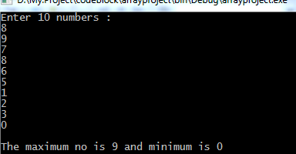

**8.WAP to input any 5 elements in an array and print them in reverse order too.**

**Code:**

|  |
| --- |
| **#include <stdio.h>**  **#include <stdlib.h>**  **int main()**  **{**  **int i,j,a[5];**  **printf("Enter any five number:\n");**  **for(i=0;i<5;i++){**  **scanf("%d",&a[i]);**  **}**  **printf("\nthe array in reverse order is:\n");**  **for(j=4;j>=0;j--){**  **printf("%d",a[j]);**  **}**  **return 0;**  **}** |

**Output:**

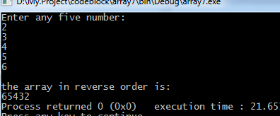

**Character array and String**

**1.WAP to input and output of String using Scanf() and Printf()**

**Code:**

|  |
| --- |
| **#include <stdio.h>**  **#include <stdlib.h>**  **int main()**  **{**  **char s[10];**  **printf("Enter your name:\n");**  **scanf("%s",s);**  **printf("\nHello %s\n",s);**  **return 0;**  **}** |

**Output:**

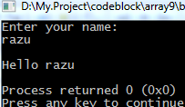

**2.** **WAP to input and output of String using gets() and Puts().**

**Code:**

|  |
| --- |
| **#include <stdio.h>**  **#include <stdlib.h>**  **int main()**  **{**  **char s[10];**  **printf("Enter your name:\n");**  **gets(s);**  **printf("\nyour name is:\n");**  **puts(s);**  **return 0;**  **}** |

**Output:**

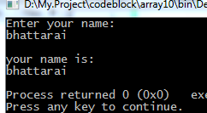

**4.WAP to input and string and find out the length of string using strlen() and without using strlen().**

**Code:**

**>.Using strlen() >.Without using strlen().**

|  |
| --- |
| **#include <stdio.h>**  **#include <stdlib.h>**  **int main()**  **{**  **char string[200];**  **printf("Enter the string:\n");**  **gets(string);**  **int i=0,l=0;**  **while(string[i]!='\0'){**  **l++;**  **}**  **printf("The length of %s is %d:\n",string,l);**  **return 0;**  **}** |

|  |
| --- |
| **#include <stdio.h>**  **#include <stdlib.h>**  **int main()**  **{**  **char string[20];**  **int i;**  **printf("Enter the string:\n");**  **gets(string);**  **i=strlen(string);**  **printf("\nThe length of %s is %d:\n",string,i);**  **return 0;**  **}** |

**Output:**

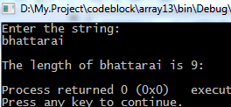 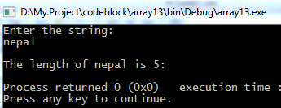

**5.WAP to copy a string from one to another using strcpy() and without using strcpy().**

**Code:**

**>.using strcpy(). >.Without using strcpy().**

|  |
| --- |
| **##include <stdio.h>**  **#include <stdlib.h>**  **int main()**  **{**  **char string[]="kathmandu";**  **char str[20];**  **strcpy(str,string);**  **printf("\n\nsoucre string = %s:\n",string);**  **printf("\ncopied string = %s:\n",str);**  **return 0;**  **}** |

|  |
| --- |
| **#include <stdio.h>**  **#include <stdlib.h>**  **int main()**  **{ char string[100],str[100],i=0;**  **printf("Enter a string:\n");**  **gets(string);**  **while(string[i]!='\0'){**  **str[i]=string[i];**  **i++;**  **}**  **str[i]='\0';**  **printf("\nThe copied string withou using strcpy() is %s:\n",str);**  **return 0;** |

**Output:**

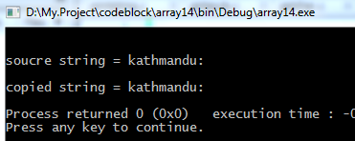 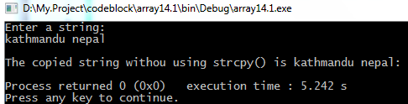

**6.WAP to concatenate two string using strcat() and without using strcat().**

**Code:**

**>.Using strcat(). >.Without using strcat().**

|  |
| --- |
| **##include <stdio.h>**  **#include <stdlib.h>**  **int main()**  **{**  **char source[100],target[200];**  **printf("Enter 1st string:\n");**  **gets(source);**  **printf("Enter 2nd string:\n");**  **gets(target);**  **strcat(source,target);**  **printf("\nThe string after concatenate is %s:\n",source);**  **return 0;**  **}** |

|  |
| --- |
| **#include <stdio.h>**  **#include <stdlib.h>**  **int main(){**  **char source[200],target[100];**  **int a;**  **printf("ENter a 1st string:\n");**  **gets(source);**  **printf("Enter 2nd string:\n");**  **gets(target);**  **int i= strlen(source);**  **int j=strlen(target);**  **int k=i+j;**  **for(a=0;a<k;a++){**  **source[i+a]=target[a];}**  **printf("The string after concatenate without using strcat() is:%s\n",source);**  **return 0;**  **}** |

**Output:**

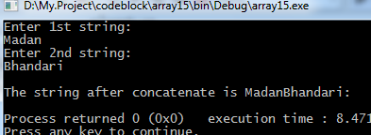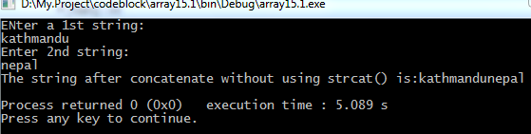

7.WAP to compare two string using strcmp() and without using Strcmp().

**Code:**

**>.Using strcmp(). >.Without using strcmp().**

|  |
| --- |
| **##include <stdio.h>**  **#include <stdlib.h>**  **int main()**  **{**  **char string[100],str[100];**  **printf("Enter 1st string:\n");**  **gets(string);**  **printf("Enter 2nd string:\n");**  **gets(str);**  **int i,j,k;**  **i=strcmp(string,str);**  **if(i==0){**  **printf("The two input string are same:\n");**  **}else{**  **printf("The two input string are different:\n");**  **}**  **return 0;**  **}** |

|  |
| --- |
| **#include <stdio.h>**  **#include <stdlib.h>**  **int main()**  **{**  **char string[100],str[100];**  **printf("Enter 1st string:\n");**  **gets(string);**  **printf("Enter 2nd string:\n");**  **gets(str);**  **int j=strlen(string);**  **int i=0,c=0;**  **while(string[i]!='\0'||str[i]!='\0'){**  **if(string[i]==str[i]){**  **c=1;**  **}else{**  **printf("The string %s and %s are different:\n",string,str);**  **c=0;**  **break; }**  **i++;**  **}**  **if(c==1){**  **printf("\nwithout strcmp()..The two string %s and %s are same:\n",string,str);**  **}**  **return 0;**  **}** |

**Output:**

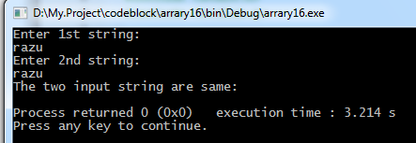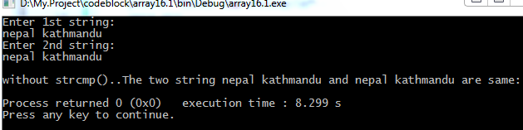

**NEXT PAGE**

**8.WAP to reverse a string using strrev() and without using strrev().**

**Code:**

**>.Using strrev(). >.Without using strrev().**

|  |
| --- |
| **##include <stdio.h>**  **#include <stdlib.h>**  **int main()**  **{**  **char string[100];**  **printf("Enter a string:\n");**  **gets(string);**  **printf("\nthe reverse is %s:\n",strrev(string));**  **return 0;**  **}** |

|  |
| --- |
| **#include <stdio.h>**  **#include <stdlib.h>**  **int main(){**  **char string[100],str[100],c;**  **printf("Enter a string:\n");**  **gets(string);**  **int j=strlen(string);**  **int a;**  **for(a=0;a<j;a++){**  **c=string[a];**  **string[a]=string[j-1];**  **string[j-1]=c;**  **j--;**  **}**  **printf("the reverse string without strrev() is %s:\n",string);**  **return 0;**  **}** |

**Output:**

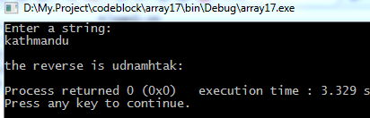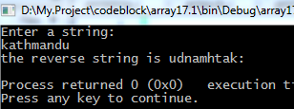

**9.WAP to find whether the given string is palindrome or not.**

**Code:**

|  |
| --- |
| **#include <stdio.h>**  **#include <stdlib.h>**  **int main()**  **{**  **char string[100];**  **int i,j,len,c=0;**  **printf("Enter the string to check palindrome:\n");**  **gets(string);**  **len=strlen(string);**  **for(i=0;i<len;i++){**  **if(string[i]==string[len-i-1]){**  **c++;**  **} }**  **if(c==len){**  **printf("\nThe String is palindrome\n");**  **}else{**  **printf("\nThe string is not palindrome\n");**  **}**  **return 0;**  **}** |

**Output:**

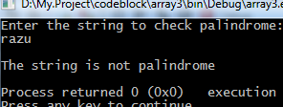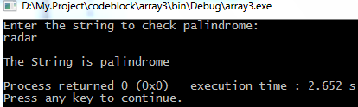

**11.WAP to input a string and convert it into upper case and vice versa.**

**Code:**

|  |
| --- |
| **#include <stdio.h>**  **#include <stdlib.h>**  **int main()**  **{**  **char string[100];**  **printf("Enter a string:\n");**  **gets(string);**  **printf("\nThe input string is %s:\n",strupr(string));**  **printf("\nThe lowercase string is %s:\n",strlwr(string));**  **return 0;**  **}** |

**Output:**

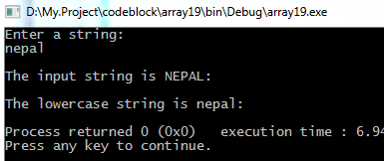

**13.Write a program to read a string and search a specified word in given string**

**Code:**

|  |
| --- |
| **#include <stdio.h>**  **#include <stdlib.h>**  **int main(){**  **char string[100],c;**  **printf("Enter a string:\n");**  **gets(string);**  **printf("Enter a word to serch:\n");**  **scanf("%c",&c);**  **int i,d=0;**  **for(i=0;i<strlen(string);i++){**  **if(string[i]==c){**  **d++;**  **} }**  **if(d==0){**  **printf("Ther are no any words in string:\n");**  **}else{**  **printf("There are %d words in string:\n",d);**  **}**  **return 0;**  **}** |

**Output:**

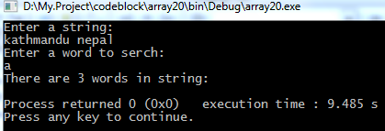

**Arrays Merging and Sorting**

**3.WAP a program to read two arrays and merge these two arrays into third array.**

**Code:**

|  |
| --- |
| **#include <stdio.h>**  **#include <stdlib.h>**  **int main()**  **{**  **int i,j,a,b;**  **printf("Enter no of elements in 1st array.\n");**  **scanf("%d",&a);**  **char c[a];**  **printf("Enter element of array 1:\n");**  **for(i=0;i<a;i++){**  **scanf("%d",&c[i]);**  **}**  **printf("Enter no of elements in 2st array.\n");**  **scanf("%d",&b);**  **char d[b];**  **int f=a+b;**  **printf("Enter element of 2nd array:\n");**  **for(j=0;j<b;j++){**  **scanf("%d",&d[j]);**  **}**  **for(i=0;i<f;i++){**  **c[a+i]=d[i];**  **}**  **printf("The merged array is:\n");**  **for(j=0;j<f;j++){**  **printf("%d\t",c[j]);**  **}**  **return 0;**  **}** |

**Output:**

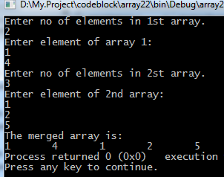

**8.WAP to find transpose of a given Matrix**

Code:

|  |
| --- |
| **#include <stdio.h>**  **#include <stdlib.h>**  **int main()**  **{**  **int i,j,a,b;**  **printf("Enter rows of an array:\n");**  **scanf("%d",&a);**  **printf("Enter columns of an array:\n");**  **scanf("%d",&b);**  **int c[a][b];**  **printf("Enter values in an array:\n");**  **for(i=0;i<a;i++){**  **for(j=0;j<b;j++){**  **scanf("%d",&c[i][j]);**  **} }**  **printf("The tranpose of above matrix is:\n");**  **for(i=0;i<a;i++){**  **for(j=0;j<b;j++){**  **printf("%d\t",c[j][i]);**  **}**  **printf("\n");**  **}**  **return 0;**  **}** |

**Output:**

