**Fundamentals of Computer programming**

**ASSIGNMENT**

**III**

**Prepared by: Raju Bhattarai**

**Shift: Morning**

**Roll Number: 16**

**BscCSIT**

1. **Write A program to display Sum of two numbers**

**C-code:**

|  |
| --- |
| **/\***  **Author: Razu Bhattarai**  **ALGORITHM**  **step 1: Start**  **step 2: Read two number a and b**  **step 3:Initialize sum=0**  **step 4: Add two numbers and stored in sum**  **sum= a+b ;**  **step 5:Display sum**  **step 6:End**  **\*/**  **#include <stdio.h>**  **#include <stdlib.h>**  **int main()**  **{**  **int a,b,sum=0;**  **printf("Enter two numbers:\n");**  **scanf("%d%d",&a,&b);**  **sum = a+b;**  **printf("\t\tThe sum of two number is:%d\n",sum);**  **return 0;**  **}** |

**Output:**

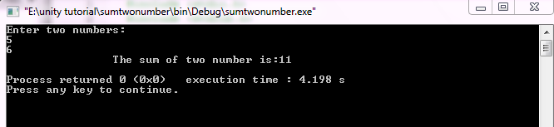

**2.Write A program to display if a number is positive, negative or zero**

**C-Code:**

|  |
| --- |
| **/\***  **Author:Razu Bhattarai**  **/\***  **ALGORITHM**  **steo 1:start**  **step 2:Read number a**  **step 3:if(a>0)**  **display a as positive**  **else if(a<0)**  **display a as negative**  **else**  **display a as zero**  **step 4: End**  **\*/**  **#include <stdio.h>**  **#include <stdlib.h>**  **int main()**  **{**  **int a;**  **printf("Enter a number:\n");**  **scanf("%d",&a);**  **if(a>0){**  **printf("\t\t%d is positive number\n",a);**  **}else if(a<0){**  **printf("\t\t%d is negative numer\n",a);**  **}else{**  **printf("\t\tIt is 0\n");**  **}**  **return 0;**  **}** |

**Output:**

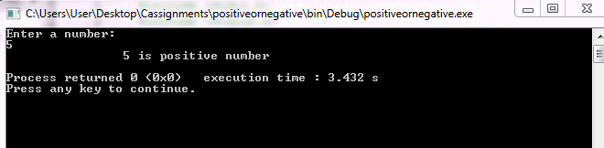

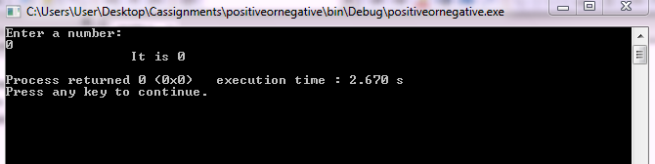

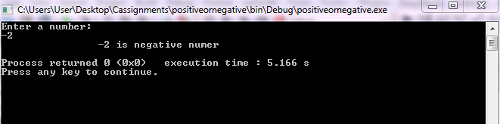

**3.Write a program to display if a number is even or odd**

**C-code:**

|  |
| --- |
| **Author:Razu Bhattarai**  **/\***  **ALGORITHM**  **step 1: start**  **step 2: Read number a**  **step 3: if(a mod 2== 0) then**  **Display a as even**  **else**  **Display a as odd**  **step 4: End**  **\*/**  **#include <stdio.h>**  **#include <stdlib.h>**  **int main()**  **{**  **int a;**  **printf("Enter a number:\n");**  **scanf("%d",&a);**  **if(a%2==0){**  **printf("\t\t%d is even number\n",a);**  **}else{**  **printf("\t\t%d is odd number\n",a);**  **}**  **return 0;**  **}** |

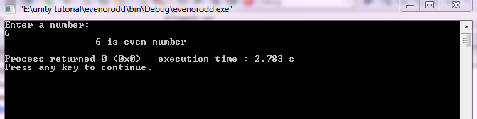

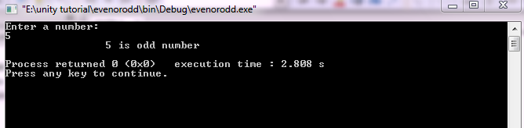

**4.Write a program to read three number and print the greatest number**

**C-code:**

|  |
| --- |
| **/\***  **Author:Raju Bhattarai**  **ALGORITHM**  **step 1: start**  **step 2: Read three number a,b,c**  **step 3: if(a>b and a>c) then**  **Display a as greatest number**  **else if (b>a and b>c)**  **Display b as greatest number**  **else**  **display c as greatest number**  **step 4:End**  **\*/**  **#include <stdio.h>**  **#include <stdlib.h>**  **int main()**  **{**  **int a,b,c;**  **printf("Enter first number:\n");**  **scanf("%d",&a);**  **printf("Enter second number:\n");**  **scanf("%d",&b);**  **printf("Enter third number:\n");**  **scanf("%d",&c);**  **if(a>b && a>c){**  **printf("\t\t%d is the greatest numebr\n",a);**  **}else if(b>a && b>c){**  **printf("\t\t%d is the greatest number\n",b);**  **}else{**  **printf("\t\t%d is the greates number\n",c);**  **}**  **return 0;**  } |

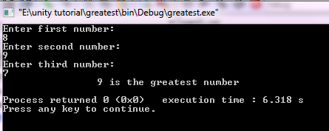

**5.write a program to find the sum of series 1+2+3+4………Up to entered n numbers**

**C-code:.**

|  |
| --- |
| **Author:Raju Bhattarai ALGORITHM**  **/\***  **Step 1: Start**  **step 2: Read number a**  **step 3:Initilize i=1 and sum=0**  **step 4:if(i>a) then Goto step 8**  **step 5:sum=sum+i**  **step 6:i=i+1**  **step 7: Goto step 4**  **step 8:Display sum**  **step 9:End**  **\*/**  **#include <stdio.h>**  **#include <stdlib.h>**  **int main()**  **{**  **int a,sum=0,i;**  **printf("Enter a number:\n");**  **scanf("%d",&a);**  **for(i=1;i<=a;i++){**  **sum=sum+i;**  **}**  **printf("\t\tThe sum of series 1+2+3+...+%d is %d\n",a,sum);**  **return 0;**  **}** |

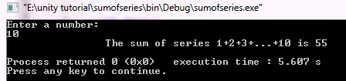

**6.Write a program to display factorial of given number N**

|  |
| --- |
| **Author:Raju Bhattarai**  **/\***  **ALGORITHM**  **step 1:start**  **step 2: Read number a**  **step 3: Initilize i=1 and f=1**  **step 4: if(i>a) then Goto step 6**  **i=i+1**  **f=f*i**  **step 5: Goto step 4**  **step 6: Display f as factorial**  **step 7: End**  **\*/**  **#include <stdio.h>**  **#include <stdlib.h>**  **int main()**  **{**  **int a,i,f=1;**  **printf("Enter a number:\n");**  **scanf("%d",&a);**  **for(i=1;i<=a;i++){**  **f=f*i;**  **}**  **printf("\t\tThe factorial of %d! is %d\n",a,f);**  **return 0;**  **}** |

**C-code:**

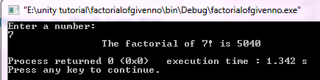

**8.Write a program to read a number n and display all of its divisors.**

|  |
| --- |
| **Author:Raju Bhattarai /\***  **ALGORITHM**  **step 1: start**  **step 2: Read number a**  **step 3: Initilize i=1,c=0**  **step 4: if(i>=a) then Goto step 7**  **step 5: if(a mod i== 0) then**  **display c=i**  **i=i+1**  **step 6: Goto step 4**  **step 7: Display the factor is c**  **step 8: End**  **\*/**  **#include <stdio.h>**  **#include <stdlib.h>**  **int main()**  **{**  **int a,i;**  **printf("Enter a number:\n");**  **scanf("%d",&a);**  **printf("\t\tThe divisor of %d is\t\n",a);**  **for(i=1;i<=a;i++){**  **if(a%i==0){**  **printf("%d \n",i);**  **}**  **}**  **return 0;**  **}** |

**C-code**:

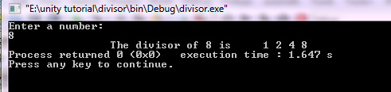

**9.Write a program which displays if a number is prime or not.**

|  |
| --- |
| **Author:Raju Bhattarai**  **/\***  **ALGORITHM**  **step 1: start**  **step 2: Read number a**  **step 3: Initilize i=2and c=0**  **step 4: if(i<a/2) then Goto step 5**  **else**  **Goto step 7**  **step 5:if(a mod i ==0) then**  **c=1**  **Goto step 7**  **step 6: i=i+1**  **Goto step 4**  **step 7:if(c==0) then**  **Display a as prime**  **else**  **Display a as not prime**  **step 8: End**  **\*/**  **#include <stdio.h>**  **#include <stdlib.h>**  **int main()**  **{**  **int a,i,c=0;**  **printf("Enter the number:\n");**  **scanf("%d",&a);**  **if(a==1){**  **printf("%d is neither prime nor composite",a);**  **}else{**  **for(i=2;i<a/2;i++){**  **if(a%i==0){**  **c=1;**  **break;**  **}**  **}**  **}**  **if(c==0){**  **printf("\t\t%d is prime number\n",a);**  **}else{**  **printf("\t\t%d is not prime number\n",a);**  **}**  **return 0;**  **}** |

**C-code:**

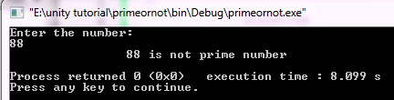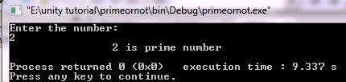

**10. What do you mean by Precedence And Associativity Of Operators in C. Explain with some examples.**

**Precedence of operators**

If more than one operators are involved in an expression, C language has a predefined rule of priority for the operators . This rule of priority of operators is called operator precedence .In C, precedence of arithmetic operators is higher than relational operators and precedence of relational operator is higher than logical operators.

Examples:

(1>2 + 3 && 4)

This expression is equivalent to :

((1>(2+3)) && 4)

Here,(2+3) executes first resulting into 5

Then, first part of the expression (1>5 ) executes resulting into 0 (false)

Then,(0 && 4 ) executes resulting into 0 (false)

OUTPUT:

0

**Associativity of operators**

If two operators of same precedence (priority ) is present in an expression, Associativity of operators indicate the order in which they execute.

Examples: 1 == 2 != 3

Here, operators == and != have same precedence . The associativity of both == and != left to right,

i.e, the expression on the left is executed first and moves towards the right.

Thus, the expression above is equivalent to:

((1 == 2) != 3)

Here , (1 == 2) executes first resulting into 0 (false)

Then,(0 != 3 ) executes resulting into 1 (true)

OUTPUT

1