Oops

**Object-Oriented Programming** is a methodology or paradigm to design a program using classes and objects. It simplifies software development and maintenance by providing some concepts:

* [Object](https://www.javatpoint.com/object-and-class-in-java)
* Class
* [Inheritance](https://www.javatpoint.com/inheritance-in-java)
* [Polymorphism](https://www.javatpoint.com/runtime-polymorphism-in-java)
* [Abstraction](https://www.javatpoint.com/abstract-class-in-java)
* [Encapsulation](https://www.javatpoint.com/encapsulation)

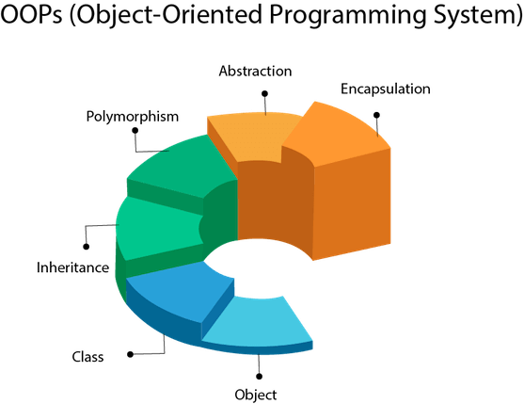

Object

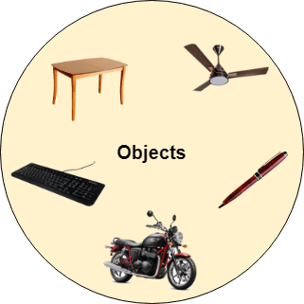

Any entity that has state and behavior is known as an object. For example, a chair, pen, table, keyboard, bike, etc. It can be physical or logical.

An Object can be defined as an instance of a class. An object contains an address and takes up some space in memory. Objects can communicate without knowing the details of each other's data or code. The only necessary thing is the type of message accepted and the type of response returned by the objects.

**Example:** A dog is an object because it has states like color, name, breed, etc. as well as behaviors like wagging the tail, barking, eating, etc.

Class

*Collection of objects* is called class. It is a logical entity.

A class can also be defined as a blueprint from which you can create an individual object. Class doesn't consume any space.

Inheritance

*When one object acquires all the properties and behaviors of a parent object*, it is known as inheritance. It provides code reusability. It is used to achieve runtime polymorphism.

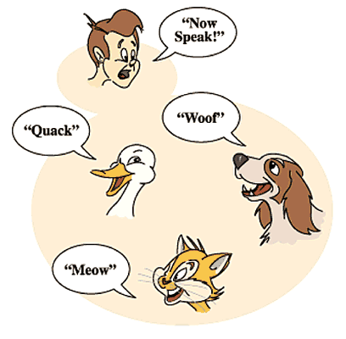

Polymorphism

If *one task is performed in different ways*, it is known as polymorphism. For example: to convince the customer differently, to draw something, for example, shape, triangle, rectangle, etc.

In Java, we use method overloading and method overriding to achieve polymorphism.

Another example can be to speak something; for example, a cat speaks meow, dog barks woof, etc.

Abstraction

*Hiding internal details and showing functionality* is known as abstraction. For example phone call, we don't know the internal processing.

In Java, we use abstract class and interface to achieve abstraction.



Encapsulation

*Binding (or wrapping) code and data together into a single unit are known as encapsulation*. For example, a capsule, it is wrapped with different medicines.

A java class is the example of encapsulation. Java bean is the fully encapsulated class because all the data members are private here.

Coupling

Coupling refers to the knowledge or information or dependency of another class. It arises when classes are aware of each other. If a class has the details information of another class, there is strong coupling. In Java, we use private, protected, and public modifiers to display the visibility level of a class, method, and field. You can use interfaces for the weaker coupling because there is no concrete implementation.

Cohesion

Cohesion refers to the level of a component which performs a single well-defined task. A single well-defined task is done by a highly cohesive method. The weakly cohesive method will split the task into separate parts. The java.io package is a highly cohesive package because it has I/O related classes and interface. However, the java.util package is a weakly cohesive package because it has unrelated classes and interfaces.

Association

Association represents the relationship between the objects. Here, one object can be associated with one object or many objects. There can be four types of association between the objects:

* One to One
* One to Many
* Many to One, and
* Many to Many

Let's understand the relationship with real-time examples. For example, One country can have one prime minister (one to one), and a prime minister can have many ministers (one to many). Also, many MP's can have one prime minister (many to one), and many ministers can have many departments (many to many).

Association can be undirectional or bidirectional.

Aggregation

Aggregation is a way to achieve Association. Aggregation represents the relationship where one object contains other objects as a part of its state. It represents the weak relationship between objects. It is also termed as a *has-a* relationship in Java. Like, inheritance represents the *is-a* relationship. It is another way to reuse objects.

Composition

The composition is also a way to achieve Association. The composition represents the relationship where one object contains other objects as a part of its state. There is a strong relationship between the containing object and the dependent object. It is the state where containing objects do not have an independent existence. If you delete the parent object, all the child objects will be deleted automatically.

## What is the difference between an object-oriented programming language and object-based programming language?

Object-based programming language follows all the features of OOPs except Inheritance. JavaScript and VBScript are examples of object-based programming languages.

* **Object** − Objects have states and behaviors. Example: A dog has states - color, name, breed as well as behavior such as wagging their tail, barking, eating. An object is an instance of a class.
* **Class** − A class can be defined as a template/blueprint that describes the behavior/state that the object of its type supports.
* **Methods** − A method is basically a behavior. A class can contain many methods. It is in methods where the logics are written, data is manipulated and all the actions are executed.
* **Instance Variables** − Each object has its unique set of instance variables. An object's state is created by the values assigned to these instance variables.

### ****ABSTRACTION****

In Page Object Model design pattern, we write locators (such as id, name, xpath etc.,) in a Page Class. We utilize these locators in tests but we can’t see these locators in the tests. Literally we hide the locators from the tests.

Abstraction is the methodology of hiding the implementation of internal details and showing the functionality to the users.

Learn more on [Abstraction](https://www.softwaretestingmaterial.com/abstraction-in-java/)

### ****INTERFACE****

Basic statement we all know in Selenium is WebDriver driver = new FirefoxDriver();

WebDriver itself is an Interface. So based on the above statement WebDriver driver = new FirefoxDriver(); we are initializing Firefox browser using Selenium WebDriver. It means we are creating a reference variable (driver) of the interface (WebDriver) and creating an Object. Here WebDriver is an Interface as mentioned earlier and FirefoxDriver is a class.

An interface in Java looks similar to a class but both the interface and class are two different concepts. An interface can have methods and variables just like the class but the methods declared in interface are by default abstract. We can achieve 100% abstraction and multiple inheritance in Java with Interface.

Learn more on [Interface here](https://www.softwaretestingmaterial.com/interface-in-java/).

### ****INHERITANCE****

We create a Base Class in the Framework to initialize WebDriver interface, WebDriver waits, Property files, Excels, etc., in the Base Class.

We extend the Base Class in other classes such as Tests and Utility Class. Extending one class into other class is known as Inheritance.

Learn more on [Inheritance here](https://www.softwaretestingmaterial.com/inheritance-in-java/).

### ****POLYMORPHISM****

Combination of overloading and overriding is known as Polymorphism. We will see both overloading and overriding below.

Polymorphism allows us to perform a task in multiple ways.

Learn more on [Polymorphism here](https://www.softwaretestingmaterial.com/polymorphism-in-java/).

### ****METHOD OVERLOADING****

We use implicit wait in Selenium. Implicit wait is an example of overloading. In Implicit wait we use different time stamps such as SECONDS, MINUTES, HOURS etc.,

A class having multiple methods with same name but different parameters is called Method Overloading

Learn more on [Overloading here](https://www.softwaretestingmaterial.com/method-overloading-in-java/).

### ****METHOD OVERRIDING****

We use a method which was already implemented in another class by changing its parameters. To understand this you need to understand Overriding in Java.

Declaring a method in child class which is already present in the parent class is called Method Overriding. Examples are get and navigate methods of different drivers in Selenium .

Learn more on [Overriding with examples here](https://www.softwaretestingmaterial.com/method-overriding-in-java/)

### ****ENCAPSULATION****

All the classes in a framework are an example of Encapsulation. In POM classes, we declare the data members using @FindBy and initialization of data members will be done using Constructor to utilize those in methods.

Encapsulation is a mechanism of binding code and data together in a single unit.

Learn more on [Encapsulation here](https://www.softwaretestingmaterial.com/encapsulation-in-java/)

I would like to discuss some other topics which we use in Automation Framework.

### ****WEB ELEMENT:****

Web element is an interface used to identify the elements in a web page.

### ****WEBDRIVER:****

WebDriver is an interface used to launch different browsers such as Firefox, Chrome, Internet Explorer, Safari etc.,

### ****FIND BY:****

FindBy is an annotation used in Page Object Model design pattern to identify the elements.

### ****FIND ELEMENT:****

Find Element is a method in POM to identify the elements in a web page.

[Learn Java](https://www.softwaretestingmaterial.com/java-tutorial/) – A customized post for Selenium Automation Testers