**Introduction:**

* Execute At Scale
* Automate Codeless like building blocks
* You can Rapidly scan the Application UI to create a business readable automation
* 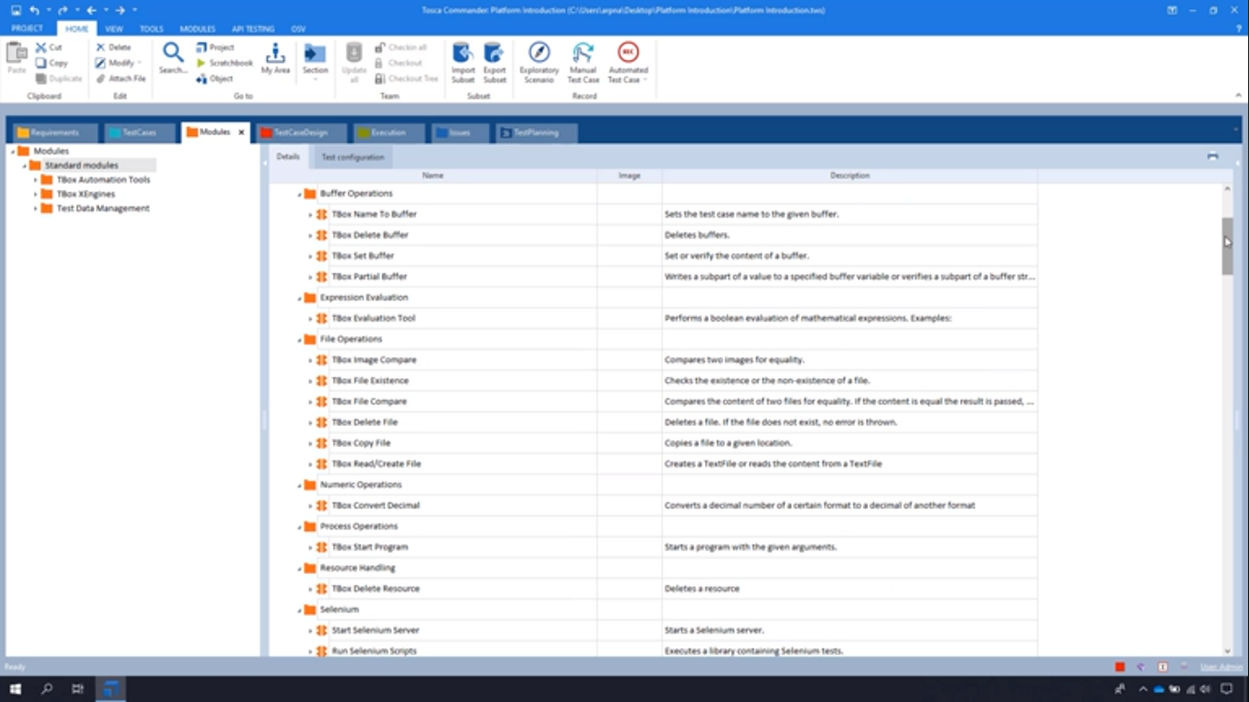

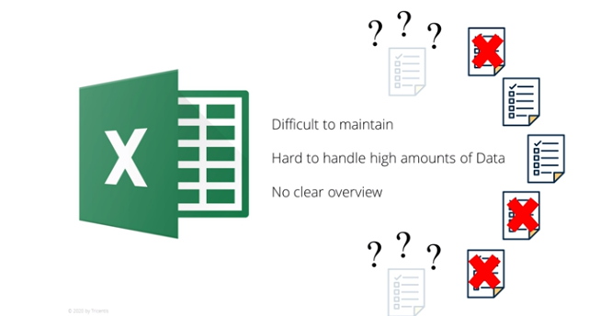

**Platform Introduction Course**

* Test Analyst
* Automation Specialist
* Extension Developer
* Performance Specialist
* Test Architect
* Test Manager

**Automation Specialist Role**

* Write Requirements
* Input on Test plan
* Practical Knowledge
* Create and execute
* Determine Data Combinations
* Create Instances
* Maintain Test Cases
* Analyze Results and Debut
* Generate Reports
* End to End Testing of UI and Non UI Testing

**Extension Developer:**

* Develop Efficient Code
* Resolve Challenges
* Maintain Upgrade
* Create Customizations
* Integrate Components and Build code

**Performance Specialist**

* Develop and Execute
* Identify Risks
* Evaluate, Measure and Improve
* Develop Test Plan

Ensures

* Stability
* Reliability
* Capacity
* Scalability
* Work Speed
* Analyze Impact
* Provide Reports
* Analyze Test Results
* Coordinate bug fixes
* Provide Support in Application Design

Test Architect

* Ensures Project Quality
* Generate and Interpret Risk Assessments
* Overall Responsibility for test infrastructure
* Identify suitable tools and technologies
* Align Technologies
* Property use resources
* Monitor Repository Health
* Design and Develop framework

Test Manager

* Setup of Test Methodology
* Process standards
* Managing
* Coordinating
* Reporting
* Keep Track of test progress
* Bug Status
* Team Requirements

Also

* Create Test Concepts
* Test strategy
* Test Plan
* Test Metrics
* Test Levels
* Test Entry Criteria
* Test Abortion criteria
* Test finalization criteria
* Test Requirements
* Analyze test effort and Automation potential
* Define Guidelines
* Ensure Acceptance
* Improve Team Efficiency and Traceability