**CHAPTER 2**

**REVIEW OF LITERATURE**

This chapter includes Review of Literature / overview.

Most well-developed countries are technologically advanced which is considered as one of the important factors for their success. Particularly in Japan, they have conducted numerous inventions including coin recognition. According to Kazuo Toji (2020), a coin recognition is defined as an apparatus for recognition of coin by using a magnetic sensor it senses characteristics like temperature, pressure, and light. It is related with the researchers’ study considering that both methods involve a sensor that senses light. Coin counter uses light sensor or commonly known as color sensor which is used in this study to indicate that a coin has been inserted, this reason was taken as synonymous for coin recognition since it also uses the senses to indicate the presence of the coin. In a simple manner, this study is not completely similar to the researchers’ study but it is related for the reason that both methods use the same sensors

In addition, there is also a study in United States about the coin processing. According to Thomas P. Adams et al. (2020), the coin processing receives coin and has a coin receptacle for slowing processed coins. The study involves a disk-type coin sorter which includes a rotatable disk that is driven by an electric motor. The study is related for the reason that it involves a coin processor that primarily means that it processes the coin or identifies it which is considerably similar to the researchers’ study

**Coin Sorter**

The Philippine coin sorter is a simple but a not so reliable type of coin sorting machine. Firstly, I use a geared motor that turns only in on direction. This can be of cause of problem in case the coins get jammed in the rotating plate. The device also uses a sorting arm which is quite long and is not always efficient in sorting because many factors interfere. Some factors are the angle of inclination of the sorting arm, the friction in the sorting arm and the length of the Sorting arm. This is why it takes longer for the Philippine coin sorter to sort coins. the display is bulky since it is stored in a computer rather than in an LCD. (Lactaeaon, 2019)

**Coin sorting apparatus with rotating disc stationary guide plate for sorting coins by their different diameter.**

Coin sorting by diameter is discussed in a Schwartz (March 6, 2019) article on a coin counter. It makes use of a revolving plate with holes in it that, when a coin is inserted, catch it. There are reference holes underneath the plate that are made to fit the various coin dimensions that need to be sorted. The coin spins within the revolving plate until it locates a hole that corresponds to its size.

Sorting coins according to their diameter is a simple and yet effective way of sorting. It only uses a rotating plate and a reference plate which can be easily made out of cheap materials. The only downside of this method is when coins get stacked above one another. A smaller coin stacked above a bigger coin can fall in the bigger coin’s hole and end up in the wrong place. This can cause some errors in sorting.

**Coin sorter apparatus and method utilizing coin thickness as a discriminating parameter**

Rasmussen (October 5, 2020) discusses sorting coins according to thickness in another article. The mechanism, according to the report, involves a set of revolving discs that move the coin into a space where it might fit. The first set of discs is arranged so that the coins will migrate to the second set of discs once they come into contact with them. The second set of discs is positioned correctly to correspond with a specific coin's thickness. Coins that are the proper thickness will flow through and be sorted. This sorting technique is not entirely dependable. It is only useful for foreign coins where the thickness is known. Philippine coins are almost of the same thickness. Sorting them accordingly using this method can impose a lot of problems. Secondly, this method requires precision in placing the disks. One miscalculation and the disks can be either too thin or too thick.

**Coin Counter**

In July 8, 2019 article, Boland describes a technique for counting coins. Denomination codes that are kept on a code disc are used to count coins. Coins land on a revolving table that is intended to catch and retain coins of various values at various locations. To calculate a coin's denomination, a sensor that records code in a disc is used in the counting process. Due to the fact that this method of coin counting uses codes specific to each type of coin, it is also highly unlikely to malfunction. The expense of the materials that will be used is the only drawback of this approach. Specialty stores sell code sensors, which are really costly! stores alone.

**The Philippine Peso Coins (https://www.bsp.gov.ph/)**

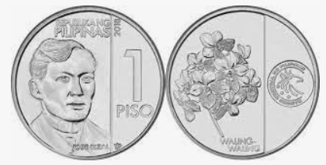

**Figure 1. A Sample of 1 Peso coin**

1 Peso

Composition: Nickel-plasted steel

Diameter: 24 mm

Thickness: 2.05 mm

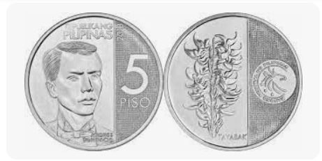

**Figure 1.2 A Sample of 5 Peso coin**

5 Peso

Composition: Nickel-plasted steel

Diameter: 25 mm

Thickness: 2.20 mm

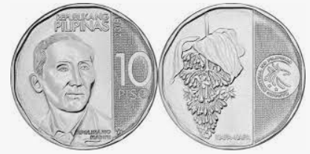

**Figure 1.3 A Sample of 10 Peso coin**

10 Peso

Composition: Nickel-plasted steel

Diameter: 27 mm

Thickness: 2.05 mm

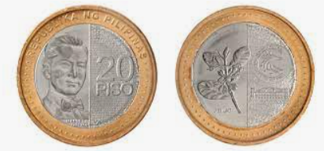

**Figure 1.4 A Sample of 20 Peso coin**

20 Peso

Composition: Bi-metallic with a bronze-plated steel outer ring and a nickel-plated steel center

Diameter: 30 mm

Thickness: 2.2 mm

**Coin Discrimination**

The study of A. Paramasivam (2021) indicates that in the structure of coin discriminators, it contains the structure and part like a sensor for distinguishing coin, coin entrance, anvil, coin tubes and electronic circuit. For the method of activity, the coin is supplemented to the coin opening and through the coin way at that point goes through the sensor which is situated along the coin way to quantify the coin’s physical properties. The properties of coins like measurements, weight, elasticity, conductivity, and dropping time are estimated dependent on the sensor utilized in the coin discriminator. For most of the part, sensors are used to improve the utilization, which are electromagnetic sensor, attractive sensor, acoustic sensor, and optical sensor. The most ordinarily sensor that can be found in the regular coin discriminator is the Electromagnetic sensor. This sensor is normally the inductive sensor or Hall Effect sensor. The lasting magnet is typically placed on the coin way and the area of the attractive sensor is straightforwardly inverse to the perpetual magnet. A consistent attractive transition and attractive field quality is produced over the coin way. At the point, when the coin goes and experiences the way, the coin will differ the attractive motion thickness so that the first type of the attractive motion thickness in the space is changed. This subsequent determined difference in the attractive sensor and immediately instigated the electromotive power (emf). The incited emf’s greatness is impacted dependent on the metallurgical property like thickness and breadth of the coin. To distinguish the pinnacle estimation of actuated emf, the attractive sensor is associated with an electronic sensor. Since various sorts of coin will deliver explicit pinnacle voltage, it very well may be utilized to check the legitimacy of coin division.

**Coin Counting and Programming**

According to P. Vidhushini (2021), In coin counting and programming process checking the sum and amount of the coin, the coin tallying programming framework can view, print and spare all tallying outcomes to the Personal Computer (PC). A total information base can be worked as the coin checking came about can be spared. The case of the element of utilizing coin checking framework are transfer coin tallying results to PC, store checking results on PC, printing the checking results, have a diagram of checking history (transaction history) and so on. The development of this coin sorter has the goal to furnish a coin arranging framework with work at fast and high precision in a size-decreased machine.