**Microprocessor Lab**

Laboratory Activity No. 2

**Arduino and Tinkercad Interface**

|  |
| --- |
|  |

Score

*Submitted by:*

**Muro, Cyron Paul T.**

**Saturday 1pm-7pm / CPE 0412-2**

*Date Submitted*

**30-09-2023**

*Submitted to:*

**Engr. Maria Rizette H. Sayo**

I. Objectives

This laboratory activity aims to implement the principles and techniques of hardware programming using Arduino through:

- creating an Arduino programming and circuit diagram.

II. Method/s

- Perform a task problem given in the presentation.

- Write a code and perform an Arduino circuit diagram of a ring counter that display eight (8)LEDs starting from left.

III. Results

**TinkerCad**

**Exercise 1: Write a code that does a ring counter display for eight (8) LEDs starting from left.**

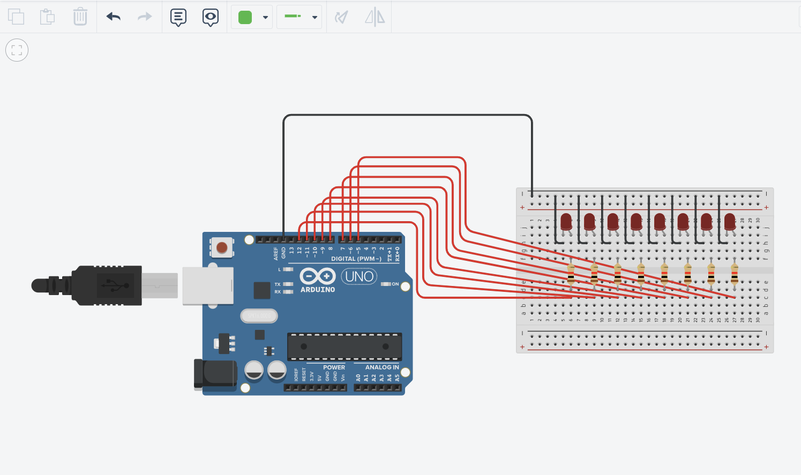

Figure No.1 Ring Counter Display Circuit Diagram

**Components Used**

1. 8 LEDs
2. Resistor
3. Breadboard

**CODE:**

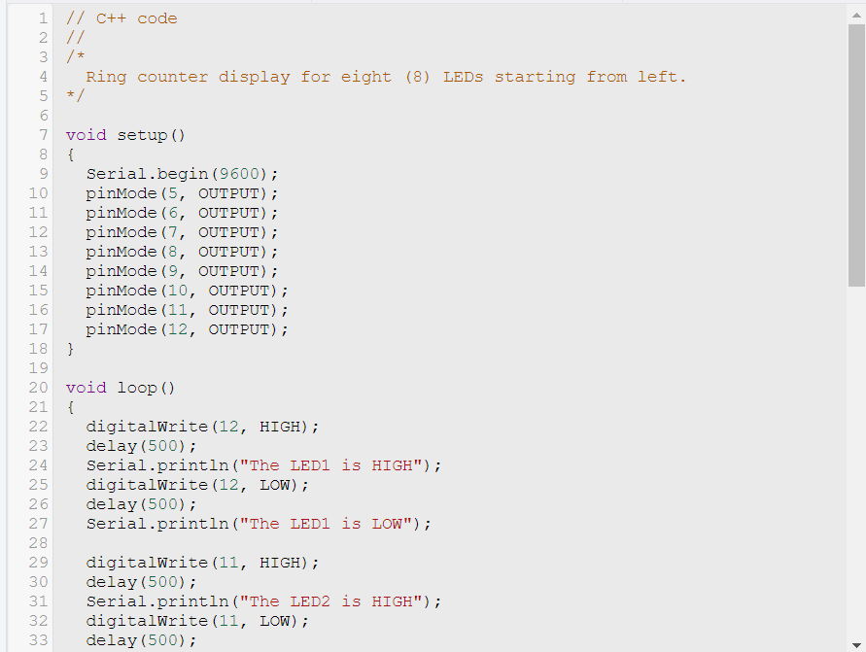

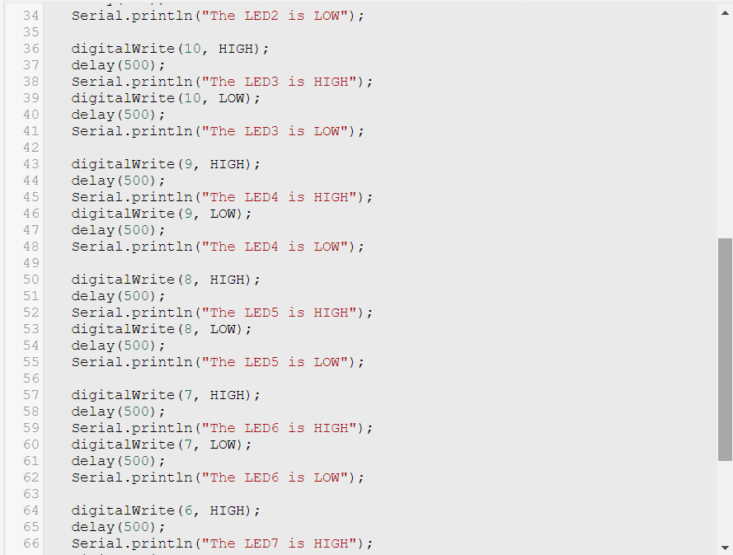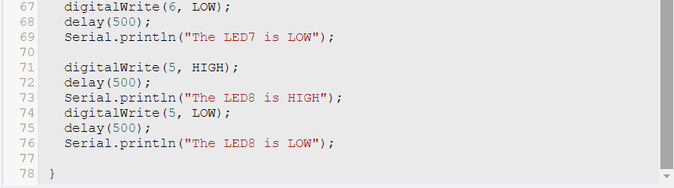

IV. Conclusion

The simulation is a simple ring counter display for eight LEDs, starting from the left. The code works by setting the digital pins connected to the LEDs as outputs, and then turning them on and off in a sequence. The code also prints messages to the serial monitor to indicate which LED is currently on.

**References**

[1] D.J.D. Sayo. “University of the City of Manila Computer Engineering Department Honor Code,” PLM-CpE Departmental Policies, 2020.

*<This is in a separate page>*