## Lab 1a

The appropriate settings and connections were set up.

Path variables:

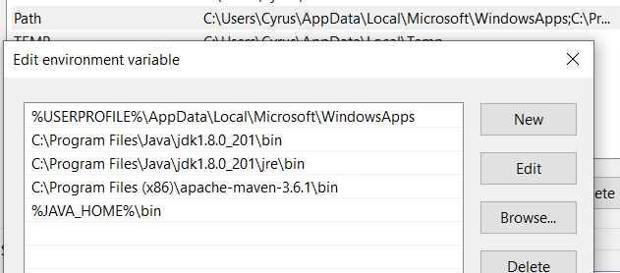

JDK policy settings:

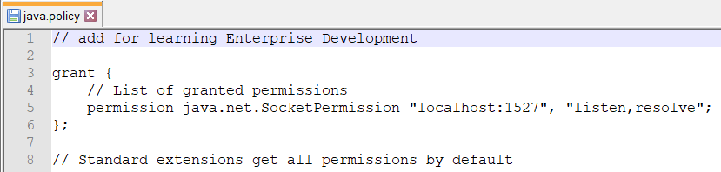

Glassfish database:

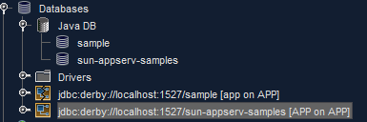

## Lab 1b

The code was copied from the lab notes and produced the following output:  
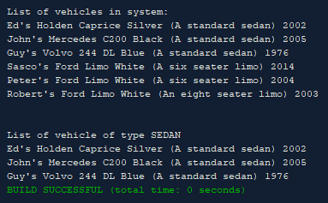

When run with the argument “sedan” the following result is given:  
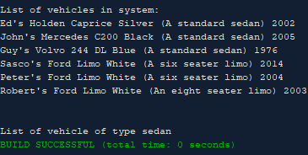

This is because none of the vehicle codes match the all lowercase “sedan” as all the vehicle codes are being set as all capitals, and even if they weren’t being created like that, the getter property will always return an all caps version of the code:  


## Lab 1c

A simple switch loop was added to act as a menu for selecting and displaying the various types of vehicles: 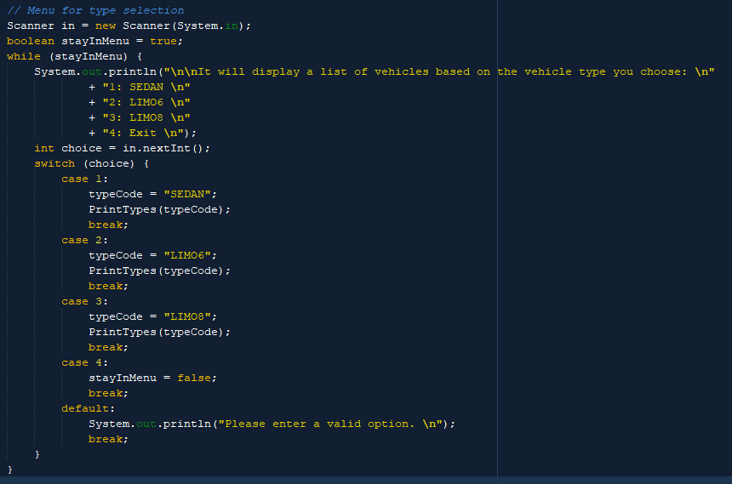

The code for displaying the list of types was extracted into its own method for repeatable use:  
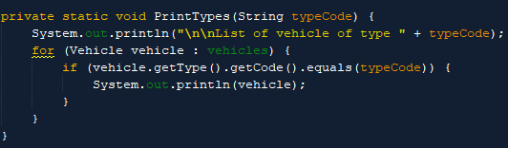

Example output:  
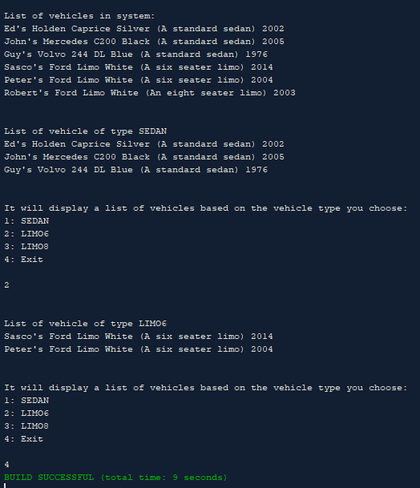

Code can be found for further review at:   
<https://github.com/CyrusEdgren/Secure_Scalable_Software/tree/master/1.1P>