# 2.1P

## Task1

The lab was completed and generated the following table when run:  
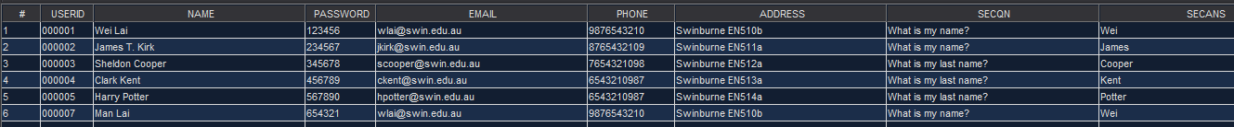

## Task 2

The required functions for CRUD operations where created.

getRecord():  
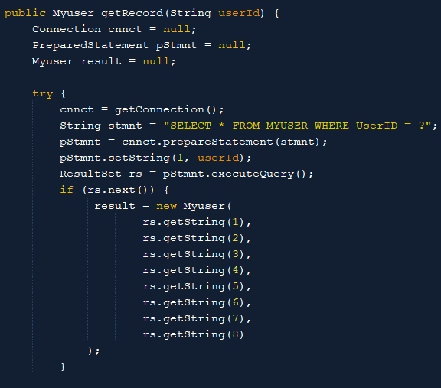  
… (omitted catch and finally for brevity)  


createRecord():  
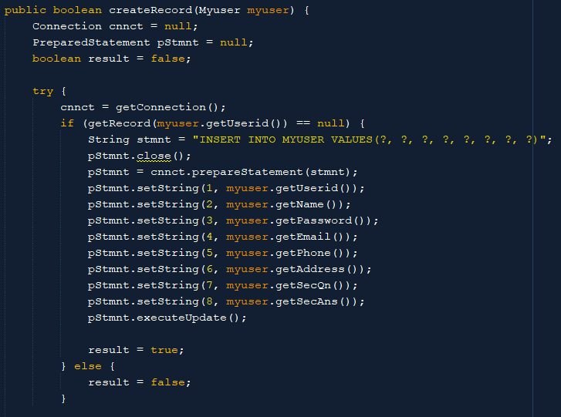  
…  


updateRecord:  
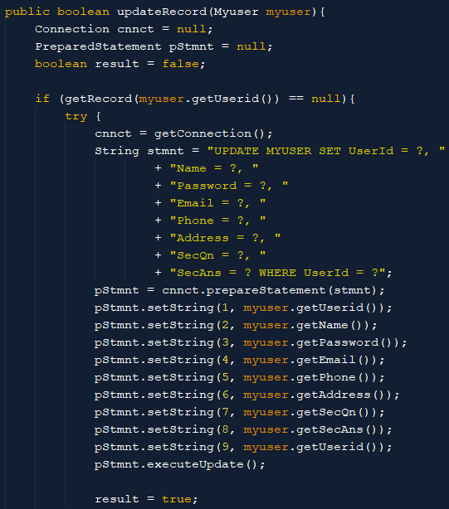  
…  


deleteRecord:  
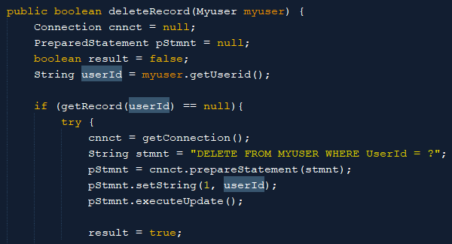  
…



## Task 3

A simple console menu (similar to last pass task) was created to test each of the operations created above.

Getting a record:  
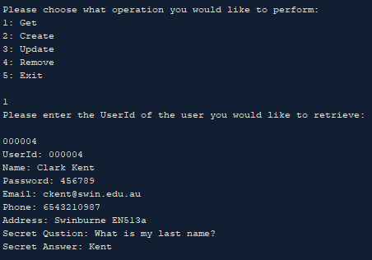

Creating a record:  
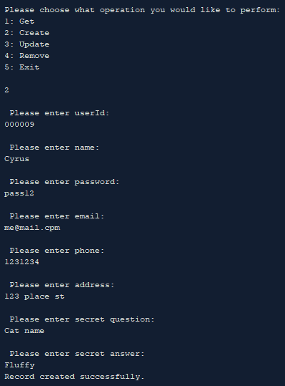

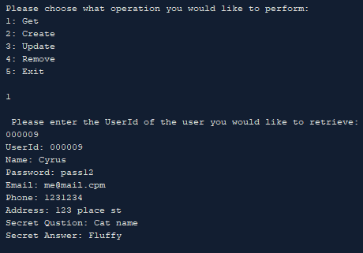

Updating a record:  
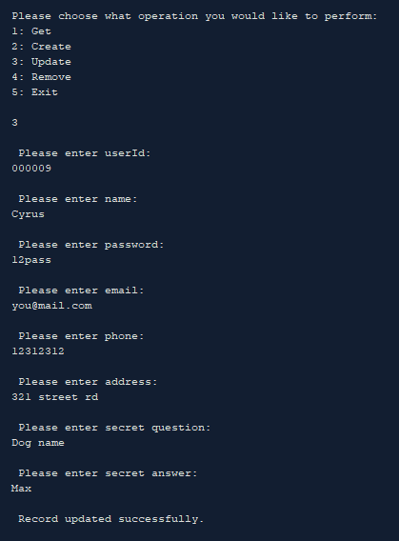

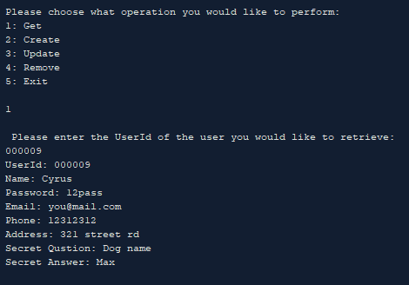

Deleting a record:

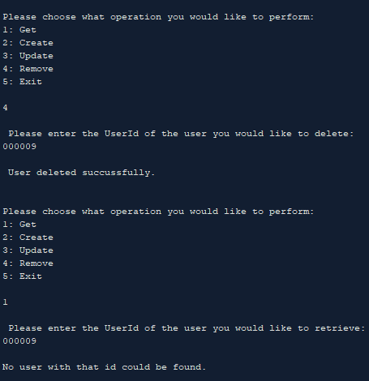

## Task 4:

4.1 The role of the Myuser class is that of a data transfer object. It does not directly change the database, it only carries the information that is used when the database is changed. The MyDB class is the data access object as it contains the methods that send the queries to the database and has a direct effect on the state of the database.

4.2 If a program calls the “myuser.setName()” function, there will be no change in the database. This is just changing the Myuser object, the DAO would still be responsible for changing the database with this new data.

4.3 Even if the Myuser (DTO) class is changed in the DAO (in this case MyDB) still no change has been made until the DAO sends that change to the database through its interface.

Code can be found for further review at: <https://github.com/CyrusEdgren/Secure_Scalable_Software/tree/master/2.1P>