# 3.1P

## Task 1.

Lab 3 was completed and gave the following output:  
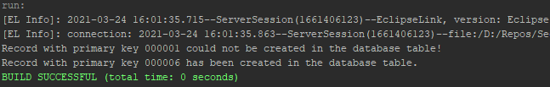

(The first record could not be created as the old table data from the last task already contained an item with the primary key 000001.)

## Task 2.

The function getRecord() was created:  
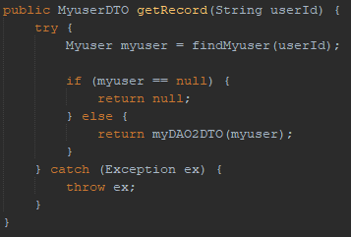

The function updateRecord() was created:  
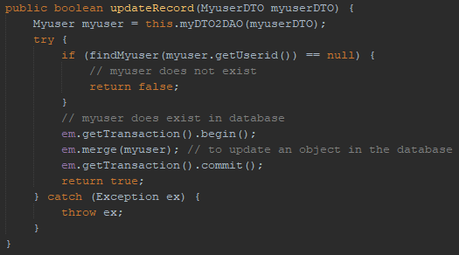

The function deleteRecord() was created:  
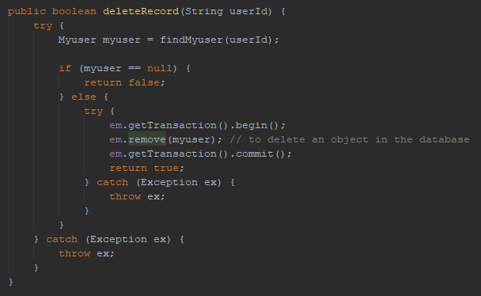

## Task 3.

The console menu code from the last pass task was copied over to this task and modified to work with the new CRUD operations.

Get record:  
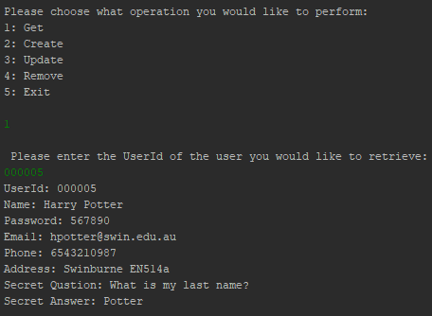

Create record:  
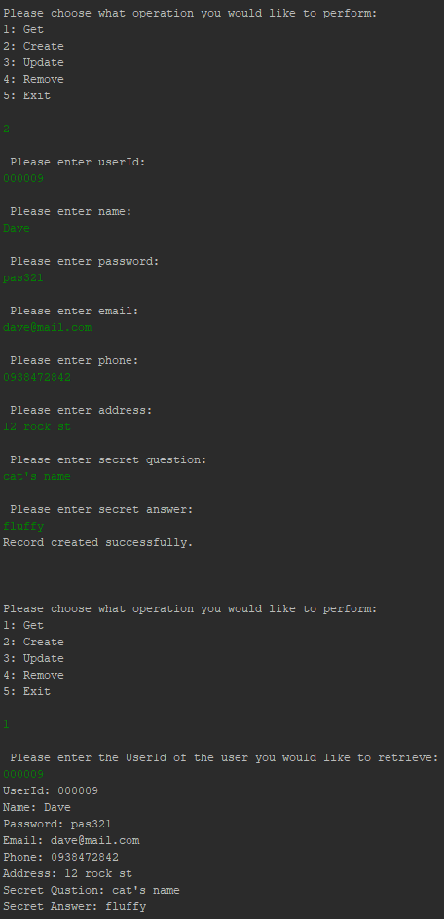

Update record:  
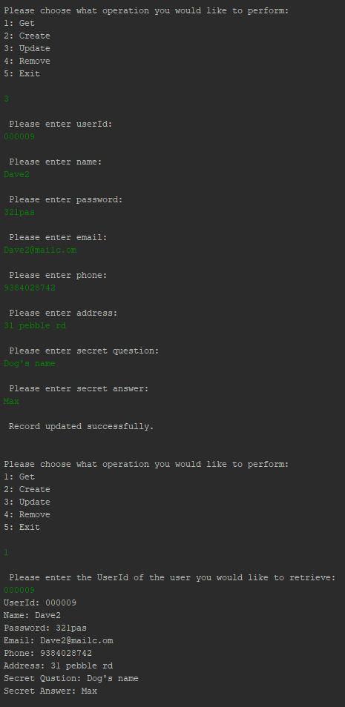

Delete record:  
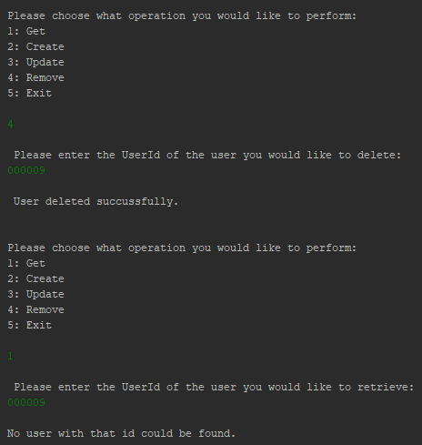

## Task 4.

4.1  
MyuserDB is responsible for doing all of the ORM work, as it handles the transformation of the data transformation object (MyuserDTO) into the entity class that is used by the database (Myuser).

4.2  
The Myuser class has a different role than it had in the application from lab 2. It is no longer a DTO, but rather the entity class that is used with the EntityManager API to control records in the database.

4.3  
The Myuser entity class in this application is in the JPA domain instead of the JDBC domain of the last lab. This is because it is now handling persistent data in a class rather than just using queries to manipulate the database.

Code can be found for further review at:   
<https://github.com/CyrusEdgren/Secure-Scalable/tree/master/3.1P>