# 6.1P

## Task 1.

The lab was completed and the following output was generated:  
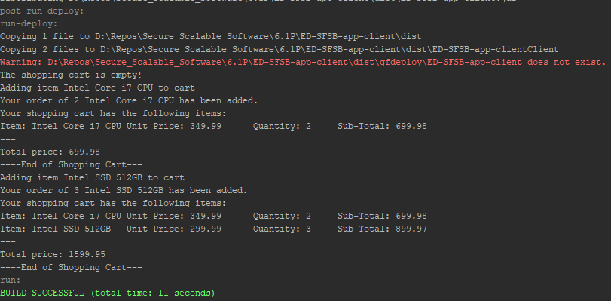

## Task 2.

The CRUD operations were added to ShopCartBean.java.

addCartItem()  
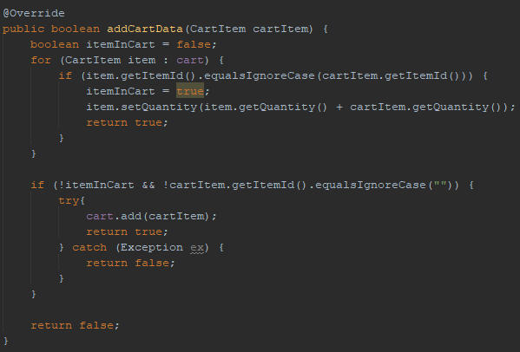

deleteCartData()  
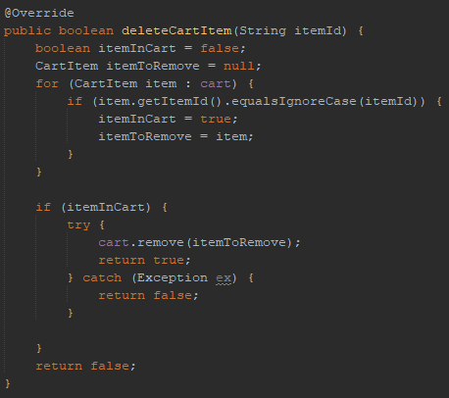

updateCartData()  
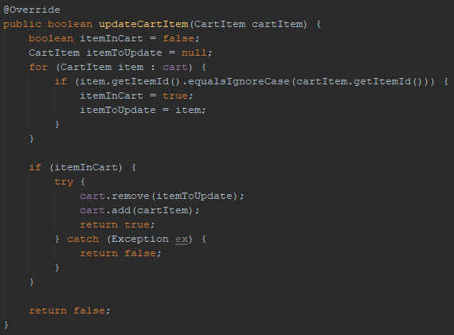

## Task 3/4.

A simple console menu was developed to test the functionality of the CRUD operations.

Adding an item:  
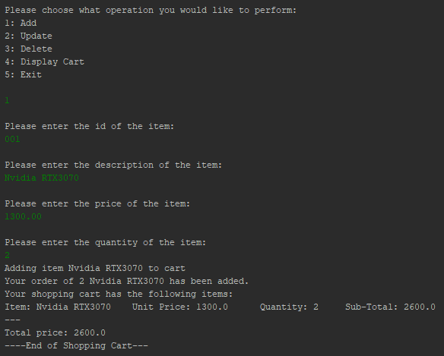  
  
Adding the same item again:  
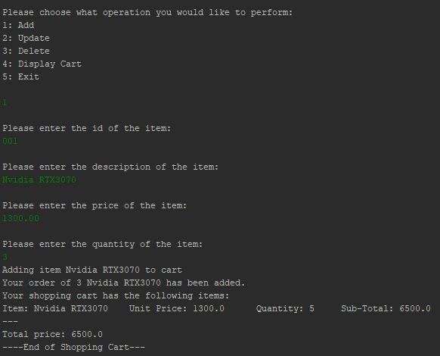

Adding a null item:  
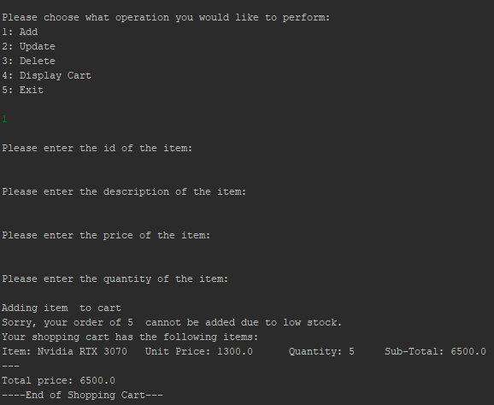

Updating an item:  
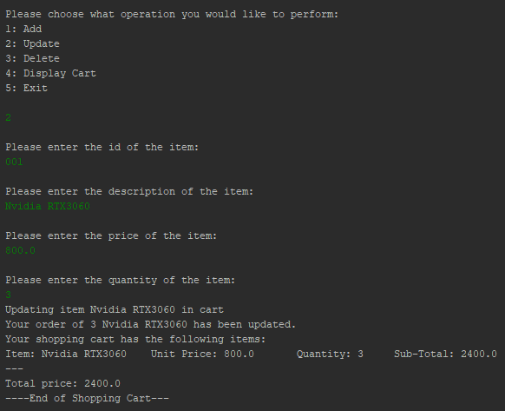

Deleting an item:  
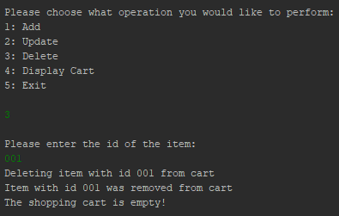

## Task 5.

### 5.1

(First Half)

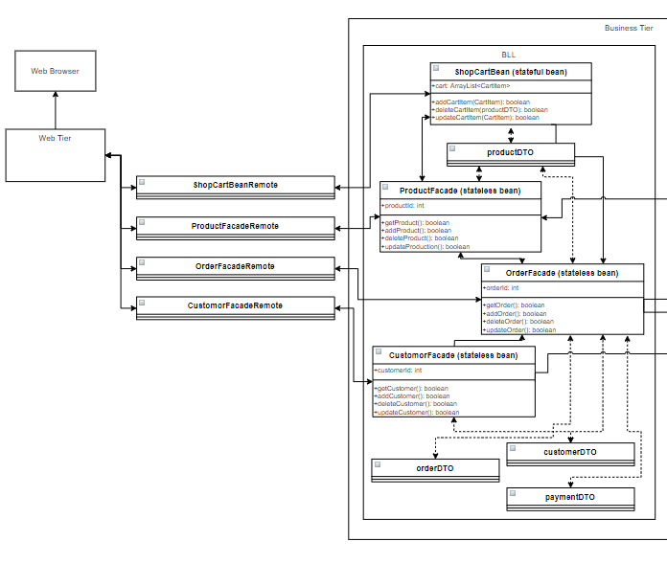

(Second Half)  
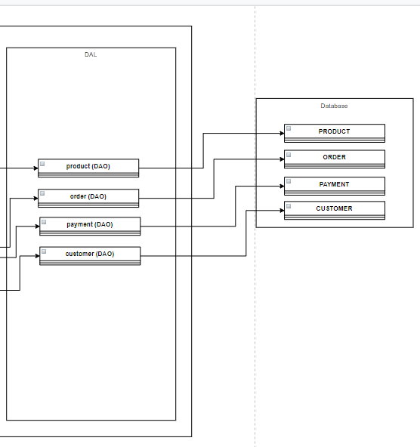

### 5.2