🍛
Sangwari Restaurant
Website — Standard Operating Procedures
Customer Guide · Admin Guide

This guide covers everything needed to place an order as a customer
and to manage the restaurant from the admin panel.

Part 1
Customer Guide
How to browse the menu and place an order

🏠 Opening the Website
Visit Sangwari online from any phone or browser

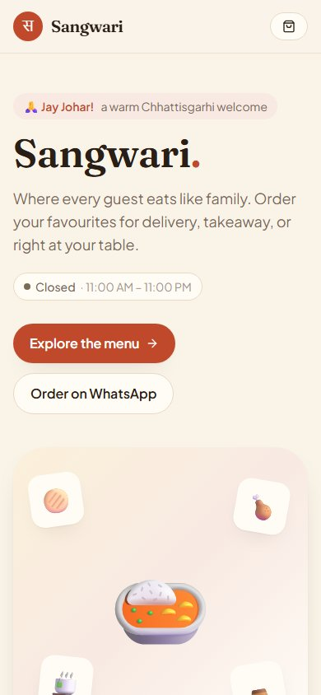 | STEP 1  Open the website  Open any browser on your phone and visit the restaurant's website.  You will see the home page with a warm welcome and the menu categories.  💡 Tap "Add to home screen" when prompted to install it like an app — no App Store needed.

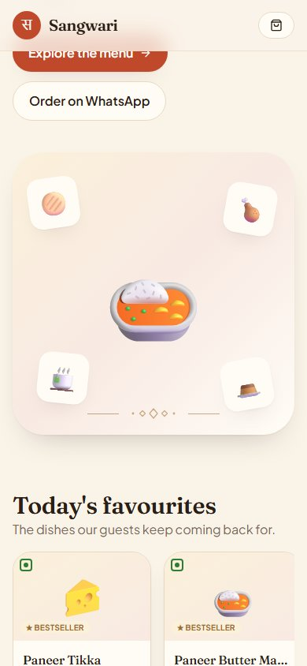 | STEP 2  Explore the home page  Scroll down to see Today's Favourites — dishes the restaurant recommends.  Below that, browse all menu categories at a glance.  💡 The green "Open now" pill at the top shows whether the restaurant is currently accepting orders.

📋 Browsing the Menu
Find your favourite dishes quickly

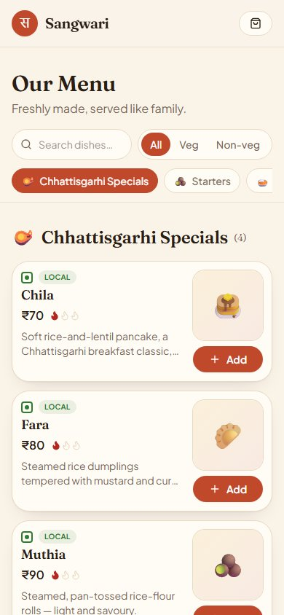 | STEP 3  Go to the Menu  Tap "Explore the menu" on the home page, or tap "Menu" in the top navigation bar.  The menu opens with a category rail at the top — tap any category to jump straight to it.  Use the Search box to find a dish by name.  Toggle Veg / Non-veg to filter dishes by your preference.

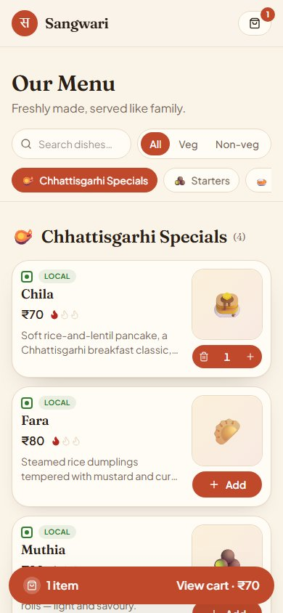 | STEP 4  Add a dish to cart  Find a dish and tap the red "Add" button.  The button changes to a + / − stepper — use it to adjust the quantity.  Tap the dish name or image to see its full description, ingredients, and spice level.  💡 Only available dishes are shown. If something is not visible, it may be sold out today.

🛒 Viewing Your Cart
Review items before placing the order

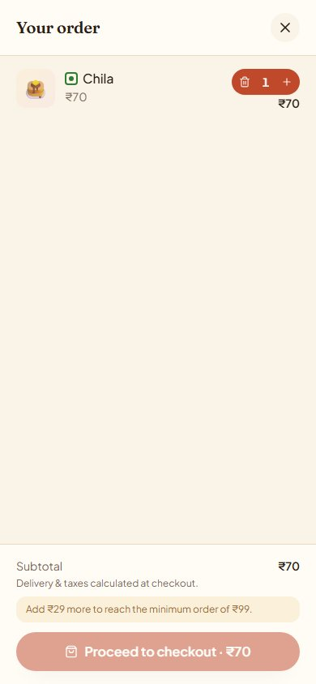 | STEP 5  Open the cart  Tap the cart icon (top-right) or the "View cart" bar at the bottom of the screen.  Your cart slides in showing all items, quantities, and a subtotal.  Use − to reduce quantity (it becomes a trash icon at qty 1 to remove the item).  Delivery fee and taxes are shown at checkout — not in the cart.  💡 The cart saves automatically — if you close the browser and come back, your items are still there.

📝 Placing an Order
Choose how you'd like to receive your food

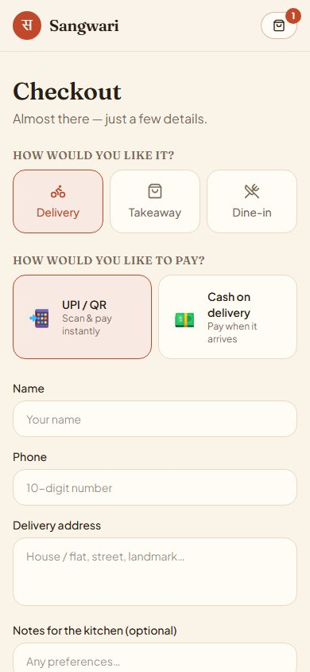 | STEP 6  Choose Delivery  Tap "Proceed to checkout" in the cart.  Select Delivery if you want food brought to your address.  Enter your Name, Phone number, and Delivery address.  Optionally add any notes for the kitchen (e.g. "no onion").  💡 Minimum order for delivery is ₹99. A ₹30 delivery fee is added at checkout.

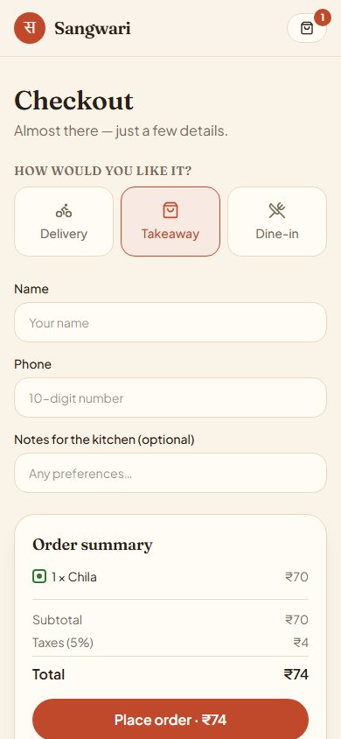 | STEP 7  Choose Takeaway or Dine-in  Select Takeaway to place your order and collect it from the restaurant.  Select Dine-in if you are already seated at the restaurant — your table number is pre-filled if you scanned the QR code on the table.  No delivery fee is charged for Takeaway or Dine-in orders.

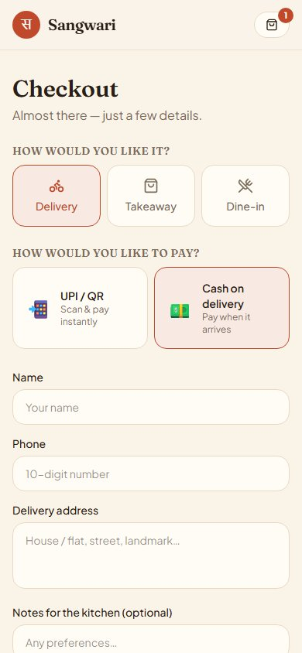 | STEP 8  Choose your payment method  For Delivery orders, choose between two payment options:  - UPI / QR — scan a QR code and pay instantly using GPay, PhonePe, or any UPI app.  - Cash on Delivery — keep cash ready to hand over when your order arrives.  💡 Takeaway and Dine-in orders are always paid by UPI at the table or counter.

💳 Completing Payment
Quick and easy — no card or account needed

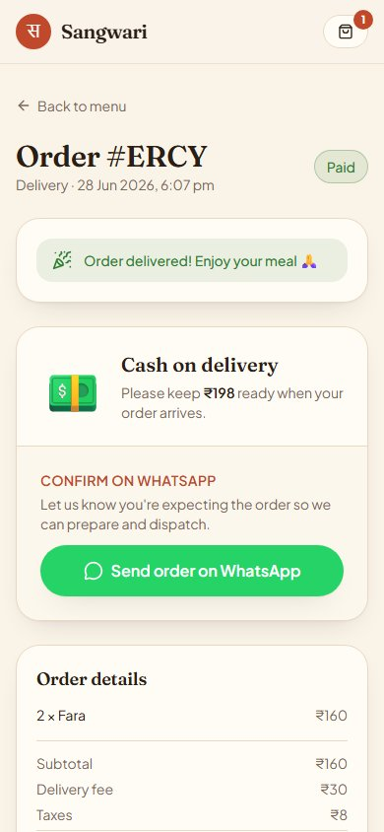 | STEP 9  Your order confirmation page  After placing the order, you land on the Order confirmation page.  For UPI orders: scan the pre-filled QR code with any UPI app — the amount is already entered.  For Cash on Delivery: your order is confirmed automatically. Keep the cash ready.  Tap the green "Send order on WhatsApp" button to send your full order to the restaurant.  💡 Save this page link or keep it open — your order status updates here live.

📍 Tracking Your Order
Watch your order's progress in real time

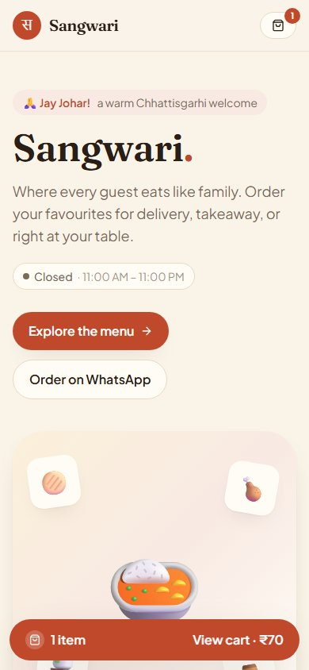 | STEP 10  Live order tracker  A tracking bar appears at the bottom of every page showing your latest order's status.  Tap "Track →" to open the full order page and see the progress steps.  For Delivery orders, the steps are: Placed → Confirmed → Preparing → On the way → Delivered!  For Takeaway/Dine-in: Placed → Confirmed → Preparing → Ready → Done.  💡 You will also receive a WhatsApp message from the restaurant at each status change.

Part 2
Admin Guide
Managing orders, menu, and restaurant settings

🔐 Logging In
Access the admin panel securely

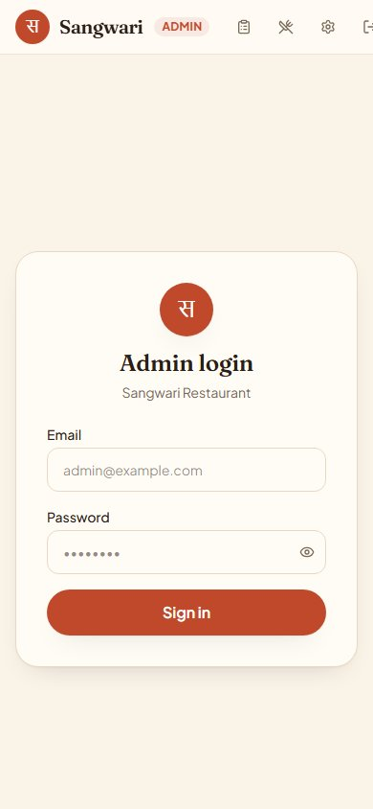 | STEP 1  Go to the admin login page  Open your browser and go to: yourwebsite.com/admin  You will be redirected to the admin login page automatically.  Enter your Email and Password, then tap Sign in.  💡 Only you have the admin password. Your email and password were set up in your Supabase dashboard.

🧾 Managing Orders
Accept, prepare, and deliver orders from one screen

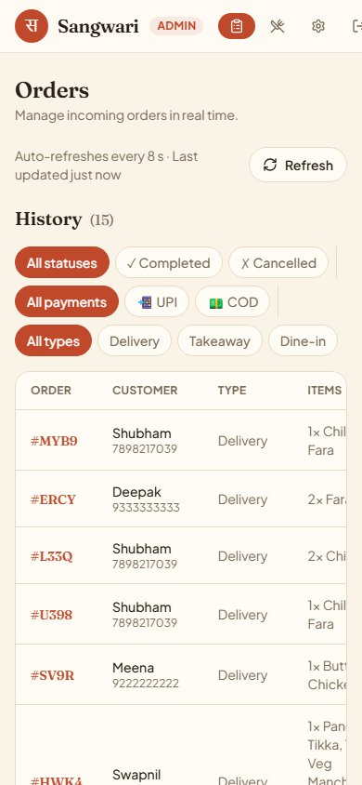 | STEP 2  The Orders Board  After login, you land on the Orders board — your main working screen.  New orders appear under "New orders" with an orange badge.  The board auto-refreshes every few seconds. A notification ping and browser alert fire when new orders arrive.  Each card shows: order code, customer name, phone, address or table, items ordered, total, and payment mode (UPI or COD).

 | STEP 3  Accept and advance an order  1. Tap "Mark paid" once you have confirmed UPI payment in your UPI app (skip for COD — already marked paid).  2. Tap "Accept order" to confirm and move the order to In Progress.  3. As you prepare the food, tap "Mark preparing", then "Out for delivery" or "Mark ready".  4. Tap "Mark delivered" / "Mark completed" when done — WhatsApp confirmation is sent automatically.  💡 To cancel an order, tap the red ✗ button. Only possible before accepting.

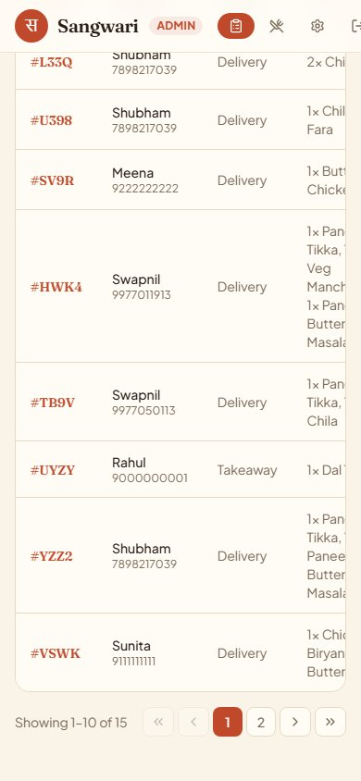 | STEP 4  Order history & filters  Scroll down below the active orders to see the History table.  Filter by: Status (Completed / Cancelled), Payment mode (UPI / COD), Order type (Delivery / Takeaway / Dine-in).  Paginated at 10 rows per page — use the arrows to navigate.  Tap any order code to open the customer's order tracking page.

🍽️ Managing the Menu
Keep your menu accurate and up to date

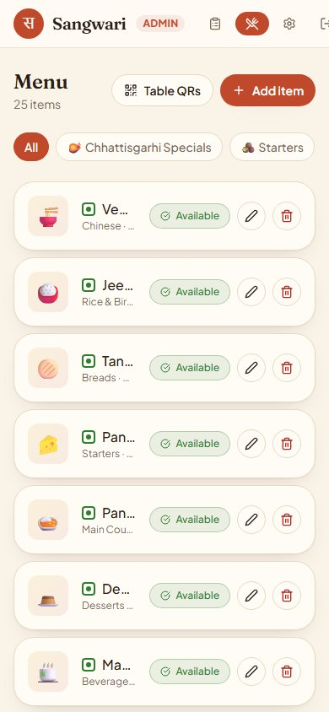 | STEP 5  The Menu page  Tap Menu in the top navigation bar.  All dishes are listed with their category, price, and availability status.  Use the category chips at the top to filter by category.  💡 Items marked "Sold out" are hidden from the customer menu automatically.

 | STEP 6  Mark an item as sold out / available  Tap the green "Available" badge on any item to toggle it to "Sold out".  Tap it again to make it available.  The change is instant — the customer menu updates immediately.  💡 Use this every morning to set today's menu, and whenever something runs out.

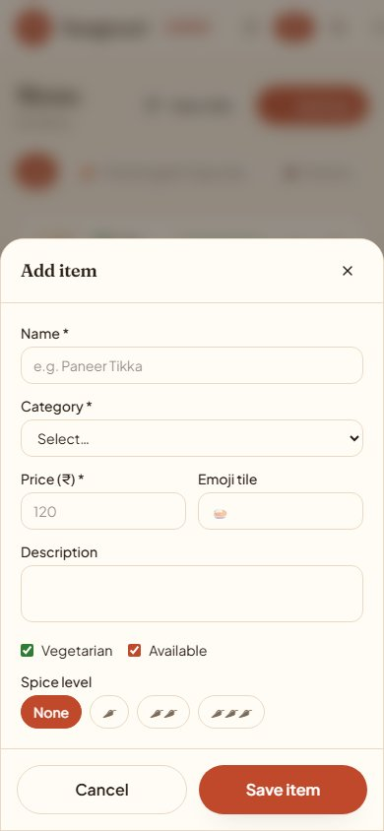 | STEP 7  Add or edit a dish  Tap "+ Add item" (top right) to add a new dish.  Tap the pencil ✏ icon on any existing dish to edit it.  Fill in: Name, Category, Price (₹), Emoji, Description, Veg/Non-veg, and Spice level.  Tap "Save item" — the dish appears on the customer menu immediately.  💡 To permanently remove a dish, tap the 🗑 delete icon and confirm.

⚙️ Settings
Update your UPI, WhatsApp, hours, and fees

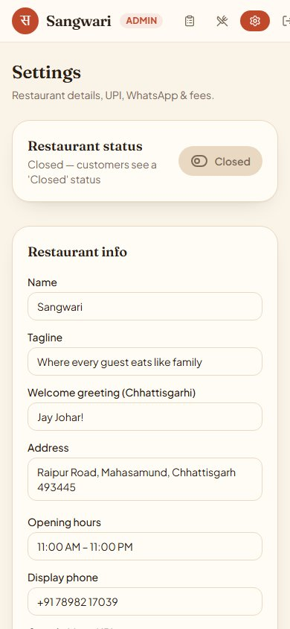 | STEP 8  Restaurant status & info  Tap Settings in the navigation bar.  The big toggle at the top controls whether the restaurant is Open or Closed.  - Open → customers can place orders normally.  - Closed → customers see a "Closed" status; ordering is paused.  Update your Restaurant name, Tagline, Address, Opening hours, and Phone number here.

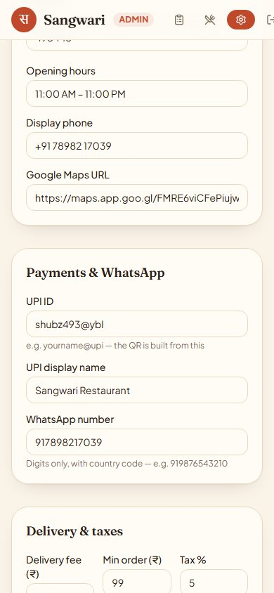 | STEP 9  Update UPI ID & WhatsApp number  Scroll down to the "Payments & WhatsApp" section.  UPI ID — this is your UPI address (e.g. yourname@upi). The auto-generated QR uses this.  WhatsApp number — digits only, with country code (e.g. 917898217039). All order messages go here.  Delivery fee, Minimum order, and Tax % can also be adjusted.  Tap "Save settings" — changes take effect immediately.  💡 If you change your UPI ID, verify it with a test order before going live.

📲 Table QR Codes
Let dine-in guests order from their table

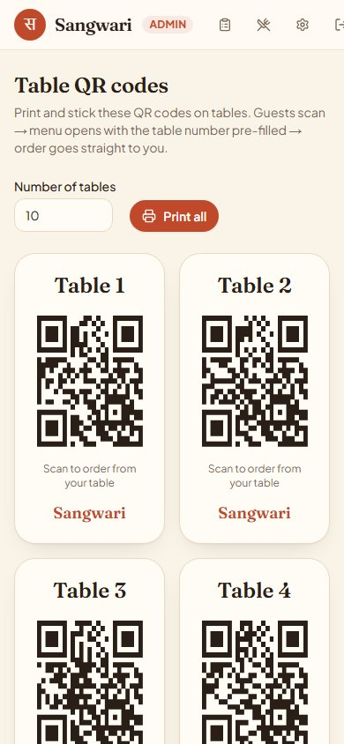 | STEP 10  Generate & print table QR codes  Tap Menu → Table QRs in the navigation (or go to /admin/tables).  Set the number of tables and the QR codes generate instantly.  Tap "Print all" — your browser's print dialog opens. Print and laminate one per table.  When a guest scans the QR with their phone camera:  - The website opens with their table number pre-filled.  - They choose Dine-in and place their order — it comes straight to you.  💡 You can regenerate new QR codes any time (e.g. if you add tables). Old codes still work.

⚡ Quick Reference

👤 Customer  1. Open website or scan QR code  2. Browse menu — search or filter by category  3. Tap Add to add dishes to cart  4. Tap cart icon → "Proceed to checkout"  5. Choose: Delivery / Takeaway / Dine-in  6. For delivery: choose UPI or Cash  7. UPI: scan QR & pay in UPI app  8. Tap "Send on WhatsApp" to confirm  9. Track order status on the order page | 🧑‍🍳 Admin  1. Go to website.com/admin → Login  2. New orders appear on Orders board  3. Confirm UPI payment → tap "Mark paid"  4. Tap "Accept order" to begin preparation  5. Advance status as food is prepared  6. "Mark delivered" → WhatsApp sent auto  7. Menu → toggle sold out / available  8. Settings → update UPI, hours, open/close  9. Tables → print QR codes for dine-in

Sangwari Restaurant — Jay Johar! 🙏

