**RIVERA, BRIAN FRIEL CYRUS C.   
BLK. 1 LT. 6 Don Fernando Homes Niugan, Malabon City  
09777629216  
cyrusrivera0126@gmail.com**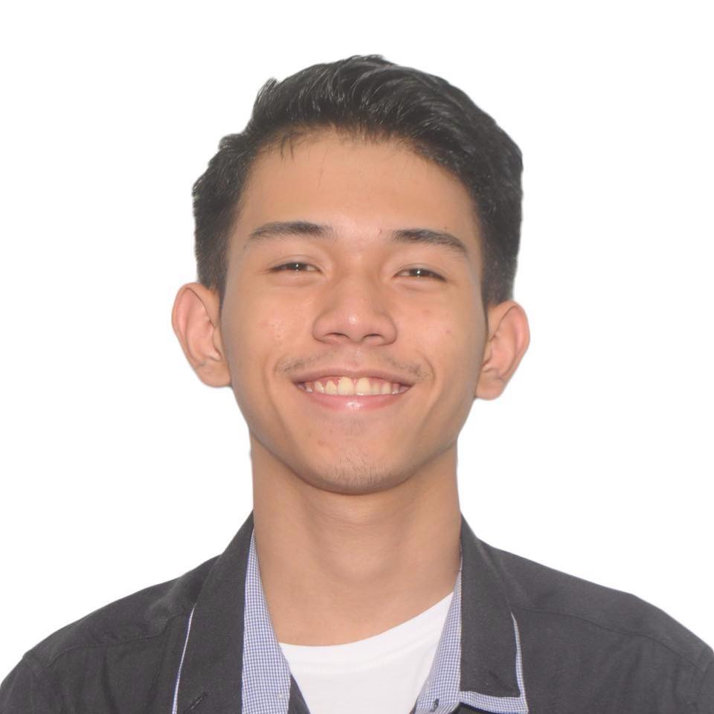

______________________________________________________________________________  
**Objectives**

* Seeking to be a part of a company’s family that serves as a challenge to my abilities and opportunity to contribute to the company’s achievement to goals while gaining personal improvements and growth head to success.

______________________________________________________________________________  
**Skills & Qualifications**

* Outstanding communication and personal skills.
* Highly personable and has the ability to create a positive working environment that uplifts companies satisfaction.
* Microsoft Word, PowerPoint and Excel literate.

______________________________________________________________________________

**Job Experience**

* Customer Service Representative at Inspiro Relia Company

______________________________________________________________________________  
**Personal Information**

Date of Birth : January 26, 1999  
Nickname: Cy  
Age: 20 y/o  
Height: 5’7  
Weight: 54kg  
Gender: Male  
Civil Status: Single  
Place of Birth: Quezon City  
Citizenship: Filipino  
Religion: Roman Catholic  
Mother’s Name: Marian C. Rivera Occupation: Assistant Manager  
Father’s Name: Brian A. Rivera Occupation: Grab Driver  
  
**Educational Background**

Tertiary: St. Augustine School of Nursing

Practical Nursing

Quezon City, 1104 Metro Manila

(2019 - 2019 )

Secondary: Nazareth School of National University  
1459 Alcantara, Sampaloc, Manila  
(2013-2014)

Primary: Immaculate Concepcion Parochial School   
272 Gen. Luna St, Concepcion, Malabon City   
(2009-2010)

**Character References**

Claire Cruz Registered Nurse

Kim Clyde Mallari Registered Nurse

**BRIAN FRIEL CYRUS RIVERA** Applicant