 Assignment Cover Sheet

Student Information (For group assignment, please state names of all members) |  | Grade/Marks
Name: Agraj K.C | ID: E2300552
Name: Roshan Shrestha | ID: E2300568
Name: Arjun Chaudhary | ID: E2300556

Module/Subject Information |  | Office Acknowledgement
Module/Subject Code | BIT 216
Module/Subject Name | Software Engineering Principles
Lecturer/Tutor/Facilitator | Mr. Sudeep Lal Bajimaya
Due Date | 12 Jun 2026
Assignment Title/Topic | Assignment 1 Submisstion (Part 1 & Part 2) - Part 1
Intake (where applicable)
Word Count |  | Date/Time

Declaration
- I/We have read and understood the Programme Handbook that explains on plagiarism, and I/we testify that, unless otherwise acknowledged, the work submitted herein is entirely my/our own.
- I/We declare that no part of this assignment has been written for me/us by any other person(s) except where such collaboration has been authorized by the lecturer concerned.
- I/We authorize the University to test any work submitted by me/us, using text comparison software, for instances of plagiarism. I/We understand this will involve the University or its contractors copying my/our work and storing it on a database to be used in future to test work submitted by others.
Note: 1) The attachment of this statement on any electronically submitted assignments will be deemed to have the same authority as a signed statement.
2) The Group Leader signs the declaration on behalf of all members.

Signature: Agraj K.C | Date: 2026-06-12
E-mail: agraj.kc23@gmail.com

Feedback/Comments*
Main Strengths
Main Weaknesses
Suggestions for improvement

 | Student acknowledge feedback/comments
Grader’s signature | Student’s signature:
Date: | Date:
Note:
- A soft and hard copy of the assignment shall be submitted.
- The signed copy of the assignment cover sheet shall be retained by the marker.
- If the Turnitin report is required, students have to submit it with the assignment. However, departments may allow students up to THREE (3) working days after submission of the assignment to submit the Turnitin report. The assignment shall only be marked upon the submission of the Turnitin report.

*Use additional sheets if required.

Table of Contents
1. Overview 4
2. Project Aims 4
3. Project Objectives 5
4. Project Scope 6
4.1 In Scope 6
4.2 Out of Scope 6
5. Project Schedule 7
5.1 Work Breakdown Structure (WBS) 7
5.2 Milestones and Deliverables 8
5.3 Gantt Chart 9
6. Technical Description of the Proposed System 10
6.1 Development Platform 10
6.2 Hardware Specification 11
6.3 Demonstration Platform 11
7. Risk Management Plan 12
References 13

1. Overview
Food waste remains a significant and escalating concern in contemporary society, with households contributing substantially to the overall volume of discarded food at both local and national levels. According to Yeong (2024), communities are increasingly seeking digital solutions to address this issue through more responsible consumption and sharing practices. MealMate is a web-based smart food waste reduction application developed to directly address this challenge by empowering household users with the tools necessary to manage, plan, and donate food effectively. In Malaysia specifically, household food waste remains a pressing national issue, with per-capita generation rates among the highest in Southeast Asia (United Nations Environment Programme [UNEP], 2024).

The primary users of MealMate are household members who wish to gain better control over their food inventory, minimise unnecessary waste, and contribute surplus food to others within their community. The application delivers a comprehensive suite of features including intelligent food inventory management, automated expiry date alerts, community-based donation facilitation, weekly meal planning, food analytics reporting, and account privacy management — all accessible through a responsive web interface.

MealMate represents a new product developed collaboratively by a team of three students as part of the BIT216 Software Engineering Principles module at HELP University. The estimated development effort spans approximately twelve (12) weeks, covering requirements analysis, system design, iterative development across two sprints, testing, and final delivery. The project is structured in alignment with iterative and incremental development methodology, ensuring continuous delivery of functional software at each milestone. This approach is consistent with established software engineering practice, which has shown that iterative and incremental development reduces project risk and improves the likelihood of successful delivery compared to traditional sequential models (Larman & Basili, 2003).

2. Project Aims
The aims of the MealMate project are as follows:

- To develop a user-centred, web-based application that enables households to actively monitor and manage their food inventory in order to minimise preventable food waste.
- To facilitate responsible food donation by providing a platform through which users can list, browse, and claim surplus food items within their local community.
- To promote informed and sustainable meal planning by integrating food inventory data with a weekly meal planner that prioritises ingredients approaching their expiry dates.
- To deliver a secure and privacy-conscious application that safeguards user data through account authentication, two-factor verification, and configurable privacy settings.
- To apply software engineering principles — including requirements analysis, iterative development, version control, and systematic testing — throughout the full project lifecycle.

3. Project Objectives
The following objectives define the specific and measurable outcomes that MealMate aims to achieve upon completion:

- To produce a complete project proposal and requirements specification document, including a detailed Work Breakdown Structure (WBS), Gantt chart, risk management plan, functional and non-functional requirements, user stories, and system design artefacts, by 26 June 2026.
- To implement and demonstrate a functional Iteration 1 prototype covering a minimum of three (3) use cases — namely User Registration and Privacy Settings, Manage Food Inventory, and Browse Food Items — with corresponding positive and negative test cases, by 24 July 2026.
- To implement and demonstrate a fully functional Iteration 2 prototype covering all six (6) use cases, with automated testing applied using an appropriate testing tool (e.g., Selenium), a complete test analysis report, and screenshots of all features, by 21 August 2026.
- To maintain consistent and evidence-based collaboration throughout the project lifecycle via GitHub, ensuring regular commits, branching, and merging activity from all three team members, as documented in the repository history.
- To deliver a final system that meets all functional requirements defined in the requirements specification, demonstrates a consistent and intuitive user interface aligned with UX principles, and includes appropriate input validation across all data entry forms.

4. Project Scope
The scope of MealMate defines the boundaries of the system — clarifying what the application will deliver and what falls outside its intended coverage — in order to prevent scope creep and ensure focused, achievable development.

4.1 In Scope
MealMate will deliver the following core functionalities, each corresponding to an identified use case:

- User Registration and Privacy Settings: Household users will be able to register on the platform, configure account privacy preferences (including 2FA), and manage food listing visibility via the account dashboard.
- Food Inventory Management: Users will log food items including item name, quantity, expiry date, category, and storage location. Items can be edited, marked as consumed, or converted to donation listings.
- Browse Food Items and Donation Listings: Users can browse available food donation listings filtered by location, category, expiry date, or storage type. Users may request or claim a donation and receive confirmation notifications.
- Food Analytics: The system will generate visual reports reflecting the user's food-saving activities, including total food saved from waste and number of donations made, filterable by time period and category.
- Notifications: The system will deliver timely alerts for upcoming food expiry dates, donation listing updates, meal planning reminders, and account-related notifications.
- Weekly Meal Planning: Users will plan meals using a calendar-based interface populated from their food inventory, with meal suggestions prioritising items approaching expiry.

4.2 Out of Scope
The following functionalities are explicitly excluded from the current version of MealMate:

- Payment processing or any form of monetary transaction between users.
- Real-time in-app chat or direct messaging between users.
- Integration with third-party grocery delivery services or external food APIs.
- A dedicated administrator panel for platform-wide content moderation or user management.
- Mobile native application development (iOS or Android); MealMate is delivered exclusively as a web application.

5. Project Schedule

5.1 Work Breakdown Structure (WBS)
The Work Breakdown Structure below decomposes the MealMate project into deliverable-oriented phases and tasks, aligned with the iterative and incremental development methodology adopted for this project.

WBS ID | Phase | Deliverable / Task | Owner
1.0 | Project Initiation | Project plan, proposal, and GitHub repository setup | All Members
1.1 |  | Team formation and role assignment | Team Leader
1.2 |  | GitHub repository creation and README | All Members
1.3 |  | Finalise project title and technology stack | All Members
2.0 | Requirements Analysis | Requirements specification document | All Members
2.1 |  | Functional and non-functional requirements | All Members
2.2 |  | Use Case 1: Register User & Privacy Settings (Epic, User Stories, AC) | Agraj K.C
2.3 |  | Use Case 4: Food Analytics (Epic, User Stories, AC) | Agraj K.C
2.4 |  | Use Case 2: Manage Food Inventory (Epic, User Stories, AC) | Arjun Chaudhary
2.5 |  | Use Case 5: View Notifications (Epic, User Stories, AC) | Arjun Chaudhary
2.6 |  | Use Case 3: Browse Food Items (Epic, User Stories, AC) | Roshan Shrestha
2.7 |  | Use Case 6: Plan Weekly Meals (Epic, User Stories, AC) | Roshan Shrestha
3.0 | System Design | Design specification document | All Members
3.1 |  | Architectural (deployment) diagram | All Members
3.2 |  | Entity Relationship Diagram (ERD) | All Members
3.3 |  | Site Map | All Members
3.4 |  | Wireframes (Figma/Canva) | All Members
3.5 |  | Data Dictionary | All Members
4.0 | Iteration 1 Development | Working prototype – 3 use cases | Individual
4.1 |  | Code: User Registration & Privacy Settings | Agraj K.C
4.2 |  | Code: Manage Food Inventory | Arjun Chaudhary
4.3 |  | Code: Browse Food Items | Roshan Shrestha
4.4 |  | Test cases (positive & negative) for UC1–UC3 | Individual
4.5 |  | Git commits, branching, and pull requests | All Members
4.6 |  | Iteration 1 presentation and demo | All Members
5.0 | Iteration 2 Development | Fully functional prototype – all 6 use cases | Individual
5.1 |  | Code: Food Analytics | Agraj K.C
5.2 |  | Code: View Notifications | Arjun Chaudhary
5.3 |  | Code: Plan Weekly Meals | Roshan Shrestha
5.4 |  | Automated testing (Selenium) and test analysis report | Individual
5.5 |  | Screenshots of all features | Individual
5.6 |  | Project review and reflection (Gantt comparison) | All Members
5.7 |  | Iteration 2 presentation and final demo | All Members

5.2 Milestones and Deliverables
The following table identifies the key project milestones, their associated deliverables, and the responsible parties. Effort estimates are based on a three-member team working part-time over the project duration.

No. | Milestone / Deliverable | Due Date | Effort (hrs) | Owner
M1 | Project Proposal & Plan (Task 1 Submission) | 12 June 2026 | 15 | All
M2 | Requirements Specification & Design Document (Task 2 Submission) | 26 June 2026 | 25 | All
M3 | Iteration 1 Prototype (3 use cases coded and tested) | 24 July 2026 | 40 | Individual
M4 | Iteration 1 Presentation and Demo | 24 July 2026 | 5 | All
M5 | Iteration 2 Prototype (all 6 use cases, automated tests) | 21 August 2026 | 40 | Individual
M6 | Final Project Document (test report, reflection, Gantt review) | 21 August 2026 | 10 | All
M7 | Iteration 2 Final Presentation and Demo | 21 August 2026 | 5 | All

5.3 Gantt Chart
The Gantt chart below illustrates the planned timeline for the MealMate project, including activity sequencing, milestone markers, and resource allocation across all team members. The baseline schedule is established here and will be compared against actual progress in Assignment 2.

Figure 5.1: MealMate Gantt Chart (GanttProject)
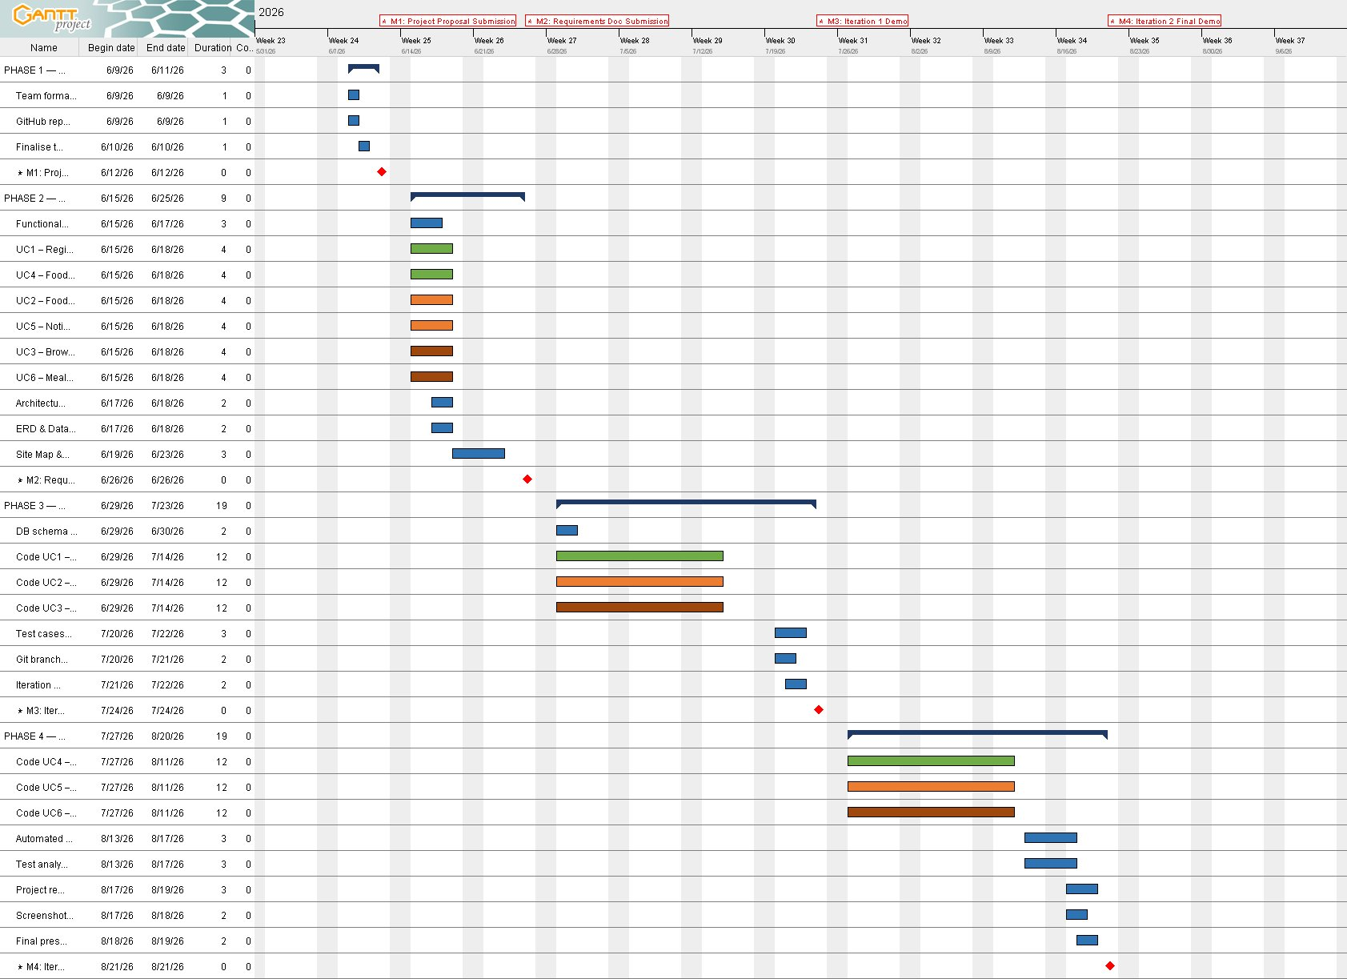
Figure 5.2: MealMate Resource Allocation Chart (GanttProject)
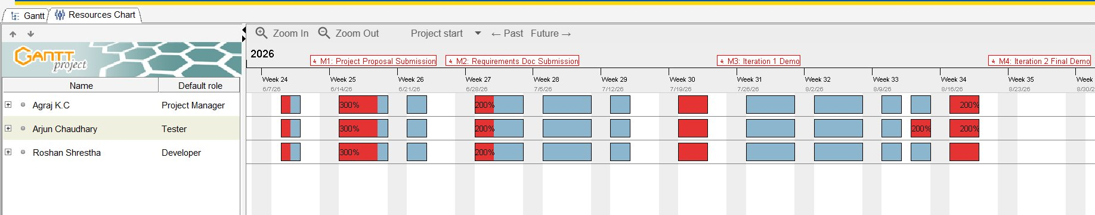

Legend: Grey shading = active development period. ◆ = Milestone / Submission deadline.

6. Technical Description of the Proposed System
This section defines the methods, tools, programming languages, and platforms to be employed during the design, implementation, testing, and documentation phases of MealMate. It has been prepared by the assigned team member responsible for the development platform.

6.1 Development Platform

Criteria | Tools / Hardware | Version | Description
Documentation | Microsoft Word | 2021 | Project proposal, requirements specification, and test reports.
Documentation | GitHub (README, Wiki) | Latest | Version-controlled documentation and team collaboration notes.
Modelling – Requirement | Visual Paradigm / draw.io | Latest | Use case diagrams, user story mapping, and system context diagrams.
Modelling – Design | Figma / Canva | Latest | Wireframes, UI mockups, and site map hierarchy diagrams.
Project Management | GanttProject | 3.x | Gantt chart creation, WBS structuring, and milestone tracking.
Collaboration | GitHub | Latest | Version control, branching, pull requests, and commit history tracking.
Framework – Front End | HTML5 / CSS3 / JavaScript | ES2022 | Responsive web interface built with semantic markup and modern CSS.
Framework – Back End | PHP | 8.x | Server-side scripting for business logic and API endpoint handling.
Database | MySQL | 8.x | Relational database for storing user accounts, food items, and notifications.
Testing | PHPUnit / Selenium | Latest | Unit testing for back-end logic; Selenium for automated UI testing in Iteration 2.

6.2 Hardware Specification

Hardware Spec | Details
Processor | Intel Core i5 / AMD Ryzen 5 (2.4 GHz or above)
RAM | 8 GB DDR4 minimum
Storage | 256 GB SSD minimum
Operating System | Windows 10/11 or macOS 12+
Display | 1920 × 1080 Full HD
Network | Stable broadband internet connection for GitHub collaboration and web testing

6.3 Demonstration Platform

Criteria | Tools / Hardware | Version | Description
Browser | Google Chrome | Latest | Primary browser for live demonstration of the MealMate web application.
Browser | Mozilla Firefox | Latest | Secondary browser for cross-browser compatibility testing during demo.
Local Server | XAMPP (Apache + MySQL) | 8.2.x | Local development and demonstration server environment.
Screen Capture | Windows Snipping Tool / OBS | Latest | Used to capture screenshots and record demo walkthroughs.

7. Risk Management Plan
The following risks have been identified, assessed for probability and impact, and assigned mitigation strategies to ensure project continuity. Risk assessment was conducted collaboratively by all team members.

Risk Name | Description | Prob. | Mitigation Strategy
Uneven team contribution | One or more team members may contribute significantly less than expected, affecting overall progress. | M | Weekly check-ins via WhatsApp/Discord; task ownership clearly defined in WBS. Escalate to lecturer if persistent.
Scope creep | Addition of unplanned features during development may delay delivery and reduce focus on core requirements. | H | Strictly follow the scope defined in Section 4. All scope change requests require team consensus before implementation.
Technical skill gaps | Team members may lack proficiency in certain tools (e.g., PHP, Selenium) required during development phases. | M | Allocate time in Week 1–2 for technical upskilling. Use online resources (W3Schools, YouTube, official docs). Peer learning within team.
Git merge conflicts | Simultaneous code commits may cause conflicts, delaying integration and testing activities. | M | Use feature branching strategy; each member works on a separate branch. Code review required before merging to main.
Hardware or software failure | A team member's device may fail, causing loss of work and disrupting the development schedule. | L | All work is committed to GitHub at the end of each session. Cloud backups (Google Drive / OneDrive) maintained for documents.
Late submission risk | Academic workload from other modules may reduce available time, leading to delays in deliverables. | M | Milestone dates set one week ahead of actual deadlines. Time-boxing applied per WBS task. Monitor progress weekly against Gantt baseline.
System integration issues | Front-end and back-end components developed separately may face integration errors during iteration demos. | M | Define clear API contracts and database schema early. Conduct integration testing at least 3 days before each demo deadline.

Probability Key: L = Low, M = Medium, H = High

Github Repository Link:
https://github.com/CyrusX10/mealmate-app

Acknowledgement of AI Tool Usage
In accordance with HELP University's academic integrity policy on the use of artificial intelligence in coursework, the team acknowledges that an AI language model (Claude, developed by Anthropic) was used during the preparation of this proposal. AI assistance was used to support the structuring of document sections, the drafting of initial content for the Overview, Aims, Objectives, and Scope sections, and the formatting of the Work Breakdown Structure and risk management tables. All AI-generated content was reviewed, verified, and edited by the team members to ensure accuracy and alignment with the project's actual scope and plan. The overall contribution of AI-generated content to this document is estimated to be below 30%, in line with the assignment requirements (BIT216 Assignment 1, Sem May 2026).

References
Yeong, A. (2024). How Malaysians are battling food waste with surplus food. FairPlanet. https://www.fairplanet.org/editors-pick/how-malaysians-are-battling-food-waste-with-surplus-food/
United Nations Environment Programme. (2024). Food Waste Index Report 2024: Think Eat Save – Tracking progress to halve food waste. UNEP. https://sdg2advocacyhub.org/wp-content/uploads/2024/03/food_waste_index_report_2024.pdf
Larman, C., & Basili, V. R. (2003). Iterative and incremental development: A brief history. Computer, 36(6), 47–56. https://doi.org/10.1109/MC.2003.1204375

Pre-Submission Review Notes
Before final submission:
• Update the Table of Contents in Microsoft Word (References → Update Table) so page numbers are correct.
• Replace the student enrollment/ID numbers with the correct values for each member.
• Verify that the Gantt chart figures and hyperlinks render correctly in the final document.

