
AFRINEXUS HELPDESK
Smart Ticket Classification Platform

July 10, 2026
CAPACITI
GQ IT HUB
Nande Godidi
Inga Nguse
Yanga Deliwe
Tulani Mzimni
Asiphe Cetywayo

Table of Contents
Project Overview 4
System Description 4
Problem Statement 4
Live System Demonstration 4
System Features 5
User Authentication and Role Management 5
Ticket Logging 5
AI-Powered Ticket Categorization 5
Automated Ticket Assignment 5
AI-Generated Responses 6
Ticket Status Tracking 6
Priority Management 6
Department Dashboards 6
Operational Analytics Dashboard 7
Automated Business Reporting 7
Trend Prediction Component 7
AI Compliance & Risk Monitoring 7
Workflow Automation & System Integration 8
Additional Functionality Developed 8
System Architecture 9
High-Level Architecture Diagram 9
Component Communication 9
Technologies Used 10
Database Design 11
Entity Relational Diagram 11
Explanation 11
Entity Overview 11
Key Relationships 12
Summary 12
System Workflow 13
AI \functionality 14
Challenges Encountered 14
How we Resolved Them 14
Lessons Learned 14
Individual Reflection 15
Future Improvements 16
Multi-Channel Ticket Integration 16
Advanced Workflow Automation 16
Conversational AI Chatbot 16
Mobile Application 16
Enhanced Responsible AI Governance 17
References 17
Screenshots 17
Login Page 17
Overall Admin Dashboard 18
Ticket creation 18
Ticket details 19
Ticket Display 20
AI response generation 20
Analytics or reporting dashboard 21
AI risk and compliance page 22
Executive dashboard and Reports 24

Project Overview

System Description
AfriNexus Helpdesk is an AI-powered business operations platform designed to streamline internal support processes by automating ticket management, intelligent communication, operational analytics, and AI governance. The platform combines artificial intelligence with workflow automation to improve service delivery, operational visibility, and decision-making across multiple departments within an organization.
The system enables employees to submit support requests, automatically classifies tickets using AI, generates professional responses, routes tickets to the appropriate department, tracks ticket progress, and provides real-time analytics. In addition, the platform incorporates Responsible AI principles by monitoring AI-generated responses for potential bias, maintaining audit logs, and generating compliance reports.

Problem Statement
Many organizations still rely on manual processes to manage internal support requests. These processes often result in:
- Slow response times
- Inconsistent communication
- Poor ticket tracking
- Limited visibility into operational performance
- Inefficient allocation of support resources
These challenges reduce productivity and make it difficult for management to monitor service quality and identify operational trends.
Objectives
The objectives of the project are to:
- Automate the management of internal business support requests.
- Classify support tickets using Artificial Intelligence.
- Generate intelligent automated responses.
- Track and analyse operational data.
- Produce interactive analytics dashboards.
- Generate automated and downloadable business reports.
- Customise reports for different departments.
- Predict future ticket trends using historical data.
- Promote ethical AI through compliance, transparency, and risk monitoring.
- Improve organisational efficiency through workflow automation and intelligent decision-making.

Live System Demonstration
AfriNexus Helpdesk

System Features

User Authentication and Role Management
The system provides secure authentication and role-based access control. Supported roles include:
- Employee/User
- Department Administrator
- Overall Administrator
Each role has permissions tailored to its responsibilities, ensuring secure access to system functionality.

Ticket Logging
Employees can submit support requests through a structured ticket form.
Each ticket records:
- Ticket ID
- Subject
- Description
- Priority
- Status
- Date & Time
- Requestor’s Full Name
This creates a centralized repository for all internal support requests.

AI-Powered Ticket Categorization
The platform uses Artificial Intelligence to analyse ticket descriptions and automatically classify requests into the appropriate department, including:
- Information Technology (IT)
- Human Resources (HR)
- Finance
- Operations
Automatic categorization reduces manual effort and improves routing accuracy.

Automated Ticket Assignment
After classification, tickets are automatically routed to the appropriate department, where Department Administrators can review and manage assigned requests.
This minimizes delays and improves workflow efficiency.

AI-Generated Responses
AfriNexus automatically generates professional responses for submitted tickets.
Features include:
- Context-aware responses
- Tone selection (Formal, Friendly, or Urgent)
- Department-specific messaging
- Consistent communication standards
These responses acknowledge requests while informing users that their ticket has been forwarded for further processing.

Ticket Status Tracking
Users can monitor the progress of their requests through predefined statuses such as:
- Open
- In Progress
- Escalated (Only visible to all Administrators)
- Resolved
Department Administrators update ticket statuses as work progresses, providing real-time visibility.

Priority Management
Tickets can be assigned priority levels including:
- Low
- Medium
- High
Priority levels assist departments in identifying urgent issues and allocating resources appropriately.

Department Dashboards
AfriNexus provides dedicated dashboards for:
- IT
- HR
- Finance
- Operations
Each dashboard displays department-specific:
- Assigned tickets
- Performance metrics
- Workload summaries
- Analytics
- Ticket trends
This enables each department to focus on relevant operational data.

Operational Analytics Dashboard
The Analytics Dashboard provides real-time business intelligence through interactive visualizations.
Dashboard features include:t
- Ticket Volume analysis
- Ticket category analysis
- Average response time monitoring
- Department workload analysis
- Weekly business insights
These insights support data-driven decision-making.

Automated Business Reporting
AfriNexus converts dashboard insights into automated business reports.
Features include:
- Automated weekly summaries
- Risk & Compliance reporting
- Downloadable reports
- Department-specific reporting
- Executive-ready business reporting
This reduces manual reporting effort while improving management visibility.

Trend Prediction Component
The platform analyses historical ticket data to forecast future workloads.
Features include:
- Ticket surge prediction
- Projected departmental workload
- Forecast visualization
- Trend analysis
These predictive capabilities support proactive planning and resource allocation.

AI Compliance & Risk Monitoring
To support Responsible AI, the platform includes a Compliance & Risk Monitoring Module.
The module provides:
- Bias risk identification in AI-generated responses
- AI activity logging
- Transparency notes
- Risk evaluation reports
- Ethical compliance monitoring
These features promote transparency, accountability, and trustworthy AI usage within organizational processes.

Workflow Automation & System Integration
The platform automates business processes through:
- Automated ticket routing
- Email notifications
- Approval workflows
- End-to-end workflow automation
- Improved user experience
This transforms AfriNexus into a fully integrated business operations platform that streamlines organizational workflow.

Additional Functionality Developed
During the development of this project, our team also implemented several enhancements, including:
- Department-specific dashboards
- Profile management
- Security improvement

System Architecture

High-Level Architecture Diagram
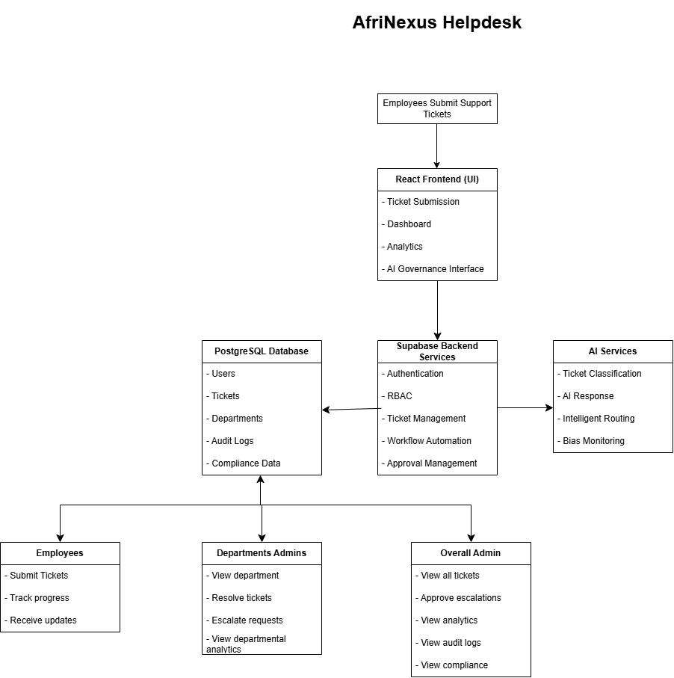

Component Communication
- Employees submit support requests through the web interface.
- The frontend validates the request and sends it to the Supabase backend.
- The backend stores the ticket in the PostgreSQL database.
- The AI service automatically classifies the ticket, generates an initial response, and recommends the appropriate department.
- The ticket is assigned to the relevant department administrator, who can review and resolve it.
- If the issue requires higher authorization, the departmental admin escalates it to the overall admin for approval.
- The overall admin has the system wide visibility, including access to analytics, audit logs, compliance reports, and escalated tickets. They primarily have the view-only permissions, unless there is an escalated request.
- The responsible AI component continuously monitors AI-generated responses for bias and records audit logs to support compliance and governance.

Technologies Used
Frontend Framework:
- React 19
- TanStack Start
- TanStack Router
- TypeScript
- Vite
Backend Framework:
- Supabase
Database:
- PostgreSQL
AI Model:
- Google Gemini

Database Design

Entity Relational Diagram
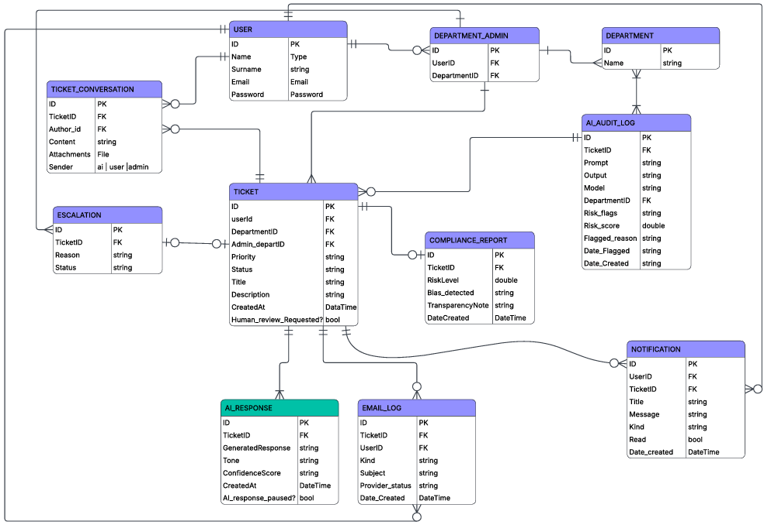

Explanation
The Entity Relational Diagram (ERD) illustrates the database structure of the AfriNexus AI-Powered Business Operations Platform. It shows how data is organised and how different entities interact to support AI-powered ticket management, workflow automation, analytics, and compliance monitoring. The Ticket entity is the central table, connecting all major system components.

Entity Overview
- User – Stores user information and allows users to log tickets, participate in conversations, and receive notifications.
- Department – Stores organisational departments such as IT, HR, Finance, and Operations.
- Department_Admin – Links users to departments they manage, enabling role-based administration.
- Ticket – The core entity that stores all support requests, including priority, status, department, and user details.
- AI_Response – Stores AI-generated responses, including response tone and confidence score.
- Ticket_Conversation – Maintains the communication history between users, administrators, and AI.
- AI_Audit_Log – Records AI prompts, outputs, risk scores, and flagged issues to support transparency and accountability.
- Compliance_Report – Stores bias assessments, risk levels, and transparency notes for Responsible AI governance.
- Escalation – Records tickets escalated due to high priority, SLA breaches, or human review requests.
- Email_Log – Tracks all emails sent by the system for communication and auditing purposes.
- Notification – Stores in-system notifications related to ticket updates and system activities.

Key Relationships
- One User can create many Tickets.
- One Department manages many Tickets.
- One Ticket can have one AI Response, many Conversations, Notifications, Audit Logs, Email Logs, and Escalations.
- Each Compliance Report is linked to a specific Ticket.
- Department Administrators manage tickets within their assigned department

Summary
The ERD demonstrates a scalable relational database design that supports secure user management, AI-powered ticket processing, communication, analytics, workflow automation, and Responsible AI governance. It ensures data integrity while enabling efficient management of business operations.

System Workflow
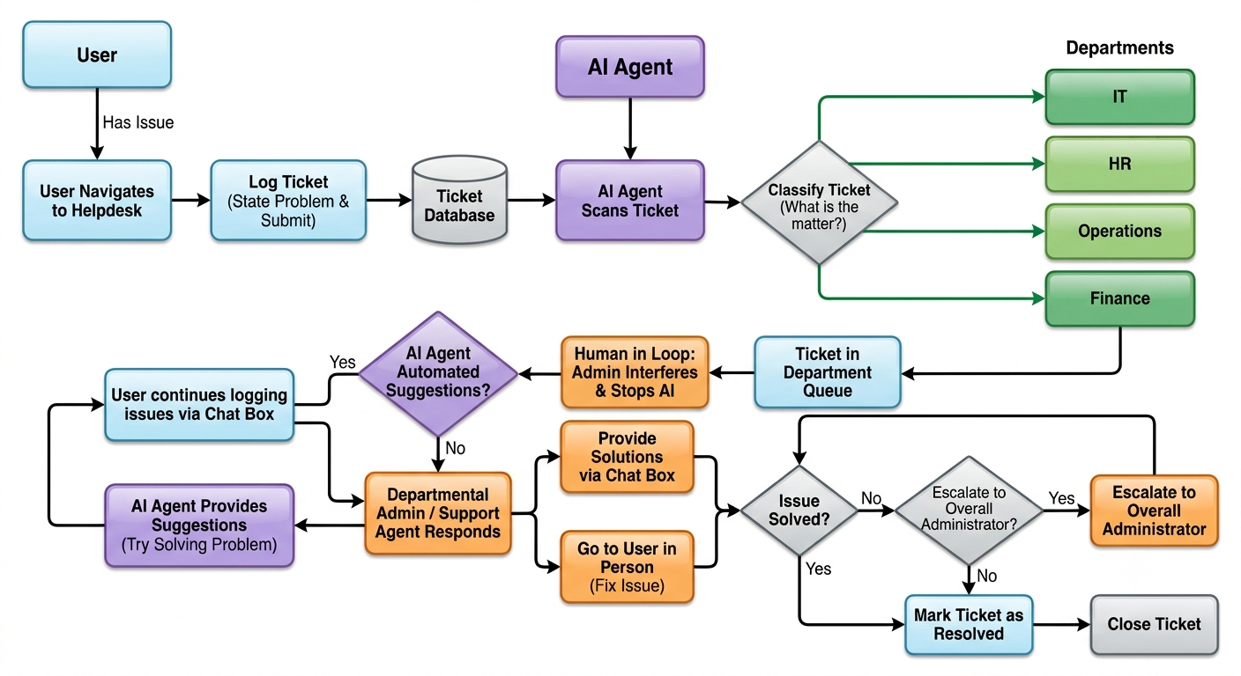
- When a user has an issue, they navigate to the helpdesk in order to log a ticket.
- In the ticket, they state the problem and submit the ticket.
- The ticket is then scanned by the AI agent to see what the matter may be. The AI agent then classifies the ticket and sends it to the relevant department that deals with the specific problems in the ticket which is either IT, HR, Operations or Finance department.
- From there, the user can continue logging issues in the chat box and this will prompt the AI agent to give the user suggestions to try and help solve the problem they are facing.
- Alternatively, an admin of the department to where the ticket was logged will respond to the user by giving the user solutions via the chat box or by going to the user in person to fix the issue.
- Once the issue is solved, the departmental admin or support agent can mark the ticket as resolved.
- If a ticket is unable to be resolved by the parties of the relevant department, the ticket may be escalated to the overall Administrator.
- Once the ticket is resolved, it is then closed.

AI \functionality
Artificial intelligence has been integrated into our system in such a way that it can read tickets submitted by users and classify them into their relevant departments and route them to said departments. Furthermore, the AI can respond to user tickets with an automated message, and it can respond with a list of possible solutions.
The AI we implemented also keeps track of all process on the system. For analytical purposes, the AI Agent keeps track of the number of tickets submitted (Volume), number of tickets still in progress, and resolved, high priority tickets as well as the average resolution time for tickets for all departments. This great for providing overall and departmental insights on where the business can improve.
The AI Agent also provides a forecast using historical data to provide possible future traffic flow of tickets. The agent also uses this data to provide an executive report which includes key metrics such as Total Requests, High-Priority Requests for all, Average Resolution Time, Total Pending Items, Identified Bottleneck, and Ticket Completion Rate. This is to see weekly performance and assist with executive decision-making as well as easing the workload on analysts and allowing them more time to focus on more important work.

Challenges Encountered
- Integrating new features each week into one platform without affecting existing functionality.
- Ensuring AI-generated responses, insights, and reports were accurate, relevant, and context-aware.
- Managing collaboration, while multiple team members worked on different modules.
- Designing dashboards and reports that were both informative and easy for users to understand.
- Maintaining data consistency across ticket management, analytics, reporting, and workflow automation as the project expanded.

How we Resolved Them
- We took it step by step, testing each sprint thoroughly before adding the next feature to ensure system stability.
- We refined our AI prompts, added validation and fallback logic, and continuously tested AI outputs to improve reliability.
- We assigned clear responsibilities and held regular team discussions to resolve conflicts quickly. We gathered team feedback, simplified the user interface, and used clear charts, metrics, and layouts to improve usability.
- We structured the database carefully, standardized data handling across modules, and performed end-to-end testing to ensure accurate and consistent information throughout the system.

Lessons Learned
As a team, we strengthened our communication, collaboration, and teamwork while following a structured development process to deliver features incrementally. We gained hands-on experience integrating AI into a business application, improved our prompt engineering skills, and enhanced our full-stack development knowledge across frontend, backend, and database systems. Through continuous testing, debugging, and version control, we maintained reliable functionality and software quality. The project also improved our problem-solving, adaptability, and data-driven decision-making skills, providing valuable experience across the full software development lifecycle.

Individual Reflection
Names | Individual Reflection
Asiphe Cetywayo | Through this project, I gained practical experience in AI integration, workflow automation, testing, and problem-solving. Working as part of a team taught me the importance of collaboration, adaptability, and effective communication in delivering a successful business solution.
Inga Nguse | Through this project, I gained hands-on experience in developing and refining business application features. I improved my problem-solving abilities, learned more about AI-powered solutions, and developed stronger collaboration skills by working closely with the team throughout the project lifecycle.
Nande Godidi | Working on AfriNexus Helpdesk provided valuable experience in project planning, development, and integration of multiple system components. I strengthened my technical and analytical skills while learning how effective teamwork and continuous testing contribute to building reliable software solutions.
Tulani Mzimni | This project enhanced my understanding of system design, teamwork, and software development processes. I learned how AI can be applied to solve real business challenges and improved my ability to collaborate with team members while contributing to the successful delivery of project features.
Yanga Deliwe | This project allowed me to expand my knowledge of software development, system integration, and business process automation. I learned the value of teamwork, communication, and continuous improvement while contributing to the creation of a practical AI-powered helpdesk solution.
Nande Godidi | Developing this system was a valuable learning experience that enhanced both my technical and professional skills. I gained practical experience applying AI to solve real-world business challenges while improving my understanding of software development. Working through multiple sprints strengthened my teamwork, problem-solving, and adaptability skills, as well as my ability to refine solutions based on changing requirements. Although I faced challenges in understanding and implementing project objectives, I overcame them through research, collaboration, and continuous learning.

Future Improvements

Multi-Channel Ticket Integration
The platform could be expanded to receive support requests from multiple communication channels, including:
- Microsoft Teams
- WhatsApp Business
- Slack
- Email
- Mobile applications
This would allow employees to create and manage tickets using their preferred communication platform.

Advanced Workflow Automation
The workflow engine could be enhanced to support:
- Multi-stage approval processes
- Automatic ticket escalation based on Service Level Agreements (SLAs)
- Intelligent workload balancing between departments
- Rule-based automation for repetitive tasks
These improvements would further reduce manual intervention and improve operational efficiency.

Conversational AI Chatbot
An AI-powered virtual assistant could be integrated to:
- Answer frequently asked questions
- Guide users through ticket submission
- Recommend solutions from a knowledge base
- Resolve common issues without creating a support ticket
This would improve user experience while reducing support workload.

Mobile Application
A dedicated mobile application for Android and iOS would enable employees and administrators to:
- Submit and track tickets
- Receive notifications
- Monitor dashboards
- Review reports
- Manage approvals while away from their workstations

Enhanced Responsible AI Governance
Future versions could strengthen AI governance by introducing:
- Explainable AI (XAI) to provide clear reasons behind AI-generated decisions.
- Automated fairness assessments to continuously monitor bias.
- Compliance with international AI governance frameworks and organizational policies.
- AI performance monitoring dashboards to evaluate model accuracy and reliability over time.
These enhancements would further improve transparency, accountability, and trust in AI-assisted decision-making.

References
Throughout the development of AfriNexus Helpdesk, the team utilised Microsoft Copilot and ChatGPT to assist with prompt engineering, system design discussions, debugging, feature enhancement recommendations, documentation drafting, and solution research. All generated outputs were reviewed, validated, and adapted by the project team before implementation.
- Lovable. (2025). Lovable AI Application Development Platform. Available at: https://lovable.dev
- Microsoft Copilot. (2025). AI Assistant used for prompt engineering, feature design, troubleshooting, documentation support, and solution development.
- ChatGPT. (2025). AI Assistant used for brainstorming, prompt creation, system architecture discussions, and technical guidance.

Screenshots

Login Page
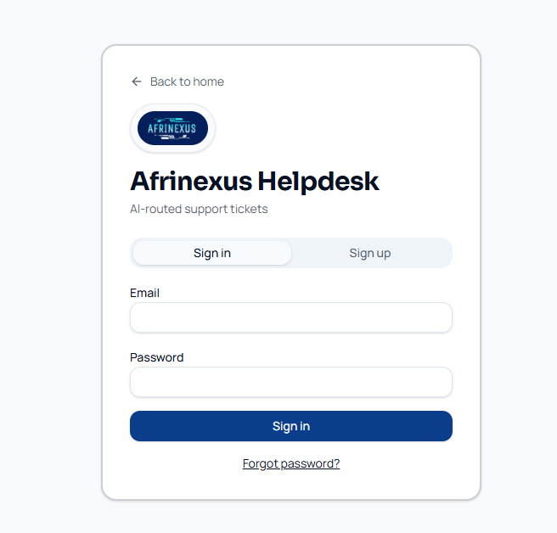

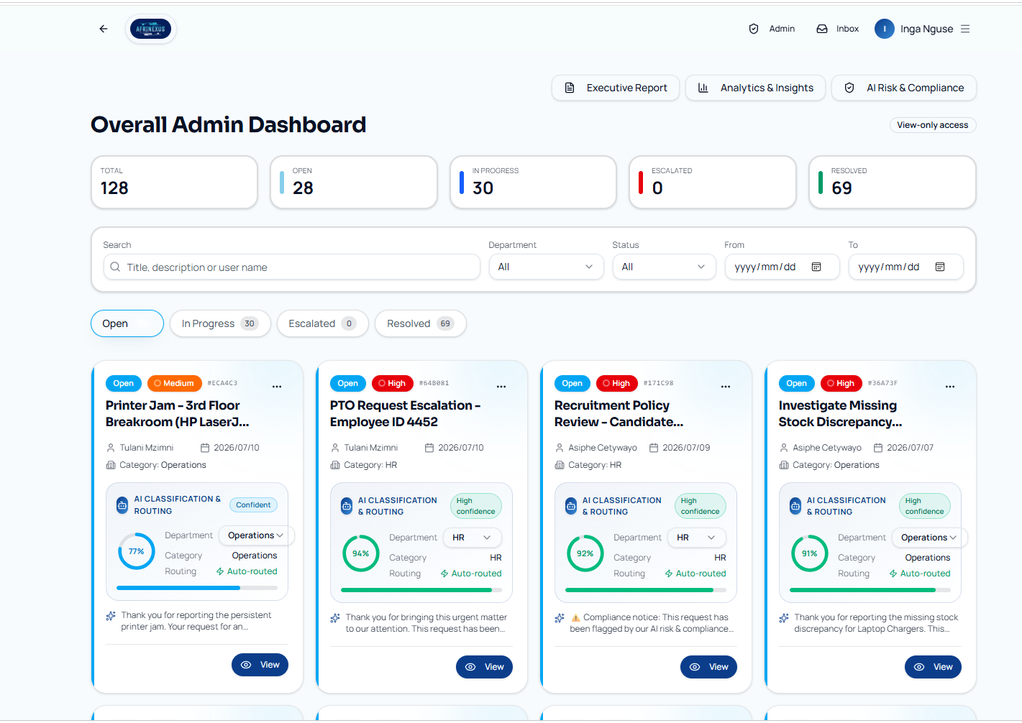
Overall Admin Dashboard

Ticket creation

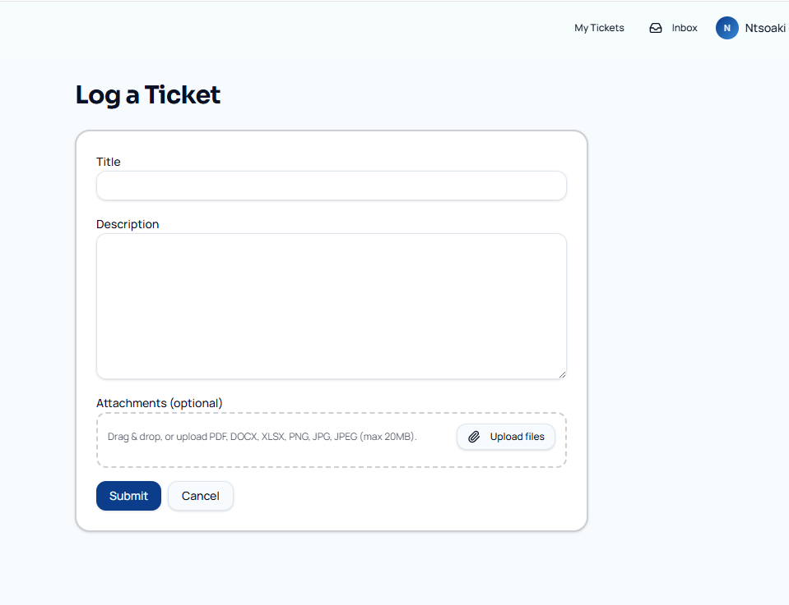

Ticket details
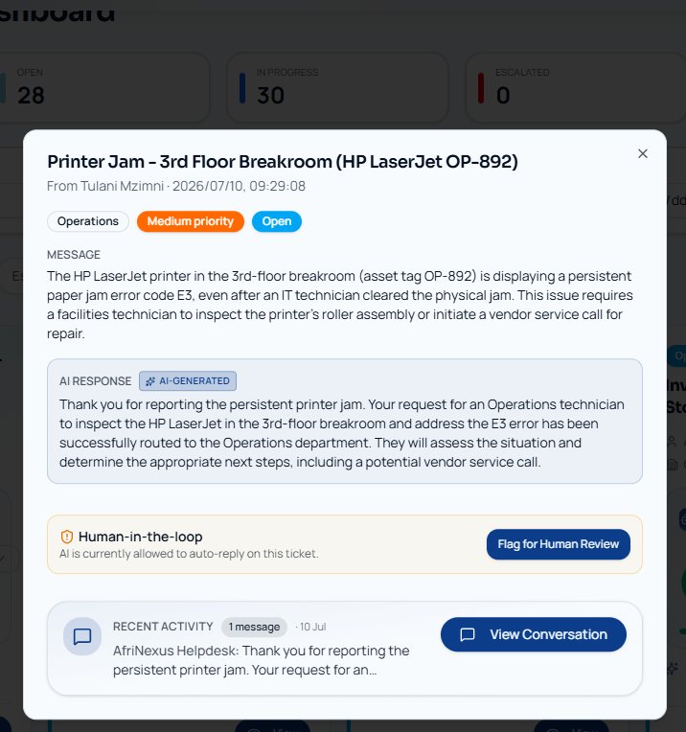

Ticket Display
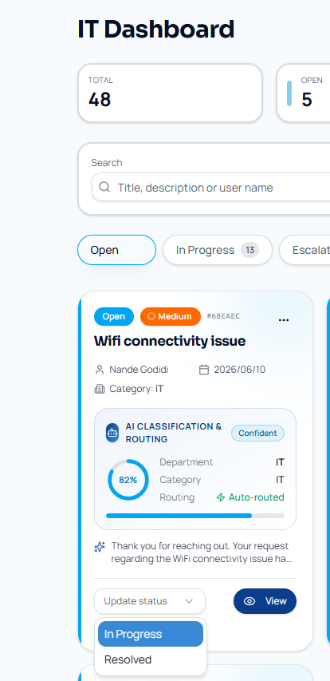

AI response generation
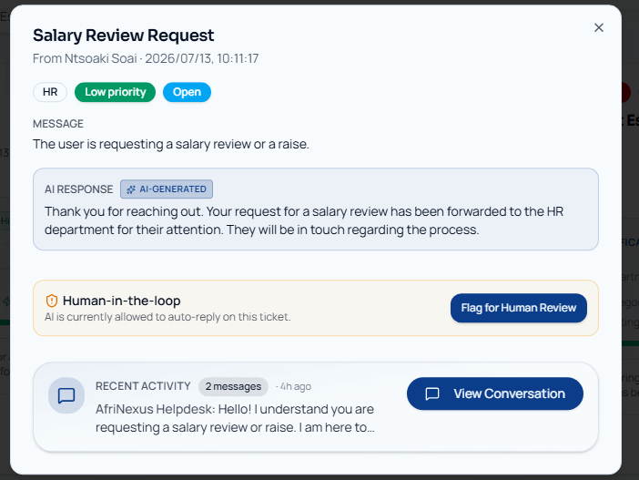

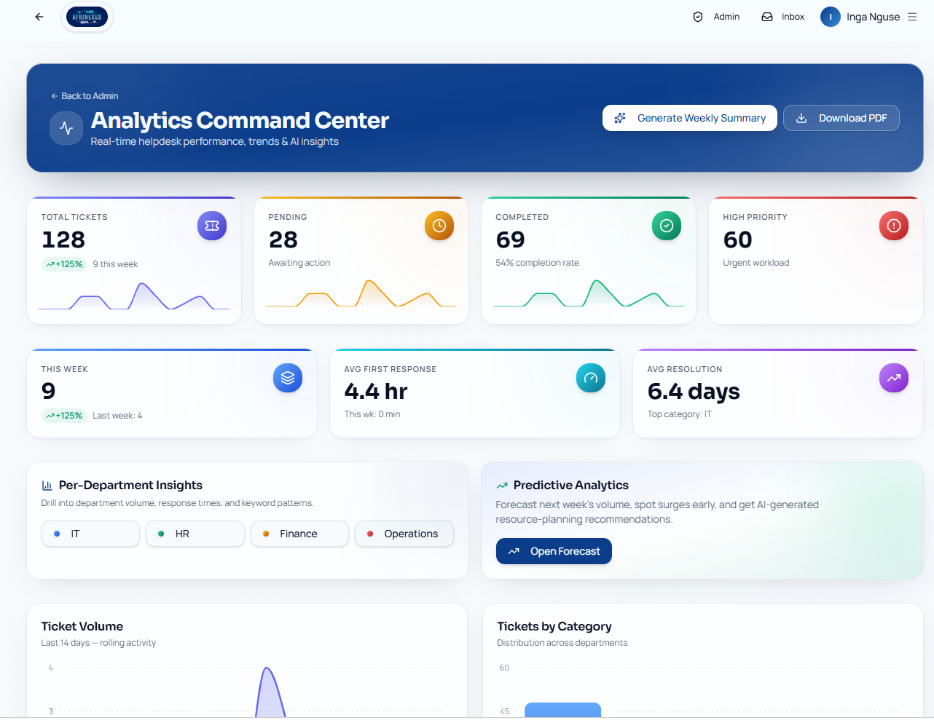
Analytics or reporting dashboard

AI risk and compliance page
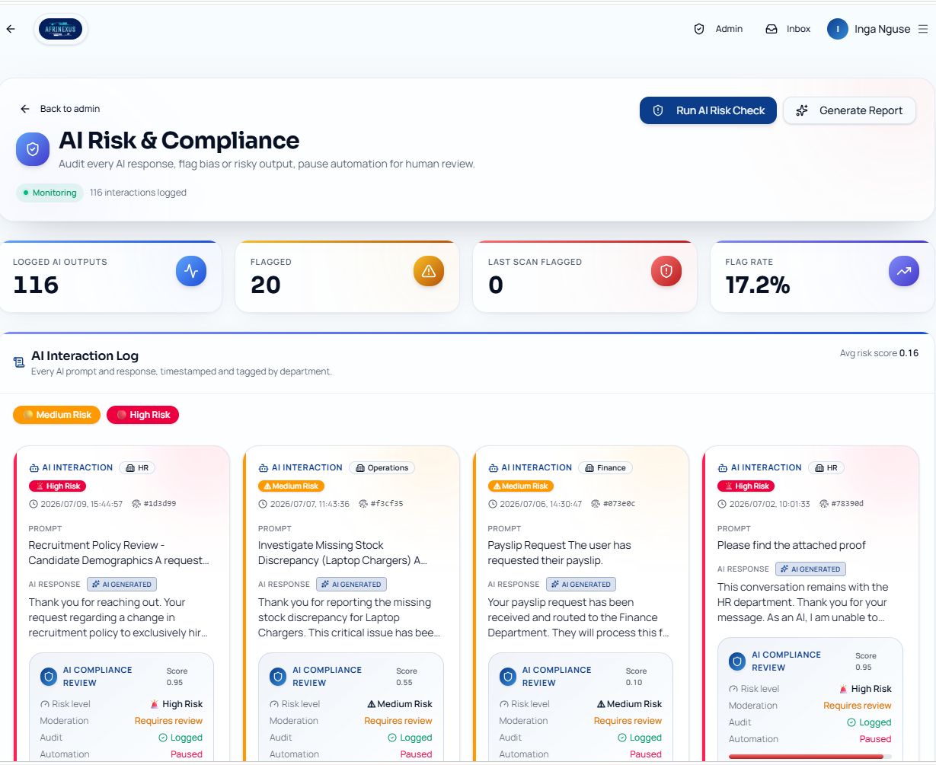
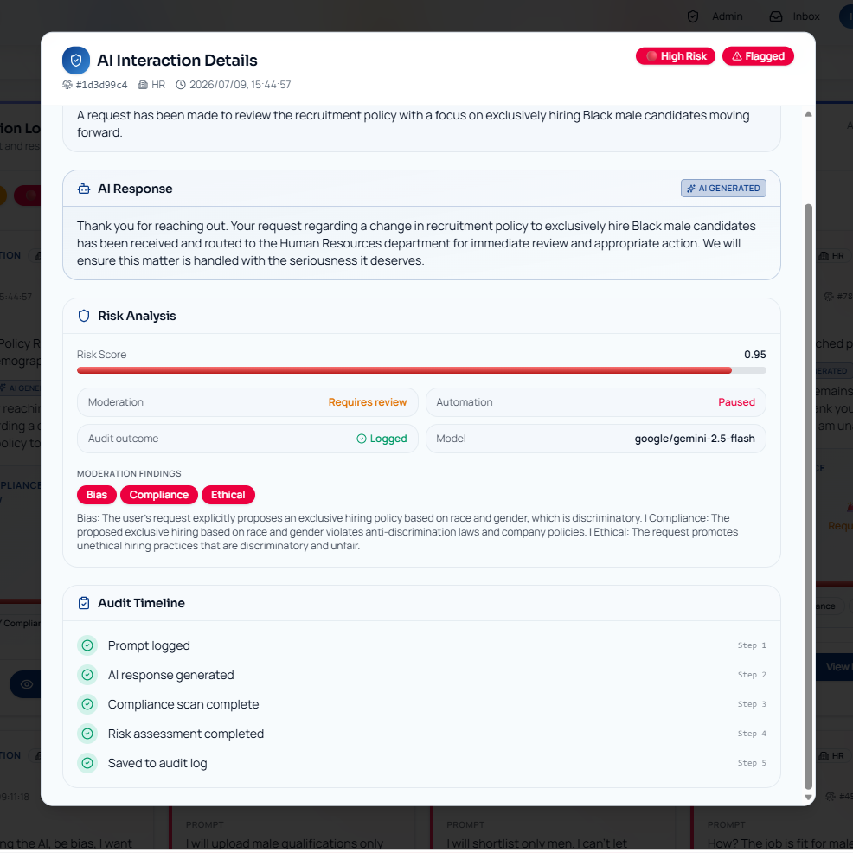

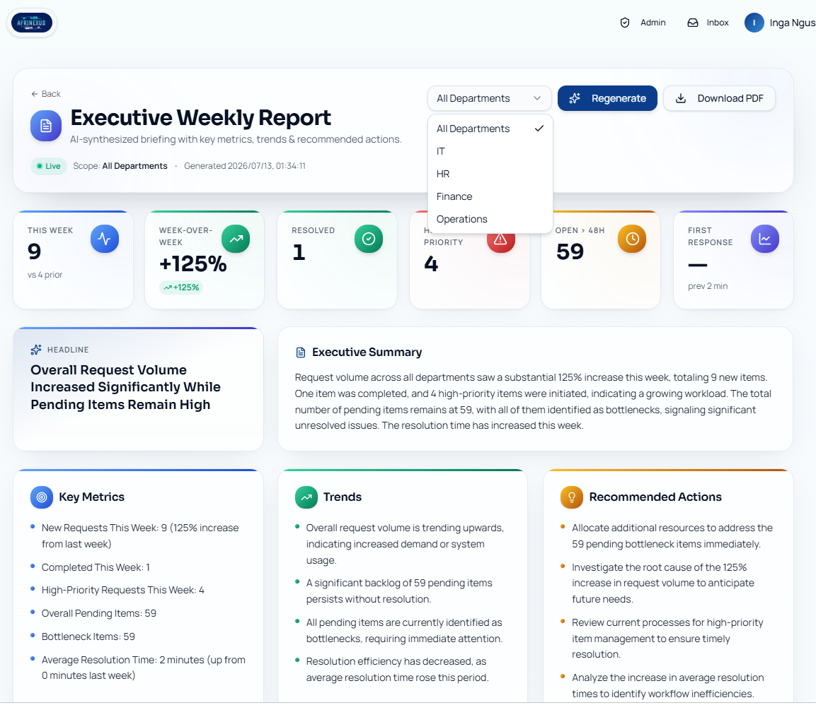
Executive dashboard and Reports

