Bayesian Assurance Using East-R

J. Kyle Wathen and Laurent Spiess

February 01, 2024

# Introduction

The intent of this example is to demonstrate the computation of Bayesian assurance, or probability of success, through the integration of East and R using a series of example. These examples begin with a 2-arm, normal outcome, fixed sample trial assuming a non-standard prior for computation of assurance. The examples progress to a more complex setting of computing assurance for a sequence of a phase 2 trial with normal outcomes followed by a phase 3 trial where the outcome is time-to-event.

The examples will all contain two treatments, Standard of Care (S) and Experimental (E) and are follows:

1. Fixed sample design using a mixture of normal distributions for computation of assurance
2. Expand example 1 to a group sequential design with an interim for futility based on a Bayesian predictive probability
3. Fixed design with a time-event-event outcome, this example provides the basis and a comparison for the phase 2 followed by a phase 3 example considered last
4. Two consecutive studies, phase 2 with a normal endpoint followed by a phase 3 with a normal endpoint
5. Two consecutive studies, phase 2 with a normal endpoint followed by a phase 3 with a time-to-event outcome

# Example 1

## Study Design

Fixed sample, with normally distributed outcomes Y.

* Sample size: 80 patients per arm
* Assume standard deviation is known: $σ=1.9$

Denote the minimum acceptable value by MAV. For patients receiving treatment $j$ = S or E, we assume the outcomes Y $∼N\left(μ_{j},σ^{2}\right)$ where, for simplicity, $μ_{j}$ is unknown and $σ$ is the known, fixed quantity. We assume *a priori $μ_{j}∼$* Normal( $θ_{j},τ_{j}^{2}={100}^{2}$), for $j=$ S or E. At the end of the study the following is computed:

$$ρ=Pr\left(μ_{E}>μ_{S}+MAV|data\right)\text{ and}$$

$$
\text{If } \rho > P_U \implies \text{ Go }\\
\text{ If } \rho \leq P_U \implies \text{ No Go }
$$

For assurance, a mixture of normal distributions is assumed. The assurance prior is specified in terms of the prior weight, mean, and variance for each component of the mixture. For simplicity, we assume mixture of two normal distributions as follows:

* Weight: 25% on $N\left(0,0.05\right)$
* Weight: 75% on $N\left(0.7,{0.3}^{2}\right)$

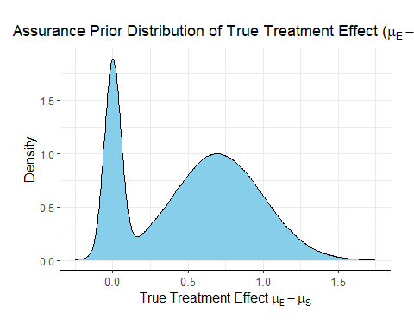

## East-R Integration

In order to evaluate the design above, one can develop an R function for analysis that can be called from East during simulation. By replacing only the analysis function with an R function, one can obtain the frequentist operating characteristics of the Bayesian design using East. In addition, by replacing how the patient data is simulated one can obtain the Bayesian assurance. Specifically, in the simulation when the patient data is simulated an R function will first sample the assurance prior then sample the patient data. The resulting power of this simulation will be the Bayesian assurance assuming the 2 component prior given above.

There is often a need for examination of posterior distribution of both observed and true treatment differences given a Go decision. These posterior distributions can be useful for planning the next phase of study and understanding potential risks. Obtaining the posterior distributions is described in the next section and they are applied to the phase 2 followed by phase 3 in later sections.

### Required R Functions

The two functions that are needed to evaluate this design and obtain the Bayesian assurance are the analysis function, AnayzeUsingBayesianNormals, and patient simulation function, SimulatePatientOutcomeNormalAssurance.

To help understand the AnayzeUsingBayesianNormals one must first derive the posterior distributions.

After observing $n$ patients on treatment $j=$ S or E, the posterior distribution of $μ_{j}$ is:

$$μ_{j}|\overset{‾}{y}∼N\left(θ_{j}^{*},τ_{j}^{2*}\right)$$

where

$$θ_{j}^{*}=\frac{\frac{θ_{j}}{τ_{j}^{2}}+\frac{n}{σ^{2}}\overset{‾}{y}}{\frac{1}{τ_{j}^{2}}+\frac{1}{σ^{2}}}\text{ and }\frac{1}{τ_{j}^{2*}}=\frac{1}{τ_{j}^{2}}+\frac{n}{σ^{2}}$$

## Results

The probability of a Go is 14.3% and the probability of a No Go is 85.7%.

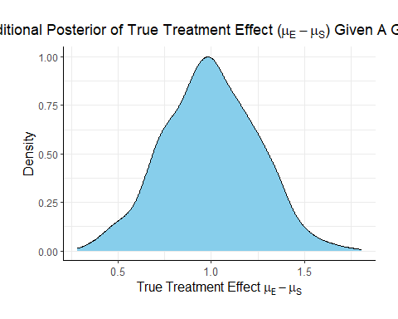

# Example 2

## Study Design

Same study design as previous example, however, this design includes an interim analysis to check for futility when 50% of the patients have their outcome observed. The futility rule is based on a Bayesian predictive probability of a No Go at the end of the study. That is, at the interim analysis if it is likely that the study will make a No Go decision at the final analysis, then the study is stopped early for futility.

Denote the data at the interim analysis by $X_{1}$ and data for patients enrolled after the IA by $X_{2}$ if the predictive probability of a No Go at the final analysis is greater than $PU_{Futility}=90$ then the trial is stopped for futility. Specifically, if

$$Pr\left(\text{End of Study No Go}|X\right)>PU_{Futility}=90\%$$

then the trial is stopped for futility. The prediction formula becomes

$$Pr\left(\text{End of Study No Go}|X\right)=Pr\left[\{Pr(μ_{E}>μ_{S}+MAV\left|X_{1},X_{2})>PU\}\right|X2\right]>PU_{Futility}$$

## East-R Integration

### Required R Functions

Same as example 1, just need to provide the $PU_{Futility}$ parameter

Add detail here

## Results

The results of the design are as follows:

* The probability of an end of study Go is: 0.143
* The probability of an end of study No Go (Stop) is: 0.2712
* The probability of futility at the interim: 0.5858
* The probability of a Go conditional on not stopping at the interim: 0.3452438
* The probability of a No Go conditional on not stopping at the interim: 0.6547562

The posterior mean of the true delta, $μ_{E}−μ_{S}$, given a Go decision is: 1

The summary of the true delta given a Go decision is:

## Min. 1st Qu. Median Mean 3rd Qu. Max.   
## 0.262 0.831 0.986 1.000 1.151 1.881

The scaled posterior distribution of the true delta given a Go decision is:

