Lab 1: Descriptive Statistics in R
Dr. Shonn Cheng
2025-03-17

Welcome to Statistics in Education!
This lab covers the following topics:
- Data Structure
- Frequency Tables
- Central Tendency and Variability
- Graphic Summaries
- APA-Style Reporting

Load Packages
#install.packages("tidyverse")
#install.packages("haven")
#install.packages("psych")
#install.packages("writexl")
library(tidyverse)
── Attaching core tidyverse packages ──────────────────────── tidyverse 2.0.0 ──
✔ dplyr 1.1.4 ✔ readr 2.1.5
✔ forcats 1.0.0 ✔ stringr 1.5.1
✔ ggplot2 3.5.1 ✔ tibble 3.2.1
✔ lubridate 1.9.3 ✔ tidyr 1.3.1
✔ purrr 1.0.2
── Conflicts ────────────────────────────────────────── tidyverse_conflicts() ──
✖ dplyr::filter() masks stats::filter()
✖ dplyr::lag() masks stats::lag()
ℹ Use the conflicted package (<http://conflicted.r-lib.org/>) to force all conflicts to become errors
library(haven)
library(psych)
Attaching package: 'psych'
The following objects are masked from 'package:ggplot2':
%+%, alpha
library(writexl)

Data Structure
Using the summersurvey.sav dataset (imported into R as a data frame)
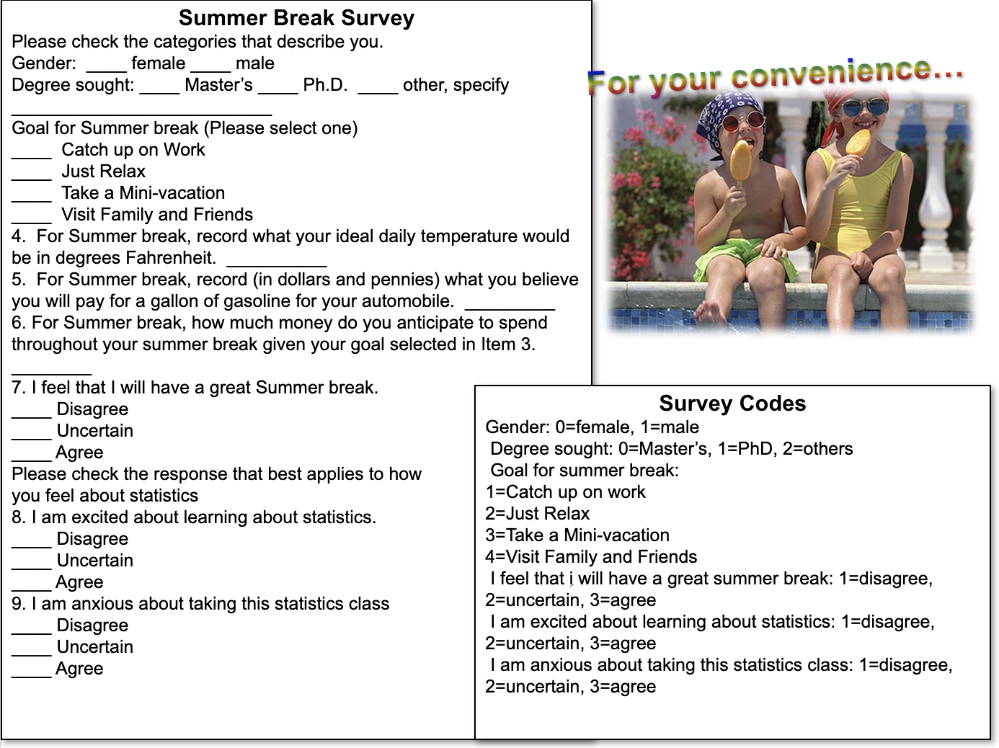
#load data
summer <- read_sav("summersurvey.sav")
#check the data structure
summer
# A tibble: 13 × 10
gender Degree Degree_Other Goal Temp Gas Money Attitude Excited Anxious
<dbl> <dbl> <chr> <dbl> <dbl> <dbl> <dbl> <dbl> <dbl> <dbl>
1 1 0 "" 4 85 0 1500 2 2 3
2 0 1 "" 1 75 3.97 200 3 3 1
3 0 0 "" 1 77 3.3 500 3 2 2
4 0 1 "" 4 75 3.8 1500 3 3 3
5 0 1 "" 1 81 3.79 1000 3 2 3
6 1 1 "" 1 78 3.87 1200 2 1 3
7 1 1 "" 2 76 4.02 799 3 3 3
8 0 2 "" 1 78 3.98 500 2 2 3
9 0 1 "" 1 70 3.85 400 3 3 3
10 0 0 "" 3 80 3.7 1500 3 3 1
11 1 0 "" 1 90 4 NA 3 2 3
12 1 2 "Graduate non… 2 70 3.8 600 3 3 2
13 1 1 "" 3 82 3.79 500 3 3 1
glimpse(summer)
Rows: 13
Columns: 10
$ gender <dbl> 1, 0, 0, 0, 0, 1, 1, 0, 0, 0, 1, 1, 1
$ Degree <dbl> 0, 1, 0, 1, 1, 1, 1, 2, 1, 0, 0, 2, 1
$ Degree_Other <chr> "", "", "", "", "", "", "", "", "", "", "", "Graduate non…
$ Goal <dbl> 4, 1, 1, 4, 1, 1, 2, 1, 1, 3, 1, 2, 3
$ Temp <dbl> 85, 75, 77, 75, 81, 78, 76, 78, 70, 80, 90, 70, 82
$ Gas <dbl> 0.00, 3.97, 3.30, 3.80, 3.79, 3.87, 4.02, 3.98, 3.85, 3.7…
$ Money <dbl> 1500, 200, 500, 1500, 1000, 1200, 799, 500, 400, 1500, NA…
$ Attitude <dbl> 2, 3, 3, 3, 3, 2, 3, 2, 3, 3, 3, 3, 3
$ Excited <dbl> 2, 3, 2, 3, 2, 1, 3, 2, 3, 3, 2, 3, 3
$ Anxious <dbl> 3, 1, 2, 3, 3, 3, 3, 3, 3, 1, 3, 2, 1
str(summer)
tibble [13 × 10] (S3: tbl_df/tbl/data.frame)
$ gender : num [1:13] 1 0 0 0 0 1 1 0 0 0 ...
..- attr(*, "format.spss")= chr "F1.0"
..- attr(*, "display_width")= int 12
$ Degree : num [1:13] 0 1 0 1 1 1 1 2 1 0 ...
..- attr(*, "format.spss")= chr "F1.0"
..- attr(*, "display_width")= int 12
$ Degree_Other: chr [1:13] "" "" "" "" ...
..- attr(*, "format.spss")= chr "A18"
..- attr(*, "display_width")= int 18
$ Goal : num [1:13] 4 1 1 4 1 1 2 1 1 3 ...
..- attr(*, "format.spss")= chr "F1.0"
..- attr(*, "display_width")= int 12
$ Temp : num [1:13] 85 75 77 75 81 78 76 78 70 80 ...
..- attr(*, "format.spss")= chr "F2.0"
..- attr(*, "display_width")= int 12
$ Gas : num [1:13] 0 3.97 3.3 3.8 3.79 3.87 4.02 3.98 3.85 3.7 ...
..- attr(*, "format.spss")= chr "F17.15"
..- attr(*, "display_width")= int 12
$ Money : num [1:13] 1500 200 500 1500 1000 1200 799 500 400 1500 ...
..- attr(*, "format.spss")= chr "F4.0"
..- attr(*, "display_width")= int 12
$ Attitude : num [1:13] 2 3 3 3 3 2 3 2 3 3 ...
..- attr(*, "format.spss")= chr "F1.0"
..- attr(*, "display_width")= int 12
$ Excited : num [1:13] 2 3 2 3 2 1 3 2 3 3 ...
..- attr(*, "format.spss")= chr "F1.0"
..- attr(*, "display_width")= int 12
$ Anxious : num [1:13] 3 1 2 3 3 3 3 3 3 1 ...
..- attr(*, "format.spss")= chr "F1.0"
..- attr(*, "display_width")= int 12
#change variable type
summer<-summer %>%
mutate(gender = as.factor(gender))
glimpse(summer)
Rows: 13
Columns: 10
$ gender <fct> 1, 0, 0, 0, 0, 1, 1, 0, 0, 0, 1, 1, 1
$ Degree <dbl> 0, 1, 0, 1, 1, 1, 1, 2, 1, 0, 0, 2, 1
$ Degree_Other <chr> "", "", "", "", "", "", "", "", "", "", "", "Graduate non…
$ Goal <dbl> 4, 1, 1, 4, 1, 1, 2, 1, 1, 3, 1, 2, 3
$ Temp <dbl> 85, 75, 77, 75, 81, 78, 76, 78, 70, 80, 90, 70, 82
$ Gas <dbl> 0.00, 3.97, 3.30, 3.80, 3.79, 3.87, 4.02, 3.98, 3.85, 3.7…
$ Money <dbl> 1500, 200, 500, 1500, 1000, 1200, 799, 500, 400, 1500, NA…
$ Attitude <dbl> 2, 3, 3, 3, 3, 2, 3, 2, 3, 3, 3, 3, 3
$ Excited <dbl> 2, 3, 2, 3, 2, 1, 3, 2, 3, 3, 2, 3, 3
$ Anxious <dbl> 3, 1, 2, 3, 3, 3, 3, 3, 3, 1, 3, 2, 1
Are there any other variables whose variable type need to be changed?
#Degree
summer<-summer %>%
mutate(Degree = as.factor(Degree))
#Goal
summer<-summer %>%
mutate(Goal = as.factor(Goal))
summer
# A tibble: 13 × 10
gender Degree Degree_Other Goal Temp Gas Money Attitude Excited Anxious
<fct> <fct> <chr> <fct> <dbl> <dbl> <dbl> <dbl> <dbl> <dbl>
1 1 0 "" 4 85 0 1500 2 2 3
2 0 1 "" 1 75 3.97 200 3 3 1
3 0 0 "" 1 77 3.3 500 3 2 2
4 0 1 "" 4 75 3.8 1500 3 3 3
5 0 1 "" 1 81 3.79 1000 3 2 3
6 1 1 "" 1 78 3.87 1200 2 1 3
7 1 1 "" 2 76 4.02 799 3 3 3
8 0 2 "" 1 78 3.98 500 2 2 3
9 0 1 "" 1 70 3.85 400 3 3 3
10 0 0 "" 3 80 3.7 1500 3 3 1
11 1 0 "" 1 90 4 NA 3 2 3
12 1 2 "Graduate non… 2 70 3.8 600 3 3 2
13 1 1 "" 3 82 3.79 500 3 3 1

Frequency Table
A frequency table takes a set of scores and tabulates them in order from highest to lowest (or lowest to highest), grouping together all individuals who have the same (or same range of) score(s).

Get Frequency Tables in R
To create a frequency table in R, use the table() function:
# Example: Frequency table for a categorical variable
summer
# A tibble: 13 × 10
gender Degree Degree_Other Goal Temp Gas Money Attitude Excited Anxious
<fct> <fct> <chr> <fct> <dbl> <dbl> <dbl> <dbl> <dbl> <dbl>
1 1 0 "" 4 85 0 1500 2 2 3
2 0 1 "" 1 75 3.97 200 3 3 1
3 0 0 "" 1 77 3.3 500 3 2 2
4 0 1 "" 4 75 3.8 1500 3 3 3
5 0 1 "" 1 81 3.79 1000 3 2 3
6 1 1 "" 1 78 3.87 1200 2 1 3
7 1 1 "" 2 76 4.02 799 3 3 3
8 0 2 "" 1 78 3.98 500 2 2 3
9 0 1 "" 1 70 3.85 400 3 3 3
10 0 0 "" 3 80 3.7 1500 3 3 1
11 1 0 "" 1 90 4 NA 3 2 3
12 1 2 "Graduate non… 2 70 3.8 600 3 3 2
13 1 1 "" 3 82 3.79 500 3 3 1
table(summer$gender)
0 1
7 6
What percentage of students plan to catch up work in the summer break? What percentage plan to “just relax”?
#frequency table
table(summer$Goal)
1 2 3 4
7 2 2 2
#solution 1
prop.table(table(summer$Goal))*100
1 2 3 4
53.84615 15.38462 15.38462 15.38462
#solution 2
summer %>%
group_by(Goal) %>%
summarize(n = n()) %>%
mutate(percent = n/13*100)
# A tibble: 4 × 3
Goal n percent
<fct> <int> <dbl>
1 1 7 53.8
2 2 2 15.4
3 3 2 15.4
4 4 2 15.4

Practice
Using the lab 1 example data.sav dataset (imported into R as a data frame):
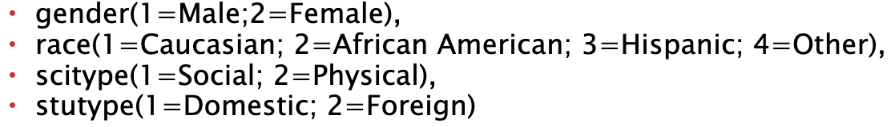
- Check the data structure. Are there any variables whose variable type need to be changed?
- How many students study social sciences? How many study physical sciences?
- List all the possible values of College GPA in descending order. What is the highest score? What percentage of students got that score?
#load data
lab1 <- read_sav("lab 1 example data.sav")
lab1
# A tibble: 44 × 10
id gender race age scitype stutype grev greq cgpa ggpa
<dbl> <dbl> <dbl> <dbl> <dbl> <dbl> <dbl> <dbl> <dbl> <dbl>
1 1 1 1 24 1 1 450 500 3.14 3.42
2 24 1 2 24 1 1 420 590 3.15 3.43
3 37 1 3 24 2 1 490 550 3.31 3.5
4 2 1 1 25 1 1 480 580 3.11 3.34
5 3 1 1 30 1 1 610 650 3.62 3.79
6 4 1 1 30 1 1 540 550 3.15 3.46
7 9 1 1 27 1 2 500 640 3.24 3.57
8 10 1 1 30 1 2 490 740 3.26 3.48
9 25 1 2 28 1 1 580 590 3.54 3.78
10 26 1 2 29 1 1 620 650 3.54 3.85
# ℹ 34 more rows
glimpse(lab1)
Rows: 44
Columns: 10
$ id <dbl> 1, 24, 37, 2, 3, 4, 9, 10, 25, 26, 28, 13, 21, 23, 29, 38, 43,…
$ gender <dbl> 1, 1, 1, 1, 1, 1, 1, 1, 1, 1, 1, 1, 1, 1, 1, 1, 1, 1, 1, 1, 1,…
$ race <dbl> 1, 2, 3, 1, 1, 1, 1, 1, 2, 2, 2, 1, 1, 1, 2, 3, 4, 1, 1, 1, 1,…
$ age <dbl> 24, 24, 24, 25, 30, 30, 27, 30, 28, 29, 29, 26, 28, 29, 27, 29…
$ scitype <dbl> 1, 1, 2, 1, 1, 1, 1, 1, 1, 1, 1, 2, 2, 2, 2, 2, 2, 2, 2, 2, 2,…
$ stutype <dbl> 1, 1, 1, 1, 1, 1, 2, 2, 1, 1, 2, 1, 2, 2, 1, 1, 1, 1, 1, 1, 2,…
$ grev <dbl> 450, 420, 490, 480, 610, 540, 500, 490, 580, 620, 640, 500, 42…
$ greq <dbl> 500, 590, 550, 580, 650, 550, 640, 740, 590, 650, 660, 480, 75…
$ cgpa <dbl> 3.14, 3.15, 3.31, 3.11, 3.62, 3.15, 3.24, 3.26, 3.54, 3.54, 3.…
$ ggpa <dbl> 3.42, 3.43, 3.50, 3.34, 3.79, 3.46, 3.57, 3.48, 3.78, 3.85, 3.…
#change varible type
lab1<-lab1 %>% mutate(gender = as.factor(gender),
race = as.factor(race),
scitype = as.factor(scitype),
stutype = as.factor(stutype)
)
#example: frequency table for major
#scitype(1=Social; 2=Physical)
table(lab1$scitype)
1 2
21 23
#example: frequency table for college GPA
table(lab1$cgpa)
3.11 3.14 3.15 3.18 3.2 3.21 3.22 3.24 3.26 3.28 3.29 3.31 3.33 3.34 3.37 3.38
1 1 2 1 1 1 1 1 2 1 1 1 1 2 1 1
3.39 3.4 3.42 3.45 3.46 3.47 3.5 3.54 3.56 3.58 3.62 3.64 3.68 3.75
2 2 1 4 2 1 2 3 1 1 2 2 1 1
#descending order
lab1 %>%
count(cgpa) %>%
arrange(desc(cgpa))
# A tibble: 30 × 2
cgpa n
<dbl> <int>
1 3.75 1
2 3.68 1
3 3.64 2
4 3.62 2
5 3.58 1
6 3.56 1
7 3.54 3
8 3.5 2
9 3.47 1
10 3.46 2
# ℹ 20 more rows
#percentage
lab1 %>%
group_by(cgpa) %>%
summarize(n = n()) %>%
arrange(desc(cgpa)) %>%
mutate(percent = n/44*100)
# A tibble: 30 × 3
cgpa n percent
<dbl> <int> <dbl>
1 3.75 1 2.27
2 3.68 1 2.27
3 3.64 2 4.55
4 3.62 2 4.55
5 3.58 1 2.27
6 3.56 1 2.27
7 3.54 3 6.82
8 3.5 2 4.55
9 3.47 1 2.27
10 3.46 2 4.55
# ℹ 20 more rows

Descriptive Statistics
Descriptive statistics provide a quantitative description of the main features of a collection of data. Examples include measures of central tendency and variability.

Central Tendency and Variability
- Central Tendency: Mean, Median, Mode
- Variability: Range, Interquartile Range (IQR), Variance, Standard Deviation (SD)

Measures of Variability
- Range: max - min
- Interquartile Range (IQR): Q3 - Q1 (middle 50% of the distribution)
- Variance & Standard Deviation: Measures of average deviation from the mean.
#solution1
summary(summer)
gender Degree Degree_Other Goal Temp Gas
0:7 0:4 Length:13 1:7 Min. :70.00 Min. :0.000
1:6 1:7 Class :character 2:2 1st Qu.:75.00 1st Qu.:3.790
2:2 Mode :character 3:2 Median :78.00 Median :3.800
4:2 Mean :78.23 Mean :3.528
3rd Qu.:81.00 3rd Qu.:3.970
Max. :90.00 Max. :4.020
Money Attitude Excited Anxious
Min. : 200.0 Min. :2.000 Min. :1.000 Min. :1.000
1st Qu.: 500.0 1st Qu.:3.000 1st Qu.:2.000 1st Qu.:2.000
Median : 699.5 Median :3.000 Median :3.000 Median :3.000
Mean : 849.9 Mean :2.769 Mean :2.462 Mean :2.385
3rd Qu.:1275.0 3rd Qu.:3.000 3rd Qu.:3.000 3rd Qu.:3.000
Max. :1500.0 Max. :3.000 Max. :3.000 Max. :3.000
NA's :1
#solution2
describe(summer)
vars n mean sd median trimmed mad min max range
gender* 1 13 1.46 0.52 1.0 1.45 0.00 1 2.00 1.00
Degree* 2 13 1.85 0.69 2.0 1.82 0.00 1 3.00 2.00
Degree_Other* 3 13 1.08 0.28 1.0 1.00 0.00 1 2.00 1.00
Goal* 4 13 1.92 1.19 1.0 1.82 0.00 1 4.00 3.00
Temp 5 13 78.23 5.57 78.0 77.91 4.45 70 90.00 20.00
Gas 6 13 3.53 1.08 3.8 3.80 0.15 0 4.02 4.02
Money 7 12 849.92 473.87 699.5 849.90 444.78 200 1500.00 1300.00
Attitude 8 13 2.77 0.44 3.0 2.82 0.00 2 3.00 1.00
Excited 9 13 2.46 0.66 3.0 2.55 0.00 1 3.00 2.00
Anxious 10 13 2.38 0.87 3.0 2.45 0.00 1 3.00 2.00
skew kurtosis se
gender* 0.14 -2.13 0.14
Degree* 0.16 -1.09 0.19
Degree_Other* 2.82 6.44 0.08
Goal* 0.68 -1.26 0.33
Temp 0.37 -0.52 1.54
Gas -2.68 5.90 0.30
Money 0.28 -1.65 136.80
Attitude -1.13 -0.76 0.12
Excited -0.67 -0.82 0.18
Anxious -0.73 -1.36 0.24

Practice
Using the lab 1 example data.sav dataset:
- Calculate the mean, median, and standard deviation of age, grev, and greq.
summary(lab1)
id gender race age scitype stutype grev
Min. : 1.00 1:26 1:23 Min. :23.00 1:21 1:31 Min. :390.0
1st Qu.:11.75 2:18 2:11 1st Qu.:26.00 2:23 2:13 1st Qu.:497.5
Median :22.50 3: 6 Median :29.00 Median :580.0
Mean :22.50 4: 4 Mean :29.02 Mean :558.4
3rd Qu.:33.25 3rd Qu.:32.00 3rd Qu.:622.5
Max. :44.00 Max. :36.00 Max. :700.0
greq cgpa ggpa
Min. :480.0 Min. :3.110 Min. :3.310
1st Qu.:540.0 1st Qu.:3.275 1st Qu.:3.487
Median :575.0 Median :3.400 Median :3.620
Mean :596.4 Mean :3.401 Mean :3.627
3rd Qu.:650.0 3rd Qu.:3.510 3rd Qu.:3.772
Max. :750.0 Max. :3.750 Max. :3.900
describe(lab1)
vars n mean sd median trimmed mad min max range skew
id 1 44 22.50 12.85 22.50 22.50 16.31 1.00 44.00 43.00 0.00
gender* 2 44 1.41 0.50 1.00 1.39 0.00 1.00 2.00 1.00 0.36
race* 3 44 1.80 1.00 1.00 1.64 0.00 1.00 4.00 3.00 0.95
age 4 44 29.02 3.35 29.00 28.97 4.45 23.00 36.00 13.00 0.02
scitype* 5 44 1.52 0.51 2.00 1.53 0.00 1.00 2.00 1.00 -0.09
stutype* 6 44 1.30 0.46 1.00 1.25 0.00 1.00 2.00 1.00 0.87
grev 7 44 558.41 83.69 580.00 561.67 88.96 390.00 700.00 310.00 -0.31
greq 8 44 596.36 77.16 575.00 591.39 74.13 480.00 750.00 270.00 0.56
cgpa 9 44 3.40 0.16 3.40 3.40 0.19 3.11 3.75 0.64 0.06
ggpa 10 44 3.63 0.17 3.62 3.63 0.21 3.31 3.90 0.59 -0.06
kurtosis se
id -1.28 1.94
gender* -1.91 0.07
race* -0.38 0.15
age -1.02 0.51
scitype* -2.04 0.08
stutype* -1.28 0.07
grev -1.04 12.62
greq -0.82 11.63
cgpa -0.88 0.02
ggpa -1.30 0.02

Graphic Summaries
Graphic summaries (charts) are useful for visualizing data distributions.

Creating Charts in R

Bar Charts
#categorical variable
summer %>%
ggplot(mapping = aes (x = gender)) +
geom_bar()
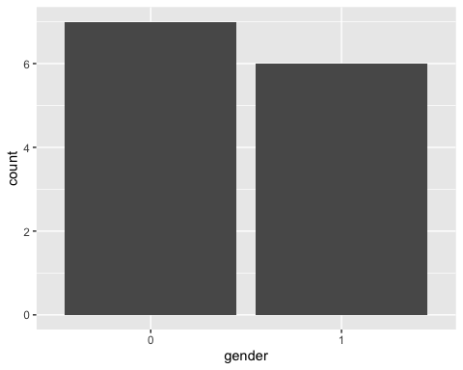

Histograms
#continuous variable
summer %>%
ggplot(mapping = aes (x = Temp)) +
geom_histogram()
`stat_bin()` using `bins = 30`. Pick better value with `binwidth`.
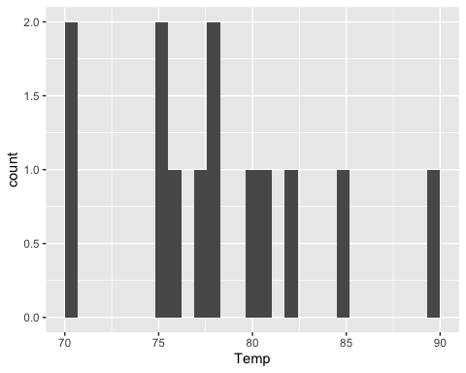
summer %>%
ggplot(mapping = aes (x = Temp)) +
geom_freqpoly()
`stat_bin()` using `bins = 30`. Pick better value with `binwidth`.
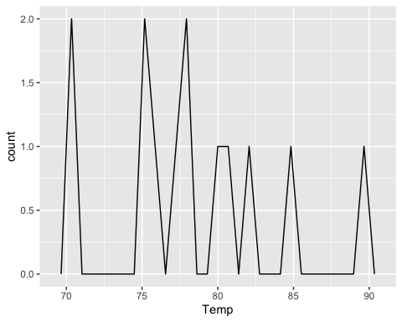
summer %>%
ggplot(mapping = aes (x = Temp)) +
geom_density()
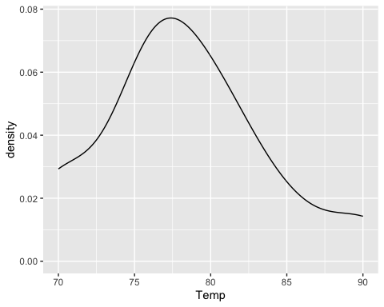

Boxplots
#continuous variable by group
summer %>%
ggplot(mapping = aes (x = gender, y = Temp)) +
geom_boxplot()
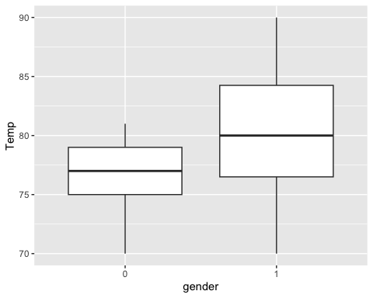

Practice
Using the lab 1 example data.sav dataset:
- Create a bar chart for race.
- Create a histogram for greq.
- Create a boxplot to show greq by race.
#task 1
lab1 %>%
ggplot(mapping = aes (x = race)) +
geom_bar()
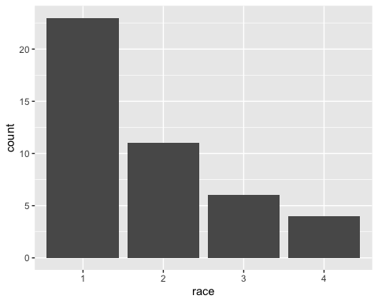
#task 2
lab1 %>%
ggplot(mapping = aes (x = greq)) +
geom_histogram()
`stat_bin()` using `bins = 30`. Pick better value with `binwidth`.
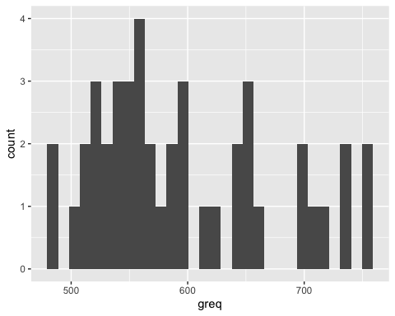
#task 3
lab1 %>%
ggplot(mapping = aes (x = greq)) +
geom_density()
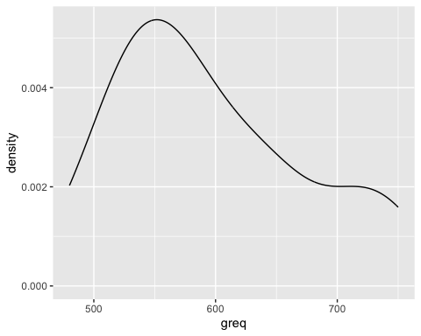
lab1 %>%
ggplot(mapping = aes (x = race, y = greq)) +
geom_boxplot()
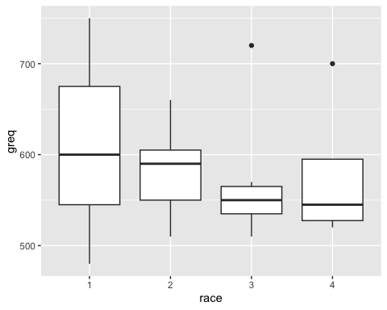

APA-Style Reporting
summer %>%
select(Temp:Anxious) %>%
describe()
vars n mean sd median trimmed mad min max range skew
Temp 1 13 78.23 5.57 78.0 77.91 4.45 70 90.00 20.00 0.37
Gas 2 13 3.53 1.08 3.8 3.80 0.15 0 4.02 4.02 -2.68
Money 3 12 849.92 473.87 699.5 849.90 444.78 200 1500.00 1300.00 0.28
Attitude 4 13 2.77 0.44 3.0 2.82 0.00 2 3.00 1.00 -1.13
Excited 5 13 2.46 0.66 3.0 2.55 0.00 1 3.00 2.00 -0.67
Anxious 6 13 2.38 0.87 3.0 2.45 0.00 1 3.00 2.00 -0.73
kurtosis se
Temp -0.52 1.54
Gas 5.90 0.30
Money -1.65 136.80
Attitude -0.76 0.12
Excited -0.82 0.18
Anxious -1.36 0.24
des<-summer %>%
select(Temp:Anxious) %>%
describe()
write_xlsx(des, "des.xlsx")

Practice
Using the lab 1 example data.sav dataset:
- Generate descriptive statistics for age, grev, greq, cgpa, and ggpa.
- Format the results in an APA-style table, ensuring appropriate labels and formatting.
- Write a brief summary interpreting the descriptive statistics.
data<-read_sav("lab 1 example data.sav")
data
# A tibble: 44 × 10
id gender race age scitype stutype grev greq cgpa ggpa
<dbl> <dbl> <dbl> <dbl> <dbl> <dbl> <dbl> <dbl> <dbl> <dbl>
1 1 1 1 24 1 1 450 500 3.14 3.42
2 24 1 2 24 1 1 420 590 3.15 3.43
3 37 1 3 24 2 1 490 550 3.31 3.5
4 2 1 1 25 1 1 480 580 3.11 3.34
5 3 1 1 30 1 1 610 650 3.62 3.79
6 4 1 1 30 1 1 540 550 3.15 3.46
7 9 1 1 27 1 2 500 640 3.24 3.57
8 10 1 1 30 1 2 490 740 3.26 3.48
9 25 1 2 28 1 1 580 590 3.54 3.78
10 26 1 2 29 1 1 620 650 3.54 3.85
# ℹ 34 more rows
df<-data %>%
select(age, grev, greq, cgpa, ggpa) %>%
describe()
write_xlsx(df, "df.xlsx")

