03_figures.R

hategeki

2023-09-05

# Libraries ----  
pacman::p_load(tidyverse, rio, gtsummary)  
  
# Options ----  
theme_set(theme_bw())  
theme_update(legend.position = "top")  
  
# Data ----  
andorra_clean <- import("MyData/andorra_clean.rds")  
  
# Visualization ----  
# 1. Emancipative distribution  
 # Simple dansity plot for the emancipative part  
(emancipative_distribution <-   
 andorra_clean %>%   
 ggplot(aes(emancipative)) +  
 geom_density(fill = "cyan", alpha = 0.5) +  
 labs(title = "Emancipative index distribution"))

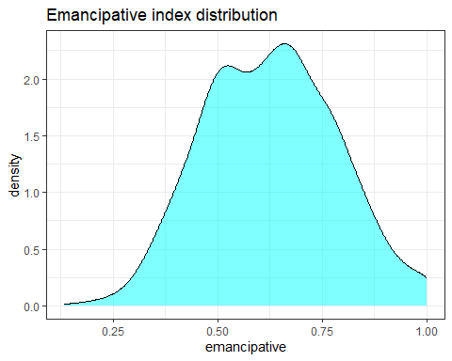

# Save png  
emancipative_distribution %>%   
 ggsave(plot = .,  
 filename = "Results/Figures/emancipative_distribution.png")

## Saving 5 x 4 in image

# Save ggplot  
emancipative_distribution %>%   
 export(file = "MyData/3_figures/emancipative_distribution.rds")  
  
# 2. Emancipaitve/sex/urbrural  
 # Emancipative destribtuion by sex and urbanicity  
 # region of residence  
(emancipative_sex_urban <-   
 andorra_clean %>%   
 ggplot(aes(emancipative, fill = h_urbrural)) +  
 geom_density(alpha = 0.5) +  
 facet_wrap(~sex) +  
 labs(title = "Emancipative index distribution",  
 subtitle = "by sex and urbanicity of region of residence",  
 fill = "Urbanicity"))

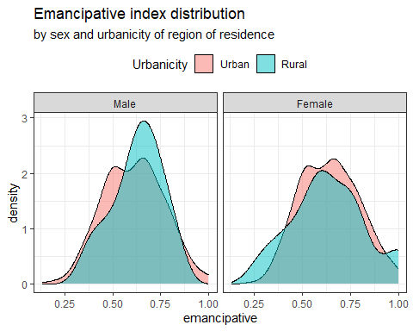

# Save png  
emancipative_sex_urban %>%   
 ggsave(plot = .,  
 scale = 1.5,  
 filename = "Results/Figures/emancipative_sex_urban.png")

## Saving 7.5 x 6 in image

# Save ggplot  
emancipative_sex_urban %>%   
 export(file = "MyData/3_figures/emancipative_sex_urban.rds")