test

Vestin

## Quarto

Quarto enables you to weave together content and executable code into a finished document. To learn more about Quarto see <https://quarto.org>.

## Running Code

When you click the **Render** button a document will be generated that includes both content and the output of embedded code. You can embed code like this:

viz

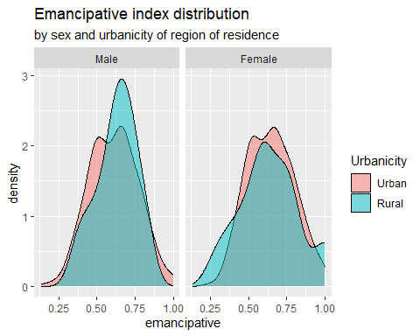

You can add options to executable code like this

tab

|  |  |
| --- | --- |
|  | RESEMAVAL-Welzel emancipative values |
| Predictors | Estimates |
| (Intercept) | 0.68 *** (0.65 – 0.71) |
| Sex: Female | 0.03 ** (0.01 – 0.05) |
| Age | -0.00 *** (-0.00 – -0.00) |
| Urban-Rural: Rural | 0.01  (-0.03 – 0.05) |
| Observations | 999 |
| R2 / R2 adjusted | 0.034 / 0.031 |
| * p<0.05   ** p<0.01   *** p<0.001 | |

The echo: false option disables the printing of code (only output is displayed).