# Set Up and Installation

This project is built completely using IntelliJ IDEA and SQL. Most of the dependencies are restricted inside the IDE project structure. Therefore, Xampp and IntelliJ IDEA needs to be installed.

## Xampp

1. The installer exe is included in the submission folder.

2. Run the installer. Leave the default setting and click next for each prompt.

3. Once Xampp is installed, run it and start the apache service and mysql service.

4. Go to any browser, and type “localhost/phpmyadmin” to enter phpMyAdmin webpage.

5. Create a database called “oop_library”. The database name is case sensitive.

6. Selected the database that you just created. At the top of the page, click the import option.

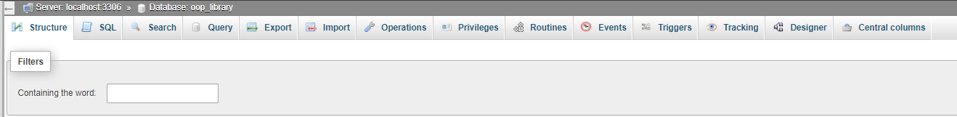



7. Import the SQL file that is included in the submission folder.

## IntelliJ IDEA

1. Install IntelliJ IDEA. The exe file is included in the submission folder. The only configuration that needs to be modify in this part only. For the other part of the installation, just leave the default configuration.

2. Once the IDE is installed, run the IDE. Open the OOP Project folder as project.



3. Select the config.properties file and modify the password section as the figure shown.

4. On the top, click File. Then, click Project Structure.



5. Select Project on the left hand side and make sure the SDK version is 1.8 or Java 8.



6. Select Modules on the left hand side. Select Dependencies on the right hand side.

7. Click the “+” button. Choose JAR or Directories. Inside the project folder, there will be a folder named “lib” and the mysql-connector JAR file is located inside the lib folder. Select the mysql-connector JAR file and click ok.

8. Click the “+” button. Choose Library and From Maven.

9. Enter Bcrypt and click the search icon. It can really take some time for the result to load. Select “at.favre.lib.bcrypt.0.9.0”. Click OK.

10. Apply the changes.

11. Madam, you may now run the program. The default user ID is user and password 12345.