Technical University of Cluj-Napoca
Computer Science Department
Farcas Teodora-Ana
Group 30433

Structure of Computer Systems
~Project~
Management Unit for Cache Memory

- Introduction
This part will provide a short introduction of what the project is about and what resources I will need in order to complete this task. I will implement a Cache Memory using Xilinx ISE which is a software tool produced by Xilinx for synthesis and analysis of HDL designs, enabling me to compile my design and perform numerous analysis on it, in other words perform a real simulation.
Cache memory, also called CPU memory, is high-speed static random access memory (SRAM) that a computer microprocessor can access more quickly than it can access regular random access memory (RAM). This memory is typically integrated directly into the CPU chip or placed on a separate chip that has a separate bus interconnect with the CPU.
Multi-tier or multilevel caching has become popular in server and desktop architectures, with different levels providing greater efficiency through managed tiering. Simply put, the less frequently certain data or instructions are accessed, the lower down the cache level the data or instructions are written.

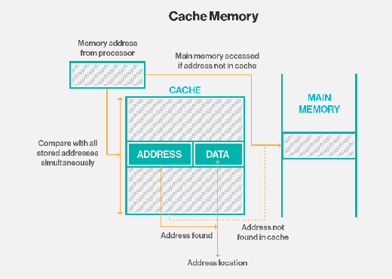

- Objectives

The aim of this laboratory work is to successfully implement a Cache Memory using the Xilinx Simulator. Level 2 cache – also referred to as secondary cache) uses the same control logic as Level 1 cache and is also implemented in SRAM.
The level 2 cache serves as the bridge for the process and memory performance gap. Its main goal is to provide the necessary stored information to the processor without any interruptions or any delays or wait-states. It also helps in reducing the access time of data, especially in certain events where that specific data was already accessed before, so it doesn’t have to be loaded again.

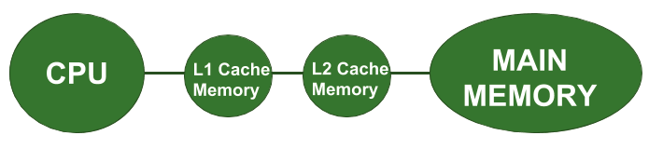

The purpose of the Level 2 cache is to supply stored information to the processor without any delay (wait-state). For this purpose, the bus interface of the processor has a special transfer protocol called burst mode. A burst cycle consists of four data transfers where only the address of the first 64 are output on the address bus. The most common Level 2 cache is synchronous pipeline burst.

- Theoretical Approach

- Central Processing Unit (CPU)
A central processing unit (CPU), also called a central processor or main processor, is the electronic circuitry within a computer that carries out the instructions of a computer program by performing the basic arithmetic, logic, controlling, and input/output (I/O) operations specified by the instructions. The computer industry has used the term "central processing unit" at least since the early 1960s. Traditionally, the term "CPU" refers to a processor, more specifically to its processing unit and control unit (CU), distinguishing these core elements of a computer from external components such as main memory and I/O circuitry.
The form, design, and implementation of CPUs have changed over the course of their history, but their fundamental operation remains almost unchanged. Principal components of a CPU include the arithmetic logic unit (ALU) that performs arithmetic and logic operations, processor registers that supply operands to the ALU and store the results of ALU operations, and a control unit that orchestrates the fetching (from memory) and execution of instructions by directing the coordinated operations of the ALU, registers and other components.
Most modern CPUs are microprocessors, where the CPU is contained on a single metal-oxide-semiconductor (MOS) integrated circuit (IC) chip. An IC that contains a CPU may also contain memory, peripheral interfaces, and other components of a computer; such integrated devices are variously called microcontrollers or systems on a chip (SoC). Some computers employ a multi-core processor, which is a single chip containing two or more CPUs called "cores"; in that context, one can speak of such single chips as "sockets".

- CPU Cache
A CPU cache is a hardware cache used by the central processing unit (CPU) of a computer to reduce the average cost (time or energy) to access data from the main memory. A cache is a smaller, faster memory, located closer to a processor core, which stores copies of the data from frequently used main memory locations. Most CPUs have different independent caches, including instruction and data caches, where the data cache is usually organized as a hierarchy of more cache levels (L1, L2, L3, L4, etc.).
All modern (fast) CPUs (with few specialized exceptions) have multiple levels of CPU caches. The first CPUs that used a cache had only one level of cache; unlike later level 1 caches, it was not split into L1d (for data) and L1i (for instructions). Almost all current CPUs with caches have a split L1 cache. They also have L2 caches and, for larger processors, L3 caches as well. The L2 cache is usually not split and acts as a common repository for the already split L1 cache. Every core of a multi-core processor has a dedicated L1 cache and is usually not shared between the cores. The L2 cache, and higher-level caches, may be shared between the cores. L4 cache is currently uncommon, and is generally on (a form of) dynamic random-access memory (DRAM), rather than on static random-access memory (SRAM), on a separate die or chip (exceptionally, the form, eDRAM is used for all levels of cache, down to L1). That was also the case historically with L1, while bigger chips have allowed integration of it and generally all cache levels, with the possible exception of the last level. Each extra level of cache tends to be bigger and optimized differently.

- Cache Entries
Data is transferred between memory and cache in blocks of fixed size, called cache lines or cache blocks. When a cache line is copied from memory into the cache, a cache entry is created. The cache entry will include the copied data as well as the requested memory location (called a tag).
When the processor needs to read or write a location in memory, it first checks for a corresponding entry in the cache. The cache checks for the contents of the requested memory location in any cache lines that might contain that address. If the processor finds that the memory location is in the cache, a cache hit has occurred. However, if the processor does not find the memory location in the cache, a cache miss has occurred. In the case of a cache hit, the processor immediately reads or writes the data in the cache line. For a cache miss, the cache allocates a new entry and copies data from main memory, then the request is fulfilled from the contents of the cache.
- Replacement Policies
To make room for the new entry on a cache miss, the cache may have to evict one of the existing entries. The heuristic it uses to choose the entry to evict is called the replacement policy. The fundamental problem with any replacement policy is that it must predict which existing cache entry is least likely to be used in the future. Predicting the future is difficult, so there is no perfect method to choose among the variety of replacement policies available. One popular replacement policy, least-recently used (LRU), replaces the least recently accessed entry.
Marking some memory ranges as non-cacheable can improve performance, by avoiding caching of memory regions that are rarely re-accessed. This avoids the overhead of loading something into the cache without having any reuse. Cache entries may also be disabled or locked depending on the context.

- Write Policies
There are two policies which define the way in which a modified cache block will be updated in the main memory: write through and write back.
In the case of write through policy, whenever the value of the cache block changes, it is further modified in the lower-level memory hierarchy as well. This policy ensures that the data is stored safely as it is written throughout the hierarchy.
However, in the case of the write back policy, the changed cache block will be updated in the lower-level hierarchy only when the cache block is evicted. A "dirty bit" is attached to each cache block and set whenever the cache block is modified. During eviction, blocks with a set dirty bit will be written to the lower-level hierarchy. Under this policy, there is a risk for data-loss as the most recently changed copy of a datum is only stored in the cache and therefore some corrective techniques must be observed.
In case of a write where the byte is not present in the cache block, the byte may be brought to the cache as determined by a write allocate or write no-allocate policy. Write allocate policy states that in case of a write miss, the block is fetched from the main memory and placed in the cache before writing. In the write no-allocate policy, if the block is missed in the cache it will write in the lower-level memory hierarchy without fetching the block into the cache.
The common combinations of the policies are "write block", "write allocate", and "write through write no-allocate".

- Cache Mapping
There are three different types of mapping used for the purpose of cache memory which are as follows: Direct mapping, Associative mapping, and Set-Associative mapping. These are explained below.
- Direct Mapping
The simplest technique, known as direct mapping, maps each block of main memory into only one possible cache line.
In Direct mapping, assign each memory block to a specific line in the cache. If a line is previously taken up by a memory block when a new block needs to be loaded, the old block is trashed. An address space is split into two parts index field and a tag field. The cache is used to store the tag field whereas the rest is stored in the main memory. Direct mapping`s performance is directly proportional to the Hit ratio.
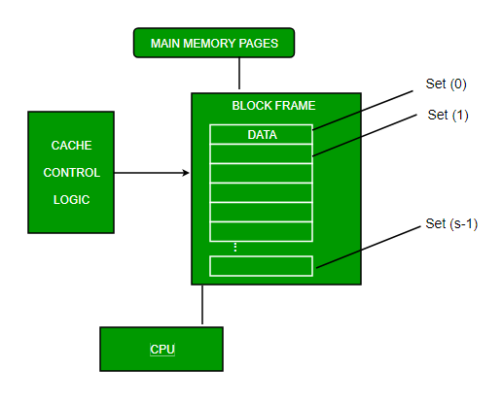
For purposes of cache access, each main memory address can be viewed as consisting of three fields. The least significant w bits identify a unique word or byte within a block of main memory. In most contemporary machines, the address is at the byte level. The remaining s bits specify one of the 2s blocks of main memory. The cache logic interprets these s bits as a tag of s-r bits (most significant portion) and a line field of r bits. This latter field identifies one of the m=2r lines of the cache.

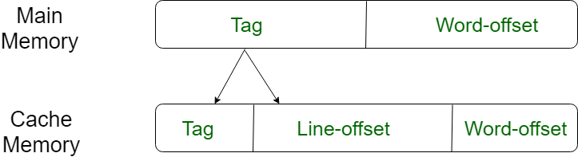

- Associative Mapping
In this type of mapping, the associative memory is used to store content and addresses of the memory word. Any block can go into any line of the cache. This means that the word id bits are used to identify which word in the block is needed, but the tag becomes all of the remaining bits. This enables the placement of any word at any place in the cache memory. It is considered to be the fastest and the most flexible mapping form.
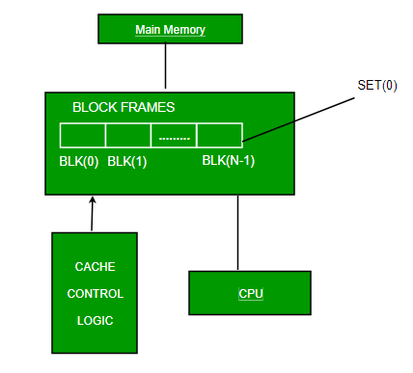
- Set-associative Mapping
This form of mapping is an enhanced form of direct mapping where the drawbacks of direct mapping are removed. Set associative addresses the problem of possible thrashing in the direct mapping method. It does this by saying that instead of having exactly one line that a block can map to in the cache, we will group a few lines together creating a set. Then a block in memory can map to any one of the lines of a specific set. Set-associative mapping allows that each word that is present in the cache can have two or more words in the main memory for the same index address. Set associative cache mapping combines the best of direct and associative cache mapping techniques.
In this case, the cache consists of a number of sets, each of which consists of a number of lines.

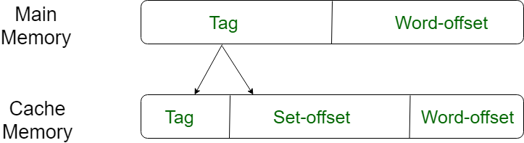

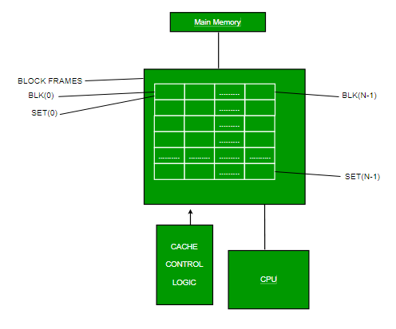
- Design Description

The design consists of a cache memory) and a cache controller that communicates between the main memory and cache memories to carry out all memory related operations. The size and specifications of the cache memory and the design approach is described in the next section.
Block diagram of the designated system:

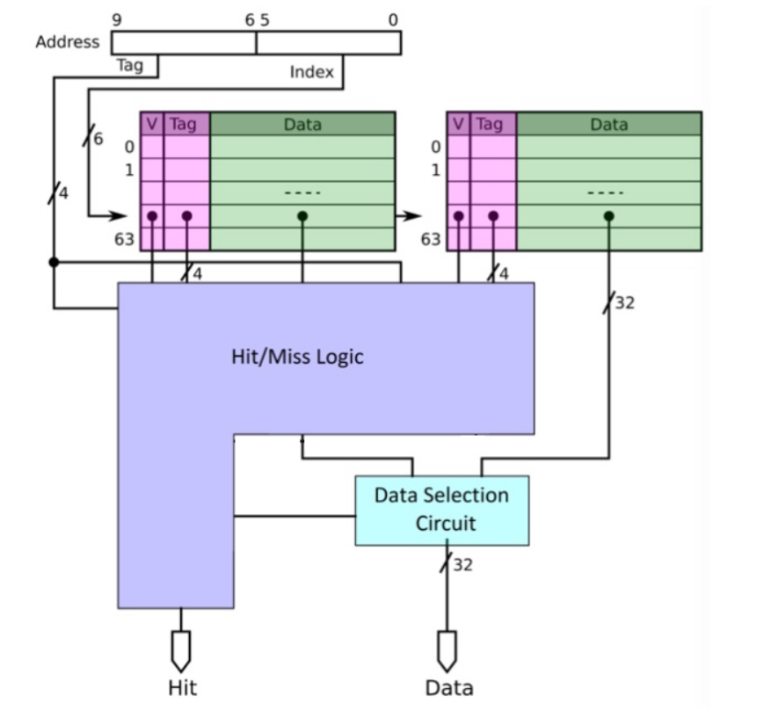

On the above scheme we have a 2-way associative Cache Memory with the number of 64 sets in each block. The address bus is 10-bit wide, while the data bus is 32-bit wide.
To select the sets in the data memory (index) we will use 6 bites, so the tag size is 10 – 6 = 4 bits.
The data memory is 2 * (64 * 32) bits, while the tag memory is 2 * (64 * 4) bits.
In the following step you will see my implementation which consists in a cache controller that is composed of a RAM and a Cache Memory. The cache controller is a hardware block responsible for managing the cache memory, in a way that is largely invisible to the program. It automatically writes code or data from main memory into the cache. It takes read and write memory requests from the core and performs the necessary actions to the cache memory or the external memory.
When it receives a request from the core, it must check to see whether the requested address is to be found in the cache. This is known as a cache look-up. It does this by comparing a subset of the address bits of the request with tag values associated with lines in the cache. If there is a match, known as a hit, and the line is marked valid, then the read or write occurs using the cache memory.
When the core requests instructions or data from a particular address, but there is no match with the cache tags, or the tag is not valid, a cache miss results and the request must be passed to the next level of the memory hierarchy, an L2 cache, or external memory.

- Implementation
6.1 RAM
The RAM's address is used as an index into the memory array. The array is declared as an integer-indexed array, but the address port is modelled as a std_logic_vector signal.

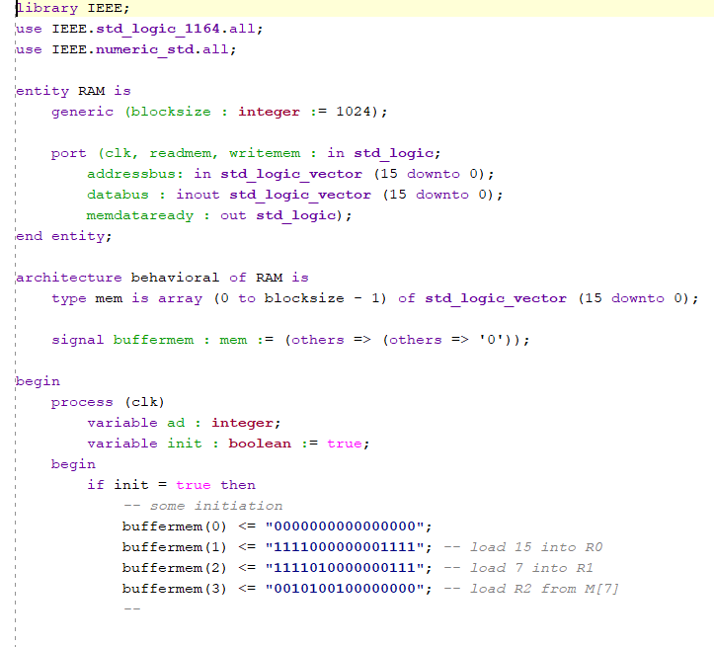

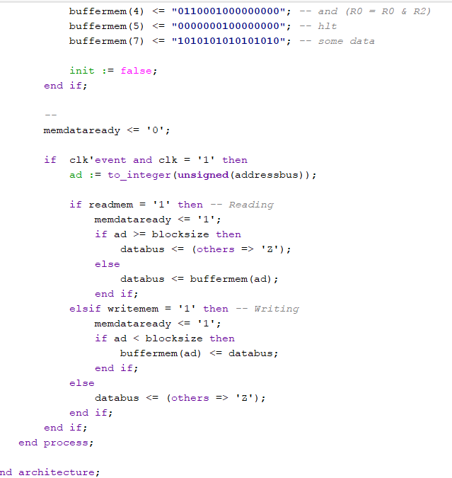

The RAM is implemented with readmem and writemem signals which decide if we are writing in the memory or reading from it. I implemented it with databus and addressbus on 16 bits. I also used a memdataready signal that becomes “1” if operations are being performed on the memory (read or write) and I initialized some values to the ram that will help us later.

6.2 Data Memory
The following is an array of data where the index where the data is stored is the set address, that is on 6 bits. We have a writeEn signal that enables the writing in the memory.

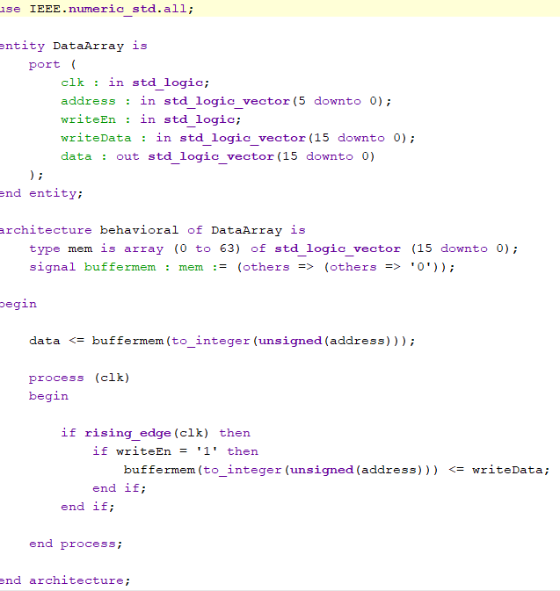

6.3 Tag Memory
The memory words are grouped in pages, either blocks or lines. Each block is marked with an address, referred to as a tag. The collection of tag addresses assigned to the cache memory is stored in a tag memory.

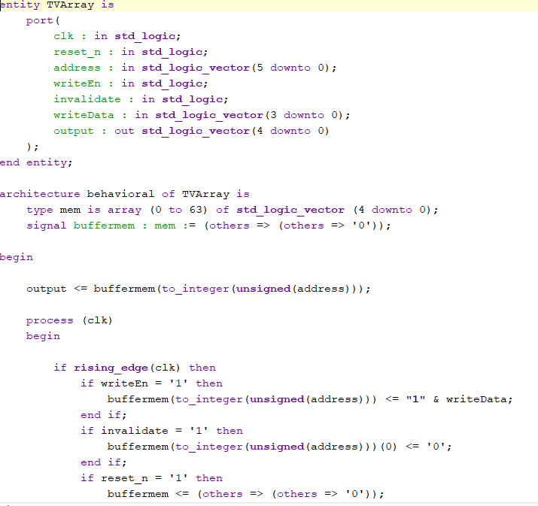

6.4 MissHitLogic

In the following step we check if it is miss or hit. Hit signal becomes 1 if we the set address in any of the two blocks matches the tag and the signals w0v and w1v are used to send further in which of the two blocks the data was found. This is due to the fact that the cache is 2-way associative.

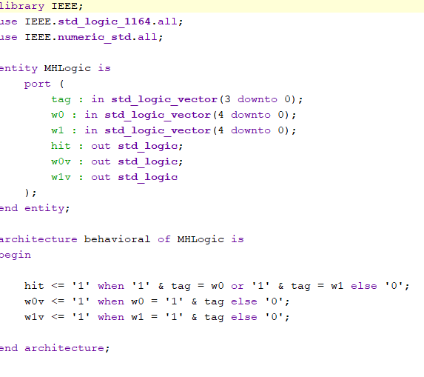

6.5 Cache Memory
Next is the Cache Memory which uses the above components and sends as output the requested data and also in which of the blocks it was found.

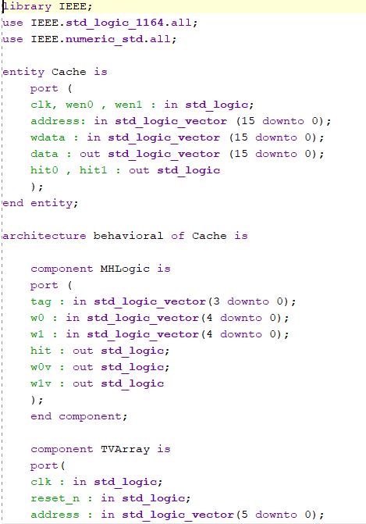
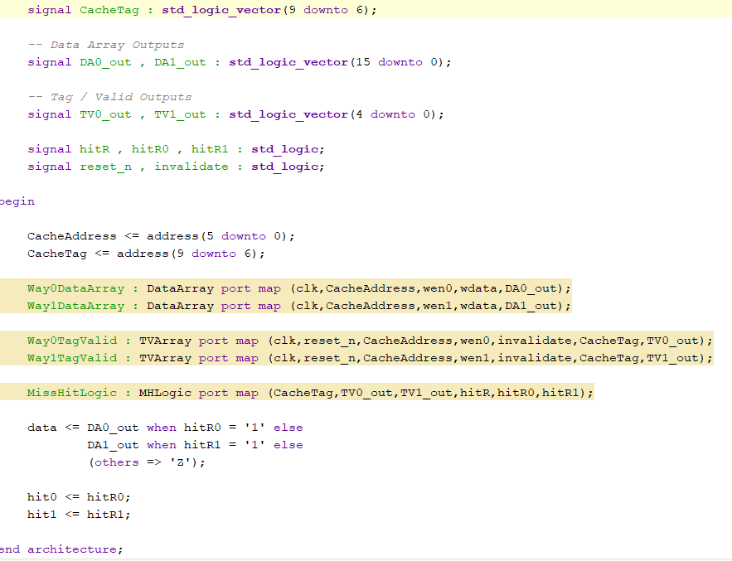

6.6 Cache Controller
The cache controller is build with 3 states, a main state in which we try to read or write a requested data and if a miss occurs it will lead to the second state which handles miss events. The last state is reset which resets all the signal to start the procedure new again.

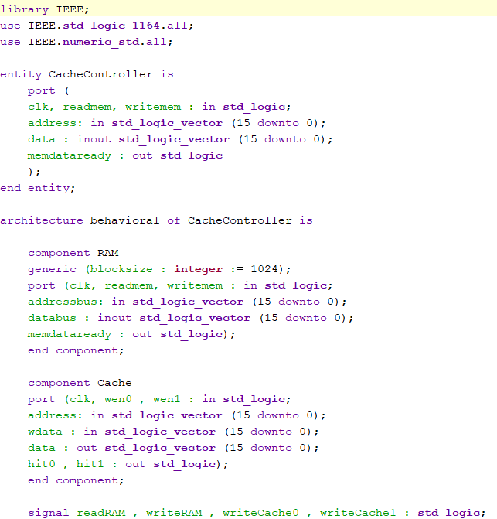

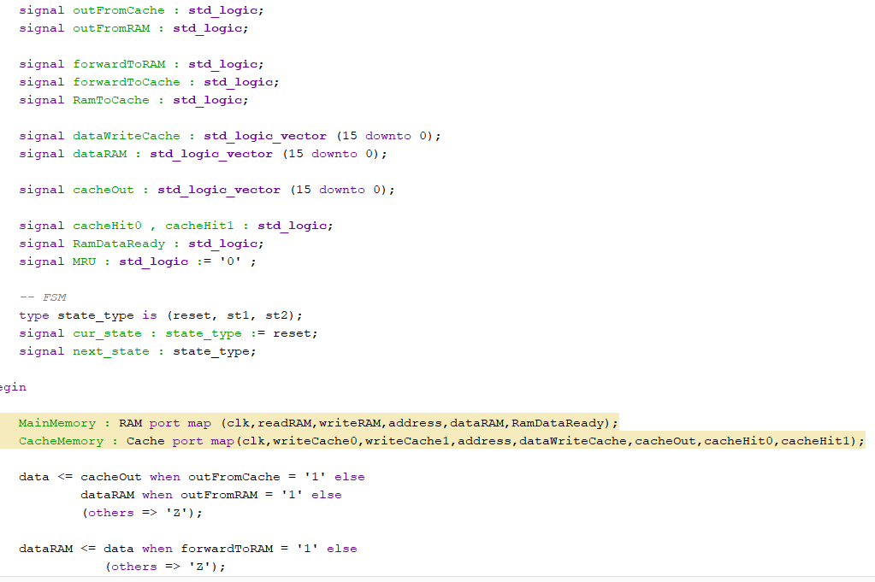
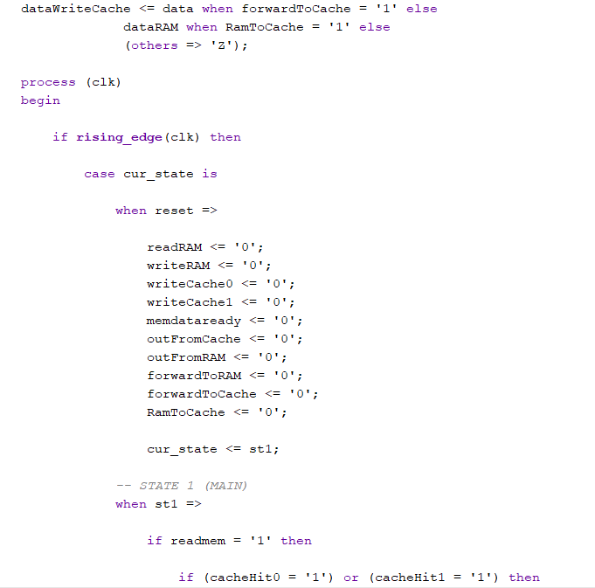
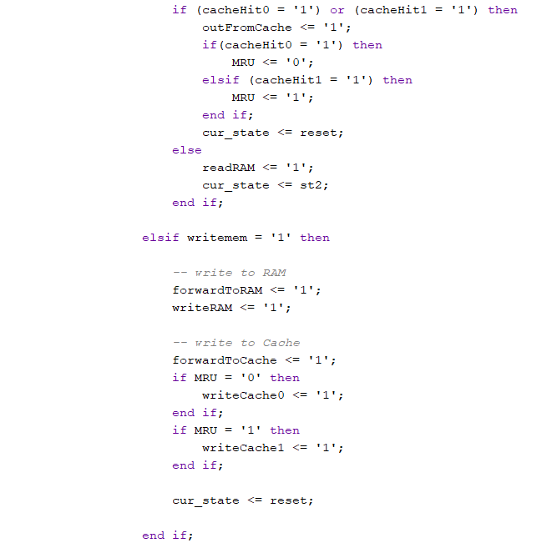
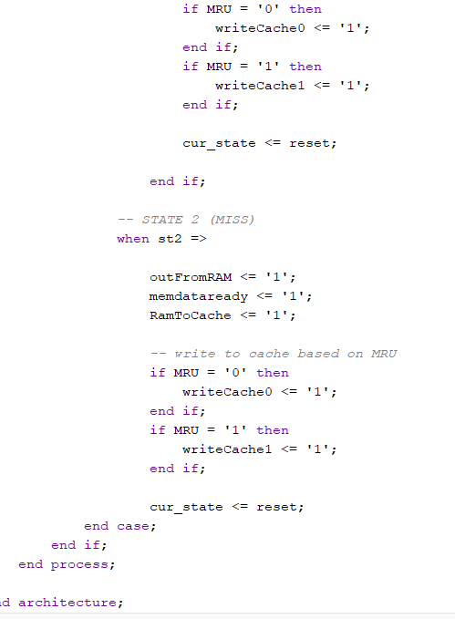

- Simulation Run

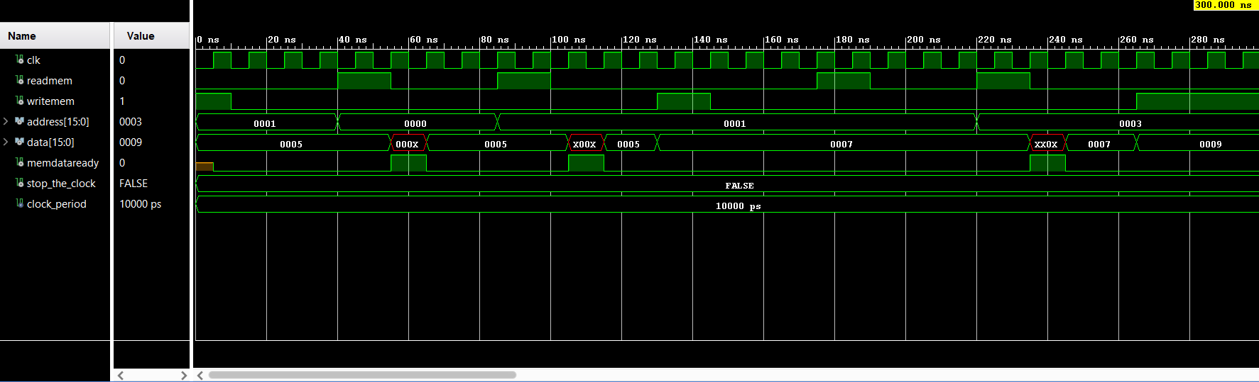

In the above simulation I first initialize the address with 0001 the data with 0005, then I try to read from the address 0000 in order to check if I get a miss and that is exactly what happens, so we take the data from RAM and bring it to the cache. Between each operation I put the read and write signals on 0 for a better understanding of the simulation. After that I further attempt to read at the data at the address 0001, which is again a miss and the RAM is accessed again. Next I write the data 0007 on the address 0001 and I read it again. This time around, a hit occurs because we have data written there and 0007 appears. Next I try again to read at address 0003 which is again a miss and further on I write the data 0009 at the address 0003.

- Further Improvements
Further improvements could be brought by building a bigger cache out of this one, this being a level 2 cache and the using both when trying to find data. When the controller does not find the data in level1 cache it will look for it in the level2 cache and the probability of finding it there will be bigger because of the size of it.
It could function as described below:
- Cache controller receives the address that the microprocessor wants to access;
- Cache controller looks for the address in the L1 cache;
- If the address is in L1 cache (cache hit occurs in L1), the data from the location is provided to the microprocessor via the data bus;
- If the address is not found in L1 cache, then cache miss occurs;
- Cache controller looks for the same address in the L2 cache;
- If the address is found in L2 cache (cache hit occurs in L2), the data from the location is provided to the microprocessor and the same data is also replaced in the L1 cache;
- If the address is not found in L2 cache, then cache miss occurs in L2;
- The controller has to request the same address in the main memory.

Because of the complexity of building a multilevel cache and the limited time I had for implementing this task, I couldn’t complete it fully, but I will try to further improve this application in the future.

- Bibliography

https://moodle.cs.utcluj.ro/pluginfile.php/44627/mod_resource/content/1/L11.pdf
https://www.sciencedirect.com/topics/computer-science/set-associative-cache
https://en.wikipedia.org/wiki/CPU_cache
https://www.slideshare.net/guest136ed3/project-report-multilevel-cache
https://www.geeksforgeeks.org/cache-memory-in-computer-organization/
https://en.wikipedia.org/wiki/Cache_hierarchy
https://searchstorage.techtarget.com/definition/cache-memory
https://en.wikipedia.org/wiki/Central_processing_unit#Cache
https://www.instructables.com/id/Design-of-a-Simple-Cache-Controller-in-VHDL/

