

ZEUS  
Zombie Epidemic Universe Simulator

Czar Ian Echavez

(24008064)

BSc Computer Science

Project ID: 370

Module: SE3IP11

Supervisor: Professor Atta Badii

# Abstract

ZEUS is a simulator that can be used to create a visual model of a theoretical zombie infestation. The simulator has a dual use as it can be used to model the aforementioned zombie infestation, or the simulation can be used to model a realistic spread of a pathogen. Users can set up a simulation which contain the parameters of the zombie infestation (or pathogen) as well as the scenarios which may be involved. The simulation may also save these simulations as well as load and use the simulations, to allow for the simulations to be passed across different users.

# Acknowledgements

I would like to thank Professor Atta Badii and Tom Thorne for supervising the project through its design and development as well as the documentation of the project.

I would also like to thank the following people for testing the ZEUS system:

* Tiago Silva
* Doreen Crump

Contents

Abstract 2

Acknowledgements 3

1. Introduction 5

2. Requirements and Analysis 6

2.1 Case Studies (Existing examples) 6

2.1.1 GLEAM Simulator 6

2.1.2 Zombietown USA 7

2.2 Simulation Mechanisms 8

2.2.1 Mathematical model of a zombie disease 8

3. Design Specification 10

3.1 ZEUS System model 10

3.1.1 Breakdown of each variable 11

3.2 Use Cases 13

3.3 User Interface 16

4. System Development 16

4.1 Tools Used 16

4.1.1 Visual Studio IDE 16

4.1.2 GitHub 16

4.2 External dependencies / libraries 16

4.2.1 SDL (Simple Direct Media Layer) 16

4.2.2 ImGUI (Immediate mode GUI) 17

4.3 Implementation 17

5. Sub-system Conformance Testing System Integration 18

6. Usability evaluation 19

7. Project outcomes (lessons learned) 20

8. Conclusions and Evaluation 21

9. Future of the project 22

10. Glossary 23

11. Appendices and References 25

# Introduction

# Requirements and Analysis

## Case Studies (Existing examples)

### GLEAM Simulator

The GLEAM (Global Epidemic and Mobility Model) Simulator [[1]] is a two-part system composed of a Client and server application. The system uses the server to run the simulations, none of the computations are done on the user’s computer. The GLEAM system uses the client application to interact with the server. The client application itself is also split into smaller modules. The client application is split into a simulation builder, simulation manager and the simulation visualiser.

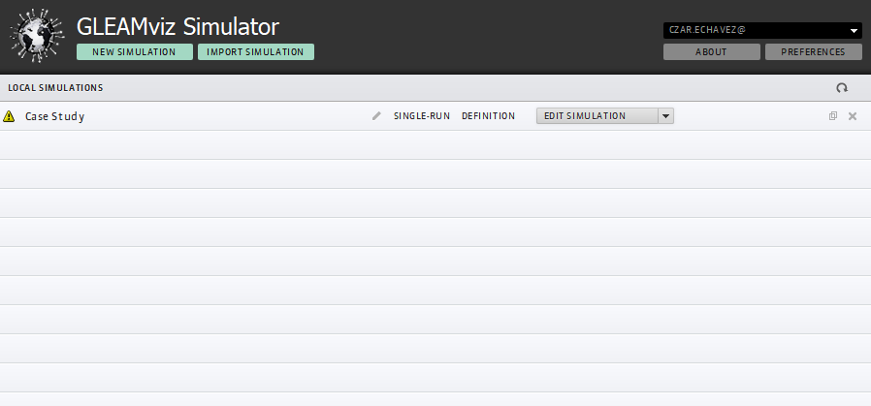

Figure 1 Simulation Manager

A user can track his/her simulations using the simulation manager. The simulation manager holds the simulations that are both complete and incomplete. Complete simulations can be submitted to the GLEAM server for the simulation to be run. Figure 1 shows the simulation manager’s user interface.

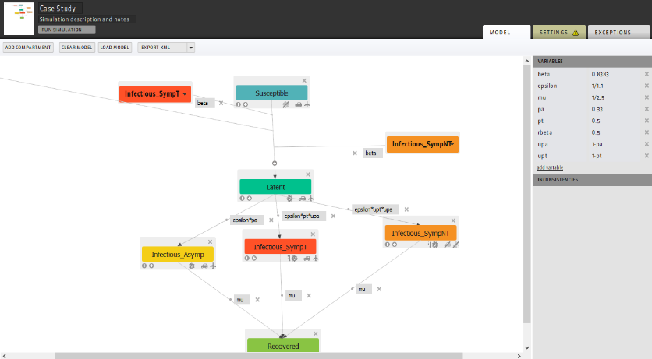

Figure 2 Simulation Builder

The simulation builder is where a user can create the spreading logic of the simulation i.e. how the disease propagates during the simulation as well as defining the starting point of the simulation. Figure 2 shows the user interface for the simulator builder.

The simulation builder works on the basis that each object on screen is a compartment and that connections between the compartments are transitions, each with a variable name (with set values) which are used to calculate the spread of the disease.

The simulation visualiser allows the user to see the results of the simulation. The visualiser has multiple settings and widgets to visualise the spread of disease in multiple ways. The world map remains the same however can be reskinned to highlight certain parts such as visualising which country is most susceptible to a pandemic. As shown in Figure 3, the visualiser also displays a graph of the new infections per day; other graphs can also be displayed.

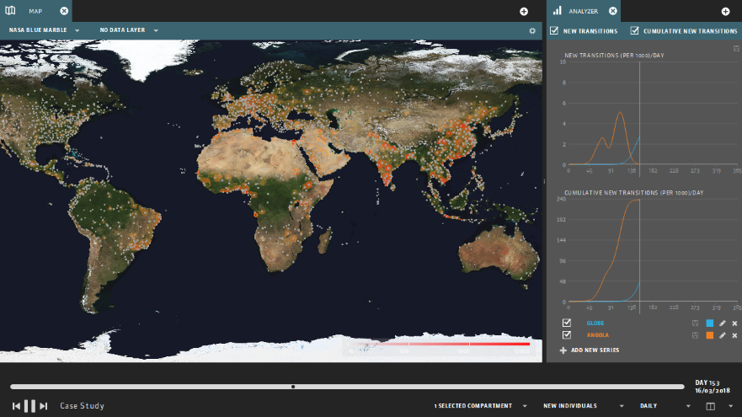

Figure 3 Simulation Visualiser

#### Evaluation of GLEAM

GLEAM has a great user interface design, however, some aspects of the software require the user to refer to the manual [[2]]. The simulator builder has on screen help, however is not clear enough for a user to be able to make sense of what should be done in order for a simulation to be deemed runnable. Only after referring to the GLEAM user manual is it possible to understand how to create a simulation that the system deemed complete to be run. GLEAM breaking down its system into multiple pieces (i.e. the manager, builder and visualiser) also means that the software is not cluttered with a large amount of settings, ensuring that only the settings available in the current application is relevant to the action that the user needs to do; the simulation manager only allows the user to create and manage existing simulations, the builder only allows the user to create the disease mechanism and the simulation scenario, etc.

GLEAM is a simulator for realistic diseases, however, the goal of this project is also to create a zombie simulator. ZEUS still requires the use of disease spread, as it is assumed that the process of being turned into a zombie is that a person is first infected before becoming a zombie (assuming that the time for an infected to become a zombie is not the same as the incubation period)

Taking note of GLEAM’s flaws would help in ensuring that the development of ZEUS has an easily understandable user interface as well as provide a good user experience when using ZEUS. ZEUS needs to be set to only one simulation logic to simplify the simulator, therefore this is taken into account during the development process.

### Zombietown USA

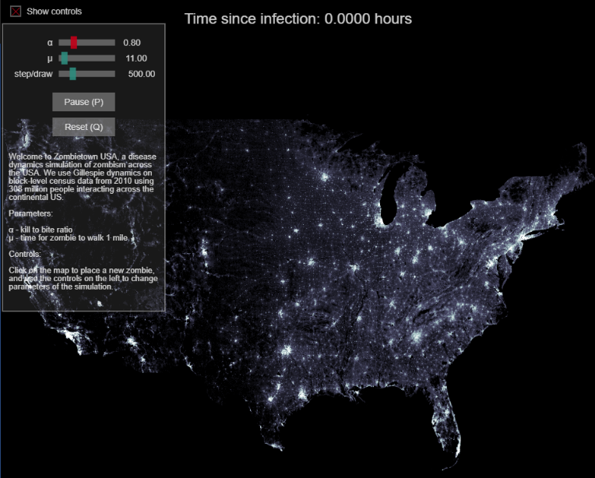

Figure 4 Zombietown USA demo

Zombietown USA [[3]][[4]] is JavaScript based application created by Matt Bierbaum and Alex Alemi.

The application is a simple simulation of how the zombies propagate through a population; the areas of high population are the lighter parts of the map, shown in Figure 4. The application only simulates the spread of zombies within the US and does not spread around the world.

The user interface for the application is also very simple, requiring only 4 different inputs from a user; the 3 variables the user can set, and the location(s) where the zombies can spread from.

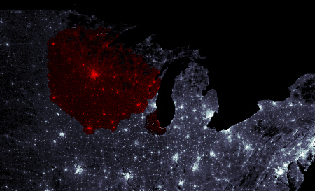

Figure 5 Infection Spread

Figure 5 shows the simulation after a few steps to show the spread of the zombies. The zombies are shown in red while healthy populations are still white (and grey). The simulator emphasises that the higher the population, the faster the zombies propagate through the region, hence the spread of zombies showing bumps on regions of high populations.

Figure 6 shows the 3 variables that the user is able to change. The sliders at the top of the interface denote the 3 variables that affect the simulation; these variables affect how the disease propagates (the chance of an infected individual turning into a zombie), how fast the disease travels (and therefore how fast a zombie should travel) and how many simulation cycles should be done before drawing the result to the screen.

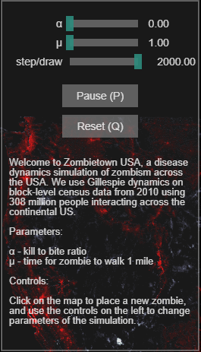

Figure 6 Simulator Variables

The user is able to set the starting point of the simulation by clicking on the map to “place” the initial zombie or if multiple points are clicked, zombies.

#### Evaluation of Zombietown USA

The user interface for this application is both easy to understand and use. The simulation is largely automated and begins as soon as the user clicks on the map where the simulation should begin from.

The parameters to control the simulation is also very easy to understand and manipulate; the explanation of how the variable affects the simulation is shown where the user changes the parameters so that the user is able to know what should happen before they choose to change the variables.

The simulator’s simplicity however, causes it to be non-realistic. The simulator is too simple and cannot simulate the fact that the disease is able to spread to other cities instead of steadily moving from the starting point (a user can simulate this by having multiple start point but should be automatic). The simulator also only simulates the spread of zombies; this can be improved by also showing the spread of the disease, however this scenario may be where an infected individual becomes a zombie straight away.

The simple UI design should be taken into account in the development of ZEUS; a simple UI design makes the simulator easy to use and understand, and if a component needs explanation, there must be a way for the user to understand the item without needing to refer to a user manual.

## Simulation Mechanisms

### Mathematical model of a zombie disease

Knowing how a zombie disease will spread across a population is required by ZEUS in order to perform the calculations for the simulator and therefore making a more realistic simulation. Making a mathematical model of the simulations also means that the simulations remain consistent across the different copies of the simulator (excepting the fact that RNG may cause slight differences).

A collaborative study by statisticians from the University of Ottawa and Carleton University [[5]] created a mathematical model of a spread of zombies across a population. The model breaks down the model into 3 distinct classes: Susceptible (people that can be infected), Zombies, and Removed (which are removed from the population pool if a zombie is destroyed or an uninfected individual dies).

Figure 7 (taken from [5]) shows the basic version of the model; S, Z and R representing Susceptible, Zombie and Removed respectively.

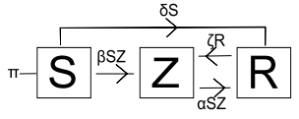

Figure 7 Basic infection model

π is an input into the population pool, the model assumes a birth rate i.e. more humans being born.

The model shows susceptible individuals becoming a zombie but cannot become uninfected, however a “removed” individual is able to be revived as a zombie again. The transitions have parameters which define the rate at which an object becomes another object e.g. βSZ is the rate of infection, αSZ is the rate of zombie elimination, ζR is the rate of reanimation (of zombies), etc.

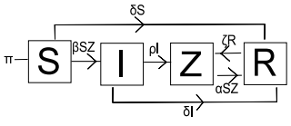

Figure 8 SIZR Model (with latent infection)

Figure 8 (taken from [5]) takes the basic model further by implementing an intermediate class between Susceptible and Zombies. This class is for infected individuals – people who have been bitten but have not yet become zombies.

In this model, new transitions are added; the infected become zombies at a rate ρI and infected individuals that do not transition into zombies at a rate of δI

The model in Figure 8 can be easily adapted to serve as the disease spread logic for ZEUS. Some alterations are done in order to simplify the model as well as ensure that the simulation runs for a limited length of time (i.e. finishes when either there are no more infected and/or zombies); the use of π introduces more individuals into the simulation and would essentially cause the simulation to last longer than required and possibly come to an equilibrium state where the disease infects at the same rate as the birth rate.

# Design Specification

## ZEUS System model

Figure 9 Proposed ZEUS Model

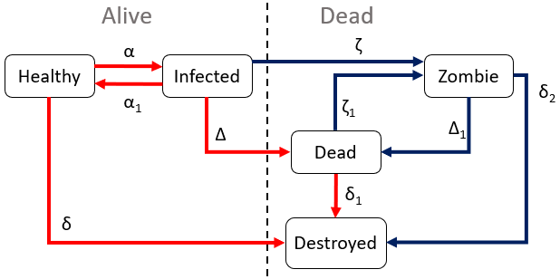

Figure 9 is the proposed simulation model for ZEUS; this model is based from the SIZR model discussed in 2.2.1 Mathematical model of a zombie disease.

The main alteration to the SIZR model is the removal of the birth rate, effectively making the model in Figure 9 a closed system i.e. the number of population in the simulation is set and no new individuals are introduced into the simulation.

Another alteration to the SIZR model is the splitting of the “Removed” class into a “Dead” and “Destroyed” class. Both act as “Removed” as in the SIZR model, however dead classes can be reanimated into zombies, and destroyed is the end point for the model i.e. once an object is deemed destroyed, it is considered fully removed from the simulation.

Figure 9 also shows the grouping of all the classes; the classes are split into “Alive” and “Dead” (not to be confused with the dead class). This clearly shows the logic behind the transitions, as dead classes cannot come back to life as either infected or healthy. The model also considers zombies as dead, therefore even if the cure is found, the zombies persist until they are destroyed.

As for the possibility of cures, an “Immune” class was planned to be implemented, however, this is scrapped, as once the cure is triggered, the healthy class automatically is converted into the immune. The infectivity α will be set to 0, meaning no more infections can occur, as well as a higher rate of infected of being cured and therefore becoming immune.

The ZEUS model also shows 2 different forms of transitions; Figure 9 shows 2 different coloured transitions in the model. Red coloured transitions are for when the simulation is running only to show the spread of the disease without the zombies. In a non-zombie based scenario, dead and destroyed classes are effectively the same. In a zombie based scenario, the blue coloured transitions would be used.

### Breakdown of each variable

Figure 9 has multiple variables attached to each transition states; these are variables that the simulation uses to calculate the portion of the population that undergoes the transition e.g. how many healthy individuals are to become infected, therefore the same amount added to the infected pool is the same amount the healthy pool is reduced by.

These variables are further broken down by different substituent parameters. The variables are affected by a singular country’s parameter such as a country’s climate; this allows the simulation to show how different the infection propagates through different countries.

|  |  |  |
| --- | --- | --- |
| α | Infection rate | This variable affects the rate of infection of the disease. The higher this value, the more healthy individuals transition into an infected state. A country’s climate can affect the overall value of the infection rate.  Multiple other parameters set by a user can affect this variable; Transmission vectors such as air, water or zoonotic (animals) can increase α. Simulation settings (such as allowing to simulate air travel and sea travel) also has an (indirect) affect on the infection rate |
| ­α1 | Recovery rate | The recovery rate affects how much of a population recovers from being infected. Normally if infected individuals recover, they become immune to the disease, this is not simulated; therefore the recovered individuals are returned to the healthy pool (unless a cure is found, in which case the healthy pool is converted into the immune pool.  This variable is affected by a country’s research budget (the research budget emulates the country’s funding of their health care system, the default data included is taken from the CIA World Factbook Health Expenditure for each country [[6]]) |
| δ | “Natural” death rate | The natural death rate is the rate at which healthy individuals die naturally i.e. without the effects of the disease. This emulates the fact that individuals can die of old age (natural causes) and/or accidents (and possibly other diseases not currently being the focus of the simulation).  These individuals are assumed to not be infected by the disease and therefore go straight into the destroyed class instead of the dead class, as the dead class should only have individuals who were infected by the disease; this also prevents uninfected dead people from being reanimated into zombies when they should not be.  The natural death rate is affected by the research budget of the country (for the same reasons as in the recovery rate) and by the GDP; higher GDP countries are assumed to have a higher quality of life (such as introductions of health and safety, food safety laws, etc) |
| δ1 | Decay rate | The decay rate is the rate at which the dead class slowly decays i.e. the corpse rotting. The dead class turns into the destroyed class, effectively removing them from the simulation; this is because as the corpse decays it is no longer possible for the object to be reanimated into a zombie.  The decay rate is affected by the country’s climate; a warmer climate causes decay of corpses to be much faster, therefore the transition from dead to destroyed occurs much faster in warmer countries. The opposite happens for colder climates, colder temperatures slow down the rate of decay and therefore decay rate decreases. |
| δ2 | Zombie elimination rate (permanent) | The zombie elimination rate is the rate at which zombies are **permanently** removed from the simulation, whether it be zombies decaying naturally or by being destroyed by alive humans.  Since the zombies can decay, the variable is affected by the climate of the country, similar to the decay rate. The country’s military budget also affects the zombie elimination rate, as a better funded military is assumed to be more effective in removing zombies within their country. |
| Δ | Death rate from disease | Death rate from disease is the variable that the simulation uses to determine how many of each infected die from the disease. In Figure 9 the infected are not classed as “destroyed” when undergoing this transition; instead the transition is towards the dead class, which means that the infected individual that dies can be reanimated into a zombie.  The death rate is affected by the research budget of each country, similar to whether or not the country is effective in being able to keep the person alive (as in the recovery rate). |
| Δ1 | Zombie elimination rate (non-permanent) | Similar to δ2 above, this variable acts the same way, removing zombies from the zombie population pool; however instead of the zombies being permanently removed, they are instead converted into the dead state, which means that the zombies can still reanimate.  This variable is also affected by the military budget of a country, for similar reasons as δ2. |
| ζ | Zombie conversion rate | The zombie conversion rate is the variable used to determine how much of the infected are converted into zombies instead of dying.  This variable is not affected by any scenario parameters (country values), instead this is a variable that can be manipulated in the simulation settings. |
| ζ1 | Reanimation rate | The reanimation rate is the variable used to determine how often the dead classes should be reanimated into zombies. Similar to ζ, this variable is not affected by anything and is a variable that can be manipulated in the simulation settings |

## Use Cases

|  |  |
| --- | --- |
| **Element:** ZEUS System GUI | **Use Case ID:** 1 |
| **Stakeholders/Interested Parties:**   * Epidemiologists * Pathogen Researchers * Hobbyists | |
| **Primary Actor:** Software User | |
| **Description:**  The user of the software will need a way to interact with the software. A Graphical User Interface will provide a user with proper prompts as well as output the correct responses depending on the input(s). | |
| **Trigger(s):**   * User gives mouse inputs via clicking or moving move around the screen * User gives key inputs via the keyboard or on screen keyboard | |
| **Conditions:**   * User needs to have a keyboard * User needs to have a mouse * Keyboard and mouse need a way to communicate with the computer running the software, either via physical wire or wireless connection | |
| **Event flow:**   * User gives input into keyboard or mouse * Keyboard or mouse transforms input into string/numerical values the computer can process * The input is passed into the software * The software check if the mouse or keyboard input is relevant and performs actions based on the input | |
| **Alternate flow:**   * User inputs values to keyboard and mouse but neither are connected to the computer, therefore the input is not detected * User inputs values but the software is not running therefore inputs are not detected * User inputs values but the inputs are irrelevant to the software | |

|  |  |
| --- | --- |
| **Element:** ZEUS Scenario Creator | **Use Case ID:** 2 |
| **Stakeholders/Interested Parties:**   * ZEUS System users | |
| **Primary Actor:** Advanced ZEUS Users | |
| **Description:**  The Scenario creator is used to create new scenarios, maps which the main simulator system can use in order to run simulations on. | |
| **Trigger(s):**   * User gives mouse inputs via clicking or moving move around the screen * User gives key inputs via the keyboard or on screen keyboard * User uses the GUI elements to interface with the system | |
| **Conditions:**   * User needs to have a keyboard * User needs to have a mouse * Keyboard and mouse need a way to communicate with the computer running the software, either via physical wire or wireless connection | |
| **Event flow:**   * User gives input parameters to create a new scenario; the scenario map (image) to be used and the name of the scenario * The user populates the scenario map with countries; each country has its own values such as population, GDP, research budget, military budget and climate * User connect countries together by adding “links” between them * User finished creation of simulation by saving it to a file location of their choosing | |
| **Alternate flow:**   * User opens an already existing scenario * User tells the program which file is to be opened for editing * The user makes necessary edits to the scenario data * User saves the file once finished | |

|  |  |
| --- | --- |
| **Element:** ZEUS System | **Use Case ID:** 2 |
| **Stakeholders/Interested Parties:**   * ZEUS System users | |
| **Primary Actor:** ZEUS Users | |
| **Description:**  The main part of the system which runs the simulations and uses the scenarios created by the scenario creator | |
| **Trigger(s):**   * User gives mouse inputs via clicking or moving move around the screen * User gives key inputs via the keyboard or on screen keyboard * User uses the GUI elements to interface with the system | |
| **Conditions:**   * User needs to have a keyboard * User needs to have a mouse * Keyboard and mouse need a way to communicate with the computer running the software, either via physical wire or wireless connection | |
| **Event flow:**   * User gives input parameters to create a new simulation. * User defines which scenario should be used in the simulation * User defines the simulation parameters * User can save the simulation setup and then run the simulation | |
| **Alternate flow:**   * User opens an already existing simulation * User tells the program which file is to be opened for editing * The user makes necessary edits to the simulation data * User saves the file once finished | |

## User Interface

#### ZEUS Scenario Creator

##### Menu bar hierarchy

The Scenario creator’s GUI will consist mainly of the menu bar and the windows that pop up when the user selects an option from the menu bar.

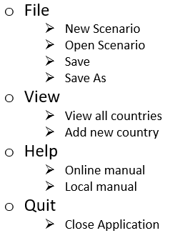

Figure 10 Scenario Creator Menu bar hierarchy

There are 4 main options in the main menu bar, each with an inner option that shows up on a drop down box when a user makes a choice.

File has options that are relevant to creating, opening and saving the scenarios that are dealt with by the scenario creator.

View has 2 options that are only relevant when a scenario is currently being worked on.

Quit drops the option that closes the scenario creator. This is done to add an extra step to ensure the scenario creator is not accidentally closed by the user.

#### ZEUS Main System

# System Development

## Tools Used

### Visual Studio IDE

### GitHub

* Version control

## External dependencies / libraries

### SDL (Simple Direct Media Layer)

* Rendering library

### ImGUI (Immediate mode GUI)

* GUI

## Implementation

# Sub-system Conformance Testing System Integration

# Usability evaluation

# Project outcomes (lessons learned)

# Conclusions and Evaluation

# Future of the project

# Glossary

|  |  |
| --- | --- |
|  |  |
|  |  |
|  |  |
|  |  |
|  |  |
|  |  |
|  |  |
|  |  |
|  |  |
|  |  |
|  |  |
|  |  |
|  |  |
|  |  |
|  |  |
|  |  |
|  |  |
|  |  |
|  |  |
|  |  |
|  |  |
|  |  |
|  |  |
|  |  |
| GUI | Graphical User Interface; a user interface that utilise graphics |
| RNG | Random Number Generator; allows for randomisation in the application/system |
| UI | User Interface; the part of the software that allows the user and the system to interact |

# Appendices and References

References will be in the format:

<Object being referred to> [<Reference type: Book, Journal, Online, etc>] [<Access date>]

<If online, the link to the reference || otherwise the book ISBN or journal ID>

1. [] GLEAM Simulator [Online] [Accessed 26 March 2018 09:33]

   <http://www.gleamviz.org/simulator/>
2. [] GLEAM Simulator version 6.8 Manual [Online] [Accessed 26 March 2018 20:10]

   <http://www.gleamviz.org/simulator/GLEAMviz_client_manual_v6.8.pdf>
3. [] Zombietown USA Source (Github page) [Online] [Accessed 26 March 2018 20:43]

   <https://github.com/mattbierbaum/zombies-usa>
4. [] Zombietown USA Browser Demo [Online] [Accessed 26 March 2018 20:45]

   <http://mattbierbaum.github.io/zombies-usa/>

  
5. [] WHEN ZOMBIES ATTACK!: MATHEMATICAL MODELLING OF AN OUTBREAK OF ZOMBIE INFECTION [Online] [Accessed 27 March 2018 02:26]

   <https://mysite.science.uottawa.ca/rsmith43/Zombies.pdf>

  
6. [] CIA World Factbook data on world Health Expenditures [Online] [Accessed 29 March 2018 17:20]

   <https://www.cia.gov/library/publications/the-world-factbook/rankorder/2225rank.html>